2) Pendulum experiences pseudo force.
It is important to consider the pseudo force ie the apparent force which manifests because of the acceleration of the frame itself if we wish to apply Newtons laws of motion in such non inertial frames. If we don't then we can't account for the seen state of the system because no physical force ie a force which has some tangible physical origin is acting on the system.
To illustrate this consider the following situation. Imagine a pendulum tied to a thread in train. Initially, the train is at rest and hence as expected the tension in the thread balances out the pendulum's weight and we have a static equilibrium. Now what happens when say the train starts accelerating in the rightward direction? We observe, that the pendulum makes a certain angle with the vertical. The angle is constant if the acceleration of the train is too. It is as if something is pushing the pendulum in the direction against the acceleration of the train. But, where is this force coming from? The answer is that the force perceived is not because of an external agent but because of the acceleration of the train itself. That is why the angle was consant when the acceleration was constant.
The rule states that to use Newton's laws of motion in such a noninertial frame, add a force with magnitude equal to m*acceleration whose direction is opposite to that of the acceleration.
Then, we can derive the equilibrium equations in the usual manner.

(insert photo)

Since there is a direct relation between acceleration and theta, we decided to plot this relation. Initially, we expected to see a monotonic increase in the angle as acceration increases. However, this is not the case! Let us have a look at 3 cases how various ranges of the acceleration.

Plot for range 1 to 10

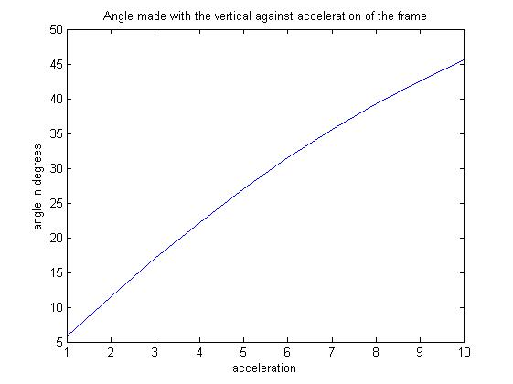

Plot for range 1 to 100

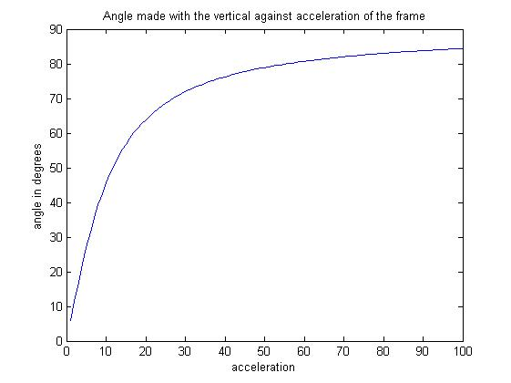
Plot for range 1 to 1000

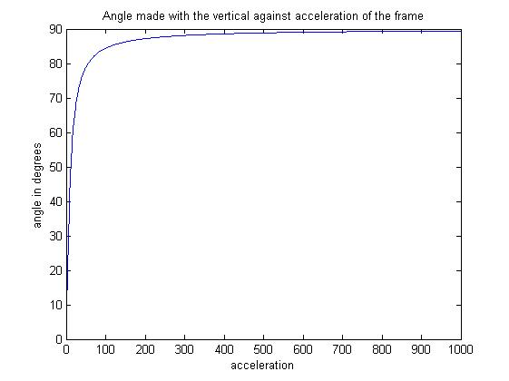

Clearly, we can make the following observations.
- For smaller accelration the relation is almost linear and monotonically increasing.
- So, we would expect this behaviour to continue. However, we notice that as the acceleration starts to increase the angle starts tending to pi/2. However, it can never seem to reach pi/2. What is the reason for this?
- We can explain this using two approaches. The first being mathematical. We know that tan(theta)= acceleration/g. So for theta pi/2 we would need infinite acceleration. In other words as the acceleration starts blowing up, the angle will tend to pi/2.
Also, if we suppose that the angle is 90 and that the pendulum is in equilibrium. Then, we get a contradiction as Tension and the pseudo force would cancel out but the weight would be unbalanced and the object could not have been in equilibruim. Hence, we see that pi/2 is the upper bound as far as the angle is concerened.

3) Catch the ball. Investigating motion of a projectile in the frame of reference of an accelerating vehicle.
We are in a vehicle at rest. We throw a ball in the air. The car accelererates along a flat rode. The acceleration is constant. The question for a given velocity at which we throw the ball, what should the angle be such that we will be able to catch the ball. In other words what should the angle be so that coordinates of the car and the ball when the ball returns close to the ground almost match. Take a practical situation in which we will be able to catch the ball it is within say 0.5m from us.
Initially, the vehicle is at rest. Decide a velocity for the ball. Now, the purpose of our assignment is to study relative motion of our standard particle motion in non inertial frame of references and to understand the notion of pseudo forces required to make Newton's laws of motion valid in these situations. So instead of using the ground frame we will use the frame of reference of the accelerating vehicle itself. So, we fix our x and y coordinate systems ( pointing rightwards and upwards respectively ). Note that the vehicle will be always be at rest in its own reference frame. While we would need to use relative velocity for the projectile. Also, more importantly, in noninertial frame of references there is a 'pseudo' force acting on the object which arises out of the acceleration of the frame of reference itself. Here as the vehicle is accelerating rightwards at a constant rate, the pseudoforce acting on the particle will be directed along the negative x direction and its magnitude will be mass*acceleration_of_the_vehicle.
So now the fdb of the object will be as follows. There will be weight acting in the downward direction (as usual) but along with it there will be the extra pseudo force along the negative x direciton. Hence in the frame of reference of the vehicle, the projectile's trajectorry will have a different nature it will not the same as that in the ground frame.
Now that we have defined the setup, it is time to tackle the actual problem. We need to find the angle for which there exists a point at which the vehicle and the projectile are at the same instant in time. That is when we will be able to catch the ball. It might be difficult to work out this problem analytically. But, using our ODE solver we can get a very simple solution. First of all, recognize that as we are analysing in the vehicle frame of reference there is no need to study the motion of the vehicle (it is at rest!). We want to find out the appropriate angle. So we must loop through angles 1 to 90 degrees. For each iteration, we compute the trajectory of the projectile in the vehicle frame using the ode solver. Then we check if there exists a point in time where the distance (using distance formula) between the projectile and the vehicle is decreasing below 0.5. We take care to consider only those points where the projectile is in the descending part of its trejectory.
We we do find such a point, we check if the coordinates make sense. We plot several graphs to visualize what is going on and to verify if the calculations made are correct.

A sample run of the program. Suppose the initial velocity is 10 m/s second then we get the following results.

Vehicles x coordinate = 0 m

projectile x coodinate = -0.2093 m

projectile's y coordinate= 0.3023 m

time of impact = 1.8000 s

angleneeded = 64 degrees.

The plots for this situation are as follows.

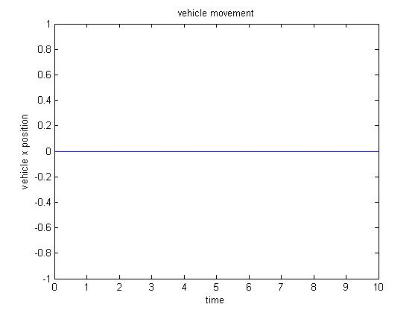
The vehicle is not moving in its own frame of reference.
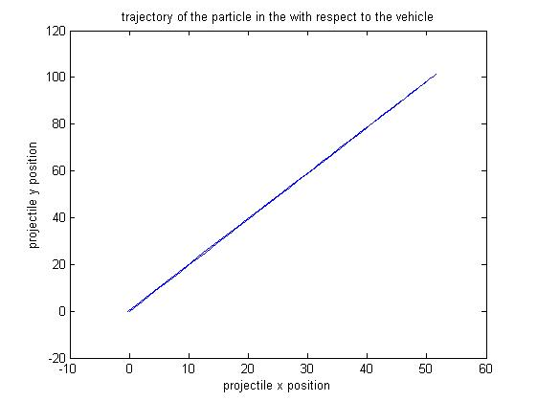
Notice that the this trajectory is similar to a projectile but it is streched in the frame of reference of the vehicle. Thus a person in the car will more or less see the projectile nature but the percepiton of motion is distorted because of the person's motion.

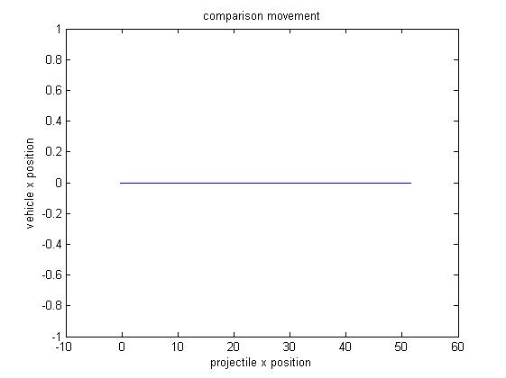
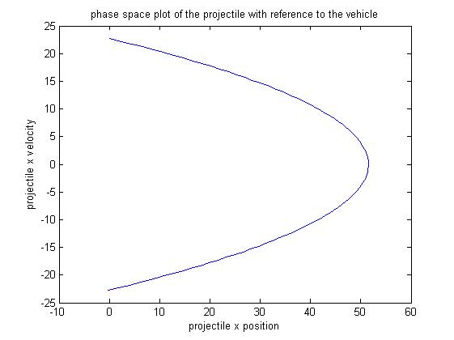
The projectile in this frame of reference beings at origin and must come back to the origin if we are to catch it. We get this phase space as expected.

Plots for higher velocity of the car, v= 100 m/s

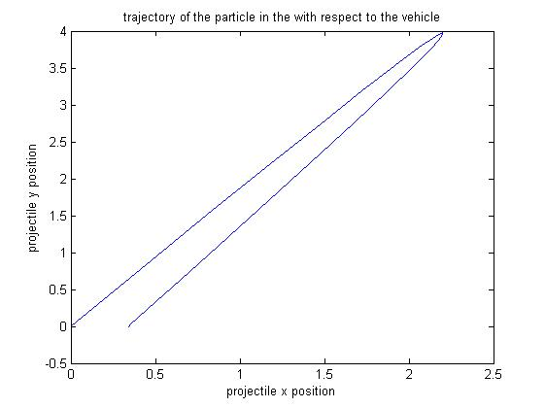

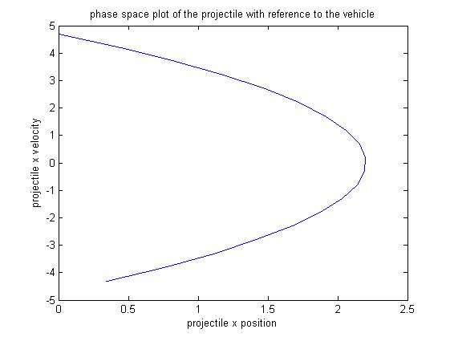

For yet higher velocitiy, this time v=100 m/s,

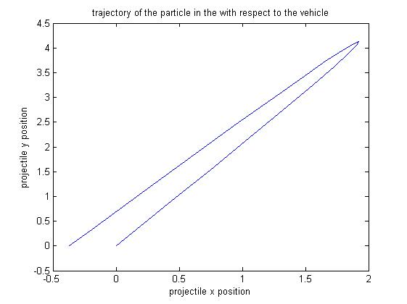
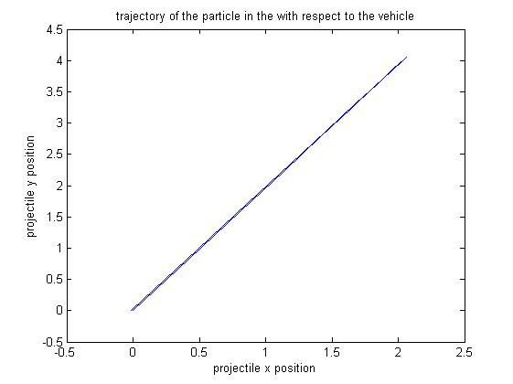
Interestingly if, we make the car accelerate leftwards and throw the ball rightwards we expect not to get any solutions. However, the code generates trivial solutions for instance giving angles of 1 degree. Which means that the projectile was so low that it fell inside the car. This however is a trivial answer. But it shows that the code is general enough to handle negative acceleration as well.

Next, we include the drag effect of wind as discussed in class. For the same situation as given in the first example we now get the following plots.

impact =

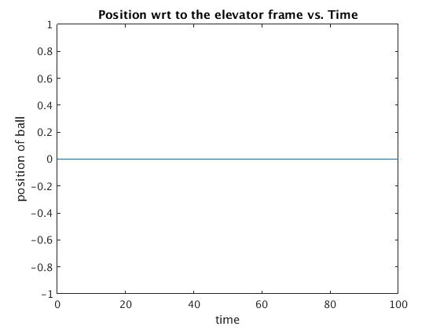
0

vehicle position=

0.2177

projectile position=

7.6427e-004

timeofimpact =

0.1000

angleneeded =

7

Interestingly, in presense of drag the angles for impact decrease. This makes sense it means that earlier for these low angles the projectile was moving way too ahead of the vehicle for us to catch it and hence we were forced to throw the ball at greater angles. But when we include drag the motion of the projectile is inhibited and this allows the car to catch it even when thrown at lower angles.

