Computer Networks
Lab Assignment 1
201401103 201401086

Objective 1: Try using Ping, to see how long does it take from your location to get to several other locations(10 locations). From the data, plot the one way transit time over the internet as a function of distance.

Domain name | Server geographic distance(in km) | One-way transit time (RTT/2) (milli seconds)
www.aalto.fi | 5505 | 36.5
www.berkeley.edu | 13038 | 149
Www.cam.ac.uk | 6809 | 75.5
Www..cmu.edu | 12381 | 133
Www.harvard.edu | 11820 | 8
Www.mit.edu | 11821 | 48
Www.ox.ac.uk | 6904 | 73
Www.utoronto.ca | 12042 | 7.5
Www.tu9.de | 6391 | 81
Uwaterloo.ac | 12102 | 116

The above graph show the university and its distance from DAIICT in 100s of kilometers in Blue bar. While the Red bar show the One-way transition time in milli seconds.
I many cases there is no relation between the geographical distance and the one-way communication time. This is because it depends on a host of other parameters like network speed, traffic and internet structure.

Screen shots:

Aalto university Finland

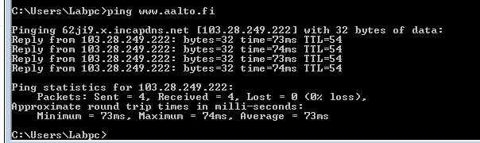

UC Berkeley

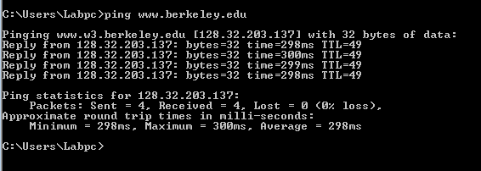
Cambridge University

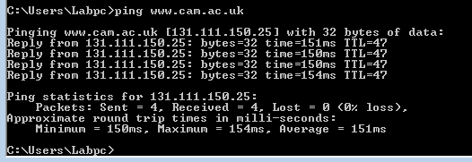
CMU

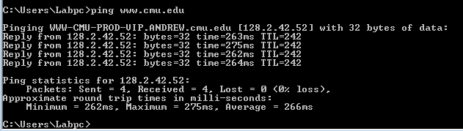

Harvard University

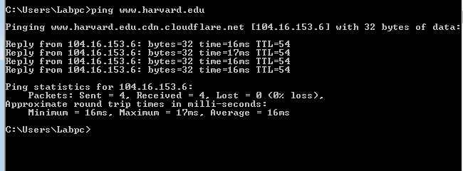

MIT
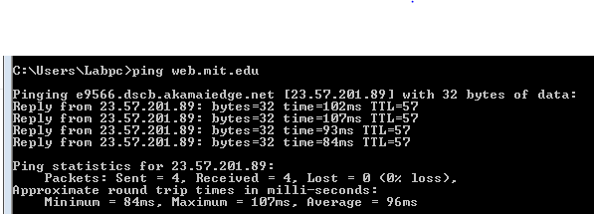

Oxford

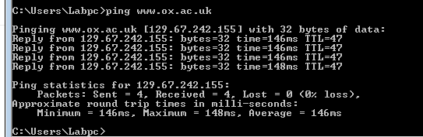

University of Toronto

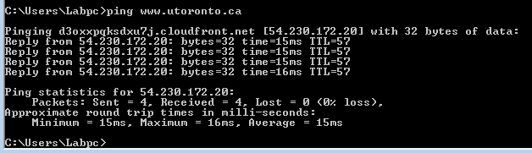

Tu Aachen, Germany

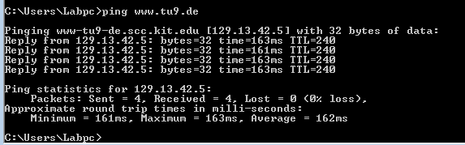

Waterloo University

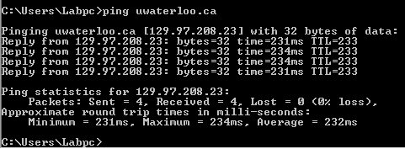

Objective 2: Look up the following commands - hostname, ipconfig, route, nbtstat, netstat. Prepare a table with the list and job of each command.

Command definitions:

nbtstat | Displays protocol statistics and current TCP/IP connections using NBT (NetBios over TCP/IP). NetBIOS is a system which allows computers on a LAN to communicate with each other.
netstat | Displays active TCP connections, ports on which the computer is listening, Ethernet statistics, the IP routing table, IPv4 statistics (for the IP, ICMP, TCP, and UDP protocols), and IPv6 statistics (for the IPv6, ICMPv6, TCP over IPv6, and UDP over IPv6 protocols). Used without parameters, displays active TCP connections
hostname | It displays the DNS name of the host machine and it allows us to change it. It requires the TCP/IP to work
route (with PRINT) | In general manipulates network routing table with ADD and DELETE parameters. Right now we are just displaying the routing table with the PRINT parameter
ipconfig | 1. Without parameters: It displays the ip address, subnet masks and default gateways for all adapters  2. In general it diplays all current TCP/Ip network configuration values and configures DHCP and DNS settings

Sources:

https://technet.microsoft.com/en-us/library/cc940063.aspx

http://searchnetworking.techtarget.com/definition/subnet-mask

https://technet.microsoft.com/en-us/library/ff961511(v=ws.11).aspx

http://www.computerhope.com/nbtstat.htm

Command runs:

hostname
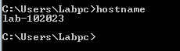

ipconfig
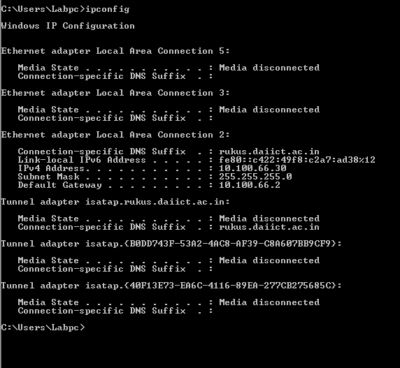

route

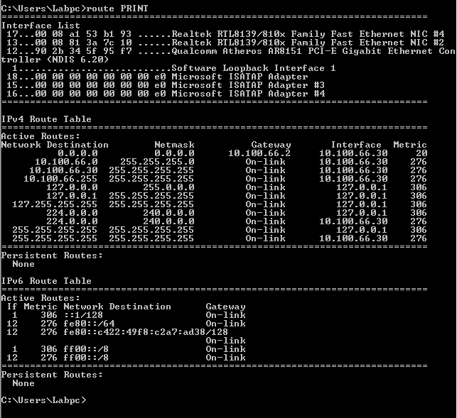

nbtstat

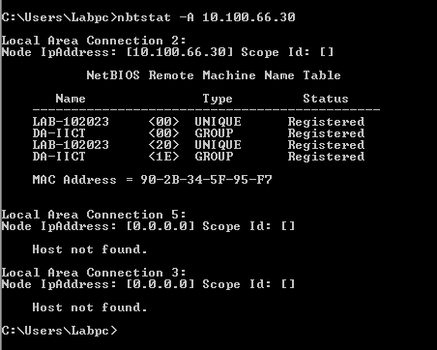

netstat

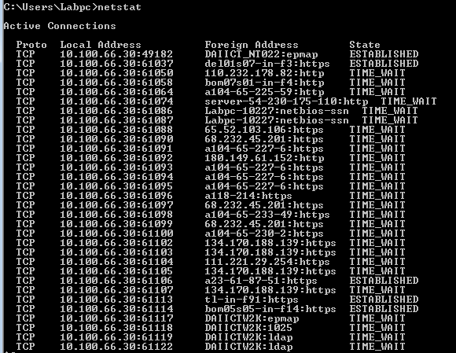

Objective 3: Find ipconfig, look at the options of the nbtstat. Run nbtstat on ip address with -A option. Write down what you see.

NBTSTAT with -A option
This gives the table showing the current TCP/IP connections of the given machine. It shows two types of machines, one is the local name of the machine which is unique and the shows the group network in which the machine resides i.e. DA-IICT.

Objective 4: Run netstat on ip address. Write down what you see.

When netstat is run with a specific ip-address, it show all the active TCP/IP connections on that particular machine. It periodically refreshes the informations. The ports can be activated directly by the machine if need be.

