CNS Lab Assignment 10
Rajdeep Pinge 201401103
Aditya Joglekar 201401086

Answer the following questions.

- What is the IP address and TCP port number used by the client computer (source) that is transferring the file to gaia.cs.umass.edu?

Answer: The IP address and TCP port number used by the client computer (source) are as follows -
IP address : 10.100.66.57
TCP Port Number : 49672
This is the same IP of our machine when checked using ipconfig command in the command prompt. It is obvious because our machine is transferring the file.

See the following images, Fig. 1 and Fig. 2

Fig. 1: Captured Messages – The first 3 messages are the 3-way handshake
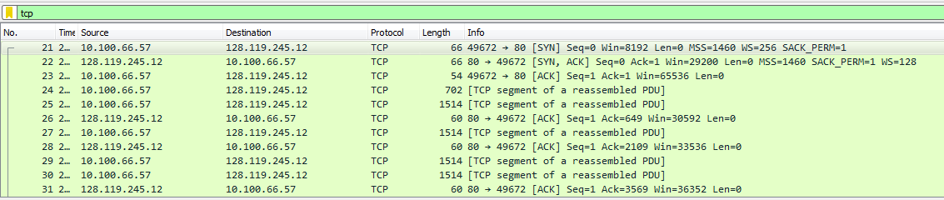
Fig. 2: One of the sent segments – Source and destination IP and TCP port are visible
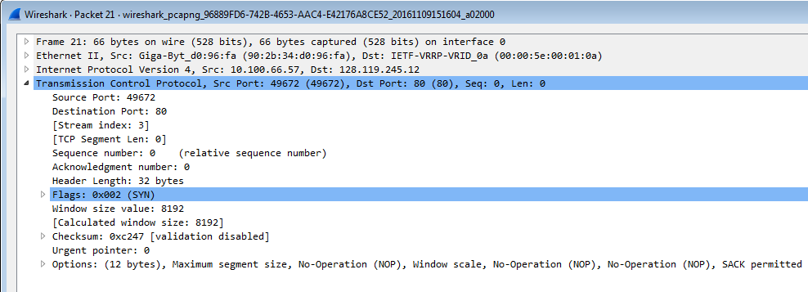

- What is the IP address of gaia.cs.umass.edu? On what port number is it sending and receiving TCP segments for this connection?

Answer: The IP address of gaia.cs.umass.edu is 128.119.245.12. This is the destination IP address in the SYN packet.
It is sending and receiving TCP segments on Port Number : 80 for this connection.
Port number used is 80 because the transmission is through HTTP protocol which happens on default port number 80.
See the above images Fig. 1 and Fig. 2

- What is the IP address and TCP port number used by your client computer (source) to transfer the file to gaia.cs.umass.edu?

Repeated Question

Answer: The IP address and TCP port number used by the client computer (source) are as follows -
IP address : 10.100.66.48
TCP Port Number : 49575
This is the same IP of our machine when checked using ipconfig command in the command prompt. It is obvious because our machine is transferring the file.

See the images, Fig. 1 and Fig. 2

Answer the following questions for the TCP segments:

- What is the sequence number of the TCP SYN segment that is used to initiate the TCP connection between the client computer and gaia.cs.umass.edu? What is it in the segment that identifies the segment as a SYN segment?

Answer:
- The sequence number is 0 for the TCP SYN segment that is used to initiate the TCP connection between the client computer and gaia.cs.umass.edu. It is because this is the first segment that is being sent to establish connection. And actual data transfer has not started yet.

- There are a certain flags in the TCP segment one of which is a SYN flag and another is ACK flag. The value of SYN flag = 1 while the value of ACK flag = 0. The overall combined value of flag bits = 0x002 which indicates that it is the SYN segment.

See Fig. 3 below for the SYN segment details:

Fig. 3 : SYN segment details
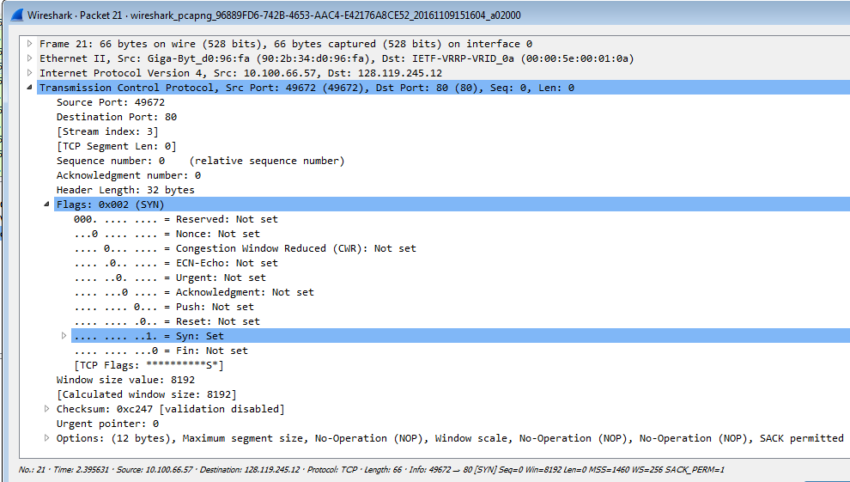

- What is the sequence number of the SYNACK segment sent by gaia.cs.umass.edu to the client computer in reply to the SYN? What is the value of the Acknowledgement field in the SYNACK segment? How did gaia.cs.umass.edu determine that value? What is it in the segment that identifies the segment as a SYNACK segment?

Answer:
- The sequence number is 0 for the SYNACK segment sent in reply to the SYN segment. Because this is the first segment that is being sent by the server while replying in the process of setting up of connection.

- The value of Acknowledgement field is 1 in the SYNACK segment because this is an acknowledgement message for the SYN request. This is acknowledgement for the SYN packet sent earlier which was of size 1. Hence the SYNACK acknowledgement fiels has value incremented by this size equal to 1 (0 previous/received sequence number + 1 size of segment).

- The SYN and ACK flags in the TCP segment identify the segment as SYNACK segment. The value of SYN flag = 1 while the value of ACK flag = 1. The overall combined value of flag bits = 0x012 which indicates that it is the SYNACK segment.

See Fig. 4 below for the SYNACK segment details:

Fig. 4 : SYNACK segment details
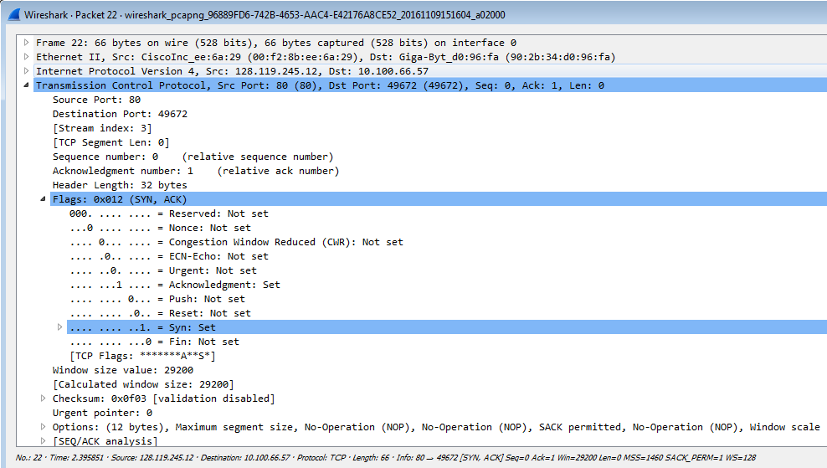

- What is the sequence number of the TCP segment containing the HTTP POST command? Note that in order to find the POST command, you’ll need to dig into the packet content field at the bottom of the Wireshark window, looking for a segment with a “POST” within its DATA field.

Answer:
- The sequence number is 1 the TCP segment containing the HTTP POST command.

- It is the same as the last segment in the 3-way handshake part. This is because of the piggy-backing. The Final ACK message is sent along with the data packet and hence the sequence number remains same.

See the image below name Fig. 5 for the message with POST in data field

Fig. 5 : Message containing HTTP POST command
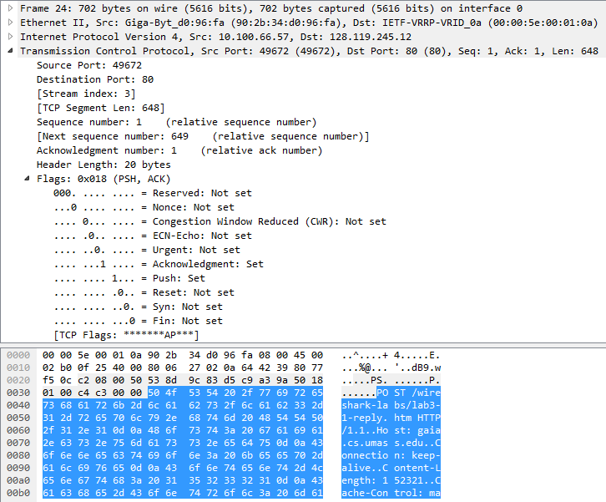

- Consider the TCP segment containing the HTTP POST as the first segment in the TCP connection. What are the sequence numbers of the first six segments in the TCP connection (including the segment containing the HTTP POST)?
Answer:
- Segment 1(Segment containing HTTP POST) : 1
- Segment 2: 649
- Segment 3: 2109
- Segment 4: 3569
- Segment 5: 5029
- Segment 6: 6489

See Fig. Below to get idea of the 6 segments
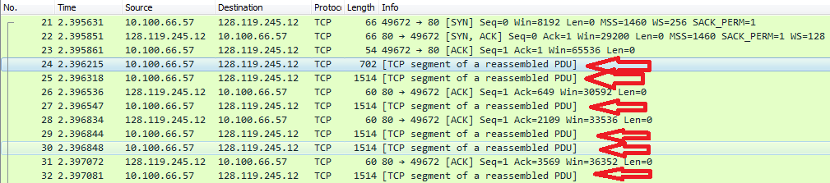

- At what time was each segment sent?
Answer:
- Segment 1(Segment containing HTTP POST) : 2.396215000
- Segment 2: 2.396318000
- Segment 3: 2.396547000
- Segment 4: 2.396844000
- Segment 5: 2.396848000
- Segment 6: 2.397081000

- When was the ACK for each segment received? Given the difference between when each TCP segment was sent, and when its acknowledgement was received, what is the RTT value for each of the six segments?
Answer:
Segment | Time when ACK received | Time when segment sent | RTT
Segment 1 (HTTP POST) | 2.396536000 | 2.396215000 | 0.000321
Segment 2 | 2.396834000 | 2.396318000 | 0.000516
Segment 3 | 2.397072000 | 2.396547000 | 0.000525
Segment 4 | 2.397503000 | 2.396844000 | 0.000659
Segment 5 | 2.397590000 | 2.396848000 | 0.000742
Segment 6 | 2.397793000 | 2.397081000 | 0.000712

- What is the length of each of the first six TCP segments?
Answer:
- Segment 1(Segment containing HTTP POST) : 648
- Segment 2: 1460
- Segment 3: 1460
- Segment 4: 1460
- Segment 5: 1460
- Segment 6: 1460

Observe here that the sequence numbers of each of the subsequent segments as present in Q7. Is just the (current sequence number + size of segment)

- What is the minimum amount of available buffer space advertised at the received for the entire trace? Does the lack of receiver buffer space ever throttle the sender?
Answer:
- The minimum amount of available buffer space advertised at the receiver for the entire trace is 29200 bytes.
- The minimum buffer size is for the SYNACK segment.
- But as we have studied, the window size depends on the load on the server. As the load changes, the window size changes.
- In our experiment, initially the buffer size is least, then it gradually increases and finally it again decreases at the end

See Fig. Below for the details of minimum buffer space

Fig. Least buffer space
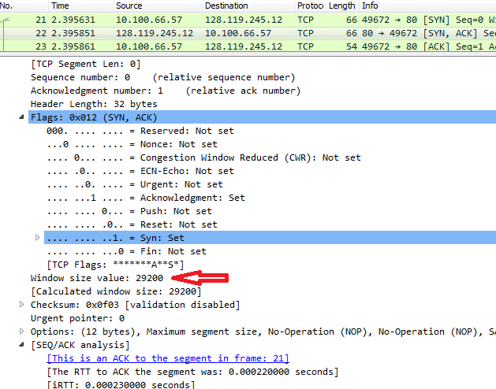

- Are there any retransmitted segments in the trace file? What did you check for (in the trace) in order to answer this question?
Answer:
- There are no retransmitted segments in the trace file.
- We can check this by observing the sequence numbers of the segments sent by our machine. None of the segments have been repeated for this experiment.

- How much data does the receiver typically acknowledge in an ACK?
Answer:
The receiver typically acknowleges 1460 byte data in the ACK. This is the typically transmitted size of the segment for this experiment.

Answer the following questions for the TCP segments the packet trace tcp-ethereal-trace-1 in http://gaia.cs.umass.edu/wireshark-labs/wireshark-traces.zip

- Use the Time-Sequence-Graph(Stevens) plotting tool to view the sequence number versus time plot of segments being sent from the client to the gaia.cs.umass.edu server. Can you identify where TCP’s slowstart phase begins and ends, and where congestion avoidance takes over? Comment on ways in which the measured data differs from the idealized behavior of TCP that we’ve studied in the text.
Answer: In the full graph we can hardly see the distinction between the segments sent but when we zoom the graph, the slight difference is visible.
The problem here is that the file size is very less which is why we don't get the graph as shown in the illustration.
It is very difficult to identify the phases but in general as per theory the threshold is determined and based on that the phase below the threshold that is the size of segment below the threshold is the slowstart phase while above the threshold is the congestion avoidance phase.

Following Figures show the graph.
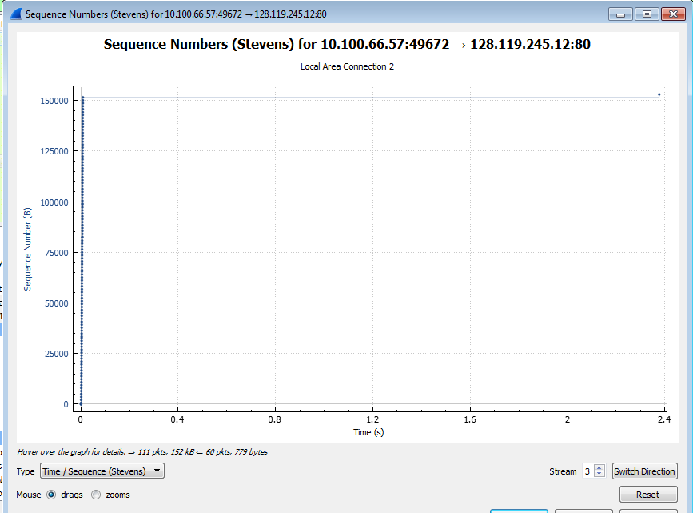

Zoomed Image
