Wireshark Lab: TCP v6.0

In this lab, we’ll investigate the behavior of TCP protocol at the basic level.

1. Capturing a bulk TCP transfer from your computer to a remote server

Do the following:
- Start up your web browser. Go the http://gaia.cs.umass.edu/wireshark-labs/alice.txt and retrieve an ASCII copy of Alice in Wonderland. Store this file somewhere on your computer.
- Next go to http://gaia.cs.umass.edu/wireshark-labs/TCP-wireshark-file1.html.
- You should see a screen that looks like:

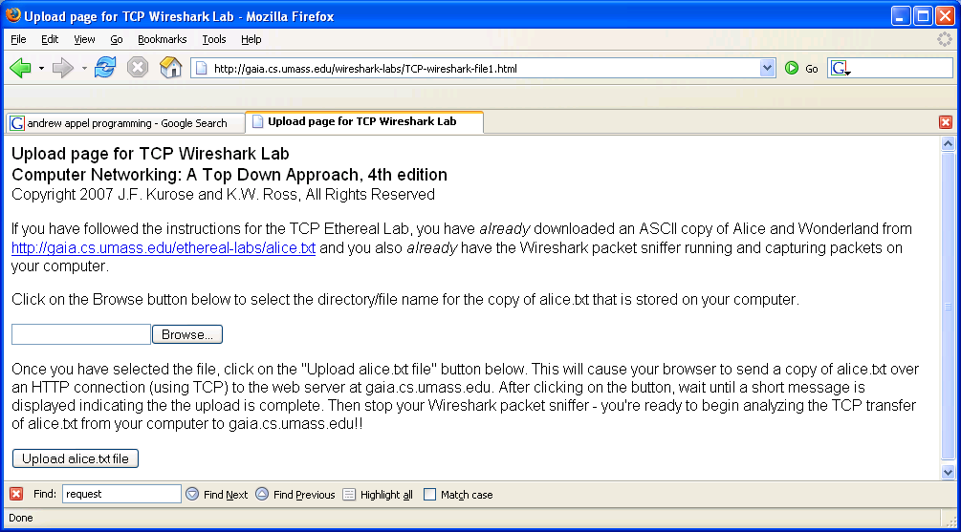

- Use the Browse button in this form to enter the name of the file (full path name) on your computer containing Alice in Wonderland (or do so manually). Don’t yet press the “Upload alice.txt file” button.
- Now start up Wireshark and begin packet capture (Capture->Start) and then press OK on the Wireshark Packet Capture Options screen (we’ll not need to select any options here).
- Returning to your browser, press the “Upload alice.txt file” button to upload the file to the gaia.cs.umass.edu server. Once the file has been uploaded, a short congratulations message will be displayed in your browser window.
- Stop Wireshark packet capture.

2. A first look at the captured trace

Before analyzing the behavior of the TCP connection in detail, let’s take a high level view of the trace.
- First, filter the packets displayed in the Wireshark window by entering “tcp”
- What you should see is series of TCP and HTTP messages between your computer and gaia.cs.umass.edu.
- You should see the initial three-way handshake containing a SYN message.
- You should see an HTTP POST message. Depending on the version of Wireshark you are using, you might see a series of “HTTP Continuation” messages being sent from your computer to gaia.cs.umass.edu. This indicates that there are multiple TCP segments being used to carry a single HTTP message.
- You should also see TCP ACK segments being returned from gaia.cs.umass.edu to your computer.

Answer the following questions.
- What is the IP address and TCP port number used by the client computer (source) that is transferring the file to gaia.cs.umass.edu.
- What is the IP address of gaia.cs.umass.edu? On what port number is it sending and receiving TCP segments for this connection?
- What is the IP address and TCP port number used by your client computer (source) to transfer the file to gaia.cs.umass.edu?

Next, select Analyze->Enabled Protocols. Then uncheck the HTTP box and select OK. This is what we’re looking for - a series of TCP segments sent between your computer and gaia.cs.umass.edu.

3. TCP Basics

Answer the following questions for the TCP segments:

- What is the sequence number of the TCP SYN segment that is used to initiate the TCP connection between the client computer and gaia.cs.umass.edu? What is it in the segment that identifies the segment as a SYN segment?
- What is the sequence number of the SYNACK segment sent by gaia.cs.umass.edu to the client computer in reply to the SYN? What is the value of the Acknowledgement field in the SYNACK segment? How did gaia.cs.umass.edu determine that value? What is it in the segment that identifies the segment as a SYNACK segment?
- What is the sequence number of the TCP segment containing the HTTP POST command? Note that in order to find the POST command, you’ll need to dig into the packet content field at the bottom of the Wireshark window, looking for a segment with a “POST” within its DATA field.
- Consider the TCP segment containing the HTTP POST as the first segment in the TCP connection. What are the sequence numbers of the first six segments in the TCP connection (including the segment containing the HTTP POST)?
- At what time was each segment sent?
- When was the ACK for each segment received? Given the difference between when each TCP segment was sent, and when its acknowledgement was received, what is the RTT value for each of the six segments?
- What is the length of each of the first six TCP segments?
- What is the minimum amount of available buffer space advertised at the received for the entire trace? Does the lack of receiver buffer space ever throttle the sender?
- Are there any retransmitted segments in the trace file? What did you check for (in the trace) in order to answer this question?
- How much data does the receiver typically acknowledge in an ACK?
4. TCP congestion control in action

Let’s now examine the amount of data sent per unit time from the client to the server. Rather than (tediously!) calculating this from the raw data in the Wireshark window, we’ll use one of Wireshark’s TCP graphing utilities - Time-Sequence-Graph(Stevens) - to plot out data.
- Select a TCP segment in the Wireshark’s “listing of captured-packets” window. Then select the menu : Statistics->TCP Stream Graph-> Time-Sequence-Graph(Stevens). You should see a plot that looks similar to the following plot, which was created from the captured packets in the packet trace tcp-ethereal-trace-1 in http://gaia.cs.umass.edu/wireshark-labs/wireshark-traces.zip (see earlier footnote ):

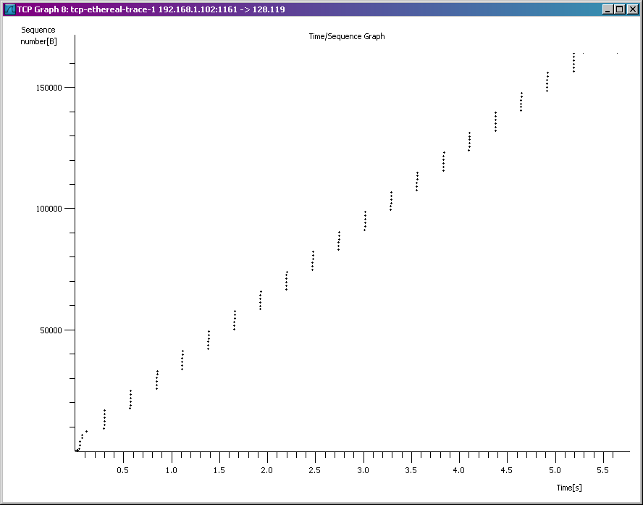

Here, each dot represents a TCP segment sent, plotting the sequence number of the segment versus the time at which it was sent. Note that a set of dots stacked above each other represents a series of packets that were sent back-to-back by the sender.

Answer the following questions for the TCP segments the packet trace tcp-ethereal-trace-1 in http://gaia.cs.umass.edu/wireshark-labs/wireshark-traces.zip
- Use the Time-Sequence-Graph(Stevens) plotting tool to view the sequence number versus time plot of segments being sent from the client to the gaia.cs.umass.edu server. Can you identify where TCP’s slowstart phase begins and ends, and where congestion avoidance takes over? Comment on ways in which the measured data differs from the idealized behavior of TCP that we’ve studied in the text.
- Answer each of two questions above for the trace that you have gathered when you transferred a file from your computer to gaia.cs.umass.edu

