Computer Networks
LAB 5
201401086
201401103

Q1. When STP is not enabled what happens?
A: The given topology has redundancies (loops). If STP is not enabled then packets sent through the network continue looping through it endlessly creating a broadcast storm. During a storm, the unnecessary packets overwhelm the network and no new packet can be transmitted through it. Hence a ping request made from a host device will time out.
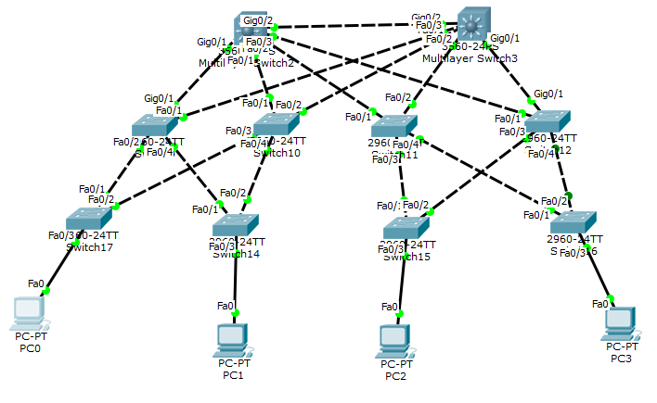

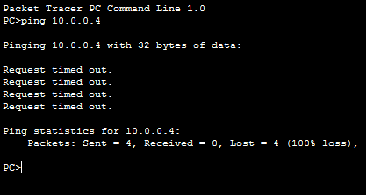
Q 2 Command for showing spanning tree.

A: > en // to enter privileged mode
# show spanning-tree // display spanning tree info. eg. root bridge, ports of bridge selected

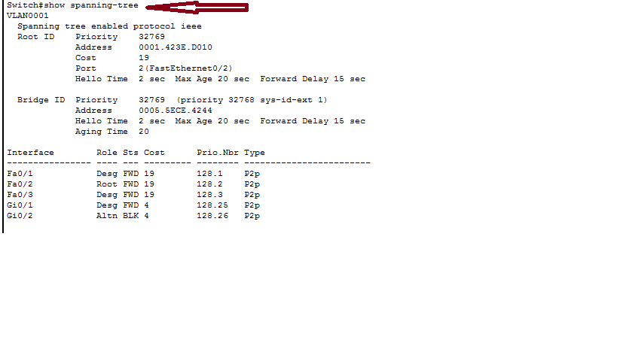
Q3. Viewing the states of switch ports in STP
A. The show spanning-tree command lists all the interfaces and their connected ports. It also shows the status of ports.
FWD: implies forward state
BLK: implied blocked state

Note that the role of BLK is Alternate while the role of FWD is either root or designated.
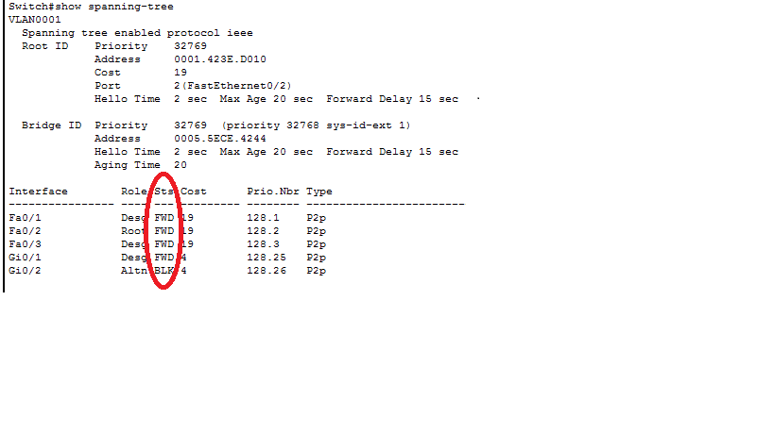

Q4. Command for listing interfaces of switches
A. This command shows all the interfaces of a given switch. In the last column, the status of the interface is given. Up means the interface is in use while down means interface is not in use.
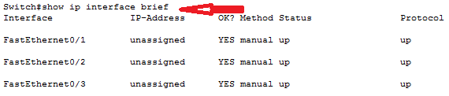
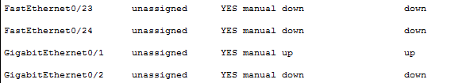

Q5. Show root bridge
A. This is the root for the current network.
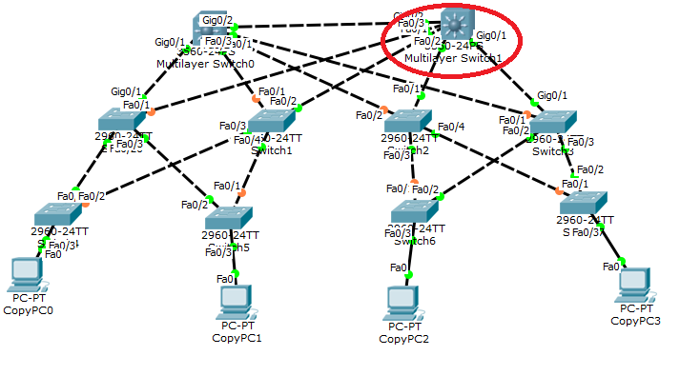
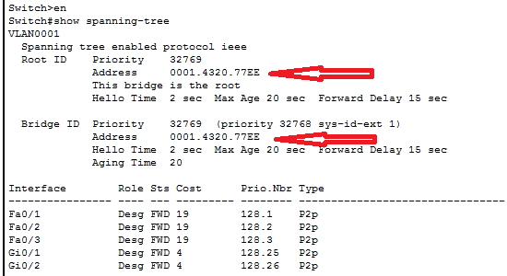

Q6. show root ports
Q7. show designated ports

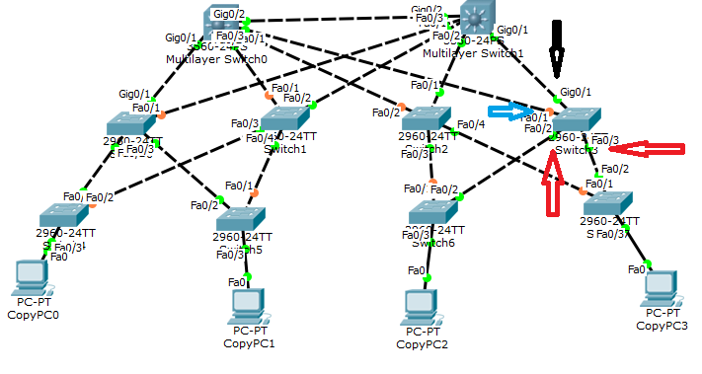
There are 4 arrows in the above image.
The Black arrow shows the root port.
The Red arrows show the designated ports.
The Blue arrow shows the alternate port which is blocked and hence shown with orange colour.

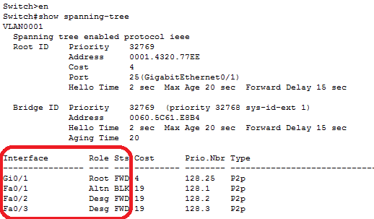
The interfaces in the diagram match with the interfaces of the above image showing the root, alternate and designated ports.

