Computer Networks
Lab Assignment 6
Rajdeep Pinge 201401103
Aditya Joglekar 201401086

Packet size 56 bytes
1. What is the IP address of your computer?
Ans. IP address of our computer is 10.100.66.41 This is the source address contained in the IPv4 packet of the Ethernet frame.

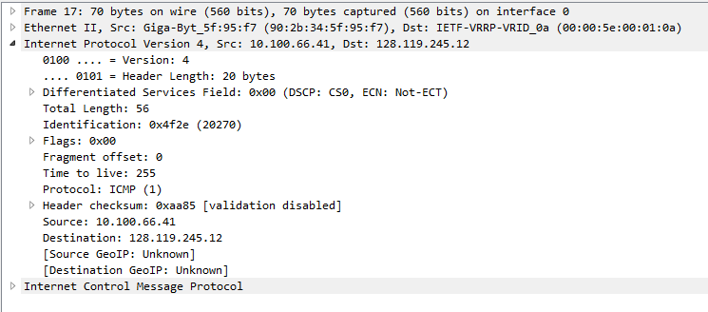
2. Within the IP packet header, what is the value in the upper layer protocol field?
Ans. The value of the upper layer protocol field is 0x1 indicating ICMP upper layer protocol.

3. How many bytes are in the IP header? How many bytes are in the payload of the
IP datagram? Explain how you determined the number of payload bytes.
Ans. There are 20 bytes in the IP header. The total length of IP packet is 56 bytes, which indicates that there are 56-20 = 36 bytes in the payload of IP datagram. This can also be verified from the ICMP packet. The ICMP header size is 8 bytes and the data in this packet is 28 bytes which gives size of ICMP packet which is the data for IPv4 equal to 36 bytes.

4. Has this IP datagram been fragmented? Explain how you determined whether or not the datagram has been fragmented.
Ans. No. This IP datagram has not been fragmented. We can determine this from the fact that wire-shark always shows the last ICMP packet and in this last packet also the offset is 0 which means that this is the only packet and no other packet before this has been sent. This means there is no fragmentation.

5. Which fields in the IP datagram always change from one datagram to the next within this series of ICMP messages sent by your computer?
Ans. Identification, Time To Live and Header checksum fields in the IP datagram always change. The Identification field uniquely identifies each packet sent so it must be different. Header checksum changes because it is dependent on the packet header which is never the same since Identification is unique. Time To Live depends on the path taken by the packet over the network and involves many other factors like traffic in the network. Hence the Time To Live is also not constant.

6. Which fields stay constant? Which of the fields must stay constant? Which fields must change? Why?
Ans. The following fields stay constant in the IP datagram:
Source IP: since the sender machine is same i.e. our PC
Destination IP: since we are sending the packet to the same destination URL.
Version=4 : same since the protocol used is same.
IP header length=20 : defined by the protocol.
Differentiated Services Field:
Flags: Here the message format is same and message size is less that fragmentation limit of 1500 bytes, hence the flags remain same.
Total Length: message size is same therefore total length is same.
Fragment Offset=0 : Since no fragmentation, therefore fragment offset is same.
Protocol = 0x1 : ICMP protocol id which is same in both cases.

The following fields must stay constant in the IP datagram:
Source IP: since the sender machine is same i.e. our PC.
Destination IP: since we are sending the packet to the same destination URL.
Version=4 : same since the protocol used is same.
IP header length=20 : defined by the protocol.
Differentiated Services Field:
Protocol = 0x1 : ICMP protocol id must always be same.

The following fields must change in the IP datagram:
Identification: Since each packet must be identified uniquely.
Header checksum: Depends on the packet header which is never same.
Time To Live: Depends on the path taken by the packet over the network which varies.

7. Describe the pattern you see in the values in the Identification field of the IP datagram.
Ans. Identification field is incremented by 0x1 for each subsequent IP datagram.

TTL exceeded packages
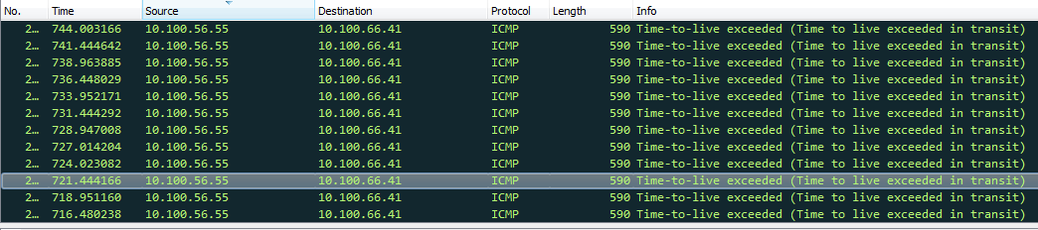
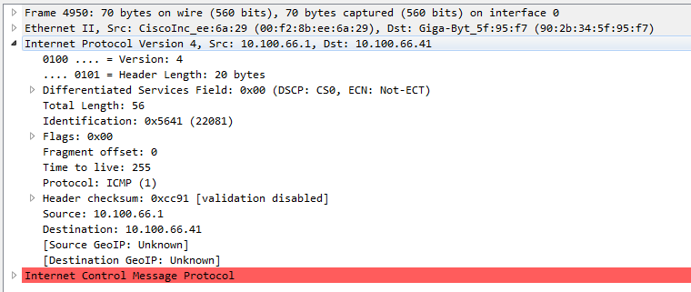
8. What is the value in the Identification field and the TTL field?
Ans. Value in the Identification field is the next designated Id of the IP packet. Here it is 0x541f.
Time To Live: 255

9. Do these values remain unchanged for all of the ICMP TTL-exceeded replies sent to your computer by the nearest (first hop) router? Why?
Ans. The Identification field changes. The TTL field remains the same because the next hop router is at a fixed location in the network.

Fragmentation
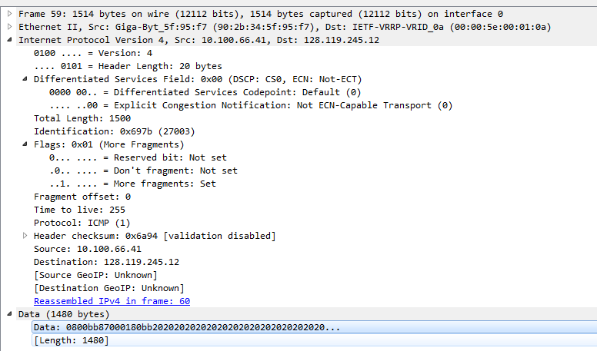
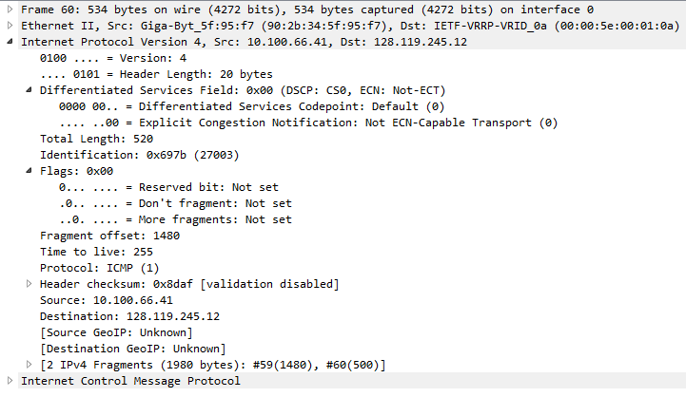
10. Find the first ICMP Echo Request message that was sent by your computer after you changed the Packet Size to be 2000. Has that message been fragmented across more than one IP datagram?
Ans. Yes. There is an extra field in the IP datagram which shows that there are 2 IPv4 Fragments. One is of size 1480 bytes, while other is of size 500 bytes. Total size is 1980 bytes. This is true since we sent the packet of size 2000 bytes of which 20 bytes is the header while 1980 bytes is data. Logically also, since ICMP fragment can accommodate maximum of 1500 bytes, the fragmentation must happen.

11. Print out the first fragment of the fragmented IP datagram. What information in the IP header indicates that the datagram been fragmented? What information in the IP header indicates whether this is the first fragment versus a latter fragment? How long is this IP datagram?
Ans. The more fragments flag in the IP datagram has been set indicating that there are more fragments to come i.e. the datagram has been fragmented. The offset value of the fragment is 0. This means that there is no fragment before this fragment and this fragment is the first one. For other fragments, the value of offset field changes. The total length of this IP datagram is 1500 bytes.

12. Print out the second fragment of the fragmented IP datagram. What information in the IP header indicates that this is not the first datagram fragment? Are the more fragments? How can you tell?
Ans. The Fragment offset is 1480. Which indicates that the information contained is from the 1481st byte. That means the earlier fragment had the previous information. The more fragments flag is not set which means there are no more fragments.

13. What fields change in the IP header between the first and second fragment?
Ans. Total Length, More Fragments Flag, Fragment Offset, Header checksum.

Packet Size 3500 bytes
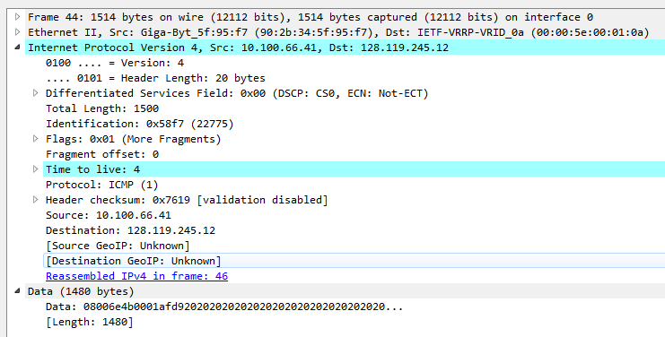

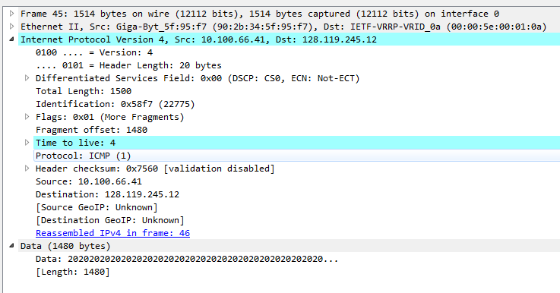
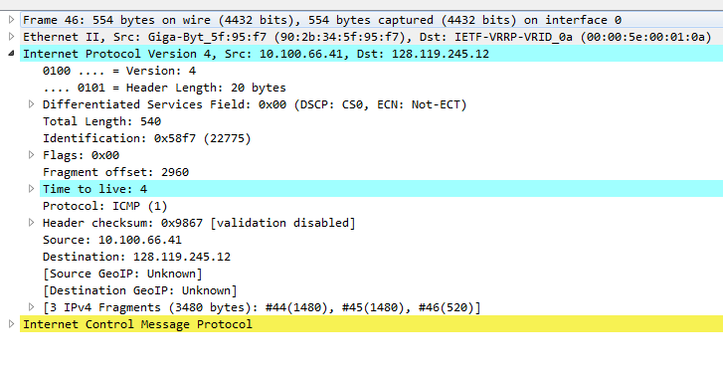
14. How many fragments were created from the original datagram?
Ans. 3 fragments were created from the original datagram.

15. What fields change in the IP header among the fragments?
Ans. Total Length, More Fragments Flag, Fragment Offset, Header checksum. The total length changes for the third fragment. Also since the third fragment is the last one, its more fragments flag is not set. Fragment offset changes for all fragments since the information contained is different. Also the header checksum changes for all.

