Computer Networks
Lab Assignment 7
Rajdeep Pinge 201401103
Aditya Joglekar 201401086

Q.1 How many subnets are in this topology?
Ans. There are 5 subnets in this topology.

Q. 2. Given 209.16.0.0 ( class C n/w address), find subnet based on the requirement of subnets.

Show the following (3 mark)

Ans. Since there are 5 subnets, we need 3 bits to represent those subnets uniquely. Therefore, we need to borrow 3 bits from the host part. Also, since this is class C address, 8 bits are alloted to host of which 3 are borrowed for subnetting and 5 are left for hosts.

a) new subnet mask and its /X representation
27 bits for network imply that /x = /27 (24 + 3 borrowed)
The subnet mask is 255.255.255.224 /27. (borrow 3 bits).

b) list of subnets and their ranges
The possible subnet IPs are as follows-
Subnet | Start Address | End Address
1 | 209.16.0.0 | 209.16.0.31
2 | 209.16.0.32 | 209.16.0.63
3 | 209.16.0.64 | 209.16.0.95
4 | 209.16.0.96 | 209.16.0.127
5 | 209.16.0.128 | 209.16.0.159
6 | 209.16.0.160 | 209.16.0.191
7 | 209.16.0.192 | 209.16.0.223
8 | 209.16.0.224 | 209.16.0.255

c. list usable host addresses for each of the subnets.
Of these the first and the last address for each subnet is reserved (the corresponding subnet and broadcast address). Hence the host range will not include these address.
So each subnet will have 16 -2 = 14 hosts capacity.

Thus range of usable host addresses will be as follows:
Subnet | Host Start Address | Host End Address
1 | 209.16.0.1 | 209.16.0.30
2 | 209.16.0.33 | 209.16.0.62
3 | 209.16.0.65 | 209.16.0.94
4 | 209.16.0.97 | 209.16.0.126
5 | 209.16.0.129 | 209.16.0.158
6 | 209.16.0.161 | 209.16.0.190
7 | 209.16.0.193 | 209.16.0.222
8 | 209.16.0.225 | 209.16.0.254

Q.3 Implement following Topology using same Subnets you identify in previous Questions.

(any 3 subnets and their host addresses ) (take Screenshot of your topology ) (10 marks )

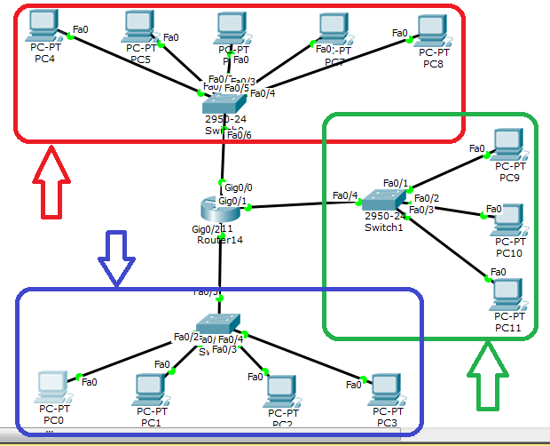
The three subnets can be distinguished from the three coloured boxes

Q.4 In packet tracer find Answers of the following Question (8 marks )

1. Assign IP address to different host according to

There are three subnets in the topology. We have taken a class C network IP address of 209.16.0.0. We used fixed length subnetting. Since there are 5 subnets, we need 3 bits to identify them uniquely and hence we have borrowed 3 bits from host part of the address.
So in the topology, we assign the IP addresses according to the subnet range found in Q1.

2. How many addresses will routers have?
The router needs to have one IP to each port corresponding to each connected subnet. This IP is chosen from the available pool of addresses for that subnet. Here there will be 3 addresses for the router. We also need to assign this address as the gateway address for all the hosts in that network.

4. Ping and show that the hosts are able to communicate.
The ping command from from host in first subnet to host in 2nd and 3rd subnet successfully worked.

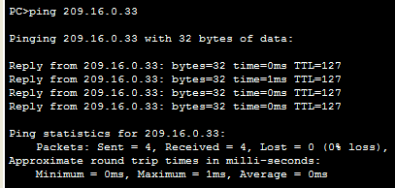
The above ping command is given from the host with address 209.16.0.1.

Variable Length Subnet Mask

Q5.
Address Area | Number of IP Addresses | 32 Address Prefix and (/) Slash Bit Mask | 32 bit Dotted Decimal Subnet Mask
Class C network Assigned | 256 total (254 usable) | 192.168.1.0 / 24 | 255.255.255.0
Router 0 LAN | 55 hosts | 192.168.1.0 / 26 | 255.255.255.192
Router 1 LAN | 26 hosts | 192.168.1.64 / 27 | 255.255.255.224
Router 2 LAN | 12 hosts | 192.168.1.96 / 28 | 255.255.255.240
Router 0-1 WAN | 2 hosts | 192.168.1.112 / 30 | 255.255.255.252
Router 1-2 WAN | 2 hosts | 192.168.1.116 / 30 | 255.255.255.252

Q6. Consider a class C network with 4 subnets each with 75,35,25,15 hosts. What will be the subnet
masks for 4 subnets, and host IP address Range in each subnet?

Number of IP Addresses | Host Start Address | Host End Address | 32 bit Dotted Decimal Subnet Mask
256 total (254 usable) | 192.168.1.1 / 24 | 192.168.1.254 / 24 | 255.255.255.0
75 hosts | 192.168.1.1 / 25 | 192.168.1.126 / 25 | 255.255.255.128
35 hosts | 192.168.1.129 / 26 | 192.168.1.190 / 26 | 255.255.255.192
25 hosts | 192.168.1.193 / 27 | 192.168.1.222 / 27 | 255.255.255.224
15 hosts | 192.168.1.225 / 27 | 192.168.1.254 / 27 | 255.255.255.224

Note here that we have left the first and the last address of the subnet. The first address corresponds to the network address of the subnet while the last address corresponds to the broadcast address of the network. Hence the available host addresses are less by 2.

