Computer Networks
Lab Assignment 8
Rajdeep Pinge 201401103
Aditya Joglekar 201401086

Q.1 Create Topology in Cisco Packet Tracer. Implement RIP step by Step as described above.
Show that it ping successfully. (i.e. screenshot of Topology and successful message Transfer. )

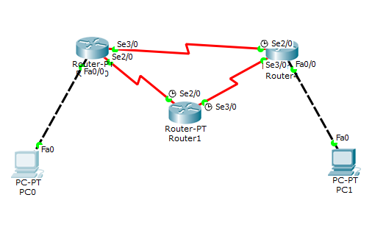
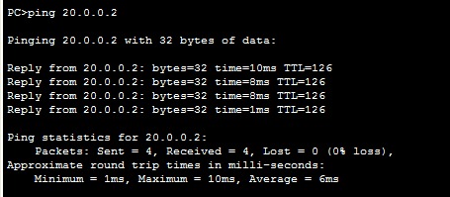

The above picture shows that the connection has been established between the two hosts.

Q.2 what do you see when “Debug IP RIP” command run on Router.
Ans. The command shows the debugging or verbose information about the RIP protocol that is running on the router.

- As shown in the figure, the red arrow shows the initial table where host 20.0.0.0 is reached in 2 hops.
- Immediately, it is updated( Blue arrow) to 1 hop since it gets the shorter path.
- The Green and Purple arrows indicate further updates in the table. All of the information in the table is broadcast periodically to address 255.255.255.255.

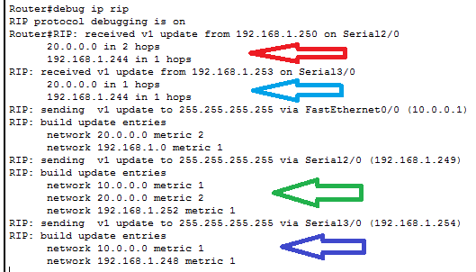

Q.3 which command is used to find RIP tables in Router. Perform it. Make screen shot of Table you found in each router.(for Topology created above)
Ans. 'show ip rip database' is the command used to find RIP tables in Router.

Router0
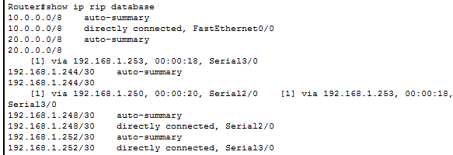
The data in the above image shows that router 0 has been connected to two hosts and two routers. It is directly connected to two routers and one host 10.0.0.0 while it is connected to the second host 20.0.0.0 via another router. It is also connected to the second router 192,168.1.244 via another route available from the intermediate router.

Router1
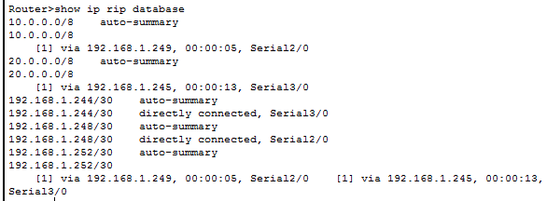
Router2
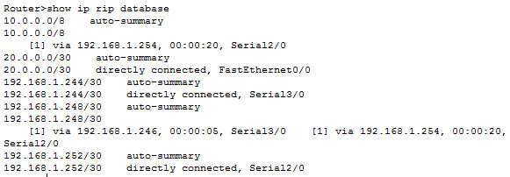

Q.4 what do you mean by Split Horizon and Poison Reverse? Explain.

Ans.

Split Horizon: It is the technique to avoid the false information about connections that are actually not present in the network. It prevents the information from circulating endlessly in the network without reaching the destination and wasting the resources.
In split horizon, the information about a particular path is not sent back on the port from which it was received. This prevents the routers from having false impression that the sender has an alternative path to the same host which in reality is not present.

Poison Reverse: This is another technique to avoid sending data on the links which are down. It also informs the whole network about the unavailability of the specific path.
Whenever a connection is down, it sets the path cost of that connection to be 16 or more. In terms of RIP, since the maximum possible hosts in a network is 15, the cost of 16 or more is considered infinite and unreachable. The router broadcasts this information to all the ports, even the ports from which it was received overruling the split horizon rule. This does not cause any problem of looping as described in the split horizon, because as it is the cost is >= 16 and hence no packet will be sent to that connection.

