CNS Lab Assignment 9

Aditya Joglekar 201401086
Rajdeep Pinge 201401103

1).Implement topology (one without LAN).Ping 2 PCs Successfully.

The complete topology after configuring routers with proper IP addresses and subnets and enabling OSPF.
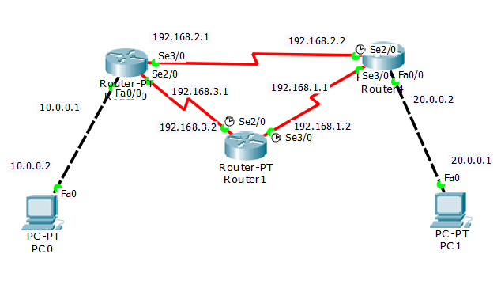
The below screen-shots imply that the connection between the device and the device to be pinged has been done successfully.

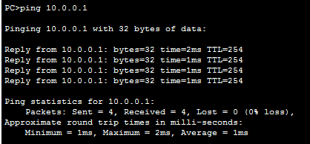

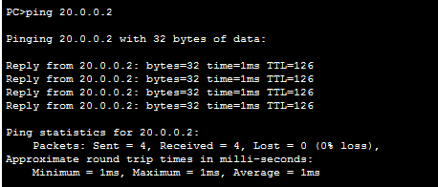

The above two ping commands clearly show that the connections are qworking properly

The below image is the screenshot of the simulation of above command.

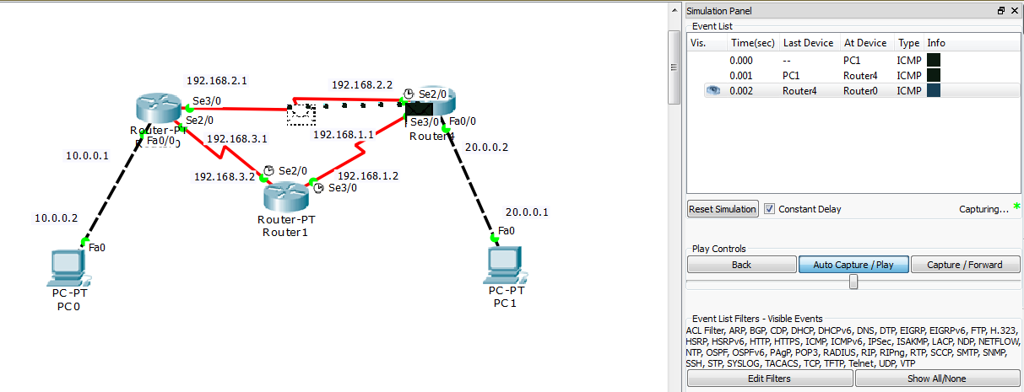
The Simulation panel on the right hand side shows the path taken buy the message till now.

If we disable an intermediate port along the path, say port with ip address 192.168.2.1, the OSPF is run again and below is the screenshot of the simulation of Ping message where OSPF has dynamically changed the path of the message.
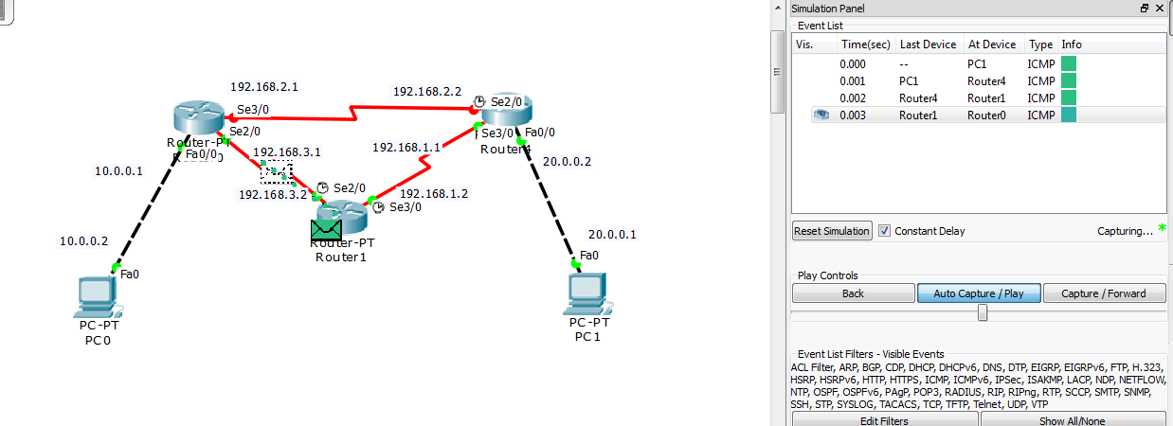

The simulation panel on the right hand side clearly shows that now the message has taken a different path through Router 1.

2).show ospf route table of any one router.
The following is the routing table of the Router0 in the above topology.

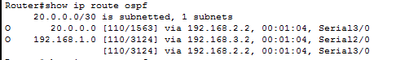

OSPF protocol stores not just the chosen path, but all possible paths to reach any host device. Hence, we see two entries in the table above.

3).Implement extended topology(add LAN).Show DR,BDR and DROTHER routers.

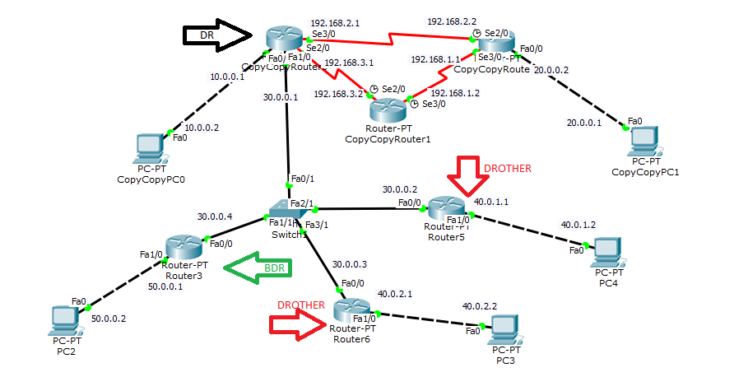

Note
Black arrow - DR
Green arrow - BDR
Red arrow - DROTHER

Here the highest router IP 192.168.2.1 is assigned as Designated Router DR for the LAN while the second highest IP 50.0.0.1 (Router3) is assigned as BDR. The remaining two routers are assigned as DROTHER.

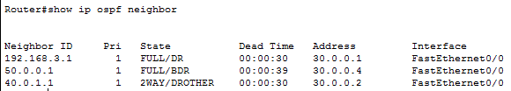
The above image shows neighbours of one of the DROTHER routers. All the three types of routers in the LAN can be seen.

The below image shows the topology while the ping message is being sent. This is just to verify that the connection is working.

4).change router id of DROTHER router using router-id command. Where w.x.y.z will be the higher ip
address than DR router-ID.After restarting OSPF process, show the new DR,BDR and DROTHER routers.

We have changed router id of router6 from 40.0.2.1 to 60.0.2.1.

The below image shows the neighbours of the previous BDR. It shows that now the BDR has been changed and the router whose ID has been changed is the new BDR because of its higher ID.
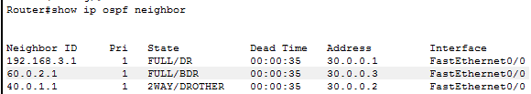

The below topology show the new DR, BDR and DROTHER.
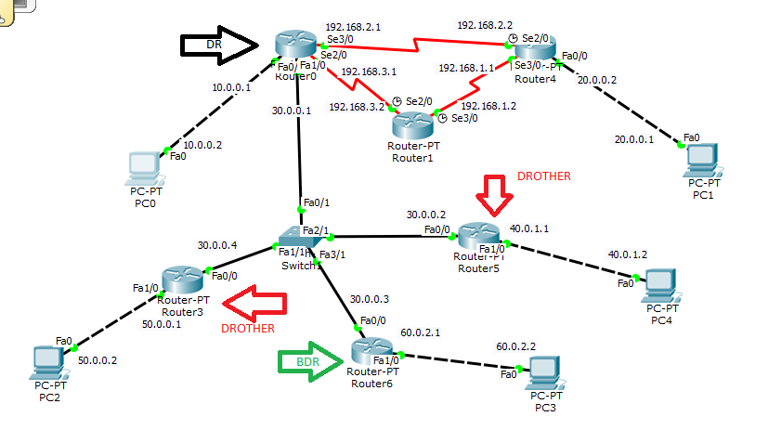

5).Ping PC1 and PC4 successfully in above topology.
The below message has been sent from PC0 to PC4.
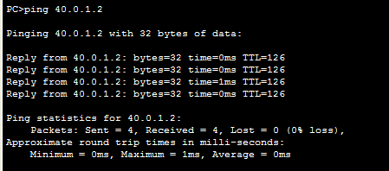
Simulation of the above command
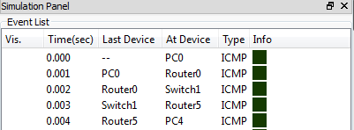
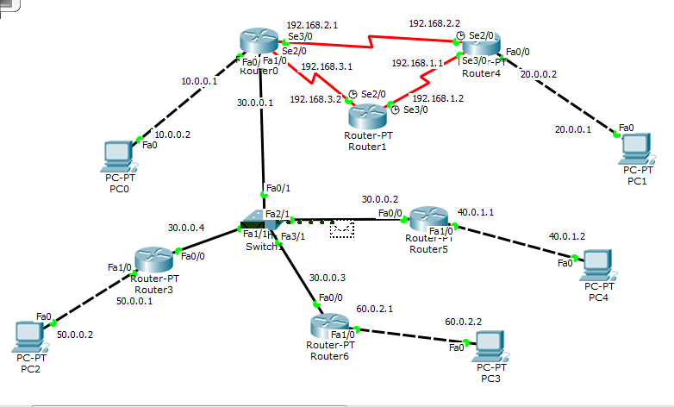
The below message is being sent from PC2 to both PC0 and PC1

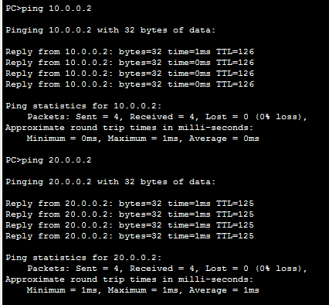

6).screenshot for command: debug ip ospf adj – not showing any additional info

alternative command - debug ip ospf events

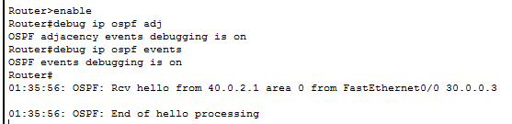
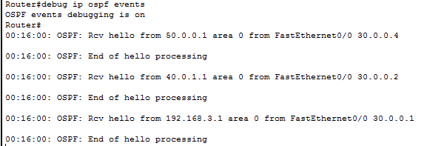
The above command shows the information related to the OSPF events. Currently it is showing the information about the hello messages that are being sent in the network.

7).Relationship between routers:[neighbor or adjacent??]

a) DR and BDR - adjacent

b) DR and DROTHER - adjacent

c) BDR and DROTHER - neighbour

d) Router outside LAN and DROTHER – no relation

e) Router outside LAN and DR – no relation

f) Router outside LAN and router outside LAN – no relation

g) DROTHER and DROTHER - neighbor

important change to topology – update to report submitted earlier

Earlier there was a problem in pinging PC2 and PC3, when we pinged these devices from the
PC0 which is outside the LAN, we noticed that out of 4 packets half of them were not being delivered to the required PC. This was happening all the time, it was not a temporary problem.
The reason was that both the PC's in the original topology were in the same subnet 40.0.0.0. Thus, the switch connecting the LAN to PC0 was not able to distinguish between the two PC's. Hence when the switch received the packet, half the time they were sent to the correct device while at times they were sent to the wrong one.
The problem was solved by putting one of the PC's and the router port connected to it onto a seperate subnet 60.0.0.1. Thus the switch was able to distinguish between the devices and now both could be pinged succesfully.

