**CS306: Data Analysis and Visualization**

**Lab 10: Report**

**Rajdeep Pinge 201401103**

**Aditya Joglekar 201401086**

**Objective:**

**To apply and understand the concept of ANOVA for analyzing real data. The considered application is video broadcasting.**

**Digital video broadcasting is a complex process with several in-line sub-processes. As a result, a number of factors are involved which may affect the quality of the video received by the end-user (eg. TV broadcasting, live streaming over the internet etc.). You are provided data in the form of an excel worksheet lab10.xls. Three full HD (1980 x 1080) video sequences (src01, src02 and src05) were first processed by 8 different upscalers and then encoded at 3 different bit rates (3,6 and 9 Mb/s). The resultant full HD videos (totally there will be 8 x 3 x 3 = 72 videos) were rated by 26 observers using a 0-10 scale (0 means worst and 10 implies excellent quality).**

**In this experiment, we will use ANOVA to identify which factor(s) (and their possible interaction) affect video quality, from a statistical view point. Such analysis is useful in making recommendations and taking decisions about video processing algorithm design to be deployed for practical implementation of video broadcasting system.**

First of all, we observe two factors present in the given data:

1. Bit Rate
2. Upscalers

But since we have 3 different videos used for analysis, we must check if the video themselves (or the source of video) is a factor.

There are 3 levels for bit rate and 8 different upscale algorithms. Hence, there are a total of 3 x 8 = 24 pairs of 2-way treatment levels for a video. We want to examine if the video source itself leads to a difference in the average opinion scores.

In order to do that we find the Grand mean for the total data of all three videos assuming that the other two factors are not significant. We get the following results.

Video 1: Grand Mean = 4.3349

Video 2: Grand Mean = 5.0689

Video 3: Grand Mean = 6.9888

On a Scale of 0-10, the difference between the means is significant. Hence it appeares that video source itself is a factor in the given data.

Therefore, ideally we should perform a three-way ANOVA. But since it is complicated, we distinguish the data into 3 parts based on 3 videos so that the video factor is constant in each part and then perform two-way ANOVA for each part separately. Therefore we perform 3 two-way ANOVAs.

Hence, to simplify things we will focus our attention to one video sequence at a time and try to analyse the effect of the interaction of bit rate and upscale algorithm.

**2-way Analysis for video 1 (src01):**

**Exploratory analysis:**

Before actually performing the test, we must first analyze data using initial visualization plot so as to get intuitive understanding of the data.

We have 24 groups corresponding to 3 levels of bit rate and 8 levels of upscalers. We plot the mean of each group in the following graph.

We can analyze a two way system in two ways.

1. Take into account the interactions between the two factors. Thus we will need to consider 24 means [of 26 opinion scores] for each pair bit rate- upscale algorithm pair.
2. The other method is to assume that the other factor is of no consequence and thus find the mean of one factor by summing over the other factor. For e.g - we can find the average opinion scores for a bit rate by summing over the upscale algorithm. We can denote this by X_bar_bitrate_star. The star indicates that we have ignored the effect of the upscale algorithm. Similarly we can also have X_bar_star_upscale. This assume there is no effect of interaction between the two factors on the mean score.

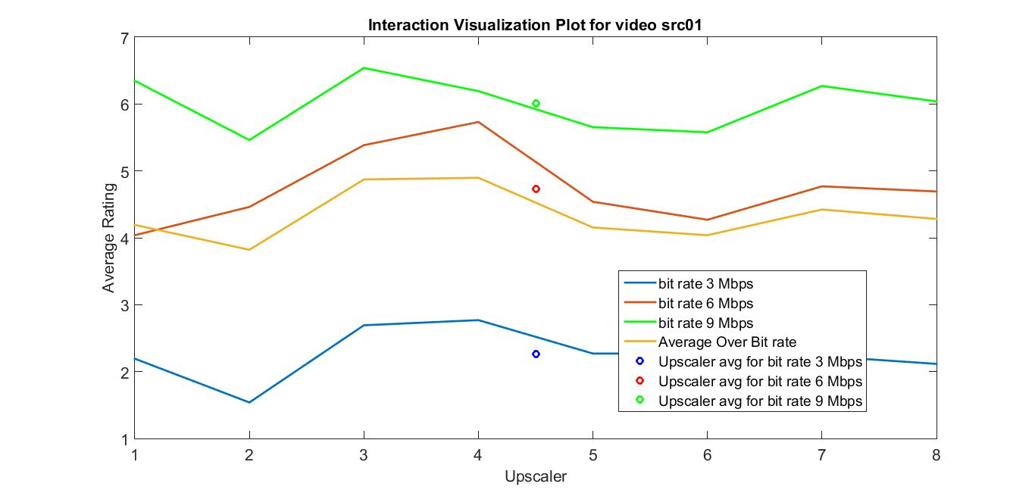

* The above graph clearly shows that the 3 lines corresponding to 3 bit rates to be fairly independent and not intersecting across all 8 upscalers. Hence intuitively the interaction between the two factors is not significant. Although minor interaction may exist because the graphs are not exactly parallel.
* We observe that the mean over upscalers for different bit rates is different. This means that bit-rate is a significant factor.
* Finally mean over all bit rates for each upscalar is similar which implies that in the data, the effect of upscalars does not appear to be numerically significant. But not that it still might be statistically significant depending on the variance present within.

**Performing ANOVA**

Assumptions:

1. Since we are using mean as the test statistic, CLT is applicable which ensures that distribution of test statistic is normal.
2. Independence of observations is assumed.
3. The following are the standard deviation values for 8 of the 24 groups:

1.5752 1.1038 1.3496 1.4228 1.4299 1.7563 1.3358 1.1073

For the rest of the groups in the data, the values are similar to above. Hence there is not much difference in the variance which indicated that the homogeneity of variance is also satisfied. As we have seen, this assumption is a practical requirement which if not satisfied, then there is no use of performing test hence this assumption must be and is satisfied in this case.

Since all the three assumptions have been satisfied, we can perform ANOVA.

Hypothesis:

Null Hypothesis - There is no significant effect of the interaction of two factors on the determination of quality of video.

For individual factors,

Null Hypothesis - There is no significant effect of the given factor on the determination of quality of video.

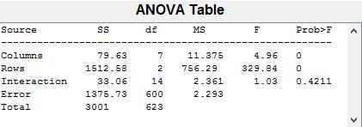

This is the table generated for 2 way ANOVA for video 1. Let us take alpha as 0.05 throughout.

1.First we check the p-val for interaction, it is p-val >> alpha and hence we say that the interaction does not lead to a statistically significant difference in the MOS. There is no evidence to suggest the interaction leads to a difference in MOS.

2. The two factors by themselves however have low p-val and hence they seem to be significant ie they lead to a difference between MOS assuming that the other factor is not playing a role (ie summing over the other factor).

Compare with exploratory analysis,

1. It predicted that there is no interaction between the factors.
2. It indicated that bit rate is significant.
3. Numerically the effect of upscaler does not seem much but it is coming out to be statistically significant. A domain expert will need to comment if the statistical significance is of any value or not.

The result of the initial test differ slightly but we follow results of actual test.

**2-way Analysis for video 2 (src02):**

**Exploratory analysis:**

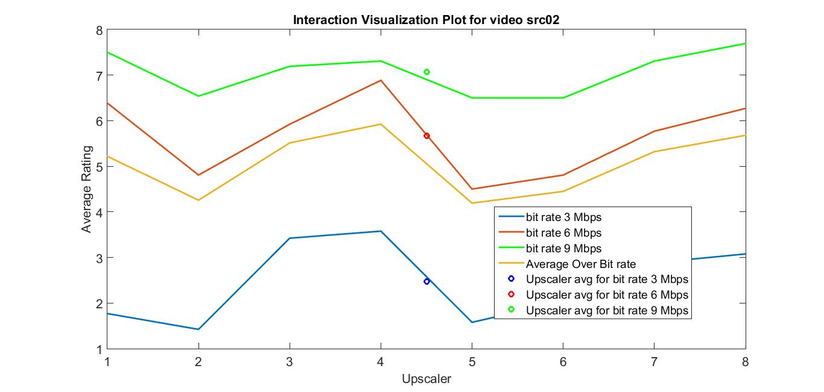

1. Again ignoring upscale and averaging over them gives us different answers for the 3 bit rates. This means that the bit rates are a significant factor.
2. Again, there are variations over bit rate. So upscale is significant.
3. The behaviour of graphs is not consistent which means that their interaction may be significant.

**Performing ANOVA**

As done in the previous part, all the three assumptions of ANOVA have been satisfied in this case as well. Hence we can perform ANOVA.

Hypothesis:

Null Hypothesis - There is no significant effect of the interaction of two factors on the determination of quality of video.

For individual factors,

Null Hypothesis - There is no significant effect of the given factor on the determination of quality of video.

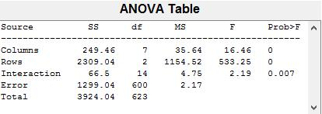

Here again we take significance level alpha = 0.05

1.Here p-val < alpha and hence we say that the interaction does lead to a statistically significant difference in the MOS.

2. The two factors by themselves however have low p-val and hence they seem to be significant i.e. they lead to a difference between MOS assuming that the other factor is not playing a role (i.e. summing over the other factor).

The above results closely match with the intuitive results.

This means that in determination of quality of video two, the interaction of the two factors matters at the same time the two factors individually also matter.

**ANOVA for Video 3 (src05):**

**Exploratory analysis:**

Here also we try to get intuitive behaviour by observing the Interaction Visualization plot.

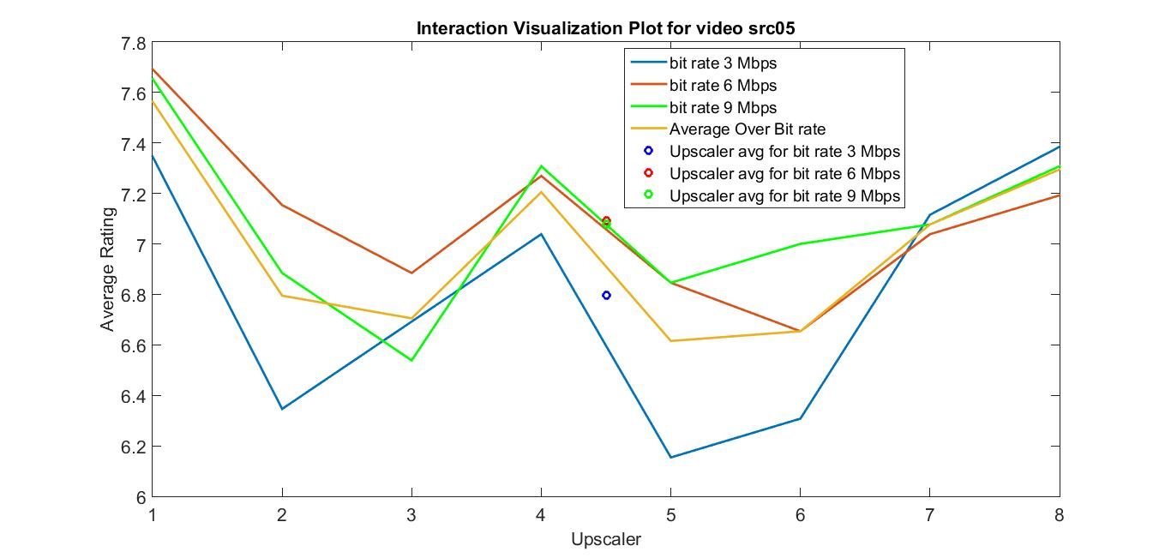

1. From this plot we observe that the three horizontal lines are overlapping which means that the interaction may be significant.
2. But for the sum over mean two averages are overlapping which means that it may not be a significant factor.
3. The intersection indicates that the interaction may be significant.

**Performing ANOVA**

In this part also, all the three assumptions of ANOVA have been satisfied in this case as well. Hence we can perform ANOVA.

Hypothesis:

Null Hypothesis - There is no significant effect of the interaction of two factors on the determination of quality of video.

For individual factors,

Null Hypothesis - There is no significant effect of the given factor on the determination of quality of video.

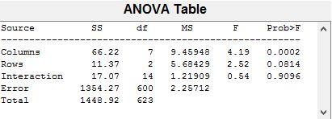

Here again we take significance level alpha = 0.05

1.Here p-val >> alpha and hence we say that the interaction does not lead to a statistically significant difference in the MOS.

2. The factor of rows, i.e. the factor of upscalers is 0.0814 > 0.05. This means the factor of upscalers is not significant in determination of quality of videos.

3. The bit rate factor has low p-val and hence it is significant i.e. it leads to a difference between MOS assuming that the other factor is not playing a role (i.e. summing over the other factor).

The results of the initial analysis differ slightly from the actual test which is understandable considering that the initial analysis is not the concrete result.

Codes:

% Get data in required ANOVA matrix format

close all;

% read in data correctly

load('vid_1data.mat')

load('vid_2data.mat')

load('vid_3data.mat')

%%%%%%%%%%%%%%%%555

% generate anova2 data matrices for vid 1,2 and 3

anova2_vid1_mat= vid_1data(1:8,:)';

anova2_vid1_mat= [anova2_vid1_mat; vid_1data(9:16,:)'];

anova2_vid1_mat= [anova2_vid1_mat; vid_1data(17:24,:)'];

save('anova2_vid1_mat.mat','anova2_vid1_mat');

%%%%%%%%%%%%%%%%%% for vid 2

anova2_vid2_mat= vid_2data(1:8,:)';

anova2_vid2_mat= [anova2_vid2_mat; vid_2data(9:16,:)'];

anova2_vid2_mat= [anova2_vid2_mat; vid_2data(17:24,:)'];

save('anova2_vid2_mat.mat','anova2_vid2_mat');

%%%%%%%%%%%%%%%%5 for vid 3

anova2_vid3_mat= vid_3data(1:8,:)';

anova2_vid3_mat= [anova2_vid3_mat; vid_3data(9:16,:)'];

anova2_vid3_mat= [anova2_vid3_mat; vid_3data(17:24,:)'];

save('anova2_vid3_mat.mat','anova2_vid3_mat');

Code for exploratory analysis

close all;

% first get mean compara for bit rates summed across the other

% average for bit rate summed across upscales

%X_b3_str= mean(vid_1data(1:8,27))

%X_b6_str= mean(vid_1data(9:16,27))

%X_b9_str= mean(vid_1data(17:24,27))

vid1 = mean(mean(vid_1data))

vid2 = mean(mean(vid_2data))

vid3 = mean(mean(vid_3data))

group_std_table_1 = [std(vid_1data(1:8, :)'); std(vid_1data(9:16, :)'); std(vid_1data(17:24, :)')];

group_std_table_2 = [std(vid_2data(1:8, :)'); std(vid_2data(9:16, :)'); std(vid_2data(17:24, :)')];

group_std_table_3 = [std(vid_3data(1:8, :)'); std(vid_3data(9:16, :)'); std(vid_3data(17:24, :)')];

group_avg_table_1 = [mean(vid_1data(1:8, :), 2)'; mean(vid_1data(9:16, :), 2)'; mean(vid_1data(17:24, :), 2)'];

group_avg_table_2 = [mean(vid_2data(1:8, :), 2)'; mean(vid_2data(9:16, :), 2)'; mean(vid_2data(17:24, :), 2)'];

group_avg_table_3 = [mean(vid_3data(1:8, :), 2)'; mean(vid_3data(9:16, :), 2)'; mean(vid_3data(17:24, :), 2)'];

l1 = group_avg_table_1(1, :);

l2 = group_avg_table_1(2, :);

l3 = group_avg_table_1(3, :);

avgLine = mean(group_avg_table_1(:, 1:8));

plot(l1, 'LineWidth', 2)

hold on

plot(l2, 'LineWidth', 2)

hold on

plot(l3, 'g', 'LineWidth', 2)

hold on

plot(avgLine, 'LineWidth', 2)

hold on

plot(4.5, mean(l1), 'bo', 'LineWidth', 2)

hold on

plot(4.5, mean(l2), 'ro', 'LineWidth', 2)

hold on

plot(4.5, mean(l3), 'go', 'LineWidth', 2)

title('Interaction Visualization Plot for video src01')

xlabel('Upscaler')

ylabel('Average Rating')

legend('bit rate 3 Mbps', 'bit rate 6 Mbps', 'bit rate 9 Mbps', 'Average Over Bit rate', 'Upscaler avg for bit rate 3 Mbps', 'Upscaler avg for bit rate 6 Mbps', 'Upscaler avg for bit rate 9 Mbps' )

set(gca,'FontSize',16)

set(findall(gcf,'type','text'),'FontSize',16)

print('Interaction_src01','-djpeg')

l1 = group_avg_table_2(1, :);

l2 = group_avg_table_2(2, :);

l3 = group_avg_table_2(3, :);

avgLine = mean(group_avg_table_2(:, 1:8));

figure

plot(l1, 'LineWidth', 2)

hold on

plot(l2, 'LineWidth', 2)

hold on

plot(l3, 'g', 'LineWidth', 2)

hold on

plot(avgLine, 'LineWidth', 2)

hold on

plot(4.5, mean(l1), 'bo', 'LineWidth', 2)

hold on

plot(4.5, mean(l2), 'ro', 'LineWidth', 2)

hold on

plot(4.5, mean(l3), 'go', 'LineWidth', 2)

title('Interaction Visualization Plot for video src02')

xlabel('Upscaler')

ylabel('Average Rating')

legend('bit rate 3 Mbps', 'bit rate 6 Mbps', 'bit rate 9 Mbps', 'Average Over Bit rate', 'Upscaler avg for bit rate 3 Mbps', 'Upscaler avg for bit rate 6 Mbps', 'Upscaler avg for bit rate 9 Mbps' )

set(gca,'FontSize',16)

set(findall(gcf,'type','text'),'FontSize',16)

print('Interaction_src02','-djpeg')

l1 = group_avg_table_3(1, :);

l2 = group_avg_table_3(2, :);

l3 = group_avg_table_3(3, :);

avgLine = mean(group_avg_table_3(:, 1:8));

figure

plot(l1, 'LineWidth', 2)

hold on

plot(l2, 'LineWidth', 2)

hold on

plot(l3, 'g', 'LineWidth', 2)

hold on

plot(avgLine, 'LineWidth', 2)

hold on

plot(4.5, mean(l1), 'bo', 'LineWidth', 2)

hold on

plot(4.5, mean(l2), 'ro', 'LineWidth', 2)

hold on

plot(4.5, mean(l3), 'go', 'LineWidth', 2)

title('Interaction Visualization Plot for video src05')

xlabel('Upscaler')

ylabel('Average Rating')

legend('bit rate 3 Mbps', 'bit rate 6 Mbps', 'bit rate 9 Mbps', 'Average Over Bit rate', 'Upscaler avg for bit rate 3 Mbps', 'Upscaler avg for bit rate 6 Mbps', 'Upscaler avg for bit rate 9 Mbps' )

set(gca,'FontSize',16)

set(findall(gcf,'type','text'),'FontSize',16)

print('Interaction_src05','-djpeg')