**CS306: Data Analysis and Visualization**

**Lab 5: Report**

**Rajdeep Pinge 201401103**

**Aditya Joglekar 201401086**

**Objective:**

**To apply the ideas of hypothesis testing on real data, and analyzing the consequence of the inference made**

**Question Description:**

A crucial issue in video transmission is that of video resolution. Naturally, a smaller resolution video is preferable as it will utilize less transmission bandwidth. As the current standard is full HD (1080 x 1920 pixels), we have two options.

**option 1: transmit the full HD video as it is**

**option 2: first down scale the full HD video to 720p (720 x 1280), then transmit the resultant lower resolution video. Finally, upscale (i.e. increase its resolution) back to full HD resolution at the receiver side.**

We can employ hypothesis testing to evaluate if the two options are equivalent. This will require the knowledge of the resultant video quality from the two options.

You are provided 4 vectors: src1_fullHD_3Mb, src1_fullHD_9Mb, src1_720p_upscaled_3Mb and src1_720p_upscaled_9Mb. Each of these is a 26-diemsnsional vector which represents the subjective quality score (based on ACR) from 26 different observers. Notice that two bit rates are considered: low bit rate (3 Mb/s) and high bit rate (9 Mb/s).

note: each element of ‘src1_fullHD_3Mb’ vector represents the quality score of the video transmitted at 3Mb and at full HD resolution. Likewise, each element in ‘src1_720p_upscaled_3Mb’ vector represents the quality score of the video transmitted at 3Mb but at 720p resolution. Same explanation for the other two vectors.

**1. Use the mean opinion scores (MOS) to suggest which of the two: option 1 or option 2, is more suitable?**

Here we only consider the mean of opinion scores of the two samples.

For 3 MB/s bandwidth:

Mean for full HD 2.1923

Mean for 720p 2.7692

For 9 MB/s bandwidth:

Mean for full HD 6.3462

Mean for 720p 6.1923

If we simply consider the above MOS values, we note that

For 3 MB/s bandwidth, MOS for option1 is lesser than option2.

Thus, we would recommend option2 for 3MB/s.

For 9 MB/s bandwidth, MOS for option1 is greater than option2.

Thus, we would recommend option1 for 9MB/s.

**Are there any shortcomings to your recommendation?**

**Ans.:** There are many shortcomings to this recommendation:

1. We have no idea of how **statistically relevant** our observations are.
2. We have been given the data and are using it as it is. The data may contain some anomalies which have not been accounted for while doing the above recommendations.
3. We have simply computed mean on samples of very small sample sizes. The samples might contain outliers which could affect the mean.
4. Moreover the samples are of small size, which may not be representative of the larger population i.e. samples may not be applicable for all types of video qualities or for all bit rates.
5. Essentially, it is not statistically rigorous to test the hypothesis using just simple mean and that too on a small sample.

**2. Suppose a video broadcasting firm approaches you to make a decision if option 1 and option 2 are equivalent in terms of the quality of video. To that end, use a t-test to arrive at your decision. Discuss any factors that will affect your analysis.**

The t-test allows us to test the hypothesis by using a very small sample size.

The formula to find the t-value and the degrees of freedom(df) is as follows. Where subscript 1 implies first data set and subscript 2 implies 2nd data set.

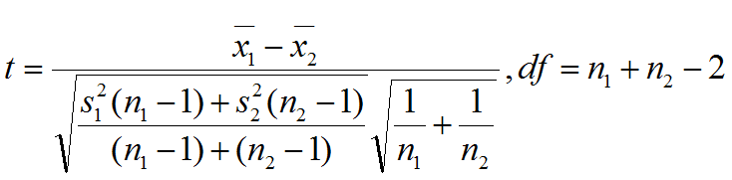

Here all the data sets are of **size 26**. There n1 = n2 = 26

Therefore **degrees of freedom df = 50**

The **T distribution is fixed based on the degrees of freedom**. Hence for df = 50, the T distribution is same for both the options to be considered

**Hypothesis**

Null hypothesis H0 : 1  - 2  = 0

Alternate hypothesis Ha : 1  - 2  0

Where 1 : mean of the first data set

2 : mean of the second data set

Now we will find the T value comparing the 2 options for both the bit rates.

**For bit rate 3 MB/s**

DataSet1 = Full HD data set, DataSet2 = scaled 720p data set

**T score = -1.3858**

Cumulative probability P(T < -1.3858) = 0.0860 As calculated from the online calculator.

1 - P(T < -1.3858) = 1 - 0.0860 = 0.9140

OR

P(T < 1.3858) = 1 - P(T < -1.3858). Due to symmetry of T distribution.

P(T < 1.3858) = 0.9140. As calculated from the online calculator.

Now let us compare for different $α$ values (critical values).

**Convention used for $α$:** As shown in the figure below, the $α$ gives the total area under the curve for which the null hypothesis must be rejected. Since the T distribution is a symmetric distribution, we can split $α$ in 2 parts with the extreme values on both sides of the distribution considered half of the rejection area ( $α$/ 2 ).

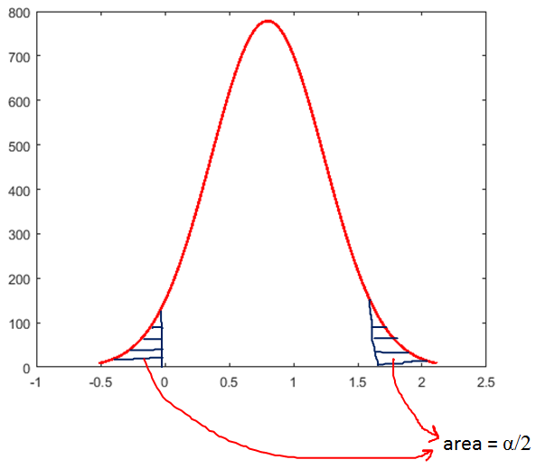

The null hypothesis will be accepted if it lies in the unshaded region in the above graph and will be rejected if it lies in the shaded $α$ region in the above graph.

For $α$ **= 0.1**

$α$/ 2 = 0.05

Cumulative probability for calculated t value P(T < -1.3858) = 0.0860

This value is greater than 0.05 therefore it lies to the right of the critical region on the left side. Hence the **null hypothesis can be accepted**.

This means that option 1 and option 2 are equivalent in terms of the quality of video for bit rate = 3 MB/s.

If we change the critical value $α$ **= 0.2**

$α$/ 2 = 0.1

P(T < -1.3858) = 0.0860 < 0.1

In this case, the cumulative probability lies in the $α$ region. Hence the **null hypothesis is rejected.** Since here, there is only one alternate hypothesis, that must be true.

Therefore, **video quality by both the options is not the same**.

Since the T value is negative (T score = -1.3858), The DataSet2 used in the calculation must be giving better results than the DataSet1 i.e. the Scaled 720p transmission is better than the FullHD transmission at bit rate 3 MB/s.

**For bit rate 9 MB/s**

DataSet1 = Full HD data set, DataSet2 = scaled 720p data set

df = 50

**T score = 0.3582**

P(T < 0.3582) = 0.6391. According to the online calculator

Now let us compare for different $α$ values (critical values).

For $α$ **= 0.1**

$α$/ 2 = 0.05

P(T < 0.3582) = 0.6391 > 0.05

P(T < 0.3582) = 0.6391 < (1 - $α$/ 2) = 0.95

Therefore the **null hypothesis can be accepted** for this case. This means that both the options will give **similar quality video**.

For $α$ **= 0.7**

$α$/ 2 = 0.35

P(T < 0.3582) = 0.6391 > 0.35

P(T < 0.3582) = 0.6391 < (1 - $α$/ 2) = 0.65

This shows that even if we increase the strictness for acceptance of null hypothesis with results in just 30% area accepted, the null hypothesis in this case will be accepted and the quality of video will almost be same irrespective of the option used. **In such cases we can further look at the ease of transmission without worrying about the quality of the video.**

**This shows that at bit rate 9 MB/s, due to the increased bandwidth, the Full HD transmission will work equally well as the scaled 720p transmission.**

**If in some case, The result lies in the $α$ region then also Full HD video will work better at this rate because the T score is positive ( T score = 0.3582 ).**

**Conclusion :**

As the bandwidth, increases, the high quality video transmission works equally well or sometimes even better that the scaled low quality transmission.

**Codes:**

**Main code**

% code to find out the quality difference between two video streaming

% approaches

clear;

close all;

load('data_lab5');

% finding mean for each data set

%%%%% bit rate 3 MB/s %%%%%%%%%%%%%

% full HD data set

mean3_hd = mean(src1_fullHD_3Mb);

% 720p data set

mean3_scaled = mean(src1_720p_upscaled_3Mb);

%%%%% bit rate 9 MB/s %%%%%%%%%%%%%

% full HD data set

mean9_hd = mean(src1_fullHD_9Mb);

% 720p data set

mean9_scaled = mean(src1_720p_upscaled_9Mb);

% finding standard deviation of each data set

%%%%% bit rate 3 MB/s %%%%%%%%%%%%%

% full HD data set

sd3_hd = std(src1_fullHD_3Mb);

% 720p data set

sd3_scaled = std(src1_720p_upscaled_3Mb);

%%%%% bit rate 9 MB/s %%%%%%%%%%%%%

% full HD data set

sd9_hd = std(src1_fullHD_9Mb);

% 720p data set

sd9_scaled = std(src1_720p_upscaled_9Mb);

% size of each data set

size_arr = length(src1_720p_upscaled_3Mb);

n1 = size_arr;

n2 = size_arr;

% calculate t value and degrees of freedom

%%%%% bit rate 3 MB/s %%%%%%%%%%%%%

[t3, df3] = calculate_t(mean3_hd, mean3_scaled, sd3_hd, sd3_scaled, n1, n2)

%%%%% bit rate 9 MB/s %%%%%%%%%%%%%

[t9, df9] = calculate_t(mean9_hd, mean9_scaled, sd9_hd, sd9_scaled, n1, n2)

**Function used**

% function to calculate degree of freedom and t value for given set of data

function [t, df] = calculate_t(x1, x2, s1, s2, n1, n2)

% parameters

% x1 : mean of first distribution

% x2 : mean of second distribution

% s1 : standard deviation of first distribution

% s2 : standard deviation of second distribution

% n1 : number of sample points of first distribution

% n2 : number of sample points of second distribution

% return values

% df : degrees of freedom

% t : t value of the data

% calculating degrees of freedom

df = n1 + n2 - 2;

% calculating t value

t = (x1 - x2) / ( sqrt( ((s1*s1*(n1-1) + s2*s2*(n2-1))/df) * (1/n1 + 1/n2) ) );

end