🌱 AGRICARE – Smart Agriculture Monitoring System
1. Introduction
Agriculture is the backbone of India’s economy, yet farmers still face challenges such as unpredictable weather, improper irrigation, fire hazards, and gas-related risks. AGRICARE is an IoT-based smart agriculture monitoring system designed to help farmers monitor critical environmental and soil parameters in real time using low-cost sensors and automation.
This project uses NodeMCU ESP8266 as the main controller and integrates multiple sensors to continuously observe field conditions. The collected data is displayed on an OLED display, and alerts are generated using a buzzer and LED, ensuring timely action and crop safety.
2. Objectives of AGRICARE
- To monitor soil moisture for efficient irrigation
- To detect gas leakage or smoke in agricultural fields
- To detect fire/flame hazards at an early stage
- To measure temperature and humidity of the environment
- To provide real-time alerts using buzzer and LED
- To display live sensor data on an OLED display
- To build a low-cost and scalable smart agriculture solution

3. System Overview
AGRICARE continuously reads data from all connected sensors. Based on predefined threshold values, the system:
- Displays real-time values on OLED
- Activates buzzer and LED during unsafe conditions
- Allows user interaction through a touch sensor
The system can be further extended to cloud platforms for remote monitoring.

4. Hardware Components Used
4.1 NodeMCU ESP8266
- Acts as the brain of the system
- Processes sensor data
- Supports WiFi connectivity for IoT applications
4.2 Soil Moisture Sensor
- Measures water content in soil
- Helps prevent over-irrigation and under-irrigation
4.3 DHT11 Sensor
- Measures temperature and humidity
- Helps analyze environmental conditions for crops

4.4 MQ-2 Gas Sensor
- Detects smoke and harmful gases
- Useful for fire and gas leak detection
4.5 Flame Sensor
- Detects fire or flame presence
- Provides early fire alerts
4.6 OLED Display (1.3 inch, I2C)
- Displays sensor readings in real time
- Consumes very low power
4.7 Touch Sensor (Field Boundary Security)
- Touch sensor is connected to a boundary wire laid around the agricultural field
- When any animal or living being touches the boundary wire, the touch sensor gets activated
- This helps in detecting animal intrusion in the field
- Once triggered, it immediately sends a signal to NodeMCU for alert generation
4.8 Buzzer and LED
- Provide audio-visual alerts during emergency conditions
5. Software Requirements
- Arduino IDE
- ESP8266 Board Package
- Libraries Used:
  - Adafruit_GFX
  - Adafruit_SSD1306
  - DHT Sensor Library
  - ESP8266WiFi

🔌 DIGITAL PIN CONNECTIONS (ONLY)
Component | NodeMCU Digital Pin
OLED (I2C)
SCL | D3
SDA | D4
DHT11 Sensor (DATA) | D8
Flame Sensor | D7
Touch Sensor (OUT – Field Boundary Wire) | D2
Buzzer (+) | D1
LED (+) | D0
Ges Sensor | D6
LDR Sensor | D5
GND | GND Negative
VCC | 5V
6. Working Principle
- Sensors continuously collect environmental and soil data
- NodeMCU reads and processes sensor values
- All real-time readings are displayed on the OLED screen
- Field Boundary Protection Using Touch Sensor:
  - A wire is installed around the agricultural field
  - If any animal or living object touches the wire, the touch sensor is triggered
  - NodeMCU instantly activates the buzzer and LED
  - This alerts the farmer and helps prevent crop damage
- If gas, fire, or unsafe environmental conditions are detected:
  - Buzzer is activated
  - LED glows as a warning signal
- The system operates continuously in real time

Circuit Image :
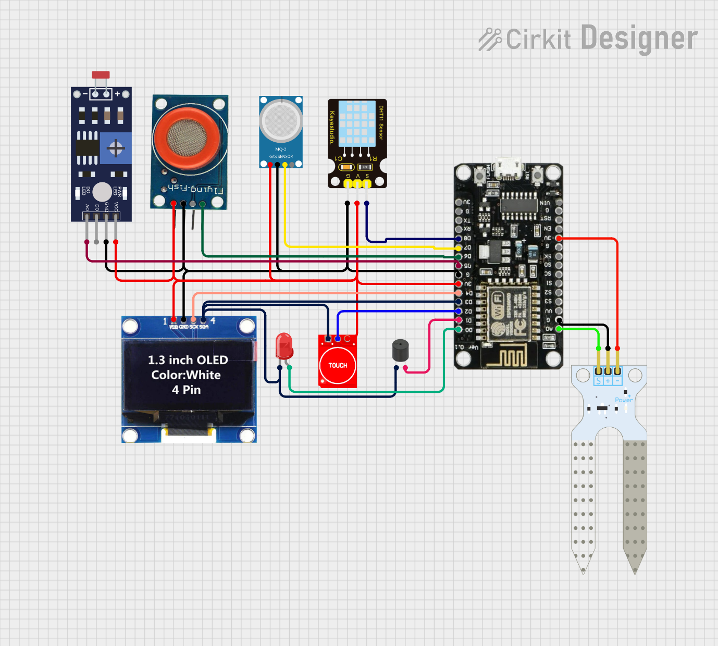
7. Applications of AGRICARE
- Smart farming and precision agriculture
- Crop safety and monitoring
- Fire detection in farms and storage areas
- Greenhouse monitoring
- Educational and research project

8. Advantages
- Low cost and energy efficient
- Easy to install and operate
- Real-time monitoring and alerts
- Reduces manual effort
- Improves crop yield and safet
9. Future Scope
- Mobile application integration
- Cloud-based data storage and analysis
- Automatic irrigation system
- AI-based crop disease prediction
- SMS and Email alert system

10. Conclusion
AGRICARE is a smart and efficient agriculture monitoring system that combines IoT and sensor technology to assist farmers in making data-driven decisions. By monitoring soil moisture, environmental conditions, and fire hazards, this project ensures better crop protection, improved productivity, and sustainable farming.

11. Developed By
Rajdeep Singh
4th Year AIML Student
IoT | AI | Robotics Enthusiast
⭐ If you like this project, don’t forget to ⭐ star the repository on GitHub!

