**Screenshots**

1. View of the good records in the database using DB Browser

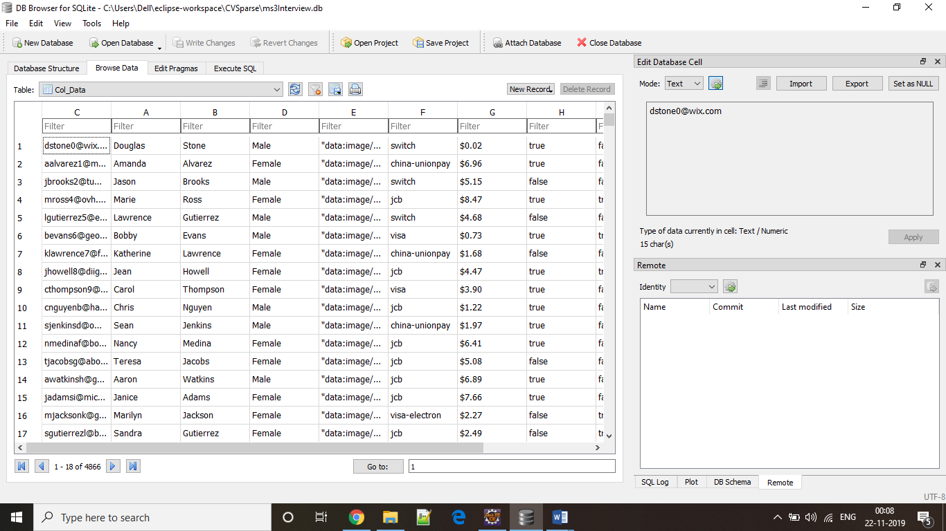

1. Picture of csv file containing the bad records

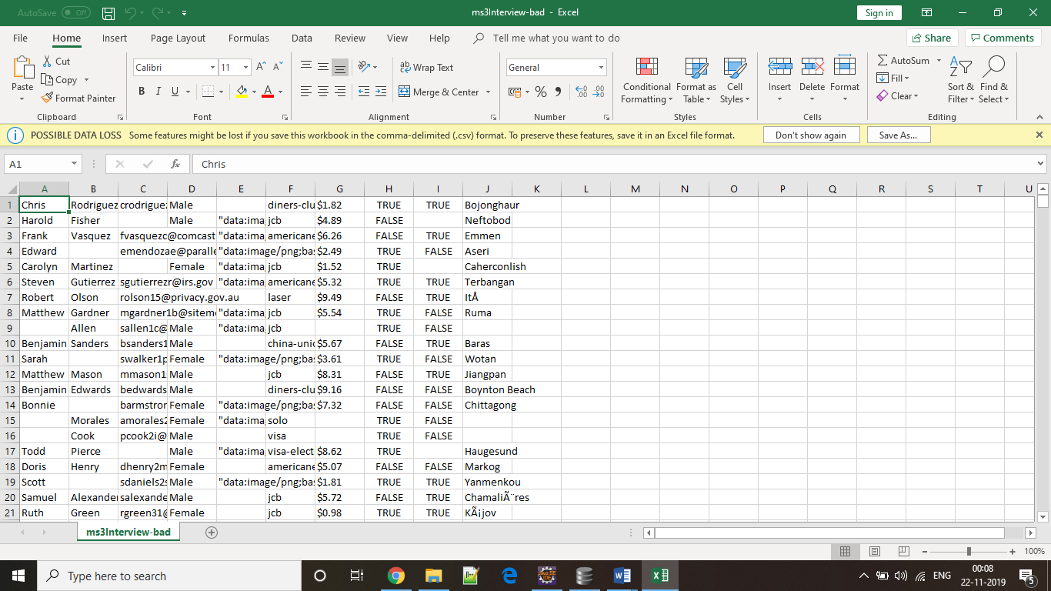

1. The log file which generated in the end

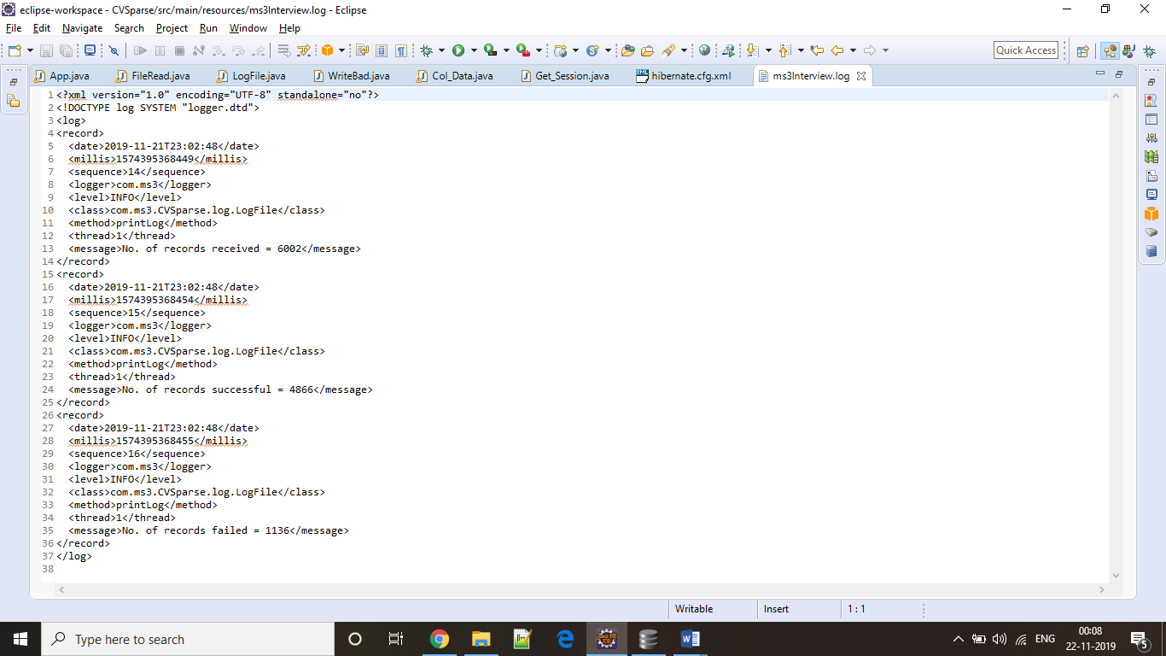

1. Locations of files in the CVSparse project.

