Challenge 1:

It's End of Financial Year and that means time for annual bonuses!

The store operates in three regions and only the top-performing employee in each region qualifies for a bonus. Find out which three employees are eligible to get bonuses for this year.

Employees are measured on total sales (₹₹).

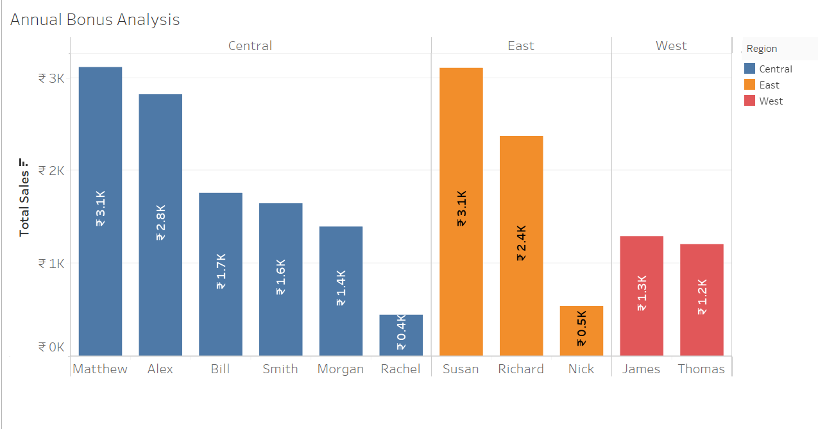**ANNUAL BONUS REPORT**