Assessment_Module_4

● Write SQL query to solve the problem given below:

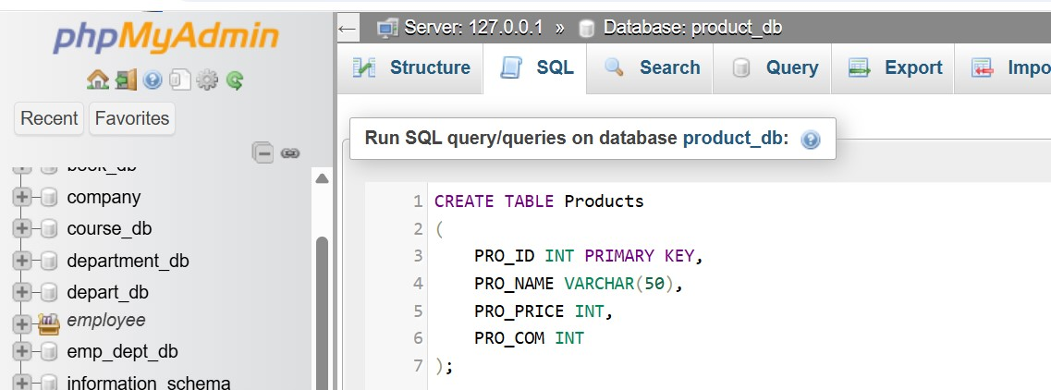

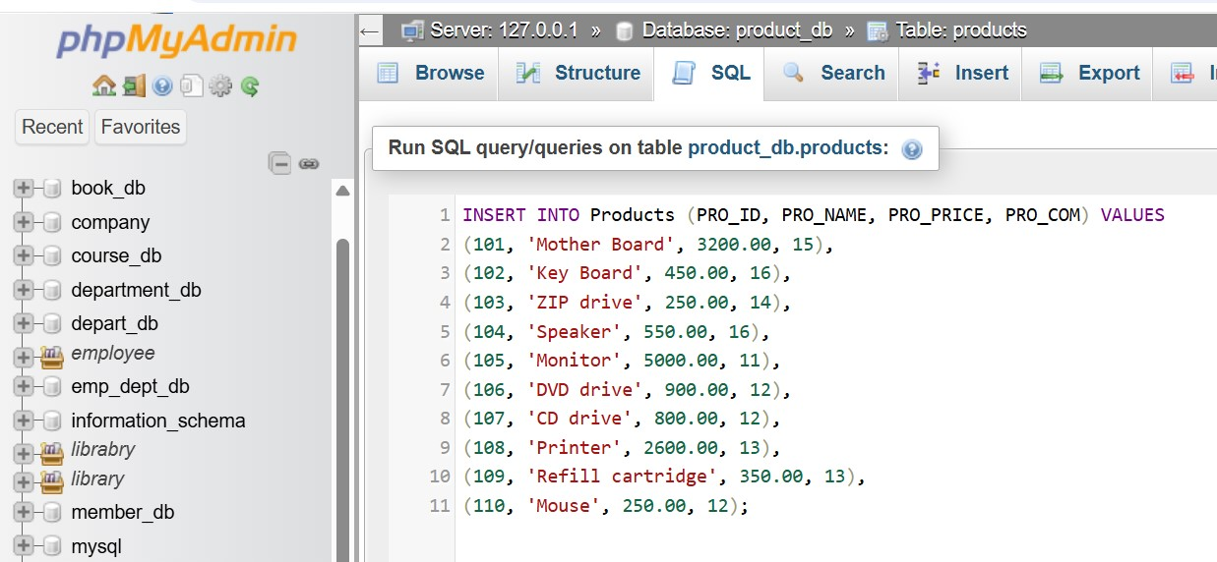

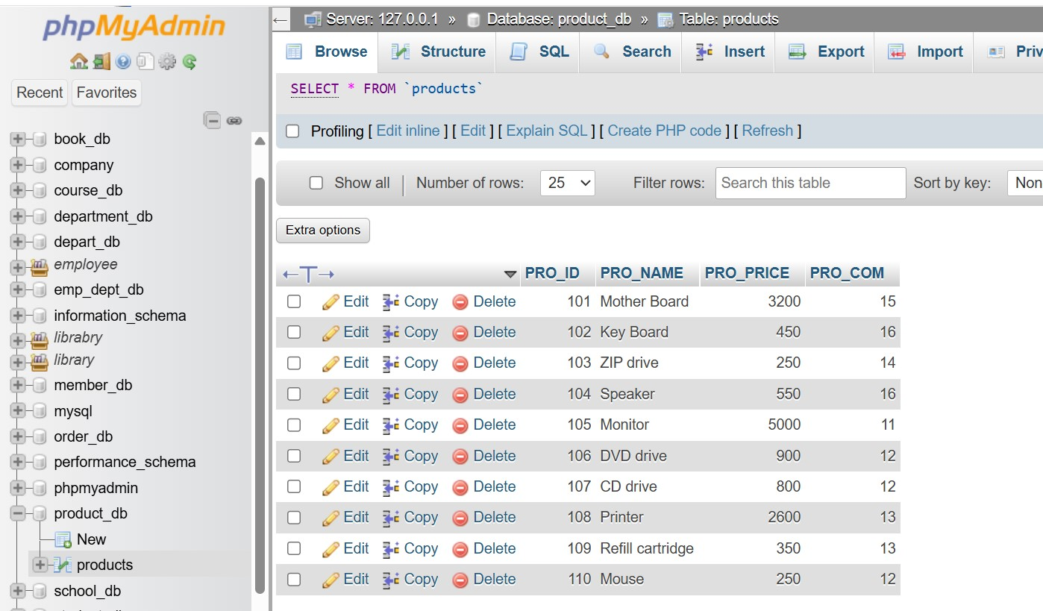

Make sure to use the right sql syntax to solve the query given below:

● Write sql query to find the items whose prices are higher than or equal to 250rs. Order the result by product price in descending, then by product name in ascending. Return pro_name and pro_price.

Ans.

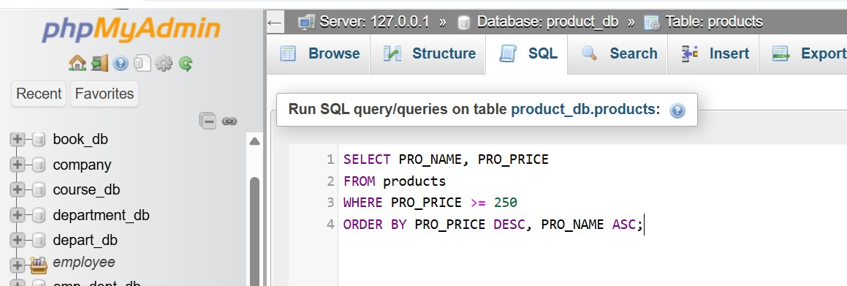

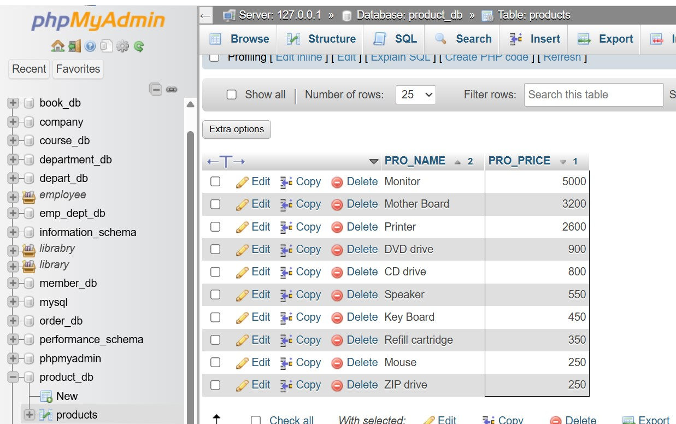

● Write a sql query to find the cheapest item. Return pro_name and pro_price.

Ans.

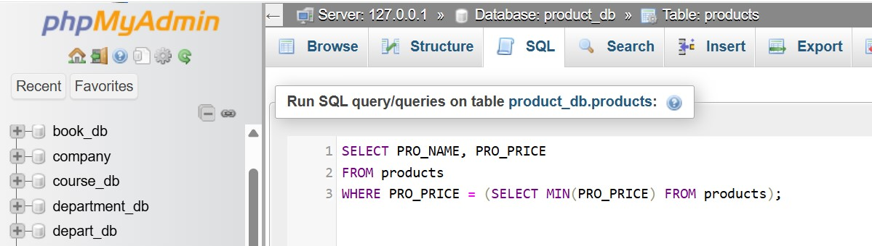

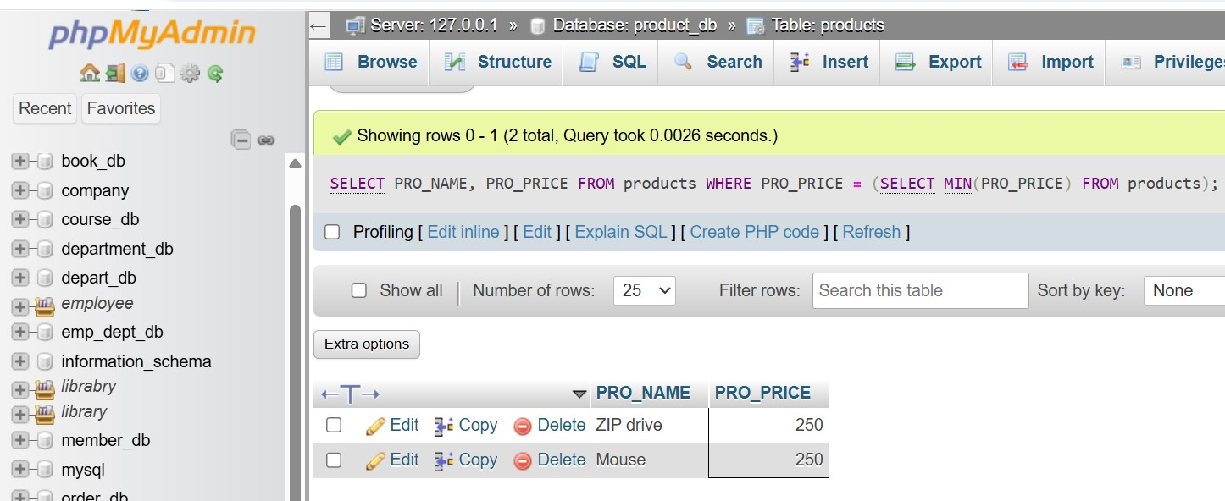

● Write the sql query to calculate the average price of the items for each company. Return the average price and company code.

Ans.

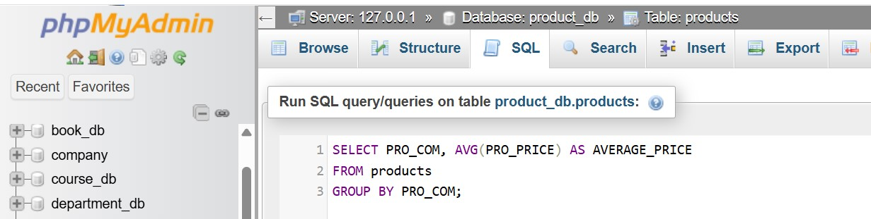

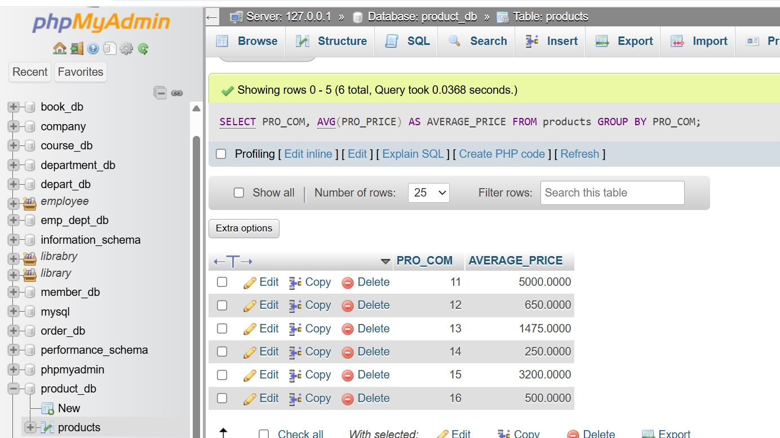

● Write the sql query to find the average total for all the products mentioned in the table.

Ans.

