**Shell script:**

1. list common commands in shell

2. command to list all the running process ( ps -ef )

3. Print a specific column **(awk -F” “ ‘{print$2}’**

4. write a script to print only errors from a remote log ( **curl google.com | grep -i error**)

5. Write a script to print the numbers that are divisible by 3 and 5 but not 15 in range of 1 to 100.

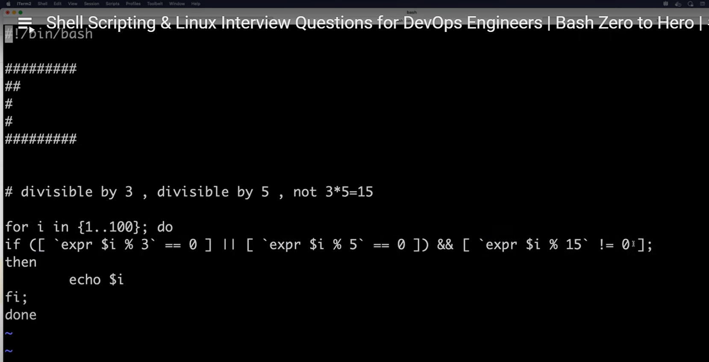

6. Print the number of time word s in mississipi

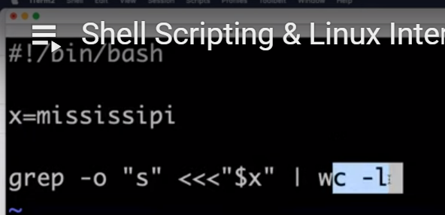

7. How will you debug your shell script? **set -x**

8. What is crontab and provide an example?

9. How to open a file in read only mode? **vim -r abc.txt**

10. Difference b/w Hardlink and softlink?

Hardlink: we create a copy of the file and if the actual file is deleted still the copy remains.

Softlink: used for creating alias. If the actual file is deleted then the copy also deletes.

11. Diff b/w break and continue statement?

Break: breaking the execution

continue: continuing the execution Skip – skip this and continue the next

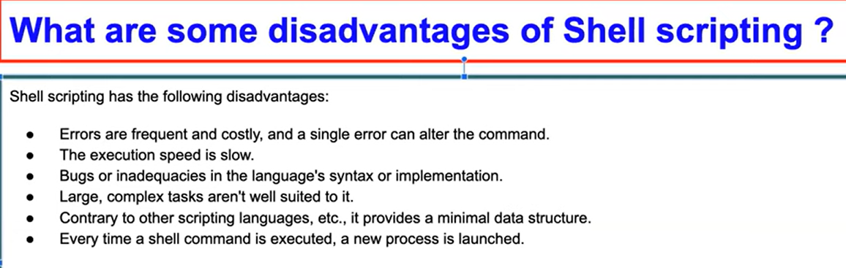

12. Is bash dynamically or statistically typed? dynamically typed

13. explain about a n/w troubleshooting utility**? traceroute google.com and tracepath (tracepath doesn’t require root previliges)**

14. How will you sort list of names in a file? **sort**

15. How will you manage logs of a system that generate huge logs every day? **logrotate**