**Task:**

Write a python script, which will convert json files to xml files and transfers it in a remote location.

Environment:

Python, Docker

Description:

Solution should be prepared as two Docker images, 1st to send files, and 2nd to receive them.

Deployment of these containers should be automated using docker-compose or shell script.

Python script on container A:

1. convert all json files to xml

2. Transfer it to a remote location (container B)

Python script on container B:

1. Receive files

2. Store files

So, in other words, pipeline should look like:

Json -> XML -> transfer -> XML

Acceptance criteria:

Any given Json putted to container A appears in XML form on container B using mentioned pipeline.

**Solution:**

**Algorithm**:

1. Create a python script which performs below functionalities:
2. Monitor the source directory for any .json file in small intervals.

if (.json file found)

* converts to xml
* append time stamp to xml and save it to target directory
* append timestamp to input json file and archive it

1. Monitor the target directory for any .xml file in small intervals.

if (.xml file found)

* ftp it to container B(ftp server), under a folder based on current date
* append timestamp to the xml file and archive it

1. Architecture Diagram:

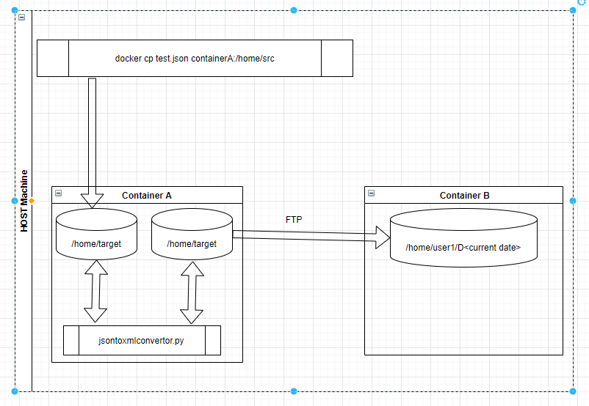

1. Create Docker file to build image for container A, with Entry point as the python script from step 1 above.

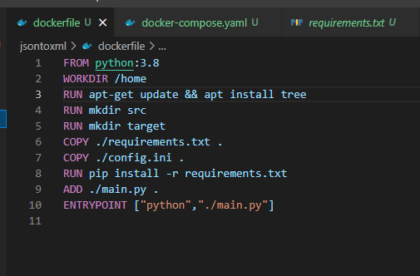

1. Create a Docker compose file, having 2 services. One for the python script to run in Container A and other to receive the file from container A.

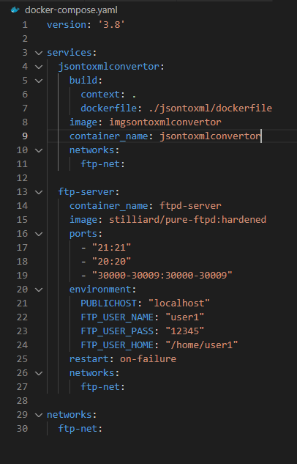

**Environment**

OS:

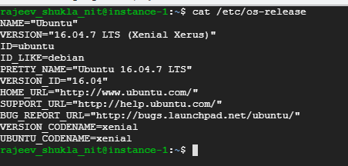

Python:



Docker:



Pip package required:



**Folder structure:**

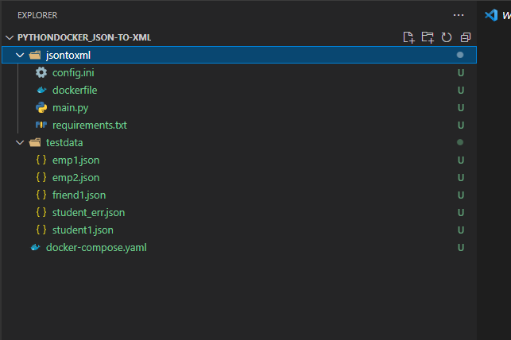

**Steps:**

1. Run sudo docker-compose up –d
2. Check the containers deployed and running



1. Copy json files under ./testdata to /home/src of jsontoxmlconvertor

sudo docker cp testdata/. jsontoxmlconvertor:/home/src

1. Xml file created and stored under the current Date folder in ftpd-server

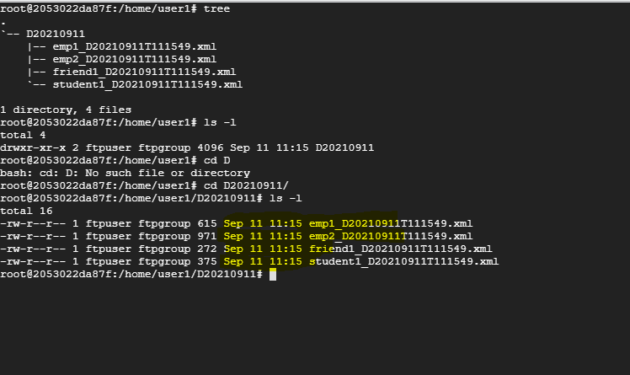

1. Check jsontoxml.log in jsontoxmlconvertor container

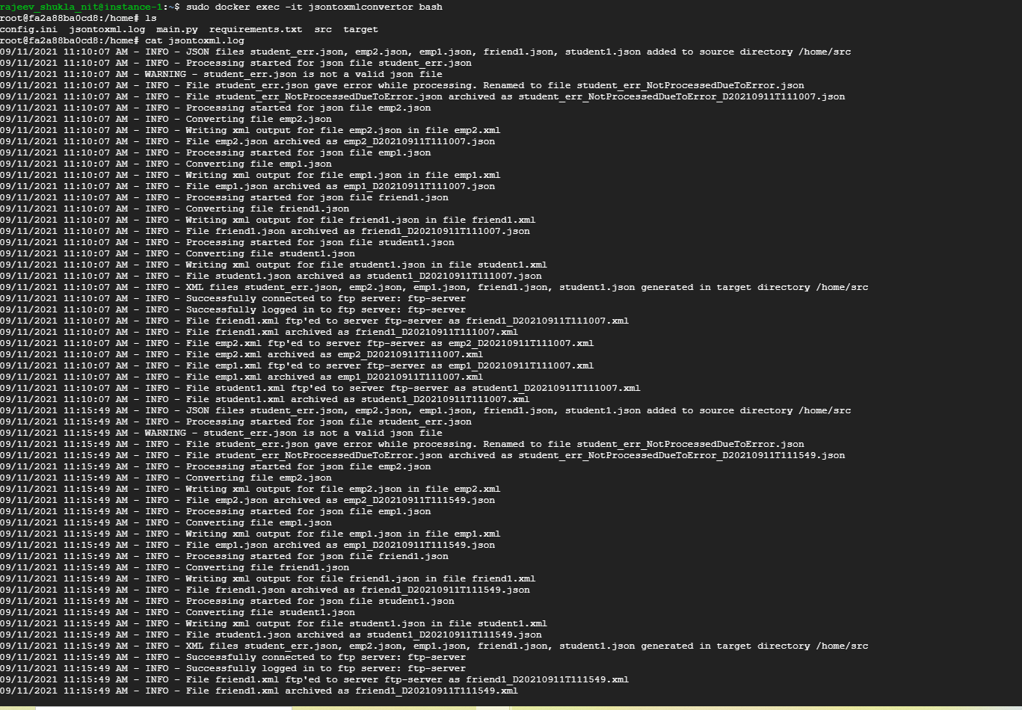

1. Check the src and target archived file

