Dt: 06.03.2024

# **SQL Training Session-1**

***Topics Covered***

1. SQL Overview
2. Introduction to Basic Database Concepts
3. E-R Modelling and Diagram

**SQL Overview:**

Structured Query Language (SQL) is a programming language for storing and processing information in a relational database.

A relational database stores information in tabular form, with rows and columns representing different data attributes and the various relationships between the data values.

We can use SQL statements to store, update, delete and retrieve information from the database. Also, we use SQL to maintain and optimize data performance.

*Ref:* [*https://aws.amazon.com/what-is/sql/*](https://aws.amazon.com/what-is/sql/)

**Introduction to Basic Database Concepts:**

A database is an electronically stored, systematic collection of data. It can contain any type of data, including words, numbers, images, videos and files. We use a software called DBMS to store, retrieve and edit data.

*Ref:* [*https://aws.amazon.com/what-is/database/*](https://aws.amazon.com/what-is/database/)

* **Concepts of Database:** To store and manage data efficiently in the database, we need to understand some key terms.

1. Database Schema: It is a design of the database that is used to represent the structure, types of data will be stored in the rows and columns, constraints, relationships between the tables.
2. Data Constraints: In a database, sometimes we put some restrictions on the table tat what type of data can be stored in one or more columns of the table, it can be done by using constraints. Constraints are defined while we are creating a table.
3. Data dictionary or Metadata: Metadata is known as the data about data or we can say that the database schema along with different types of constraints on the data is stored by DBMS in the dictionary is known as Metadata.
4. Database Instance: In a database, a database instance is used to define the complete database environment and its components. Or we can say that it is a set of memory structures and background processes that are used to access the database files.
5. Query: In a database, a query is used to access data from the database. So, users have to write queries to retrieve or manipulate data from the database.
6. Data Manipulation: In a database, we can easily manipulate data using the three main operations that is Insertion, Deletion, and updation.
7. Data Engine: It is an underlying component that is used to create and manage various database queries.

*Ref:* [*https://www.geeksforgeeks.org/basic-database-concepts/*](https://www.geeksforgeeks.org/basic-database-concepts/)

**E-R Modelling and Diagram:**

ER model stands for an Entity-Relationship model. It is a high-level data model. This model is used to define the data elements and relationship for a specified system.

It develops a conceptual design for the database. It also develops a very simple and easy design to view.

**For example**, suppose we design a school database. In this database, the student will be an entity with attributes like address, name, id, age, etc. The address can be another entity with attributes like city, street name, pin code, etc and there will be a relationship between them.

Components of E-R diagram:

1. Entity: An entity may be any object, class, person or place. In the ER diagram, an entity can be represented as rectangles.

Consider an organization as an example- manager, product, employee, department etc. can be taken as an entity.

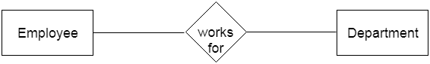

1. Weak Entity: An entity that depends on another entity called a weak entity. The weak entity doesn't contain any key attribute of its own. The weak entity is represented by a double rectangle.

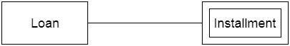

1. Attribute: The attribute is used to describe the property of an entity. Eclipse is used to represent an attribute.

**For example**, id, age, contact number, name, etc. can be attributes of a student.

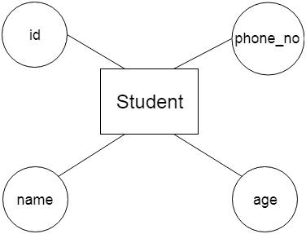

1. Key Attribute: The key attribute is used to represent the main characteristics of an entity. It represents a primary key. The key attribute is represented by an ellipse with the text underlined.

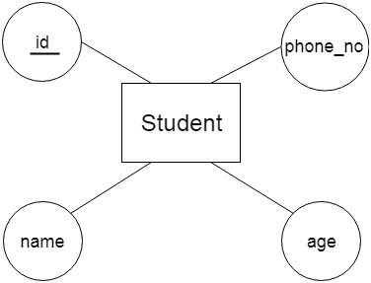

1. Composite Attribute: An attribute that composed of many other attributes is known as a composite attribute. The composite attribute is represented by an ellipse, and those ellipses are connected with an ellipse.

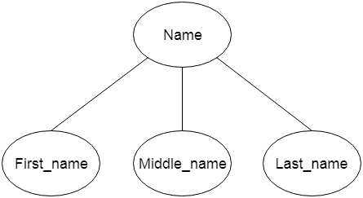

1. Multivalued Attribute: An attribute can have more than one value. These attributes are known as a multivalued attribute. The double oval is used to represent multivalued attribute.

**For example**, a student can have more than one phone number.

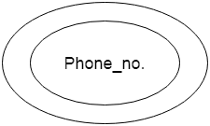

1. Derived Attribute: An attribute that can be derived from another attribute is known as a derived attribute. It can be represented by a dashed ellipse.

**For example**, A person's age changes over time and can be derived from another attribute like Date of birth.

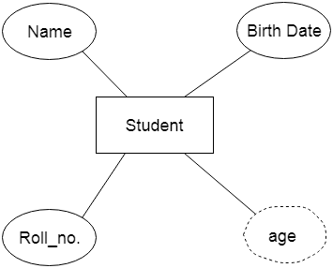

1. Relationship: A relationship is used to describe the relation between entities. Diamond or rhombus is used to represent the relationship.

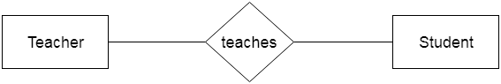

Types of relationship are as follows:

1. One-to-One relationship: When only one instance of an entity is associated with the relationship, then it is known as one-to-one relationship.

**For example**, A female can marry to one male, and a male can marry to one female.

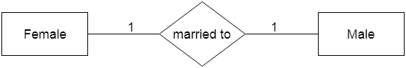

1. One-to-many relationship: When only one instance of the entity on the left, and more than one instance of an entity on the right associates with the relationship then this is known as a one-to-many relationship.

**For example**, Scientist can invent many inventions, but the invention is done by the only specific scientist.

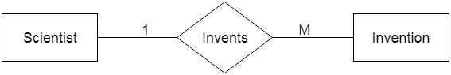

1. Many-to-one relationship: When more than one instance of the entity on the left, and more than one instance of an entity on the right associates with the relationship then it is known as a many-to-many relationship.

**For example**, Employee can assign by many projects and project can have many employees.

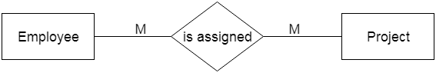

*Ref:* [*https://www.javatpoint.com/dbms-er-model-concept*](https://www.javatpoint.com/dbms-er-model-concept)