**Prepared by Asif Bhat**

# Python Tutorial

In [103]:

**import** sys

**import** keyword

**import** operator

**from** datetime **import** datetime

**import** os

## Keywords

Keywords are the reserved words in Python and can't be used as an identifier

In [3]:

print(keyword.kwlist) *# List all Python Keywords*

['False', 'None', 'True', 'and', 'as', 'assert', 'async', 'await', 'break', 'cl

ass', 'continue', 'def', 'del', 'elif', 'else', 'except', 'finally', 'for', 'fr

om', 'global', 'if', 'import', 'in', 'is', 'lambda', 'nonlocal', 'not', 'or',

'pass', 'raise', 'return', 'try', 'while', 'with', 'yield']

In [4]:

len(keyword.kwlist) *# Python contains 35 keywords*

Out[4]: 35

## Identifiers

An identifier is a name given to entities like class, functions, variables, etc. It helps to differentiate one entity from another.

In [13]:

1var **=** 10 *# Identifier can't start with a digit*

#### File "<ipython-input-13-37e58aaf2d3b>", line 1

**1var = 10 # Identifier can't start with a digit**

#### ^

**SyntaxError:** invalid syntax

In [14]:

val2**@ =** 35 *# Identifier can't use special symbols*

#### File "<ipython-input-14-cfbf60736601>", line 1

**val2@ = 35 # Identifier can't use special symbols**

#### ^

**SyntaxError:** invalid syntax

In [15]:

**import =** 125 *# Keywords can't be used as identifiers*

#### File "<ipython-input-15-f7061d4fc9ba>", line 1

**import = 125 # Keywords can't be used as identifiers**

#### ^

**SyntaxError:** invalid syntax

In [16]:

"""

Correct way of defining an identifier

(Identifiers can be a combination of letters in lowercase (a to z) or uppercase """

val2 **=** 10

In [17]:

val_ **=** 99

# Comments in Python

Comments can be used to explain the code for more readabilty.

In [18]:

*# Single line comment*

val1 **=** 10

In [19]:

*# Multiple # line*

*# comment*

val1 **=** 10

In [20]:

'''

Multiple line

comment '''

val1 **=** 10

In [21]:

"""

Multiple line

comment """

val1 **=** 10

## Statements

Instructions that a Python interpreter can execute.

In [27]:

*# Single line statement*

p1 **=** 10 **+** 20

p1

Out[27]: 30

In [28]:

*# Single line statement*

p2 **=** ['a' , 'b' , 'c' , 'd']

p2

Out[28]: ['a', 'b', 'c', 'd']

In [26]:

*# Multiple line statement*

p1 **=** 20 **+** 30 \

**+** 40 **+** 50 **+**\

**+** 70 **+** 80

p1

Out[26]: 290

In [29]:

*# Multiple line statement*

p2 **=** ['a' ,

'b' ,

'c' ,

'd'

]

p2

Out[29]: ['a', 'b', 'c', 'd']

## Indentation

Indentation refers to the spaces at the beginning of a code line. It is very important as Python uses indentation to indicate a block of code.If the indentation is not correct we will endup with **IndentationError** error.

In [37]:

p **=** 10

**if** p **==** 10:

print ('P is equal to 10') *# correct indentation*

P is equal to 10

In [38]:

*# if indentation is skipped we will encounter "IndentationError: expected an ind*

p **=** 10

**if** p **==** 10:

print ('P is equal to 10')

#### File "<ipython-input-38-d7879ffaae93>", line 3 print ('P is equal to 10')

**^**

**IndentationError:** expected an indented block

In [39]:

**for** i **in** range(0,5):

print(i)

*# correct indentation*

0

1

2

3

4

In [43]:

*# if indentation is skipped we will encounter "IndentationError: expected an ind*

**for** i **in** range(0,5): print(i)

#### File "<ipython-input-43-4a6de03bf63e>", line 2 print(i)

**^**

**IndentationError:** expected an indented block

In [45]:

**for** i **in** range(0,5): print(i) *# correct indentation but less readable*

0

1

2

3

4

In [48]:

j**=**20

**for** i **in** range(0,5):

print(i) *# inside the for loop*

print(j) *# outside the for loop*

0

1

2

3

4

20

## Docstrings

1. Docstrings provide a convenient way of associating documentation with functions, classes, methods or modules.
2. They appear right after the definition of a function, method, class, or module.

In [49]:

**def** square(num):

'''Square Function :- This function will return the square of a number'''

**return** num**\*\***2

In [51]:

square(2)

Out[51]: 4

In [52]:

square. doc *# We can access the Docstring using doc method*

Out[52]:

'Square Function :- This function will return the square of a number'

In [53]:

**def** evenodd(num):

'''evenodd Function :- This function will test whether a numbr is Even or Od

**if** num **%** 2 **==** 0:

print("Even Number")

**else**:

print("Odd Number")

In [54]:

evenodd(3)

Odd Number

In [55]:

evenodd(2)

Even Number

In [56]:

evenodd. doc

Out[56]:

'evenodd Function :- This function will test whether a numbr is Even or Odd'

## Variables

A Python variable is a reserved memory location to store values.A variable is created the moment you first assign a value to it.

In [75]:

p **=** 30

In [76]:

'''

id() function returns the “identity” of the object. The identity of an object - Is an integer

* Guaranteed to be unique
* Constant for this object during its lifetime.

'''

id(p)

Out[76]: 140735029552432

In [77]:

hex(id(p)) *# Memory address of the variable*

Out[77]:

'0x7fff6d71a530'

In [94]:

p **=** 20 *#Creates an integer object with value 20 and assigns the variable p to p* q **=** 20 *# Create new reference q which will point to value 20. p & q will be poi* r **=** q *# variable r will also point to the same location where p & q are pointin* p , type(p), hex(id(p)) *# Variable P is pointing to memory location '0x7fff6d71a*

Out[94]: (20, int, '0x7fff6d71a3f0')

In [95]:

q , type(q), hex(id(q))

Out[95]:

(20, int, '0x7fff6d71a3f0')

In [96]:

r , type(r), hex(id(r))

Out[96]:

(20, int, '0x7fff6d71a3f0')

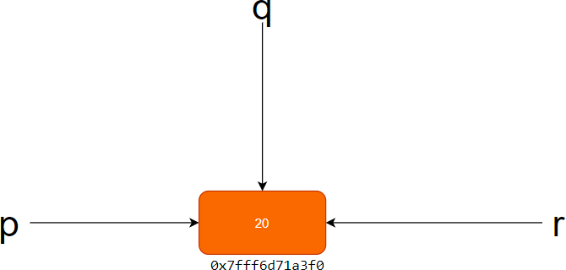

In [146]:

p **=** 20

p **=** p **+** 10 *# Variable Overwriting*

p

Out[146]: 30

### Variable Assigment

In [100]:

intvar **=** 10 *# Integer variable*

floatvar **=** 2.57 *# Float Variable*

strvar **=** "Python Language" *# String variable*

print(intvar)

print(floatvar) print(strvar)

10

2.57

Python Language

### Multiple Assignments

In [102]:

intvar , floatvar , strvar **=** 10,2.57,"Python Language" *# Using commas to separat*

print(intvar)

print(floatvar) print(strvar)

10

2.57

Python Language

In [105]:

p1 **=** p2 **=** p3 **=** p4 **=** 44 *# All variables pointing to same value*

print(p1,p2,p3,p4)

44 44 44 44

# Data Types

## Numeric

In [135]:

val1 **=** 10 *# Integer data type*

print(val1)

print(type(val1)) *# type of object*

print(sys.getsizeof(val1)) *# size of integer object in bytes*

print(val1, " is Integer?", isinstance(val1, int)) *# val1 is an instance of int*

10

<class 'int'> 28

10 is Integer? True

In [126]:

val2 **=** 92.78 *# Float data type*

print(val2)

print(type(val2)) *# type of object*

print(sys.getsizeof(val2)) *# size of float object in bytes*

print(val2, " is float?", isinstance(val2, float)) *# Val2 is an instance of floa*

92.78

<class 'float'> 24

92.78 is float? True

In [136]:

val3 **=** 25 **+** 10j *# Complex data type*

print(val3)

print(type(val3)) *# type of object*

print(sys.getsizeof(val3)) *# size of float object in bytes*

print(val3, " is complex?", isinstance(val3, complex)) *# val3 is an instance of*

(25+10j)

<class 'complex'> 32

(25+10j) is complex? True

In [119]:

sys.getsizeof(int()) *# size of integer object in bytes*

Out[119]: 24

In [120]:

sys.getsizeof(float()) *# size of float object in bytes*

Out[120]: 24

In [138]:

sys.getsizeof(complex()) *# size of complex object in bytes*

Out[138]: 32

## Boolean

Boolean data type can have only two possible values **true** or **false**.

In [139]:

bool1 **= True**

In [140]:

bool2 **= False**

In [143]:

print(type(bool1))

<class 'bool'>

In [144]:

print(type(bool2))

<class 'bool'>

In [148]:

isinstance(bool1, bool)

Out[148]:

True

In [235]:

bool(0)

Out[235]: False

In [236]:

bool(1)

Out[236]:

True

In [237]:

bool(**None**)

Out[237]:

False

In [238]:

bool (**False**)

Out[238]: False

## Strings

### String Creation

In [193]:

str1 **=** "HELLO PYTHON"

print(str1)

HELLO PYTHON

In [194]:

mystr **=** 'Hello World' *# Define string using single quotes*

print(mystr)

Hello World

In [195]:

mystr **=** "Hello World" *# Define string using double quotes*

print(mystr)

Hello World

In [196]:

mystr **=** '''Hello

World ''' *# Define string using triple quotes*

print(mystr)

Hello

World

In [197]:

mystr **=** """Hello

World""" *# Define string using triple quotes*

print(mystr)

Hello

World

In [198]:

mystr **=** ('Happy '

'Monday ' 'Everyone')

print(mystr)

Happy Monday Everyone

In [199]:

mystr2 **=** 'Woohoo ' mystr2 **=** mystr2**\***5 mystr2

Out[199]: 'Woohoo Woohoo Woohoo Woohoo Woohoo '

In [200]:

len(mystr2) *# Length of string*

Out[200]: 35

### String Indexing

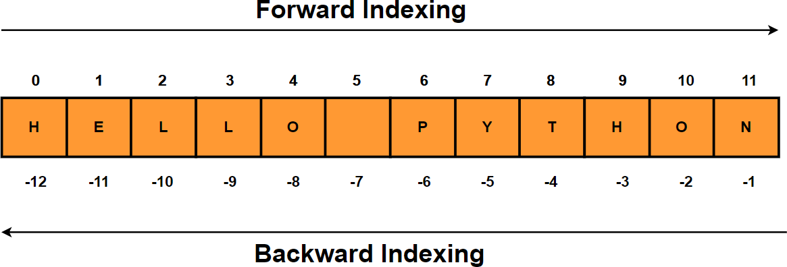

In [201]:

Out[201]:

str1

'HELLO PYTHON'

In [202]:

str1[0] *# First character in string "str1"*

Out[202]: 'H'

In [203]:

str1[len(str1)**-**1] *# Last character in string using len function*

Out[203]:

'N'

In [204]:

str1[**-**1] *# Last character in string*

Out[204]:

'N'

In [205]:

str1[6] *#Fetch 7th element of the string*

Out[205]:

'P'

In [206]:

str1[5]

Out[206]: ' '

### String Slicing

In [207]:

str1[0:5] *# String slicing - Fetch all characters from 0 to 5 index location exc*

Out[207]:

'HELLO'

In [208]:

str1[6:12] *# String slicing - Retreive all characters between 6 - 12 index loc e*

Out[208]:

'PYTHON'

In [209]:

str1[**-**4:] *# Retreive last four characters of the string*

Out[209]:

'THON'

In [210]:

Out[210]:

'PYTHON'

str1[**-**6:] *# Retreive last six characters of the string*

In [211]:

str1[:4] *# Retreive first four characters of the string*

Out[211]:

'HELL'

In [212]:

str1[:6] *# Retreive first six characters of the string*

Out[212]: 'HELLO '

### Update & Delete String

In [213]:

str1

Out[213]:

'HELLO PYTHON'

In [214]:

*#Strings are immutable which means elements of a string cannot be changed once t*

str1[0:5] **=** 'HOLAA'

#### ---------------------------------------------------------------------------

**TypeError** Traceback (most recent call last)

**<ipython-input-214-ea670ff3ec72>** in <module>

#### 1 #Strings are immutable which means elements of a string cannot be chang ed once they have been assigned.

**----> 2** str1**[0:5] = 'HOLAA'**

**TypeError**: 'str' object does not support item assignment

In [215]:

**del** str1 *# Delete a string*

print(srt1)

#### ---------------------------------------------------------------------------

**NameError** Traceback (most recent call last)

**<ipython-input-215-7fcc0cc83dcc>** in <module>

1 **del** str1 **# Delete a string**

**----> 2** print**(**srt1**)**

**NameError**: name 'srt1' is not defined

### String concatenation

In [216]:

*# String concatenation*

s1 **=** "Hello" s2 **=** "Asif" s3 **=** s1 **+** s2 print(s3)

HelloAsif

In [217]:

*# String concatenation*

s1 **=** "Hello" s2 **=** "Asif"

s3 **=** s1 **+** " " **+** s2

print(s3)

Hello Asif

### Iterating through a String

In [218]:

mystr1 **=** "Hello Everyone"

In [219]:

*# Iteration*

**for** i **in** mystr1: print(i)

H

e l l o

E

v e r y o n e

In [220]:

**for** i **in** enumerate(mystr1): print(i)

(0, 'H')

(1, 'e')

(2, 'l')

(3, 'l')

(4, 'o')

(5, ' ')

(6, 'E')

(7, 'v')

(8, 'e')

(9, 'r')

(10, 'y')

(11, 'o')

(12, 'n')

(13, 'e')

In [221]:

list(enumerate(mystr1)) *# Enumerate method adds a counter to an iterable and ret*

|  |  |  |
| --- | --- | --- |
| Out[221]: | [(0, | 'H'), |
|  | (1, | 'e'), |
|  | (2, | 'l'), |
|  | (3, | 'l'), |
|  | (4, | 'o'), |
|  | (5, | ' '), |
|  | (6, | 'E'), |
|  | (7, | 'v'), |
|  | (8, | 'e'), |
|  | (9, | 'r'), |
|  | (10, | 'y'), |
|  | (11, | 'o'), |
|  | (12, | 'n'), |
|  | (13, | 'e')] |

### String Membership

In [222]:

*# String membership*

mystr1 **=** "Hello Everyone"

print ('Hello' **in** mystr1) *# Check whether substring "Hello" is present in string* print ('Everyone' **in** mystr1) *# Check whether substring "Everyone" is present in* print ('Hi' **in** mystr1) *# Check whether substring "Hi" is present in string "mysr*

True True False

### String Partitioning

In [256]:

"""

The partition() method searches for a specified string and splits the string int

* The first element contains the part before the argument string.
* The second element contains the argument string.
* The third element contains the part after the argument string. """

str5 **=** "Natural language processing with Python and R and Java" L **=** str5.partition("and")

print(L)

('Natural language processing with Python ', 'and', ' R and Java')

In [257]:

"""

The rpartition() method searches for the last occurence of the specified string containing three elements.

* The first element contains the part before the argument string.
* The second element contains the argument string.
* The third element contains the part after the argument string. """

str5 **=** "Natural language processing with Python and R and Java" L **=** str5.rpartition("and")

print(L)

('Natural language processing with Python and R ', 'and', ' Java')

### String Functions

In [267]:

mystr2 **=** " Hello Everyone " mystr2

Out[267]: ' Hello Everyone '

In [268]:

mystr2.strip() *# Removes white space from begining & end*

Out[268]:

'Hello Everyone'

In [270]:

mystr2.rstrip() *# Removes all whitespaces at the end of the string*

Out[270]:

' Hello Everyone'

In [269]:

mystr2.lstrip() *# Removes all whitespaces at the begining of the string*

Out[269]:

'Hello Everyone '

In [272]:

mystr2 **=** "*********Hello Everyone***********All the Best**********" mystr2

Out[272]: '*********Hello Everyone***********All the Best**********'

In [273]:

mystr2.strip('*') *# Removes all '*' characters from begining & end of the string*

Out[273]:

'Hello Everyone***********All the Best'

In [274]:

mystr2.rstrip('*') *# Removes all '*' characters at the end of the string*

Out[274]:

'*********Hello Everyone***********All the Best'

In [275]:

mystr2.lstrip('*') *# Removes all '*' characters at the begining of the string*

Out[275]: 'Hello Everyone***********All the Best**********'

In [276]:

mystr2 **=** " Hello Everyone "

In [277]:

mystr2.lower() *# Return whole string in lowercase*

Out[277]:

' hello everyone '

In [278]:

mystr2.upper() *# Return whole string in uppercase*

Out[278]:

' HELLO EVERYONE '

In [279]:

mystr2.replace("He" , "Ho") *#Replace substring "He" with "Ho"*

Out[279]:

' Hollo Everyone '

In [280]:

mystr2.replace(" " , "") *# Remove all whitespaces using replace function*

Out[280]:

'HelloEveryone'

In [281]:

mystr5 **=** "one two Three one two two three"

In [230]:

mystr5.count("one") *# Number of times substring "one" occurred in string.*

Out[230]: 2

In [231]:

mystr5.count("two") *# Number of times substring "two" occurred in string.*

Out[231]: 3

In [232]:

mystr5.startswith("one") *# Return boolean value True if string starts with "one*

Out[232]:

True

In [233]:

mystr5.endswith("three") *# Return boolean value True if string ends with "three"*

Out[233]:

True

In [234]:

mystr4 **=** "one two three four one two two three five five six seven six seven one

In [235]:

mylist **=** mystr4.split() *# Split String into substrings*

mylist

Out[235]: ['one',

'two',

'three',

'four',

'one',

'two',

'two',

'three',

'five',

'five',

'six',

'seven',

'six',

'seven',

'one',

'one',

'one',

'ten',

'eight',

'ten',

'nine',

'eleven',

'ten',

'ten',

'nine']

In [236]:

*# Combining string & numbers using format method*

item1 **=** 40

item2 **=** 55

item3 **=** 77

res **=** "Cost of item1 , item2 and item3 are {} , {} and {}" print(res.format(item1,item2,item3))

Cost of item1 , item2 and item3 are 40 , 55 and 77

In [237]:

*# Combining string & numbers using format method*

item1 **=** 40

item2 **=** 55

item3 **=** 77

res **=** "Cost of item3 , item2 and item1 are {2} , {1} and {0}" print(res.format(item1,item2,item3))

Cost of item3 , item2 and item1 are 77 , 55 and 40

In [238]:

str2 **=** " WELCOME EVERYONE "

str2 **=** str2.center(100) *# center align the string using a specific character as*

print(str2)

WELCOME EVERYONE

In [239]:

str2 **=** " WELCOME EVERYONE "

str2 **=** str2.center(100,'*') *# center align the string using a specific character*

print(str2)

***************************************** WELCOME EVERYONE ********************

*********************

In [240]:

str2 **=** " WELCOME EVERYONE "

str2 **=** str2.rjust(50) *# Right align the string using a specific character as the*

print(str2)

WELCOME EVERYONE

In [241]:

str2 **=** " WELCOME EVERYONE "

str2 **=** str2.rjust(50,'*') *# Right align the string using a specific character ('*

print(str2)

******************************** WELCOME EVERYONE

In [242]:

str4 **=** "one two three four five six seven"

loc **=** str4.find("five") *# Find the location of word 'five' in the string "str4"*

print(loc)

19

In [243]:

str4 **=** "one two three four five six seven"

loc **=** str4.index("five") *# Find the location of word 'five' in the string "str4"*

print(loc)

19

In [244]:

mystr6 **=** '123456789'

print(mystr6.isalpha()) *# returns True if all the characters in the text are let* print(mystr6.isalnum()) *# returns True if a string contains only letters or num* print(mystr6.isdecimal()) *# returns True if all the characters are decimals (0-9* print(mystr6.isnumeric()) *# returns True if all the characters are numeric (0-9)*

False True True True

In [245]:

mystr6 **=** 'abcde'

print(mystr6.isalpha()) *# returns True if all the characters in the text are let* print(mystr6.isalnum()) *# returns True if a string contains only letters or num* print(mystr6.isdecimal()) *# returns True if all the characters are decimals (0-9* print(mystr6.isnumeric()) *# returns True if all the characters are numeric (0-9)*

True True False False

In [246]:

mystr6 **=** 'abc12309'

print(mystr6.isalpha()) *# returns True if all the characters in the text are let* print(mystr6.isalnum()) *# returns True if a string contains only letters or num* print(mystr6.isdecimal()) *# returns True if all the characters are decimals (0-9* print(mystr6.isnumeric()) *# returns True if all the characters are numeric (0-9)*

|  |  |  |  |  |  |  |  |  |  |  |  |  |  |
| --- | --- | --- | --- | --- | --- | --- | --- | --- | --- | --- | --- | --- | --- |
|  | | False  True False False |  | | | | | | | | | | |
| In | [247]: | mystr7 **=** 'ABCDEF'  print(mystr7.isupper()) | *#* | *Returns* | *True* | *if* | *all* | *the* | *characters* | *are* | *in* | *upper* | *case* |
|  |  | print(mystr7.islower()) | *#* | *Returns* | *True* | *if* | *all* | *the* | *characters* | *are* | *in* | *lower* | *case* |
|  |  | True False |  |  |  |  |  |  |  |  |  |  |  |
| In | [248]: | mystr8 **=** 'abcdef'  print(mystr8.isupper()) | *#* | *Returns* | *True* | *if* | *all* | *the* | *characters* | *are* | *in* | *upper* | *case* |
|  |  | print(mystr8.islower()) | *#* | *Returns* | *True* | *if* | *all* | *the* | *characters* | *are* | *in* | *lower* | *case* |
|  |  | False True |  |  |  |  |  |  |  |  |  |  |  |

In [258]:

str6 **=** "one two three four one two two three five five six one ten eight ten nin

loc **=** str6.rfind("one") *# last occurrence of word 'one' in string "str6"*

print(loc)

51

In [259]:

loc **=** str6.rindex("one") *# last occurrence of word 'one' in string "str6"*

print(loc)

51

In [264]:

txt **=** " abc def ghi "

txt.rstrip()

Out[264]: ' abc def ghi'

In [265]:

txt **=** " abc def ghi "

txt.lstrip()

Out[265]: 'abc def ghi '

In [266]:

txt **=** " abc def ghi "

txt.strip()

Out[266]: 'abc def ghi'

### Using Escape Character

In [252]:

*#Using double quotes in the string is not allowed.*

mystr **=** "My favourite TV Series is "Game of Thrones""

#### File "<ipython-input-252-0fa35a74da86>", line 2

**mystr = "My favourite TV Series is "Game of Thrones""**

#### ^

**SyntaxError:** invalid syntax

In [253]:

*#Using escape character to allow illegal characters* mystr **=** "My favourite series is \"Game of Thrones\"" print(mystr)

My favourite series is "Game of Thrones"

# List

1. List is an ordered sequence of items.
2. We can have different data types under a list. E.g we can have integer, float and string items in a same list.

### List Creation

In [423]:

list1 **=** [] *# Empty List*

In [491]:

print(type(list1))

<class 'list'>

In [424]:

list2 **=** [10,30,60] *# List of integers numbers*

In [425]:

list3 **=** [10.77,30.66,60.89] *# List of float numbers*

In [426]:

list4 **=** ['one','two' , "three"] *# List of strings*

In [427]:

list5 **=** ['Asif', 25 ,[50, 100],[150, 90]] *# Nested Lists*

In [428]:

list6 **=** [100, 'Asif', 17.765] *# List of mixed data types*

In [429]:

list7 **=** ['Asif', 25 ,[50, 100],[150, 90] , {'John' , 'David'}]

In [430]:

len(list6) *#Length of list*

Out[430]: 3

### List Indexing

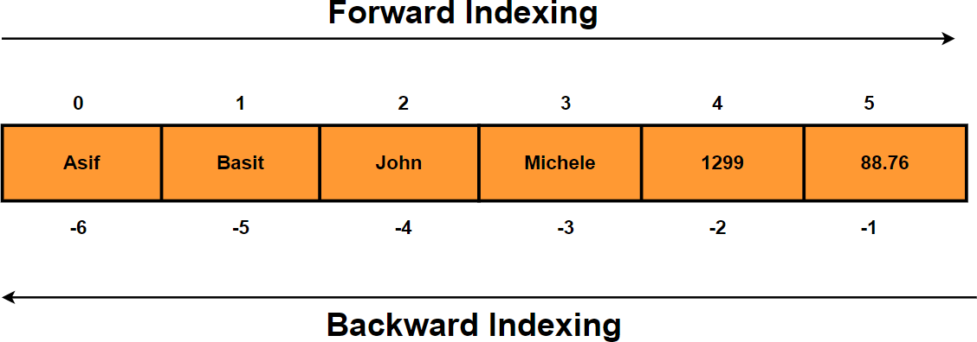

In [432]:

list2[0] *# Retreive first element of the list*

Out[432]: 10

In [433]:

list4[0] *# Retreive first element of the list*

Out[433]:

'one'

In [434]:

list4[0][0] *# Nested indexing - Access the first character of the first list ele*

Out[434]: 'o'

In [435]:

list4[**-**1] *# Last item of the list*

Out[435]:

'three'

In [436]:

list5[**-**1] *# Last item of the list*

Out[436]:

[150, 90]

### List Slicing

In [437]:

mylist **=** ['one' , 'two' , 'three' , 'four' , 'five' , 'six' , 'seven' , 'eight']

In [438]:

mylist[0:3] *# Return all items from 0th to 3rd index location excluding the item*

Out[438]:

['one', 'two', 'three']

In [439]:

mylist[2:5] *# List all items from 2nd to 5th index location excluding the item a*

Out[439]:

['three', 'four', 'five']

In [440]:

mylist[:3] *# Return first three items*

Out[440]:

['one', 'two', 'three']

In [441]:

mylist[:2] *# Return first two items*

Out[441]:

['one', 'two']

In [442]:

mylist[**-**3:] *# Return last three items*

Out[442]:

['six', 'seven', 'eight']

In [443]:

mylist[**-**2:] *# Return last two items*

Out[443]:

['seven', 'eight']

In [444]:

mylist[**-**1] *# Return last item of the list*

Out[444]:

'eight'

In [445]:

mylist[:] *# Return whole list*

Out[445]: ['one', 'two', 'three', 'four', 'five', 'six', 'seven', 'eight']

### Add , Remove & Change Items

In [446]:

mylist

Out[446]:

['one', 'two', 'three', 'four', 'five', 'six', 'seven', 'eight']

In [447]:

mylist.append('nine') *# Add an item to the end of the list*

mylist

Out[447]: ['one', 'two', 'three', 'four', 'five', 'six', 'seven', 'eight', 'nine']

In [448]:

mylist.insert(9,'ten') *# Add item at index location 9*

mylist

Out[448]: ['one', 'two', 'three', 'four', 'five', 'six', 'seven', 'eight', 'nine', 'ten']

In [449]:

mylist.insert(1,'ONE') *# Add item at index location 1*

mylist

Out[449]: ['one',

'ONE',

'two',

'three',

'four',

'five',

'six',

'seven',

'eight',

'nine',

'ten']

In [450]:

mylist.remove('ONE') *# Remove item "ONE"*

mylist

Out[450]: ['one', 'two', 'three', 'four', 'five', 'six', 'seven', 'eight', 'nine', 'ten']

In [451]:

mylist.pop() *# Remove last item of the list*

mylist

Out[451]: ['one', 'two', 'three', 'four', 'five', 'six', 'seven', 'eight', 'nine']

In [452]:

mylist.pop(8) *# Remove item at index location 8*

mylist

Out[452]: ['one', 'two', 'three', 'four', 'five', 'six', 'seven', 'eight']

In [453]:

**del** mylist[7] *# Remove item at index location 7*

mylist

Out[453]: ['one', 'two', 'three', 'four', 'five', 'six', 'seven']

In [454]:

*# Change value of the string*

|  |  |  |
| --- | --- | --- |
| mylist[0] | **=** | 1 |
| mylist[1] | **=** | 2 |
| mylist[2] | **=** | 3 |
| mylist |  |  |

Out[454]: [1, 2, 3, 'four', 'five', 'six', 'seven']

In [455]:

mylist.clear() *# Empty List / Delete all items in the list*

mylist

Out[455]: []

In [456]:

**del** mylist *# Delete the whole list*

mylist

#### ---------------------------------------------------------------------------

**NameError** Traceback (most recent call last)

**<ipython-input-456-50c7849aa2cb>** in <module>

1 **del** mylist **# Delete the whole list**

**----> 2** mylist

**NameError**: name 'mylist' is not defined

### Copy List

In [457]:

mylist **=** ['one', 'two', 'three', 'four', 'five', 'six', 'seven', 'eight', 'nine'

In [458]:

mylist1 **=** mylist *# Create a new reference "mylist1"*

In [459]:

id(mylist) , id(mylist1) *# The address of both mylist & mylist1 will be the same*

Out[459]: (1537348392776, 1537348392776)

In [460]:

mylist2 **=** mylist.copy() *# Create a copy of the list*

In [461]:

id(mylist2) *# The address of mylist2 will be different from mylist because mylis*

Out[461]:

1537345955016

In [462]:

mylist[0] **=** 1

In [463]:

mylist

Out[463]: [1, 'two', 'three', 'four', 'five', 'six', 'seven', 'eight', 'nine', 'ten']

In [464]:

mylist1 *# mylist1 will be also impacted as it is pointing to the same list*

Out[464]:

[1, 'two', 'three', 'four', 'five', 'six', 'seven', 'eight', 'nine', 'ten']

In [465]:

mylist2 *# Copy of list won't be impacted due to changes made on the original lis*

Out[465]:

['one', 'two', 'three', 'four', 'five', 'six', 'seven', 'eight', 'nine', 'ten']

### Join Lists

In [466]:

list1 **=** ['one', 'two', 'three', 'four']

list2 **=** ['five', 'six', 'seven', 'eight']

In [467]:

list3 **=** list1 **+** list2 *# Join two lists by '+' operator*

list3

Out[467]: ['one', 'two', 'three', 'four', 'five', 'six', 'seven', 'eight']

In [468]:

list1.extend(list2) *#Append list2 with list1*

list1

Out[468]: ['one', 'two', 'three', 'four', 'five', 'six', 'seven', 'eight']

### List Membership

In [469]:

list1

Out[469]:

['one', 'two', 'three', 'four', 'five', 'six', 'seven', 'eight']

In [470]:

'one' **in** list1 *# Check if 'one' exist in the list*

Out[470]: True

In [471]:

'ten' **in** list1 *# Check if 'ten' exist in the list*

Out[471]:

False

In [472]:

**if** 'three' **in** list1: *# Check if 'three' exist in the list*

print('Three is present in the list')

**else**:

print('Three is not present in the list')

Three is present in the list

In [473]:

**if** 'eleven' **in** list1: *# Check if 'eleven' exist in the list*

print('eleven is present in the list')

**else**:

print('eleven is not present in the list')

eleven is not present in the list

### Reverse & Sort List

In [474]:

list1

Out[474]:

['one', 'two', 'three', 'four', 'five', 'six', 'seven', 'eight']

In [475]:

list1.reverse() *# Reverse the list*

list1

Out[475]: ['eight', 'seven', 'six', 'five', 'four', 'three', 'two', 'one']

In [476]:

list1 **=** list1[::**-**1] *# Reverse the list*

list1

Out[476]: ['one', 'two', 'three', 'four', 'five', 'six', 'seven', 'eight']

In [477]:

mylist3 **=** [9,5,2,99,12,88,34]

mylist3.sort() *# Sort list in ascending order*

mylist3

Out[477]: [2, 5, 9, 12, 34, 88, 99]

In [478]:

mylist3 **=** [9,5,2,99,12,88,34]

mylist3.sort(reverse**=True**) *# Sort list in descending order*

mylist3

Out[478]: [99, 88, 34, 12, 9, 5, 2]

In [584]:

mylist4 **=** [88,65,33,21,11,98]

sorted(mylist4)

*# Returns a new sorted list and doesn't change original l*

Out[584]: [11, 21, 33, 65, 88, 98]

In [585]:

mylist4

Out[585]:

[88, 65, 33, 21, 11, 98]

### Loop through a list

In [481]:

list1

Out[481]:

['one', 'two', 'three', 'four', 'five', 'six', 'seven', 'eight']

In [482]:

**for** i **in** list1: print(i)

one two

three four five six

seven eight

In [483]:

**for** i **in** enumerate(list1): print(i)

(0, 'one')

(1, 'two')

(2, 'three')

(3, 'four')

(4, 'five')

(5, 'six')

(6, 'seven')

(7, 'eight')

### Count

In [485]:

list10 **=**['one', 'two', 'three', 'four', 'one', 'one', 'two', 'three']

In [486]:

list10.count('one') *# Number of times item "one" occurred in the list.*

Out[486]: 3

In [487]:

list10.count('two') *# Occurence of item 'two' in the list*

Out[487]: 2

In [489]:

list10.count('four') *#Occurence of item 'four' in the list*

Out[489]: 1

### All / Any

The **all()** method returns:

**True** - If all elements in a list are true

**False** - If any element in a list is false

The **any()** function returns True if any element in the list is True. If not, any() returns False.

In [816]:

L1 **=** [1,2,3,4,0]

In [817]:

all(L1) *# Will Return false as one value is false (Value 0)*

Out[817]:

False

In [818]:

any(L1) *# Will Return True as we have items in the list with True value*

Out[818]:

True

In [819]:

L2 **=** [1,2,3,4,**True**,**False**]

In [820]:

all(L2) *# Returns false as one value is false*

Out[820]:

False

In [821]:

any(L2) *# Will Return True as we have items in the list with True value*

Out[821]:

True

In [822]:

L3 **=** [1,2,3,**True**]

In [823]:

all(L3) *# Will return True as all items in the list are True*

Out[823]:

True

In [824]:

Out[824]:

True

any(L3) *# Will Return True as we have items in the list with True value*

### List Comprehensions

List Comprehensions provide an elegant way to create new lists.

It consists of brackets containing an expression followed by a for clause, then zero or more for or if clauses.

In [287]:

mystring **=** "WELCOME"

mylist **=** [ i **for** i **in** mystring ] *# Iterating through a string Using List Compreh*

mylist

Out[287]: ['W', 'E', 'L', 'C', 'O', 'M', 'E']

In [289]:

mylist1 **=** [ i **for** i **in** range(40) **if** i **%** 2 **==** 0] *# Display all even numbers betwe*

mylist1

Out[289]: [0, 2, 4, 6, 8, 10, 12, 14, 16, 18, 20, 22, 24, 26, 28, 30, 32, 34, 36, 38]

In [290]:

mylist2 **=** [ i **for** i **in** range(40) **if** i **%** 2 **==** 1] *# Display all odd numbers betwee*

mylist2

Out[290]: [1, 3, 5, 7, 9, 11, 13, 15, 17, 19, 21, 23, 25, 27, 29, 31, 33, 35, 37, 39]

In [325]:

mylist3 **=** [num**\*\***2 **for** num **in** range(10)] *# calculate square of all numbers betwee*

mylist3

Out[325]: [0, 1, 4, 9, 16, 25, 36, 49, 64, 81]

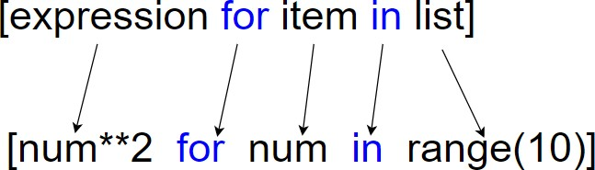

In [317]:

*# Multiple whole list by 10*

list1 **=** [2,3,4,5,6,7,8]

list1 **=** [i**\***10 **for** i **in** list1] list1

Out[317]: [20, 30, 40, 50, 60, 70, 80]

In [299]:

*#List all numbers divisible by 3 , 9 & 12 using nested "if" with List Comprehens*

mylist4 **=** [i **for** i **in** range(200) **if** i **%** 3 **==** 0 **if** i **%** 9 **==** 0 **if** i **%** 12 **==** 0] mylist4

Out[299]: [0, 36, 72, 108, 144, 180]

In [309]:

*# Odd even test*

l1 **=** [print("{} is Even Number".format(i)) **if** i**%**2**==**0 **else** print("{} is odd numbe

1. is Even Number
2. is odd number
3. is Even Number
4. is odd number
5. is Even Number
6. is odd number
7. is Even Number
8. is odd number
9. is Even Number
10. is odd number

In [315]:

*# Extract numbers from a string*

mystr **=** "One 1 two 2 three 3 four 4 five 5 six 6789" numbers **=** [i **for** i **in** mystr **if** i.isdigit()]

numbers

Out[315]: ['1', '2', '3', '4', '5', '6', '7', '8', '9']

In [316]:

*# Extract letters from a string*

mystr **=** "One 1 two 2 three 3 four 4 five 5 six 6789" numbers **=** [i **for** i **in** mystr **if** i.isalpha()]

numbers

Out[316]: ['O',

'n',

'e',

't',

'w',

'o',

't',

'h',

'r',

'e',

'e',

'f',

'o',

'u',

'r',

'f',

'i',

'v',

'e',

's',

'i',

'x']

# Tuples

* 1. Tuple is similar to List except that the objects in tuple are immutable which means we cannot change the elements of a tuple once assigned.
  2. When we do not want to change the data over time, tuple is a preferred data type.
  3. Iterating over the elements of a tuple is faster compared to iterating over a list.

### Tuple Creation

In [533]:

tup1 **=** () *# Empty tuple*

In [534]:

tup2 **=** (10,30,60) *# tuple of integers numbers*

In [535]:

tup3 **=** (10.77,30.66,60.89) *# tuple of float numbers*

In [536]:

tup4 **=** ('one','two' , "three") *# tuple of strings*

In [537]:

tup5 **=** ('Asif', 25 ,(50, 100),(150, 90)) *# Nested tuples*

In [538]:

tup6 **=** (100, 'Asif', 17.765) *# Tuple of mixed data types*

In [539]:

tup7 **=** ('Asif', 25 ,[50, 100],[150, 90] , {'John' , 'David'} , (99,22,33))

In [540]:

len(tup7) *#Length of list*

Out[540]: 6

### Tuple Indexing

In [541]:

tup2[0] *# Retreive first element of the tuple*

Out[541]: 10

In [542]:

tup4[0] *# Retreive first element of the tuple*

Out[542]:

'one'

In [543]:

tup4[0][0] *# Nested indexing - Access the first character of the first tuple ele*

Out[543]:

'o'

In [544]:

tup4[**-**1] *# Last item of the tuple*

Out[544]: 'three'

In [545]:

Out[545]:

(150, 90)

tup5[**-**1] *# Last item of the tuple*

### Tuple Slicing

In [560]:

mytuple **=** ('one' , 'two' , 'three' , 'four' , 'five' , 'six' , 'seven' , 'eight'

In [547]:

mytuple[0:3] *# Return all items from 0th to 3rd index location excluding the ite*

Out[547]:

('one', 'two', 'three')

In [548]:

mytuple[2:5] *# List all items from 2nd to 5th index location excluding the item*

Out[548]:

('three', 'four', 'five')

In [549]:

mytuple[:3] *# Return first three items*

Out[549]:

('one', 'two', 'three')

In [550]:

mytuple[:2] *# Return first two items*

Out[550]:

('one', 'two')

In [551]:

mytuple[**-**3:] *# Return last three items*

Out[551]:

('six', 'seven', 'eight')

In [552]:

mytuple[**-**2:] *# Return last two items*

Out[552]:

('seven', 'eight')

In [553]:

mytuple[**-**1] *# Return last item of the tuple*

Out[553]: 'eight'

In [554]:

mytuple[:] *# Return whole tuple*

Out[554]:

('one', 'two', 'three', 'four', 'five', 'six', 'seven', 'eight')

### Remove & Change Items

In [555]:

mytuple

Out[555]:

('one', 'two', 'three', 'four', 'five', 'six', 'seven', 'eight')

In [556]:

**del** mytuple[0] *# Tuples are immutable which means we can't DELETE tuple items*

#### ---------------------------------------------------------------------------

**TypeError** Traceback (most recent call last)

**<ipython-input-556-667a276aa503>** in <module>

**----> 1 del** mytuple**[0]**

**TypeError**: 'tuple' object doesn't support item deletion

In [557]:

mytuple[0] **=** 1 *# Tuples are immutable which means we can't CHANGE tuple items*

#### ---------------------------------------------------------------------------

**TypeError** Traceback (most recent call last)

**<ipython-input-557-4cf492702bfd>** in <module>

**----> 1** mytuple**[0] = 1**

**TypeError**: 'tuple' object does not support item assignment

In [561]:

**del** mytuple *# Deleting entire tuple object is possible*

### Loop through a tuple

In [570]:

mytuple

Out[570]:

('one', 'two', 'three', 'four', 'five', 'six', 'seven', 'eight')

In [571]:

**for** i **in** mytuple: print(i)

one two

three four five six

seven eight

In [572]:

**for** i **in** enumerate(mytuple): print(i)

(0, 'one')

(1, 'two')

(2, 'three')

(3, 'four')

(4, 'five')

(5, 'six')

(6, 'seven')

(7, 'eight')

### Count

In [573]:

mytuple1 **=**('one', 'two', 'three', 'four', 'one', 'one', 'two', 'three')

In [574]:

mytuple1.count('one') *# Number of times item "one" occurred in the tuple.*

Out[574]: 3

In [575]:

mytuple1.count('two') *# Occurence of item 'two' in the tuple*

Out[575]: 2

In [576]:

mytuple1.count('four') *#Occurence of item 'four' in the tuple*

Out[576]: 1

### Tuple Membership

In [577]:

mytuple

Out[577]:

('one', 'two', 'three', 'four', 'five', 'six', 'seven', 'eight')

In [578]:

'one' **in** mytuple *# Check if 'one' exist in the list*

Out[578]:

True

In [579]:

'ten' **in** mytuple *# Check if 'ten' exist in the list*

Out[579]:

False

In [581]:

**if** 'three' **in** mytuple: *# Check if 'three' exist in the list*

print('Three is present in the tuple')

**else**:

print('Three is not present in the tuple')

Three is present in the tuple

In [583]:

**if** 'eleven' **in** mytuple: *# Check if 'eleven' exist in the list*

print('eleven is present in the tuple')

**else**:

print('eleven is not present in the tuple')

eleven is not present in the tuple

### Index Position

In [586]:

mytuple

Out[586]:

('one', 'two', 'three', 'four', 'five', 'six', 'seven', 'eight')

In [587]:

mytuple.index('one') *# Index of first element equal to 'one'*

Out[587]: 0

In [590]:

mytuple.index('five') *# Index of first element equal to 'five'*

Out[590]: 4

In [591]:

mytuple1

Out[591]: ('one', 'two', 'three', 'four', 'one', 'one', 'two', 'three')

In [593]:

mytuple1.index('one') *# Index of first element equal to 'one'*

Out[593]: 0

### Sorting

In [594]:

mytuple2 **=** (43,67,99,12,6,90,67)

In [595]:

sorted(mytuple2) *# Returns a new sorted list and doesn't change original tuple*

Out[595]:

[6, 12, 43, 67, 67, 90, 99]

In [596]:

sorted(mytuple2, reverse**=True**) *# Sort in descending order*

Out[596]:

[99, 90, 67, 67, 43, 12, 6]

# Sets

1. Unordered & Unindexed collection of items.
2. Set elements are unique. Duplicate elements are not allowed.
3. Set elements are immutable (cannot be changed).
4. Set itself is mutable. We can add or remove items from it.

### Set Creation

In [634]:

myset **=** {1,2,3,4,5} *# Set of numbers*

myset

Out[634]: {1, 2, 3, 4, 5}

In [635]:

len(myset) *#Length of the set*

Out[635]: 5

In [636]:

my_set **=** {1,1,2,2,3,4,5,5}

my_set *# Duplicate elements are not allowed.*

Out[636]: {1, 2, 3, 4, 5}

In [637]:

myset1 **=** {1.79,2.08,3.99,4.56,5.45} *# Set of float numbers*

myset1

Out[637]: {1.79, 2.08, 3.99, 4.56, 5.45}

In [638]:

myset2 **=** {'Asif' , 'John' , 'Tyrion'} *# Set of Strings*

myset2

Out[638]: {'Asif', 'John', 'Tyrion'}

In [639]:

myset3 **=** {10,20, "Hola", (11, 22, 32)} *# Mixed datatypes*

myset3

Out[639]: {(11, 22, 32), 10, 20, 'Hola'}

In [640]:

myset3 **=** {10,20, "Hola", [11, 22, 32]} *# set doesn't allow mutable items like li*

myset3

#### ---------------------------------------------------------------------------

**TypeError** Traceback (most recent call last)

**<ipython-input-640-d23fdc3a319e>** in <module>

#### ----> 1 myset3 = {10,20, "Hola", [11, 22, 32]} # set doesn't allow mutable item s like lists

2 myset3

**TypeError**: unhashable type: 'list'

In [641]:

myset4 **=** set() *# Create an empty set*

print(type(myset4))

<class 'set'>

In [673]:

my_set1 **=** set(('one' , 'two' , 'three' , 'four')) my_set1

Out[673]: {'four', 'one', 'three', 'two'}

### Loop through a Set

In [776]:

myset **=** {'one', 'two', 'three', 'four', 'five', 'six', 'seven', 'eight'}

**for** i **in** myset: print(i)

eight one

seven three five two

six four

In [777]:

**for** i **in** enumerate(myset): print(i)

(0, 'eight')

(1, 'one')

(2, 'seven')

(3, 'three')

(4, 'five')

(5, 'two')

(6, 'six')

(7, 'four')

### Set Membership

In [675]:

myset

Out[675]: {'eight', 'five', 'four', 'one', 'seven', 'six', 'three', 'two'}

In [676]:

'one' **in** myset *# Check if 'one' exist in the set*

Out[676]:

True

In [677]:

'ten' **in** myset *# Check if 'ten' exist in the set*

Out[677]:

False

In [678]:

**if** 'three' **in** myset: *# Check if 'three' exist in the set*

print('Three is present in the set')

**else**:

print('Three is not present in the set')

Three is present in the set

In [679]:

**if** 'eleven' **in** myset: *# Check if 'eleven' exist in the list*

print('eleven is present in the set')

**else**:

print('eleven is not present in the set')

eleven is not present in the set

### Add & Remove Items

In [680]:

myset

Out[680]:

{'eight', 'five', 'four', 'one', 'seven', 'six', 'three', 'two'}

In [681]:

myset.add('NINE') *# Add item to a set using add() method*

myset

Out[681]: {'NINE', 'eight', 'five', 'four', 'one', 'seven', 'six', 'three', 'two'}

In [683]:

myset.update(['TEN' , 'ELEVEN' , 'TWELVE']) *# Add multiple item to a set using*

myset

Out[683]: {'ELEVEN',

'NINE',

'TEN',

'TWELVE',

'eight',

'five',

'four',

'one',

'seven',

'six',

'three',

'two'}

In [684]:

myset.remove('NINE') *# remove item in a set using remove() method*

myset

Out[684]: {'ELEVEN',

'TEN',

'TWELVE',

'eight',

'five',

'four',

'one',

'seven',

'six',

'three',

'two'}

In [685]:

myset.discard('TEN') *# remove item from a set using discard() method*

myset

Out[685]: {'ELEVEN',

'TWELVE',

'eight',

'five',

'four',

'one',

'seven',

'six',

'three',

'two'}

In [688]:

myset.clear() *# Delete all items in a set*

myset

Out[688]: set()

In [689]:

**del** myset *# Delete the set object*

myset

#### ---------------------------------------------------------------------------

**NameError** Traceback (most recent call last)

**<ipython-input-689-0912ea1b8932>** in <module>

1 **del** myset

**----> 2** myset

**NameError**: name 'myset' is not defined

### Copy Set

In [705]:

myset **=** {'one', 'two', 'three', 'four', 'five', 'six', 'seven', 'eight'} myset

Out[705]: {'eight', 'five', 'four', 'one', 'seven', 'six', 'three', 'two'}

In [706]:

myset1 **=** myset *# Create a new reference "myset1"*

myset1

Out[706]: {'eight', 'five', 'four', 'one', 'seven', 'six', 'three', 'two'}

In [707]:

id(myset) , id(myset1) *# The address of both myset & myset1 will be the same as*

Out[707]:

(1537349033320, 1537349033320)

In [708]:

my_set **=** myset.copy() *# Create a copy of the list*

my_set

Out[708]: {'eight', 'five', 'four', 'one', 'seven', 'six', 'three', 'two'}

In [710]:

id(my_set) *# The address of my_set will be different from myset because my_set i*

Out[710]: 1537352902024

In [711]:

myset.add('nine') myset

Out[711]: {'eight', 'five', 'four', 'nine', 'one', 'seven', 'six', 'three', 'two'}

In [712]:

myset1 *# myset1 will be also impacted as it is pointing to the same Set*

Out[712]:

{'eight', 'five', 'four', 'nine', 'one', 'seven', 'six', 'three', 'two'}

In [713]:

my_set *# Copy of the set won't be impacted due to changes made on the original S*

Out[713]: {'eight', 'five', 'four', 'one', 'seven', 'six', 'three', 'two'}

### Set Operation

#### Union

In [757]:

A **=** {1,2,3,4,5}

B **=** {4,5,6,7,8}

C **=** {8,9,10}

In [758]:

A **|** B *# Union of A and B (All elements from both sets. NO DUPLICATES)*

Out[758]:

{1, 2, 3, 4, 5, 6, 7, 8}

In [759]:

A.union(B) *# Union of A and B*

Out[759]:

{1, 2, 3, 4, 5, 6, 7, 8}

In [760]:

A.union(B, C) *# Union of A, B and C.*

Out[760]:

{1, 2, 3, 4, 5, 6, 7, 8, 9, 10}

In [761]:

"""

Updates the set calling the update() method with union of A , B & C.

For below example Set A will be updated with union of A,B & C. """

A.update(B,C) A

Out[761]: {1, 2, 3, 4, 5, 6, 7, 8, 9, 10}

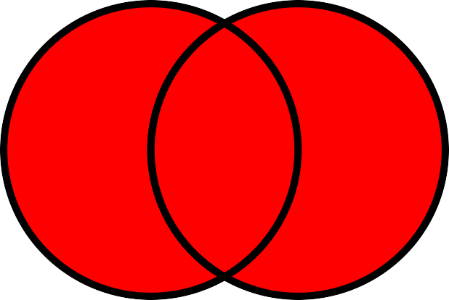

#### Intersection

In [762]:

A **=** {1,2,3,4,5}

B **=** {4,5,6,7,8}

In [763]:

Out[763]:

{4, 5}

A **&** B *# Intersection of A and B (Common items in both sets)*

In [764]:

A.intersection(B) Intersection of A **and** B

#### File "<ipython-input-764-f01b60f4d31d>", line 1 A.intersection(B) Intersection of A and B

**^**

**SyntaxError:** invalid syntax

In [765]:

"""

Updates the set calling the intersection_update() method with the intersection o

For below example Set A will be updated with the intersection of A & B. """

A.intersection_update(B) A

Out[765]: {4, 5}

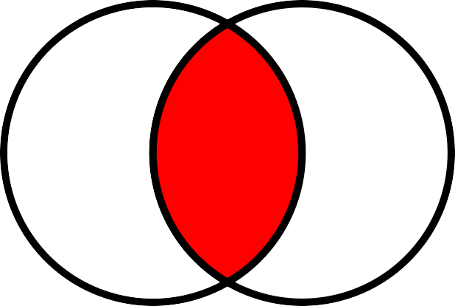

#### Difference

In [766]:

A **=** {1,2,3,4,5}

B **=** {4,5,6,7,8}

In [767]:

A **-** B *# set of elements that are only in A but not in B*

Out[767]: {1, 2, 3}

In [768]:

A.difference(B) *# Difference of sets*

Out[768]:

{1, 2, 3}

In [769]:

Out[769]:

{6, 7, 8}

B**-** A *# set of elements that are only in B but not in A*

In [770]:

B.difference(A)

Out[770]:

{6, 7, 8}

In [771]:

"""

Updates the set calling the difference_update() method with the difference of se

For below example Set B will be updated with the difference of B & A. """

B.difference_update(A) B

Out[771]: {6, 7, 8}

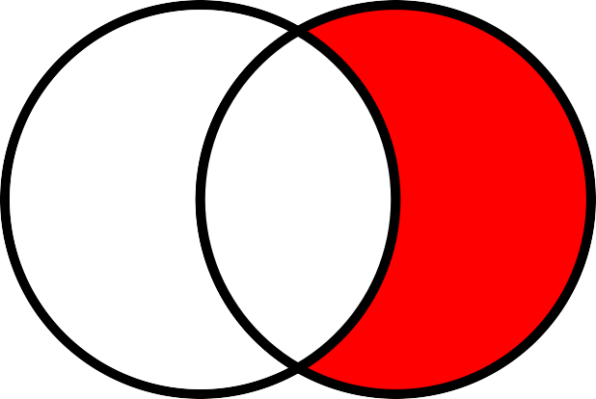

#### Symmetric Difference

In [772]:

A **=** {1,2,3,4,5}

B **=** {4,5,6,7,8}

In [773]:

A **^** B *# Symmetric difference (Set of elements in A and B but not in both. "EXCLU*

Out[773]:

{1, 2, 3, 6, 7, 8}

In [774]:

A.symmetric_difference(B) *# Symmetric difference of sets*

Out[774]:

{1, 2, 3, 6, 7, 8}

In [775]:

"""

Updates the set calling the symmetric_difference_update() method with the symmet

For below example Set A will be updated with the symmetric difference of A & B. """

A.symmetric_difference_update(B) A

Out[775]: {1, 2, 3, 6, 7, 8}

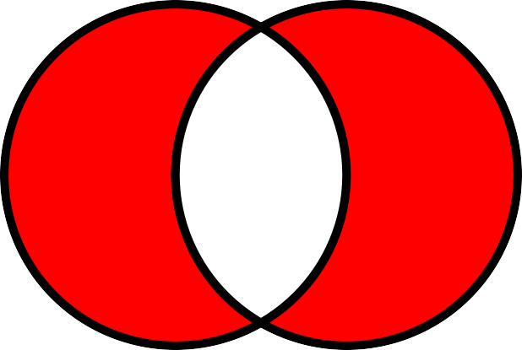

### Subset , Superset & Disjoint

In [784]:

A **=** {1,2,3,4,5,6,7,8,9}

B **=** {3,4,5,6,7,8}

C **=** {10,20,30,40}

In [785]:

B.issubset(A) *# Set B is said to be the subset of set A if all elements of B are*

Out[785]:

True

In [786]:

A.issuperset(B) *# Set A is said to be the superset of set B if all elements of B*

Out[786]:

True

In [787]:

C.isdisjoint(A) *# Two sets are said to be disjoint sets if they have no common e*

Out[787]: True

In [788]:

B.isdisjoint(A) *# Two sets are said to be disjoint sets if they have no common e*

Out[788]:

False

### Other Builtin functions

In [789]:

Out[789]:

{1, 2, 3, 4, 5, 6, 7, 8, 9}

A

In [790]:

sum(A)

Out[790]: 45

In [791]:

max(A)

Out[791]: 9

In [792]:

min(A)

Out[792]: 1

In [793]:

len(A)

Out[793]: 9

In [795]:

list(enumerate(A))

Out[795]:

[(0, 1), (1, 2), (2, 3), (3, 4), (4, 5), (5, 6), (6, 7), (7, 8), (8, 9)]

In [798]:

D**=** sorted(A,reverse**=True**) D

Out[798]: [9, 8, 7, 6, 5, 4, 3, 2, 1]

In [799]:

sorted(D)

Out[799]:

[1, 2, 3, 4, 5, 6, 7, 8, 9]

# Dictionary

Dictionary is a mutable data type in Python.

A python dictionary is a collection of key and value pairs separated by a colon (:) & enclosed in curly braces {}.

Keys must be unique in a dictionary, duplicate values are allowed.

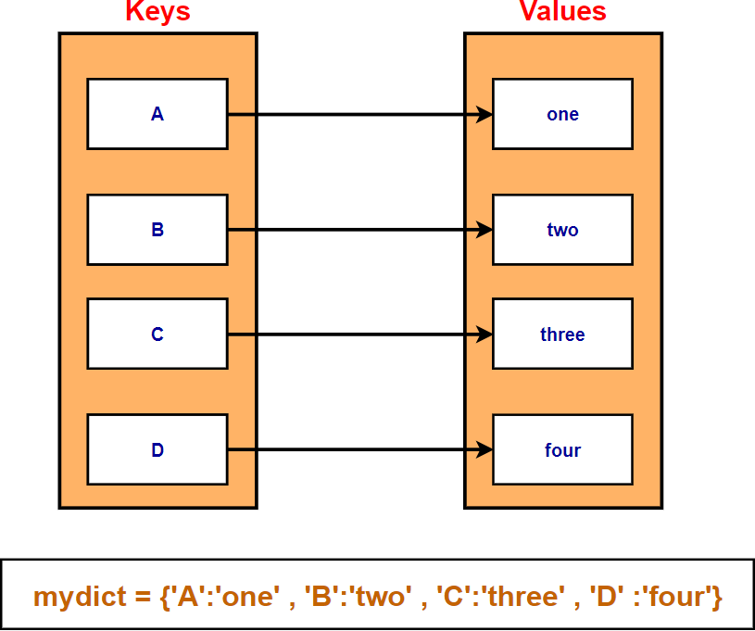

### Create Dictionary

In [947]:

mydict **=** dict() *# empty dictionary*

mydict

Out[947]: {}

In [948]:

mydict **=** {} *# empty dictionary*

mydict

Out[948]: {}

In [949]:

mydict **=** {1:'one' , 2:'two' , 3:'three'} *# dictionary with integer keys*

mydict

Out[949]: {1: 'one', 2: 'two', 3: 'three'}

In [950]:

mydict **=** dict({1:'one' , 2:'two' , 3:'three'}) *# Create dictionary using dict()*

mydict

Out[950]: {1: 'one', 2: 'two', 3: 'three'}

In [951]:

mydict **=** {'A':'one' , 'B':'two' , 'C':'three'} *# dictionary with character keys*

mydict

Out[951]: {'A': 'one', 'B': 'two', 'C': 'three'}

In [318]:

mydict **=** {1:'one' , 'A':'two' , 3:'three'} *# dictionary with mixed keys*

mydict

Out[318]: {1: 'one', 'A': 'two', 3: 'three'}

In [319]:

mydict.keys() *# Return Dictionary Keys using keys() method*

Out[319]:

dict_keys([1, 'A', 3])

In [320]:

mydict.values() *# Return Dictionary Values using values() method*

Out[320]:

dict_values(['one', 'two', 'three'])

In [321]:

mydict.items() *# Access each key-value pair within a dictionary*

Out[321]:

dict_items([(1, 'one'), ('A', 'two'), (3, 'three')])

In [955]:

mydict **=** {1:'one' , 2:'two' , 'A':['asif' , 'john' , 'Maria']} *# dictionary with*

mydict

Out[955]: {1: 'one', 2: 'two', 'A': ['asif', 'john', 'Maria']}

In [956]:

mydict **=** {1:'one' , 2:'two' , 'A':['asif' , 'john' , 'Maria'], 'B':('Bat' , 'ca mydict

Out[956]: {1: 'one',

2: 'two',

'A': ['asif', 'john', 'Maria'],

'B': ('Bat', 'cat', 'hat')}

In [1]:

mydict **=** {1:'one' , 2:'two' , 'A':{'Name':'asif' , 'Age' :20}, 'B':('Bat' , 'ca mydict

Out[1]: {1: 'one',

2: 'two',

'A': {'Name': 'asif', 'Age': 20},

'B': ('Bat', 'cat', 'hat')}

In [957]:

keys **=** {'a' , 'b' , 'c' , 'd'}

mydict3 **=** dict.fromkeys(keys) *# Create a dictionary from a sequence of keys*

mydict3

Out[957]: {'c': None, 'd': None, 'a': None, 'b': None}

In [958]:

keys **=** {'a' , 'b' , 'c' , 'd'} value **=** 10

mydict3 **=** dict.fromkeys(keys , value) *# Create a dictionary from a sequence of*

mydict3

Out[958]: {'c': 10, 'd': 10, 'a': 10, 'b': 10}

In [959]:

keys **=** {'a' , 'b' , 'c' , 'd'} value **=** [10,20,30]

mydict3 **=** dict.fromkeys(keys , value) *# Create a dictionary from a sequence of*

mydict3

Out[959]: {'c': [10, 20, 30], 'd': [10, 20, 30], 'a': [10, 20, 30], 'b': [10, 20, 30]}

In [960]:

value.append(40) mydict3

|  |  |  |  |  |  |
| --- | --- | --- | --- | --- | --- |
| Out[960]: | {'c': | [10, | 20, | 30, | 40], |
|  | 'd': | [10, | 20, | 30, | 40], |
|  | 'a': | [10, | 20, | 30, | 40], |
|  | 'b': | [10, | 20, | 30, | 40]} |

### Accessing Items

In [961]:

mydict **=** {1:'one' , 2:'two' , 3:'three' , 4:'four'} mydict

Out[961]: {1: 'one', 2: 'two', 3: 'three', 4: 'four'}

In [962]:

mydict[1] *# Access item using key*

Out[962]:

'one'

In [963]:

mydict.get(1) *# Access item using get() method*

Out[963]:

'one'

In [964]:

mydict1 **=** {'Name':'Asif' , 'ID': 74123 , 'DOB': 1991 , 'job' :'Analyst'} mydict1

Out[964]: {'Name': 'Asif', 'ID': 74123, 'DOB': 1991, 'job': 'Analyst'}

In [965]:

mydict1['Name'] *# Access item using key*

Out[965]:

'Asif'

In [966]:

mydict1.get('job') *# Access item using get() method*

Out[966]:

'Analyst'

### Add, Remove & Change Items

In [967]:

mydict1 **=** {'Name':'Asif' , 'ID': 12345 , 'DOB': 1991 , 'Address' : 'Hilsinki'} mydict1

Out[967]: {'Name': 'Asif', 'ID': 12345, 'DOB': 1991, 'Address': 'Hilsinki'}

In [968]:

mydict1['DOB'] **=** 1992 *# Changing Dictionary Items*

mydict1['Address'] **=** 'Delhi' mydict1

Out[968]: {'Name': 'Asif', 'ID': 12345, 'DOB': 1992, 'Address': 'Delhi'}

In [969]:

dict1 **=** {'DOB':1995}

mydict1.update(dict1) mydict1

Out[969]: {'Name': 'Asif', 'ID': 12345, 'DOB': 1995, 'Address': 'Delhi'}

In [970]:

mydict1['Job'] **=** 'Analyst' *# Adding items in the dictionary*

mydict1

Out[970]: {'Name': 'Asif',

'ID': 12345,

'DOB': 1995,

'Address': 'Delhi',

'Job': 'Analyst'}

In [971]:

mydict1.pop('Job') *# Removing items in the dictionary using Pop method*

mydict1

Out[971]: {'Name': 'Asif', 'ID': 12345, 'DOB': 1995, 'Address': 'Delhi'}

In [972]:

mydict1.popitem() *# A random item is removed*

Out[972]:

('Address', 'Delhi')

In [973]:

mydict1

Out[973]:

{'Name': 'Asif', 'ID': 12345, 'DOB': 1995}

In [974]:

**del**[mydict1['ID']] *# Removing item using del method*

mydict1

Out[974]: {'Name': 'Asif', 'DOB': 1995}

In [975]:

mydict1.clear() *# Delete all items of the dictionary using clear method*

mydict1

Out[975]: {}

In [976]:

**del** mydict1 *# Delete the dictionary object*

mydict1

#### ---------------------------------------------------------------------------

**NameError** Traceback (most recent call last)

**<ipython-input-976-da2fba4eca0f>** in <module>

1 **del** mydict1 **# Delete the dictionary object**

**----> 2** mydict1

**NameError**: name 'mydict1' is not defined

### Copy Dictionary

In [977]:

mydict **=** {'Name':'Asif' , 'ID': 12345 , 'DOB': 1991 , 'Address' : 'Hilsinki'} mydict

Out[977]: {'Name': 'Asif', 'ID': 12345, 'DOB': 1991, 'Address': 'Hilsinki'}

In [978]:

mydict1 **=** mydict *# Create a new reference "mydict1"*

In [979]:

id(mydict) , id(mydict1) *# The address of both mydict & mydict1 will be the same*

Out[979]:

(1537346312776, 1537346312776)

In [980]:

mydict2 **=** mydict.copy() *# Create a copy of the dictionary*

In [981]:

id(mydict2) *# The address of mydict2 will be different from mydict because mydic*

Out[981]:

1537345875784

In [982]:

mydict['Address'] **=** 'Mumbai'

In [983]:

mydict

Out[983]:

{'Name': 'Asif', 'ID': 12345, 'DOB': 1991, 'Address': 'Mumbai'}

In [984]:

mydict1 *# mydict1 will be also impacted as it is pointing to the same dictionary*

Out[984]:

{'Name': 'Asif', 'ID': 12345, 'DOB': 1991, 'Address': 'Mumbai'}

In [985]:

mydict2 *# Copy of list won't be impacted due to the changes made in the original*

Out[985]:

{'Name': 'Asif', 'ID': 12345, 'DOB': 1991, 'Address': 'Hilsinki'}

### Loop through a Dictionary

In [986]:

mydict1 **=** {'Name':'Asif' , 'ID': 12345 , 'DOB': 1991 , 'Address' : 'Hilsinki' , mydict1

Out[986]: {'Name': 'Asif',

'ID': 12345,

'DOB': 1991,

'Address': 'Hilsinki', 'Job': 'Analyst'}

In [987]:

**for** i **in** mydict1:

print(i , ':' , mydict1[i]) *# Key & value pair*

Name : Asif ID : 12345

DOB : 1991

Address : Hilsinki Job : Analyst

In [988]:

**for** i **in** mydict1:

print(mydict1[i]) *# Dictionary items*

Asif 12345

1991

Hilsinki Analyst

### Dictionary Membership

In [989]:

mydict1 **=** {'Name':'Asif' , 'ID': 12345 , 'DOB': 1991 , 'Job': 'Analyst'} mydict1

Out[989]: {'Name': 'Asif', 'ID': 12345, 'DOB': 1991, 'Job': 'Analyst'}

In [990]:

'Name' **in** mydict1 *# Test if a key is in a dictionary or not.*

Out[990]:

True

In [991]:

'Asif' **in** mydict1 *# Membership test can be only done for keys.*

Out[991]:

False

In [992]:

'ID' **in** mydict1

Out[992]:

True

In [993]:

'Address' **in** mydict1

Out[993]:

False

### All / Any

The **all()** method returns:

**True** - If all all keys of the dictionary are true

**False** - If any key of the dictionary is false

The **any()** function returns True if any key of the dictionary is True. If not, any() returns False.

In [995]:

mydict1 **=** {'Name':'Asif' , 'ID': 12345 , 'DOB': 1991 , 'Job': 'Analyst'} mydict1

Out[995]: {'Name': 'Asif', 'ID': 12345, 'DOB': 1991, 'Job': 'Analyst'}

In [996]:

all(mydict1) *# Will Return false as one value is false (Value 0)*

Out[996]:

True

In [997]:

Out[997]:

True

any(mydict1) *# Will Return True as we have items in the dictionary with True va*

In [998]:

mydict1[0] **=** 'test1' mydict1

Out[998]: {'Name': 'Asif', 'ID': 12345, 'DOB': 1991, 'Job': 'Analyst', 0: 'test1'}

In [999]:

all(mydict1) *# Returns false as one value is false*

Out[999]:

False

In [1000]: Out[1000]:

any(mydict1) *# Will Return True as we have items in the dictionary with True va*

True

### Dictionary Comprehension

In [323]:

double **=** {i:i**\***2 **for** i **in** range(10)} *#double each value using dict comprehension*

double

Out[323]: {0: 0, 1: 2, 2: 4, 3: 6, 4: 8, 5: 10, 6: 12, 7: 14, 8: 16, 9: 18}

In [327]:

square **=** {i:i**\*\***2 **for** i **in** range(10)} square

Out[327]: {0: 0, 1: 1, 2: 4, 3: 9, 4: 16, 5: 25, 6: 36, 7: 49, 8: 64, 9: 81}

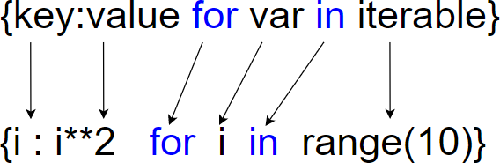

In [329]:

key **=** ['one' , 'two' , 'three' , 'four' , 'five'] value **=** [1,2,3,4,5]

mydict **=** {k:v **for** (k,v) **in** zip(key,value)} *# using dict comprehension to create*

mydict

Out[329]: {'one': 1, 'two': 2, 'three': 3, 'four': 4, 'five': 5}

In [332]:

mydict1 **=** {'a':10 , 'b':20 , 'c':30 , 'd':40 , 'e':50}

mydict1 **=** {k:v**/**10 **for** (k,v) **in** mydict1.items()} *# Divide all values in a diction*

mydict1

Out[332]: {'a': 1.0, 'b': 2.0, 'c': 3.0, 'd': 4.0, 'e': 5.0}

In [334]:

str1 **=** "Natural Language Processing"

mydict2 **=** {k:v **for** (k,v) **in** enumerate(str1)} *# Store enumerated values in a dict*

mydict2

|  |  |  |
| --- | --- | --- |
| Out[334]: | {0: | 'N', |
|  | 1: | 'a', |
|  | 2: | 't', |
|  | 3: | 'u', |
|  | 4: | 'r', |
|  | 5: | 'a', |
|  | 6: | 'l', |
|  | 7: | ' ', |
|  | 8: | 'L', |
|  | 9: | 'a', |
|  | 10: | 'n', |
|  | 11: | 'g', |
|  | 12: | 'u', |
|  | 13: | 'a', |
|  | 14: | 'g', |
|  | 15: | 'e', |
|  | 16: | ' ', |
|  | 17: | 'P', |
|  | 18: | 'r', |
|  | 19: | 'o', |
|  | 20: | 'c', |
|  | 21: | 'e', |
|  | 22: | 's', |
|  | 23: | 's', |
|  | 24: | 'i', |
|  | 25: | 'n', |
|  | 26: | 'g'} |

In [337]:

str1 **=** "abcdefghijklmnopqrstuvwxyz"

mydict3 **=** {i:i.upper() **for** i **in** str1} *# Lower to Upper Case*

mydict3

Out[337]: {'a': 'A',

'b': 'B',

'c': 'C',

'd': 'D',

'e': 'E',

'f': 'F',

'g': 'G',

'h': 'H',

'i': 'I',

'j': 'J',

'k': 'K',

'l': 'L',

'm': 'M',

'n': 'N',

'o': 'O',

'p': 'P',

'q': 'Q',

'r': 'R',

's': 'S',

't': 'T',

'u': 'U',

'v': 'V',

'w': 'W',

'x': 'X',

'y': 'Y',

'z': 'Z'}

### Word Frequency using dictionary

In [61]:

mystr4 **=** "one two three four one two two three five five six seven six seven one

In [64]:

mylist **=** mystr4.split() *# Split String into substrings*

mylist

Out[64]: ['one',

'two',

'three',

'four',

'one',

'two',

'two',

'three',

'five',

'five',

'six',

'seven',

'six',

'seven',

'one',

'one',

'one',

'ten',

'eight',

'ten',

'nine',

'eleven',

'ten',

'ten',

'nine']

In [63]:

mylist1 **=** set(mylist) *# Unique values in a list*

mylist1 **=** list (mylist1) mylist1

Out[63]: ['nine',

'one',

'eight',

'two',

'seven',

'ten',

'four',

'five',

'three',

'eleven',

'six']

In [60]:

*# Calculate frequenct of each word*

count1 **=** [0] **\*** len(mylist1) mydict5 **=** dict()

**for** i **in** range(len(mylist1)):

**for** j **in** range(len(mylist)):

**if** mylist1[i] **==** mylist[j]: count1[i] **+=** 1

mydict5[mylist1[i]] **=** count1[i] print(mydict5)

{'nine': 2, 'one': 5, 'eight': 1, 'two': 3, 'seven': 2, 'ten': 4, 'four': 1, 'f

ive': 2, 'three': 2, 'eleven': 1, 'six': 2}

# Operators

**Operators are special symbols in Python which are used to perform operations on variables/values.**

**Arithmetic Operators**

In [81]:

a **=** 5

b **=** 2

x **=** 'Asif' y **=** 'Bhat'

*# Addition*

c **=** a **+** b

print('Addition of {} and {} will give :- {}\n'.format(a,b,c))

*#Concatenate string using plus operator*

z **=** x**+**y

print ('Concatenate string \'x\' and \'y\' using \'+\' operaotr :- {}\n'.format(

*# Subtraction*

c **=** a **-** b

print('Subtracting {} from {} will give :- {}\n'.format(b,a,c))

*# Multiplication*

c **=** a **\*** b

print('Multiplying {} and {} will give :- {}\n'.format(a,b,c))

*# Division*

c **=** a **/** b

print('Dividing {} by {} will give :- {}\n'.format(a,b,c))

*# Modulo of both number*

c **=** a **%** b

print('Modulo of {} , {} will give :- {}\n'.format(a,b,c))

*# Power*

c **=** a **\*\*** b

print('{} raised to the power {} will give :- {}\n'.format(a,b,c))

*# Division(floor)*

c **=** a **//** b

print('Floor division of {} by {} will give :- {}\n'.format(a,b,c))

Addition of 5 and 2 will give :- 7

Concatenate string 'x' and 'y' using '+' operaotr :- AsifBhat Subtracting 2 from 5 will give :- 3

Multiplying 5 and 2 will give :- 10

|  |  |  |  |
| --- | --- | --- | --- |
| Dividing 5 by | 2 | will give :- | 2.5 |
| Modulo of 5 , | 2 | will give :- | 1 |

5 raised to the power 2 will give :- 25 Floor division of 5 by 2 will give :- 2

### Comparison Operators

Comparison operators are used to compare values.

In [84]:

x **=** 20

y **=** 30

print('Is x greater than y :- ',x**>**y) print('\nIs x less than y :- ',x**<**y) print('\nIs x equal to y :- ',x**==**y)

print('\nIs x not equal to y :- ',x**!=**y)

print('\nIs x greater than or equal to y :- ',x**>=**y) print('\nIs x less than or equal to y :- ',x**<=**y)

Is x greater than y :- False Is x less than y :- True

Is x equal to y :- False

Is x not equal to y :- True

Is x greater than or equal to y :- False Is x less than or equal to y :- True

In [87]:

a **=** 'Asif' b **=** 'Bhat' c **=** 'Asif'

a **==** b , a **==**c , a **!=** b *# Comparison operators on string*

Out[87]: (False, True, True)

### Logical Operators

In [92]:

x **= True**

y **= False**

print('Logical AND operation :- ',x **and** y) *# True if both values are true*

print('Logical OR operation :- ',x **or** y) *# True if either of the values is true*

print('NOT operation :- ',**not** x ) *# True if operand is false*

Logical AND operation :- False Logical OR operation :- True

NOT operation :- False

### Bitwise operators

#### Bitwise operators act on bits and performs bit by bit operation.

In [98]:

x **=** 18 *# binary form 10010*

y **=** 6 *# binary form 00110*

print('Bitwise AND operation - {}'.format(x**&**y)) print('Bitwise OR operation - {}'.format(x**|**y)) print('Bitwise XOR operation - {}'.format(x**^**y)) print('Bitwise NOT operation - {}'.format(**~**x))

print('Bitwise right shift operation - {}'.format(x**>>**2)) print('Bitwise left shift operation - {}'.format(x**<<**2))

Bitwise AND operation - 2 Bitwise OR operation - 22 Bitwise XOR operation - 20

Bitwise NOT operation - -19

Bitwise right shift operation - 4 Bitwise left shift operation - 72

### Assignment Operators

In [120]:

x **=** 10

print('Initialize x with value 10 (x=10)) :- ',x)

x**+=**20 *# x = x+20*

print ('Add 20 to x :- ',x)

x**-=**20 *# x = x-20*

print ('subtract 20 from x :- ',x)

x**/=**10 *# x = x/10*

print ('Divide x by 10 :- ',x)

x**\*=**10 *# x = x/10*

print ('Multiply x by 10 :- ',x) x **=** int(x)

x**\*\*=**2 *# x = x/10*

print ('x raised to the power 2 :- ',x)

x**%=**2

print ('Modulo Division :- ',x)

x **=** 20

x**//=**3

print ('Floor Division :- ',x)

x**&=**2

print('Bitwise AND :- ',x)

x**|=**2

print('Bitwise OR :- ',x)

x**^=**2

print('Bitwise XOR :- ',x)

x **=** 10

x**<<=**2

print('Bitwise right shift operation',x) Initialize x with value 10 (x=10)) :- 10 Add 20 to x :- 30

print('Bitwise left shift operation',x)

x**>>=**2

subtract 20 from x :- 10

Divide x by 10 :- 1.0

Multiply x by 10 :- 10.0

x raised to the power 2 :- 100 Modulo Division :- 0

Floor Division :- 6 Bitwise AND :- 2

Bitwise OR :- 2 Bitwise XOR :- 0

Bitwise left shift operation 40 Bitwise right shift operation 10

### Membership Operators

#### Membership Operators are used to test whether a value / variable is present in a sequence.

In [122]:

mystr **=** 'Asif Ali Bhat'

'Asif' **in** mystr , 'John' **in** mystr

Out[122]: (True, False)

In [123]:

mystr **=** 'Asif Ali Bhat'

'Asif' **not in** mystr , 'John' **not in** mystr

Out[123]: (False, True)

# Functions

A function is a block of organized code written to carry out a specified task.

Functions help break our program into smaller and modular chunks for better readability. Information can be passed into a function as arguments.

Parameters are specified after the function name inside the parentheses.

We can add as many parameters as we want. Parameters must be separated with a comma. A function may or may not return data.

In Python a function is defined using the **def** keyword

### Parameter VS Argument

A parameter is the variable listed inside the parentheses in the function definition. An argument is the value that is sent to the function when it is called.

### Three types of functions in Python:-

**Built-in function :-** Python predefined functions that are readily available for use like min() , max() , sum() , print() etc.

**User-Defined Functions:-** Function that we define ourselves to perform a specific task.

**Anonymous functions :** Function that is defined without a name. Anonymous functions are also called as lambda functions. They are not declared with the **def** keyword.

### Syntax

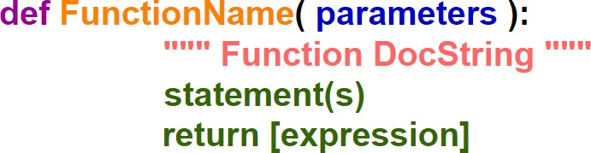

**Modularity**

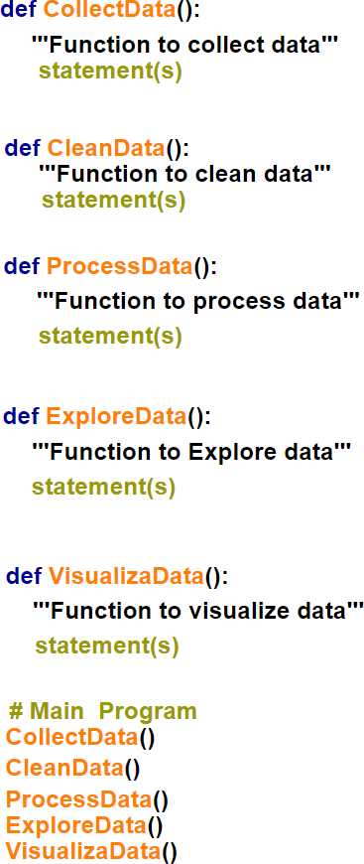

In [582]:

**def** myfunc():

print("Hello Python Lovers")

myfunc()

Hello Python Lovers

In [585]:

**def** details(name,userid,country): *# Function to print User details*

print('Name :- ', name)

print('User ID is :- ', userid) print('Country :- ',country)

details('Asif' , 'asif123' , 'India')

Name :- Asif

User ID is :- asif123 Country :- India

In [586]:

**def** square (n): *#function to find square of a number*

n**=** n**\***n

**return** n

square (10)

Out[586]: 100

In [39]:

**def** even_odd (num): *#Even odd test*

""" This function will check whether a number is even or odd"""

**if** num **%** 2 **==**0:

print (num, ' is even number')

**else**:

print (num, ' is odd number')

even_odd(3) even_odd(4)

print(even_odd. doc ) *# Print function documentation string*

1. is odd number
2. is even number

This function will check whether a number is even or odd

In [590]:

**def** fullname (firstname , middlename ,lastname): *#Concatenate Strings*

fullname **=** "{} {} {}".format(firstname,middlename,lastname) print (fullname)

fullname('Asif' , 'Ali' , 'Bhat')

Asif Ali Bhat

In [591]:

**def** fullname (firstname , middlename ,lastname): *#Concatenate Strings*

fullname **=** "{} {} {}".format(firstname,middlename,lastname) print (fullname)

fullname(lastname **=** 'Bhat' , middlename**=**'Ali' , firstname**=**'Asif') *# Keyword Argu*

Asif Ali Bhat

In [592]:

fullname ('Asif') *# This will throw error as function is expecting 3 arguments.*

#### ---------------------------------------------------------------------------

**TypeError** Traceback (most recent call last)

**<ipython-input-592-d194f8b98253>** in <module>

**----> 1** fullname **('Asif')**

**TypeError**: fullname() missing 2 required positional arguments: 'middlename' and 'lastname'

In [596]:

**def** myfunc(city **=** 'Mumbai'):

print('Most Populous City :- ', city)

myfunc() *# When a function is called without an argument it will use default val*

Most Populous City :- Mumbai

In [26]:

var1 **=** 100 *# Variable with Global scope.*

**def** myfunc():

print(var1) *# Value 100 will be displayed due to global scope of var1*

myfunc()

print(var1)

100

100

In [27]:

**def** myfunc1():

var2 **=** 10 *# Variable with Local scope*

print(var2)

**def** myfunc2():

print(var2) *# This will throw error because var2 has a local scope. Var2 is*

myfunc1() myfunc2()

10

#### ---------------------------------------------------------------------------

**NameError** Traceback (most recent call last)

**<ipython-input-27-6a1c34e80ca2>** in <module> 8

9 myfunc1**()**

**---> 10** myfunc2**()**

**<ipython-input-27-6a1c34e80ca2>** in myfunc2**()** 5

6 **def** myfunc2**():**

#### ----> 7 print(var2) # Value 100 will be displayed due to global scope of va r1

8

9 myfunc1**()**

**NameError**: name 'var2' is not defined

In [29]:

var1 **=** 100 *# Variable with Global scope.*

**def** myfunc():

var1 **=** 99 *# Local scope*

print(var1)

myfunc()

print(var1) *# The original value of var1 (100) will be retained due to global sc*

99

100

In [33]:

list1 **=** [11,22,33,44,55]

**def** myfunc(list1):

**del** list1[0]

print('"List1" before calling the function:- ',list1)

myfunc(list1) *# Pass by reference (Any change in the parameter within the funct*

print('"List1" after calling the function:- ',list1)

"List1" before calling the function:- [11, 22, 33, 44, 55]

"List1" after calling the function:- [22, 33, 44, 55]

In [34]:

list1 **=** [11,22,33,44,55]

**def** myfunc(list1):

list1.append(100)

print('"List1" before calling the function:- ',list1)

myfunc(list1) *# Pass by reference (Any change in the parameter within the funct*

print('"List1" after calling the function:- ',list1)

"List1" before calling the function:- [11, 22, 33, 44, 55]

"List1" after calling the function:- [11, 22, 33, 44, 55, 100]

In [46]:

list1 **=** [11,22,33,44,55]

**def** myfunc(list1):

list1 **=** [10,100,1000,10000] *# link of 'list1' with previous object is broken*

print('"List1" before calling the function:- ',list1)

myfunc(list1) *# Pass by reference (Any change in the parameter within the funct*

print('"List1" after calling the function:- ',list1)

"List1" before calling the function:- [11, 22, 33, 44, 55]

"List1" after calling the function:- [11, 22, 33, 44, 55]

In [45]:

**def** swap(a,b): temp **=** a

a **=** b *# link of 'a' with previous object is broken now as new object is*

b **=** temp *# link of 'b' with previous object is broken now as new object is*

a **=** 10

b **=** 20

swap(a,b) a,b

Out[45]: (10, 20)

In [601]:

**def** factorial(num): *# Calculate factorial of a number using recursive function*

**if** num **<=**1 :

**return** 1

**else**:

**return** num **\*** factorial(num**-**1)

factorial(4)

Out[601]: 24

In [618]:

**def** add(num): *# Sum of first n natural numbers*

**if** num **==** 0:

**return** 0

**else**:

**return** num **+** add(num**-**1)

add(5) *# Sum of first five natural numbers (1,2,3,4,5)*

Out[618]: 15

In [12]:

**def** fiboacci(num):

**if** num **<=** 1:

**return** num

**if** num **==** 2:

**return** 1

**else**:

**return**(fiboacci(num**-**1) **+** fiboacci(num**-**2))

nums **=** int(input("How many fibonacci numbers you want to generate -"))

**for** i **in** range(nums):

print(fiboacci(i)) *# Generate Fibonacci series*

How many fibonacci numbers you want to generate -10 0

1

1

2

3

5

8

13

21

34

# args & kwargs

#### *args

When we are not sure about the number of arguments being passed to a function then we can use *args as function parameter.

*args allow us to pass the variable number of **Non Keyword Arguments** to function. We can simply use an asterisk * before the parameter name to pass variable length arguments.

The arguments are always passed as a tuple.

We can rename it to anything as long as it is preceded by a single asterisk (*). It's best practice to keep naming it args to make it immediately recognizable.

#### **kwargs

**kwargs allows us to pass the variable number of **Keyword Arguments** to the function. We can simply use an double asterisk ** before the parameter name to pass variable length arguments.

The arguments are passed as a dictionary.

We can rename it to anything as long as it is preceded by a double asterisk (**). It's best practice to keep naming it kwargs to make it immediately recognizable.

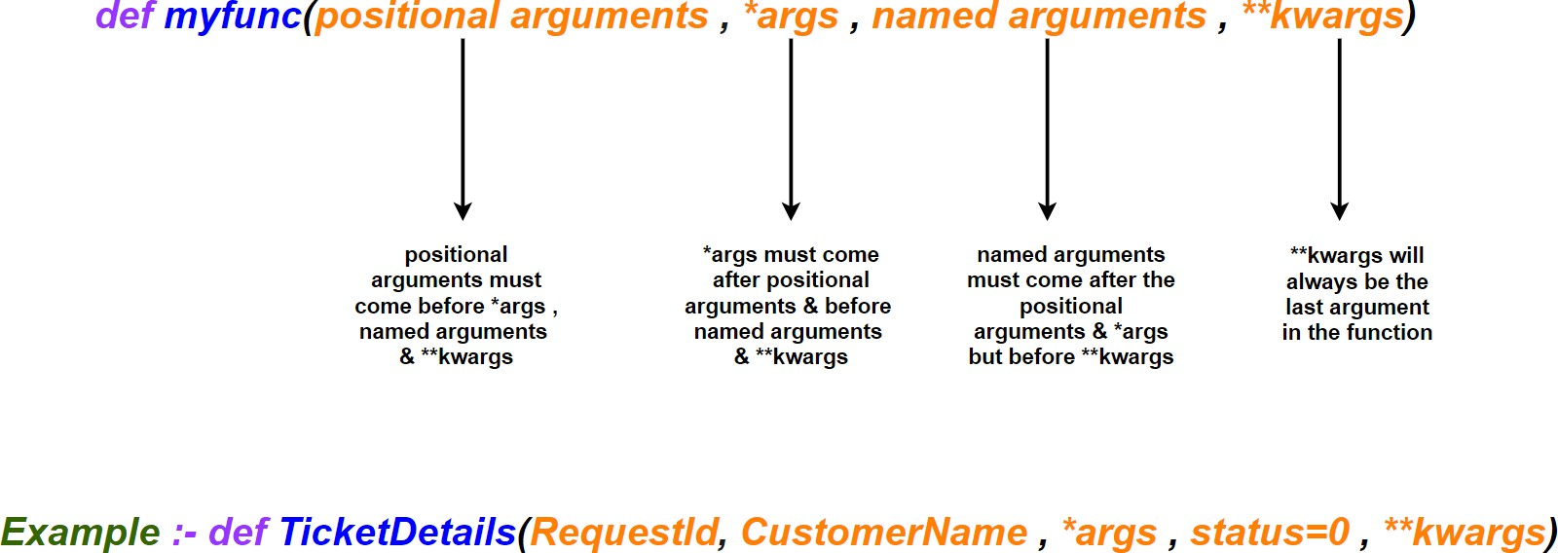

In [578]:

**def** add(a,b,c):

**return** a**+**b**+**c

print(add(10,20,30)) *# Sum of two numbers*

60

In [577]:

print(add(1,2,3,4)) '''This will throw below error as this function will only ta If we want to make argument list dynamic then *args wil come in picture'''

#### File "<ipython-input-577-565d47b69332>", line 2

**If we want to make argument list dynamic then *args wil come in picture'''**

#### ^

**SyntaxError:** invalid syntax

In [566]:

**def** some_args(arg_1, arg_2, arg_3): print("arg_1:", arg_1)

print("arg_2:", arg_2) print("arg_3:", arg_3)

my_list **=** [2, 3]

some_args(1, **\***my_list)

arg_1: 1

arg_2: 2

arg_3: 3

In [524]:

**def** add1(**\***args):

**return** sum(args)

print(add(1,2,3))

print(add(1,2,3,4)) *# *args will take dynamic argument list. So add() function*

print(add(1,2,3,4,5))

print(add(1,2,3,4,5,6))

print(add(1,2,3,4,5,6,7))

6

10

15

21

28

In [561]:

list1 **=** [1,2,3,4,5,6,7]

tuple1 **=** (1,2,3,4,5,6,7)

add1(**\***list1) , add1(**\***tuple1) *#tuple & list items will be passed as argument list*

Out[561]: (28, 28)

In [562]:

list1 **=** [1,2,3,4,5,6,7]

list2 **=** [1,2,3,4,5,6,7]

list3 **=** [1,2,3,4,5,6,7]

list4 **=** [1,2,3,4,5,6,7]

add1(**\***list1 , **\***list2 , **\***list3 , **\***list4 ) *#All four lists are unpacked and each i*

Out[562]: 112

In [511]:

**def** UserDetails(**\***args): print(args)

UserDetails('Asif' , 7412 , 41102 , 33 , 'India' , 'Hindi')

''' For the above example we have no idea about the parameters passed e.g 7412 , In such cases we can take help of Keyworded arguments (**kwargs) '''

('Asif', 7412, 41102, 33, 'India', 'Hindi')

In [517]:

**def** UserDetails(**\*\***kwargs): print(kwargs)

UserDetails(Name**=**'Asif' , ID**=**7412 , Pincode**=**41102 , Age**=** 33 , Country**=** 'India'

{'Name': 'Asif', 'ID': 7412, 'Pincode': 41102, 'Age': 33, 'Country': 'India', 'Language': 'Hindi'}

In [519]:

**def** UserDetails(**\*\***kwargs):

**for** key,val **in** kwargs.items():

print("{} :- {}".format(key,val))

UserDetails(Name**=**'Asif' , ID**=**7412 , Pincode**=**41102 , Age**=** 33 , Country**=** 'India'

Name :- Asif ID :- 7412

Pincode :- 41102

Age :- 33

Country :- India Language :- Hindi

In [523]:

mydict **=** {'Name': 'Asif', 'ID': 7412, 'Pincode': 41102, 'Age': 33, 'Country': 'I

UserDetails(**\*\***mydict)

Name :- Asif ID :- 7412

Pincode :- 41102

Age :- 33

Country :- India Language :- Hindi

In [553]:

**def** UserDetails(licenseNo, **\***args , phoneNo**=**0 , **\*\***kwargs): *# Using all four argu*

print('License No :- ', licenseNo) j**=**''

**for** i **in** args: j **=** j**+**i

print('Full Name :-',j)

print('Phone Number:- ',phoneNo)

**for** key,val **in** kwargs.items():

print("{} :- {}".format(key,val))

name **=** ['Asif' , ' ' , 'Ali' , ' ','Bhat']

mydict **=** {'Name': 'Asif', 'ID': 7412, 'Pincode': 41102, 'Age': 33, 'Country': 'I

UserDetails('BHT145' , **\***name , phoneNo**=**1234567890,**\*\***mydict )

License No :- BHT145

Full Name :- Asif Ali Bhat Phone Number:- 1234567890 Name :- Asif

ID :- 7412

Pincode :- 41102

Age :- 33

Country :- India Language :- Hindi

In [554]:

**def** UserDetails(licenseNo, **\***args , phoneNo**=**0, **\*\***kwargs): *# Using all four argume*

print('Nothing')

In [557]:

**def** UserDetails(licenseNo, **\*\***kwargs , **\***args): *# This will fail. *args MUST come*

print('Nothing')

#### File "<ipython-input-557-dcd3c92277bc>", line 1

**def UserDetails(licenseNo, **kwargs , *args): # This will fail. *args MUST come before **kwargs in the argument list**

#### ^

**SyntaxError:** invalid syntax

In [564]:

*#The below function will fail. Default argument/positional argument (licenseNo)*

**def** UserDetails(ID **=** 1, licenseNo, **\***args): print('Nothing')

#### File "<ipython-input-564-8a3e722c7ed7>", line 2 def UserDetails(ID = 1, licenseNo, *args):

**^**

**SyntaxError:** non-default argument follows default argument

# Lambda, Filter, Map and Reduce

#### Lambda

A lambda function is an anonymous function (function without a name).

Lambda functions can have any number of arguments but only one expression. The expression is evaluated and returned.

We use lambda functions when we require a nameless function for a short period of time.

#### Syntax:-

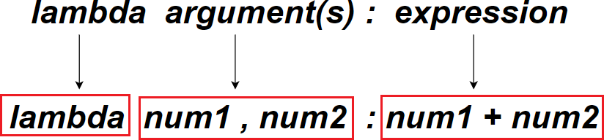

**Filter**

It is used to filter the iterables/sequence as per the conditions.

Filter function filters the original iterable and passes the items that returns True for the function provided to filter.

It is normally used with Lambda functions to filter list, tuple, or sets. filter() method takes two parameters:

**function** - function tests if elements of an iterable returns true or false

**iterable** - Sequence which needs to be filtered, could be sets, lists, tuples, or any iterators

#### Syntax:

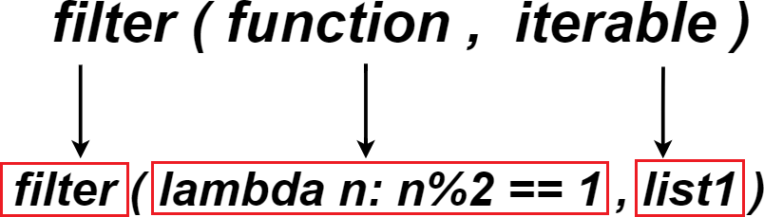

**Map**

The map() function applies a given function to each item of an iterable (list, tuple etc.) and returns a list of the results.

map() function takes two Parameters :

**function** : The function to execute for each item of given iterable.

**iterable** : It is a iterable which is to be mapped.

**Returns** : Returns a list of the results after applying the given function to each item of a given iterable (list, tuple etc.)

#### Syntax:

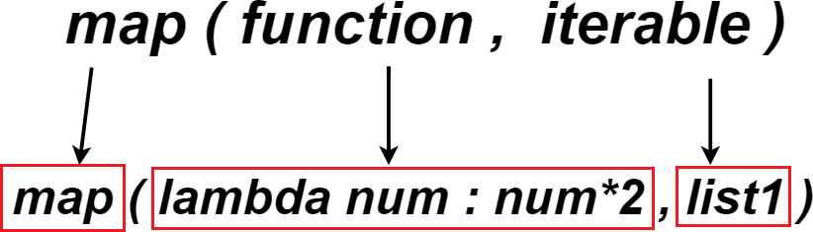

**Reduce**

The reduce() function is defined in the **functools** python module.The reduce() function

receives two arguments, a function and an iterable. However, it doesn't return another iterable, instead it returns a single value.

#### Working:

1. Apply a function to the first two items in an iterable and generate a partial result.
2. The function is then called again with the result obtained in **step 1** and the next value in the sequence. This process keeps on repeating until there are items in the sequence.
3. The final returned result is returned and printed on console.

#### Syntax:

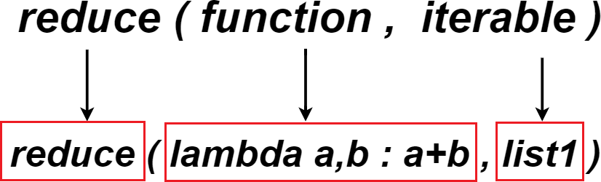

In [392]:

addition **= lambda** a : a **+** 10 *# This lambda function adds value 10 to an argumen*

print(addition(5))

15

In [393]:

product **= lambda** a, b : a **\*** b *#This lambda function takes two arguments (a,b) an*

print(product(5, 6))

30

In [394]:

addition **= lambda** a, b, c : a **+** b **+** c *#This lambda function takes three argumen*

print(addition(5, 6, 2))

13

In [364]:

res **=** (**lambda \***args: sum(args)) *# This lambda function can take any number of a*

res(10,20) , res(10,20,30,40) , res(10,20,30,40,50,60,70)

Out[364]: (30, 100, 280)

In [370]:

res1 **=** (**lambda \*\***kwargs: sum(kwargs.values())) *# This lambda function can take a*

res1(a **=** 10 , b**=** 20 , c **=** 30) , res1(a **=** 10 , b**=** 20 , c **=** 30, d **=** 40 , e **=** 50)

Out[370]: (60, 150)

In [386]:

res1 **=** (**lambda \*\***kwargs: sum(kwargs.values())) *# This lambda function can take a*

res1(a **=** 10 , b**=** 20 , c **=** 30) , res1(a **=** 10 , b**=** 20 , c **=** 30, d **=** 40 , e **=** 50)

Out[386]: (60, 150)

In [446]:

*# User defined function to find product of numbers*

**def** product(nums): total **=** 1

**for** i **in** nums: total **\*=** i

**return** total

*# This lambda function can take any number of arguments and return thier product*

res1 **=** (**lambda \*\***kwargs: product(kwargs.values()))

res1(a **=** 10 , b**=** 20 , c **=** 30) , res1(a **=** 10 , b**=** 20 , c **=** 30, d **=** 40 , e **=** 50)

Out[446]: (6000, 12000000)

In [447]:

**def** myfunc(n):

**return lambda** a : a **+** n

add10 **=** myfunc(10) add20 **=** myfunc(20) add30 **=** myfunc(30)

print(add10(5)) print(add20(5)) print(add30(5))

15

25

35

In [437]:

list1 **=** [1,2,3,4,5,6,7,8,9]

**def** odd(n):

**if** n**%**2 **==**1: **return True else**: **return False**

odd_num **=** list(filter(odd,list1)) *# This Filter function filters list1 and passe*

odd_num

Out[437]: [1, 3, 5, 7, 9]

In [438]:

list1 **=** [1,2,3,4,5,6,7,8,9]

*# The below Filter function filters "list1" and passes all odd numbers using lam*

odd_num **=** list(filter(**lambda** n: n**%**2 **==**1 ,list1)) odd_num

Out[438]: [1, 3, 5, 7, 9]

In [439]:

**def** twice(n):

**return** n**\***2

doubles **=** list(map(twice,odd_num)) *# The map function will apply user defined "t*

doubles

Out[439]: [2, 6, 10, 14, 18]

In [440]:

doubles **=** list(map(**lambda** n:n**\***2,odd_num)) *# This map function will double all it*

doubles

Out[440]: [2, 6, 10, 14, 18]

In [441]:

**from** functools **import** reduce

**def** add(a,b):

**return** a**+**b

sum_all **=** reduce(add,doubles) *# This reduce function will perform sum of all ite*

sum_all

Out[441]: 50

In [442]:

*#The below reduce() function will perform sum of all items in the list using lam*

sum_all **=** reduce(**lambda** a,b : a**+**b,doubles) sum_all

Out[442]: 50

In [448]:

*# Putting all together*

sum_all **=** reduce(**lambda** a,b : a**+**b,list(map(**lambda** n:n**\***2,list(filter(**lambda** n: n**%** sum_all

Out[448]: 50

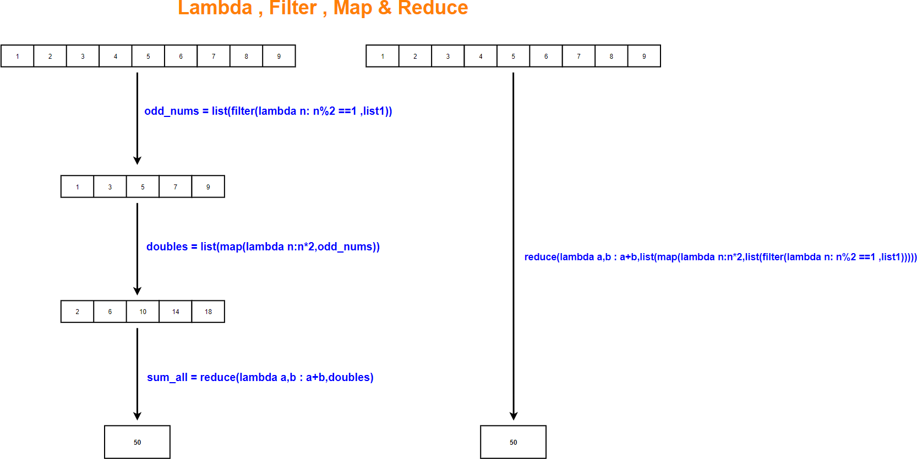

In [ ]:

*# More examples on Map , Filter , Reduce*

In [497]:

list1 **=** [1,2,3,4,5,6,7,8,9,10]

even **=** list(filter(**lambda** n: n**%**2 **==**0 ,list1)) *# Filter even numbers from the lis*

odd **=** list(filter(**lambda** n: n**%**2 **!=**0 ,list1)) *# Filter odd numbers from the li*

print(' ')

print(even) print(odd)

print(' ')

list2 **=** ['one' , 'TWO' , 'three' , 'FOUR']

upper **=** list(filter(**lambda** x: x.isupper() , list2)) *# filter uppercase strings f*

lower **=** list(filter(**lambda** x: x.islower() , list2)) *# filter lowercase strings f*

print(upper)

print(lower)

print(' ')

list3 **=** ['one' , 'two2' , 'three3' ,'88' , '99' , '102']

numeric **=** list(filter(**lambda** x:x.isnumeric(), list3)) *# filter numbers from the*

alpha **=** list(filter(**lambda** x:x.isalpha(), list3))

*# filter character string*

alphanum **=** list(filter(**lambda** x:x.isalnum(), list3)) *# filtr numbers & character*

print(alpha)

print(numeric) print(alphanum)

print(' ')

*#Vowel Test*

[2, 4, 6, 8, 10]

[1, 3, 5, 7, 9]

['TWO', 'FOUR']

['one', 'three']

['one']

['88', '99', '102']

['one', 'two2', 'three3', '88', '99', '102']

In [501]:

list1 **=** [1,2,3,4]

list2 **=** [5,6,7,8]

**def** double(x):

**return** x**+**x

**def** add(x,y):

**return** x**+**y

**def** square(x):

**return** x**\***x

print(' ')

print(list(map(double, list1))) *# Double each number using map & User defined fu* print(list(map(add, list1, list2))) *# add two items using map & User defined fu* print(list(map(square, list1))) *#Square numbers using map & User defined functio*

print(' ')

print(list(map(**lambda** x: x **+** x, list1))) *# Double each number using map & lambda* print(list(map(**lambda** x, y: x **+** y, list1, list2))) *# add two items using map &* print(list(map(**lambda** x: x**\***x, list1))) *#Square numbers using map & lambda*

print(' ')

|  |  |  |
| --- | --- | --- |
| [2, | 4, | 6, 8] |
| [6, | 8, | 10, 12] |
| [1, | 4, | 9, 16] |
| [2, | 4, | 6, 8] |
| [6, | 8, | 10, 12] |
| [1, | 4, | 9, 16] |

In [459]:

list2 **=** [1,2,3,4]

product **=** reduce (operator.mul,list2) *# Product of all numbers in a list*

add **=** reduce(operator.add,list2) *# Add all numbers in the list*

concat_str **=** reduce(operator.add , ['Python' , ' ' , 'Rocks']) *# Concatenate str*

prod **=** reduce(operator.mul,['Hello ' , 3]) *#Repeat a string multiple times*

min_num **=** reduce(**lambda** a, b: a **if** a **<** b **else** b, list2) *# Minimum number in the* max_num **=** reduce(**lambda** a, b: a **if** a **>** b **else** b, list2) *# Maximum number in the* print(product)

print(add)

print(concat_str) print(prod)

print(min_num)

print(max_num)

24

10

Python Rocks

Hello Hello Hello 1

4

In [461]:

**def** min_func(a, b):

**return** a **if** a **<** b **else** b

**def** max_func(a, b):

**return** a **if** a **>** b **else** b

min_num **=** reduce(min_func, list2) *# Minimum number in the list using reduce () &* max_num **=** reduce(max_func, list2) *# Maximum number in the list using reduce () &* min_num , max_num

Out[461]: (1, 4)

|  |  |  |  |  |  |  |  |  |  |  |  |  |  |  |  |  |  |
| --- | --- | --- | --- | --- | --- | --- | --- | --- | --- | --- | --- | --- | --- | --- | --- | --- | --- |
| In | [474]: | print(' ') |  | | | | | | | | | | | | | | |
|  |  | print(reduce(**lambda** | a, | b: | bool(a | **and** | b), | [0, | 0, | 1, | 0, | 0])) | *#* | *Returns* | *True* | *if* | *all* |
|  |  | print(reduce(**lambda** | a, | b: | bool(a | **and** | b), | [2, | 3, | 1, | 5, | 6])) | *#* | *Returns* | *True* | *if* | *all* |
|  |  | print(reduce(**lambda** | a, | b: | bool(a | **and** | b), | [8, | 9, | 1, | 0, | 9])) | *#* | *Returns* | *True* | *if* | *all* |
|  |  | print(' ') |  |  |  |  |  |  |  |  |  |  |  |  |  |  |  |
|  |  | print(reduce(**lambda** | a, | b: | bool(a | **or** | b), | [0, | 0, | 0, | 0, | 0])) | *#* | *Returns* | *True* | *if* | *any* |
|  |  | print(reduce(**lambda** | a, | b: | bool(a | **or** | b), | [2, | 3, | 1, | 5, | 6])) | *#* | *Returns* | *True* | *if* | *any* |
|  |  | print(reduce(**lambda** | a, | b: | bool(a | **or** | b), | [8, | 9, | 1, | 0, | 9])) | *#* | *Returns* | *True* | *if* | *any* |
|  |  | print(' ') |  |  |  |  |  |  |  |  |  |  |  |  |  |  |  |
|  |  |  |  |  |  |  |  |  |  |  |  |  |  |  |  |  |  |
|  |  | False True False |  |  |  |  |  |  |  |  |  |  |  |  |  |  |  |
|  |  | False True True |  |  |  |  |  |  |  |  |  |  |  |  |  |  |  |

# Classes & Objects

A Class is an object constructor or a "blueprint" for creating objects.

Objects are nothing but an encapsulation of variables and functions into a single entity. Objects get their variables and functions from classes.

To create a class we use the keyword **class**.

The first string inside the class is called docstring which gives the brief description about the class.

init ()

All classes have a function called being initiated.

which is always executed when the class is

We can use function to assign values to object properties or other operations

init ()

that are necessary to perform when the object is being created

The **self** parameter is a reference to the current instance of the class and is used to access class variables.

**self** must be the first parameter of any function in the class

The **super()** builtin function returns a temporary object of the superclass that allows us to access methods of the base class.

**super()** allows us to avoid using the base class name explicitly and to enable multiple inheritance.

#### Syntax

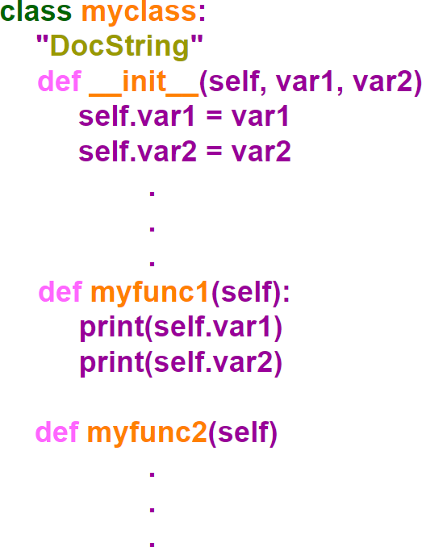

In [49]:

*# Create a class with property "var1"*

**class** myclass: var1 **=** 10

obj1 **=** myclass() *# Create an object of class "myclass()"*

print(obj1.var1)

10

In [70]:

*# Create an employee class*

**class** Employee:

**def** init (self, name, empid): *# init () function is used to assign value*

self.name **=** name

self.empid **=** empid

**def** greet(self): *# Class Method*

print("Thanks for joining ABC Company {}!!".format(self.name)) emp1 **=** Employee("Asif", 34163) *# Create an employee object*

print('Name :- ',emp1.name)

print('Employee ID :- ',emp1.empid) emp1.greet()

Name :- Asif

Employee ID :- 34163

Thanks for joining ABC Company Asif!!

In [71]:

emp1.name **=** 'Basit' *# Modify Object Properties*

emp1.name

Out[71]: 'Basit'

In [72]:

**del** emp1.empid *# Delete Object Properties*

emp1.empid

#### ---------------------------------------------------------------------------

**AttributeError** Traceback (most recent call last)

**<ipython-input-72-b111c8b828fc>** in <module>

1 **del** emp1**.**empid **# Delete Object Properties**

**----> 2** emp1**.**empid

**AttributeError**: 'Employee' object has no attribute 'empid'

In [73]:

**del** emp1 *# Delete the object*

emp1

#### ---------------------------------------------------------------------------

**NameError** Traceback (most recent call last)

**<ipython-input-73-db2cb77ec9fb>** in <module>

1 **del** emp1 **# Delete the object**

**----> 2** emp1

**NameError**: name 'emp1' is not defined

In [75]:

emp2 **=** Employee("Michael", 34162) *# Create an employee object*

print('Name :- ',emp2.name)

print('Employee ID :- ',emp2.empid) emp2.greet()

Name :- Michael

Employee ID :- 34162

Thanks for joining ABC Company Michael!!

In [77]:

emp2.country **=** 'India' *#instance variable can be created manually*

emp2.country

Out[77]: 'India'

**Inheritance**

Inheritance is a powerful feature in object oriented programming.

Inheritance provides code reusability in the program because we can use an existing class (Super Class/ Parent Class / Base Class) to create a new class (Sub Class / Child Class / Derived Class) instead of creating it from scratch.

The child class inherits data definitions and methods from the parent class which facilitates the reuse of features already available. The child class can add few more definitions or redefine a base class method.

Inheritance comes into picture when a new class possesses the '**IS A**' relationship with an existing class. E.g Student is a person. Hence person is the base class and student is derived class.

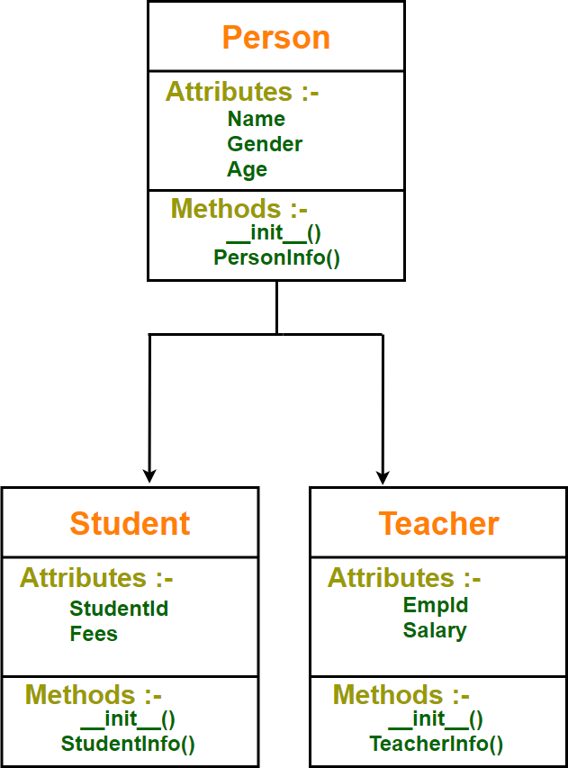

In [163]:

**class** person: *# Parent Class*

**def** init (self, name , age , gender): self.name **=** name

self.age **=** age

self.gender **=** gender

**def** PersonInfo(self):

print('Name :- {}'.format(self.name))

print('Age :- {}'.format(self.age))

print('Gender :- {}'.format(self.gender))

**class** student(person): *# Child Class*

**def** init (self,name,age,gender,studentid,fees): person. init (self,name,age,gender)

self.studentid **=** studentid self.fees **=** fees

**def** StudentInfo(self):

print('Student ID :- {}'.format(self.studentid)) print('Fees :- {}'.format(self.fees))

**class** teacher(person): *# Child Class*

**def** init (self,name,age,gender,empid,salary): person. init (self,name,age,gender)

self.empid **=** empid self.salary **=** salary

**def** TeacherInfo(self):

print('Employee ID :- {}'.format(self.empid)) print('Salary :- {}'.format(self.salary))

stud1 **=** student('Asif' , 24 , 'Male' , 123 , 1200) print('Student Details')

print(' ')

stud1.PersonInfo() *# PersonInfo() method presnt in Parent Class will be acces*

stud1.StudentInfo() print()

teacher1 **=** teacher('Basit' , 36 , 'Male' , 456 , 80000) print('Employee Details')

print(' ')

teacher1.PersonInfo() *# PersonInfo() method presnt in Parent Class will be ac*

teacher1.TeacherInfo()



Student Details

Name :- Asif

Age :- 24



Gender :- Male

Student ID :- 123 Fees :- 1200

Employee Details

Name :- Basit Age :- 36

Gender :- Male

Employee ID :- 456 Salary :- 80000

In [4]:

**class** person: *# Parent Class*

**def** init (self, name , age , gender): self.name **=** name

self.age **=** age

self.gender **=** gender

**def** PersonInfo(self):

print('Name :- {}'.format(self.name))

print('Age :- {}'.format(self.age))

print('Gender :- {}'.format(self.gender))

**class** student(person): *# Child Class*

**def** init (self,name,age,gender,studentid,fees): person. init (self,name,age,gender)

self.studentid **=** studentid self.fees **=** fees

**def** StudentInfo(self):

print('Student ID :- {}'.format(self.studentid)) print('Fees :- {}'.format(self.fees))

stud1 **=** student('Asif' , 24 , 'Male' , 123 , 1200) print('Student Details')

print(' ')

stud1.PersonInfo() *# PersonInfo() method presnt in Parent Class will be acces*

stud1.StudentInfo() print()

Student Details

Name :- Asif Age :- 24

Gender :- Male

Student ID :- 123 Fees :- 1200

In [182]:

*# super() builtin function allows us to access methods of the base class.*

**class** person: *# Parent Class*

**def** init (self, name , age , gender): self.name **=** name

self.age **=** age

self.gender **=** gender

**def** PersonInfo(self):

print('Name :- {}'.format(self.name))

print('Age :- {}'.format(self.age))

print('Gender :- {}'.format(self.gender))

**class** student(person): *# Child Class*

**def** init (self,name,age,gender,studentid,fees): super(). init (name,age,gender)

self.studentid **=** studentid self.fees **=** fees

**def** StudentInfo(self):

super().PersonInfo()

print('Student ID :- {}'.format(self.studentid)) print('Fees :- {}'.format(self.fees))

stud **=** student('Asif' , 24 , 'Male' , 123 , 1200) print('Student Details')

print(' ')

stud.StudentInfo()

Name :- Asif Age :- 24

Gender :- Male

Student ID :- 123 Fees :- 1200

### Multi-level Inheritance

In this type of inheritance, a class can inherit from a child class or derived class. Multilevel Inheritance can be of any depth in python

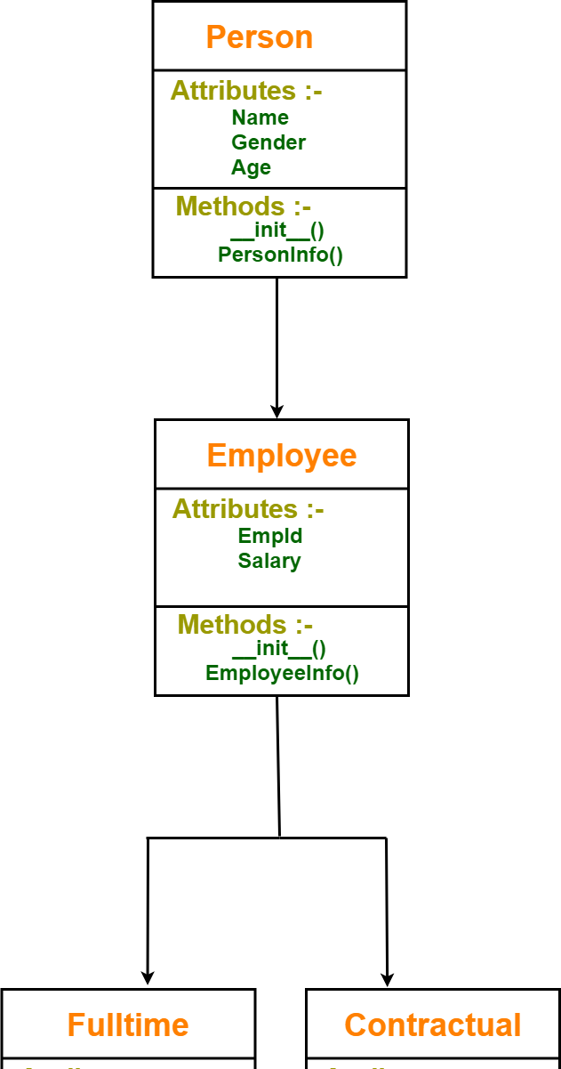

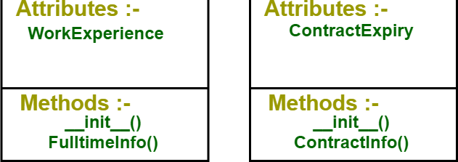

In [196]:

**class** person: *# Parent Class*

**def** init (self, name , age , gender): self.name **=** name

self.age **=** age

self.gender **=** gender

**def** PersonInfo(self):

print('Name :- {}'.format(self.name))

print('Age :- {}'.format(self.age))

print('Gender :- {}'.format(self.gender))

**class** employee(person): *# Child Class*

**def** init (self,name,age,gender,empid,salary): person. init (self,name,age,gender)

self.empid **=** empid self.salary **=** salary

**def** employeeInfo(self):

print('Employee ID :- {}'.format(self.empid)) print('Salary :- {}'.format(self.salary))

**class** fulltime(employee): *# Grand Child Class*

**def** init (self,name,age,gender,empid,salary,WorkExperience): employee. init (self,name,age,gender,empid,salary)

self.WorkExperience **=** WorkExperience

**def** FulltimeInfo(self):

print('Work Experience :- {}'.format(self.WorkExperience))

**class** contractual(employee): *# Grand Child Class*

**def** init (self,name,age,gender,empid,salary,ContractExpiry): employee. init (self,name,age,gender,empid,salary)

self.ContractExpiry **=** ContractExpiry

**def** ContractInfo(self):

print('Contract Expiry :- {}'.format(self.ContractExpiry))

print('Contractual Employee Details') print('****************************')

contract1 **=** contractual('Basit' , 36 , 'Male' , 456 , 80000,'21-12-2021') contract1.PersonInfo()

contract1.employeeInfo() contract1.ContractInfo()

print('\n \n')

print('Fulltime Employee Details')

print('****************************')

fulltim1**=** fulltime('Asif' , 22 , 'Male' , 567 , 70000, 12) fulltim1.PersonInfo()

fulltim1.employeeInfo() fulltim1.FulltimeInfo()

Contractual Employee Details

**************************** Name :- Basit

Age :- 36

Gender :- Male

Employee ID :- 456 Salary :- 80000

Contract Expiry :- 21-12-2021

Fulltime Employee Details

**************************** Name :- Asif

Age :- 22

Gender :- Male

Employee ID :- 567 Salary :- 70000

Work Experience :- 12

### Multiple Inheritance

Multiple inheritance is a feature in which a class (derived class) can inherit attributes and methods from more than one parent class.

The derived class inherits all the features of the base case.

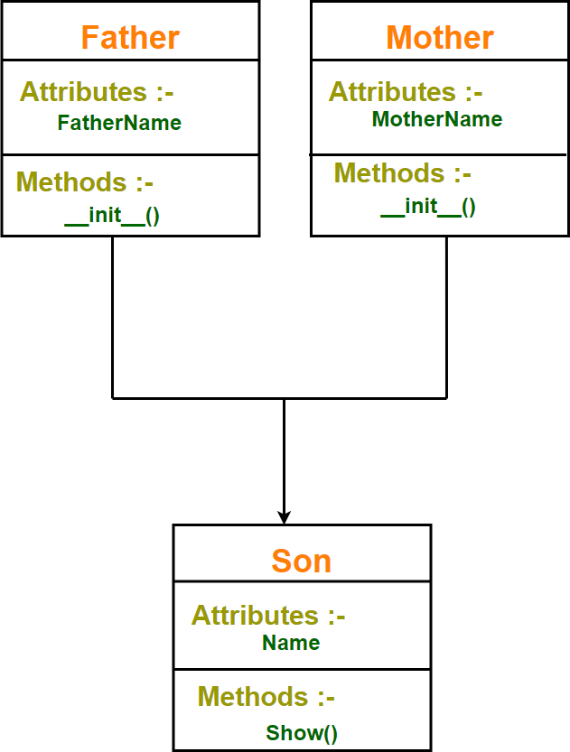

In [120]:

*# Super Class*

**class** Father:

**def** init (self):

self.fathername **=** str()

*# Super Class*

**class** Mother:

**def** init (self):

self.mothername **=** str()

*# Sub Class*

**class** Son(Father, Mother): name **=** str()

**def** show(self):

print('My Name :- ',self.name)

print("Father :", self.fathername) print("Mother :", self.mothername)

s1 **=** Son()

s1.name **=** 'Bill'

s1.fathername **=** "John"

s1.mothername **=** "Kristen" s1.show()

My Name :- Bill Father : John

Mother : Kristen

In [215]:

**class** Date:

**def** init (self,date): self.date **=** date

**class** Time:

**def** init (self,time): self.time **=** time

**class** timestamp(CurrentDate,CurrentTime):

**def** init (self,date,time):

CurrentDate. init (self,date) CurrentTime. init (self,time)

DateTime **=** self.date **+** ' ' **+** self.time print(DateTime)

datetime1 **=** timestamp( '2020-08-09', '23:48:55')

2020-08-09 23:48:55

### Method Overriding

Overriding is a very important part of object oreinted programming because it makes inheritance exploit its full power.

Overriding is the ability of a class (Sub Class / Child Class / Derived Class) to change the implementation of a method provided by one of its parent classes.

When a method in a subclass has the same name, same parameter and same return type as a method in its super-class, then the method in the subclass is said to override the method in the super-class.

The version of a method that is executed will be determined by the object that is used to invoke it.

If an object of a parent class is used to invoke the method, then the version in the parent class will be executed, but if an object of the subclass is used to invoke the method, then the version in the child class will be executed.

In [173]:

**class** person: *# Parent Class*

**def** init (self, name , age , gender): self.name **=** name

self.age **=** age

self.gender **=** gender

**def** greet(self):

print("Hello Person")

**class** student(person): *# Child Class*

**def** init (self,name,age,gender,studentid,fees): person. init (self,name,age,gender)

self.studentid **=** studentid self.fees **=** fees

**def** greet(self):

print("Hello Student")

stud **=** student('Gabriel' , 56 , 'Male' , 45 , 345678)

stud.greet() *# greet() method defined in subclass will be triggered as "stud" is*

person1 **=** person('Gabriel' , 56 , 'Male')

person1.greet() *# greet() method defined in superclass will be triggered because*

Hello Student Hello Person

# Container

Containers are data structures that hold data values.

They support membership tests which means we can check whether a value exists in the container or not.

Generally containers provide a way to access the contained objects and to iterate over them.

Examples of containers include tuple, list, set, dict, str

In [124]:

list1 **=** ['asif' , 'john' , 'Michael' , 'Basit']

'asif' **in** list1 *# Membership check using 'in' operator*

Out[124]: True

In [128]:

**assert** 'john' **in** list1 *# If the condition returns true the program does nothing*

In [127]:

**assert** 'john1' **in** list1 *# If the condition returns false, Assert will stop the p*

#### ---------------------------------------------------------------------------

**AssertionError** Traceback (most recent call last)

**<ipython-input-127-f7bcea8c4682>** in <module>

#### ----> 1 assert 'john1' in list1

**AssertionError**:

In [130]:

mydict **=** {'Name':'Asif' , 'ID': 12345 , 'DOB': 1991 , 'Address' : 'Hilsinki'} mydict

Out[130]: {'Name': 'Asif', 'ID': 12345, 'DOB': 1991, 'Address': 'Hilsinki'}

In [131]:

'Asif' **in** mydict *# Dictionary membership will always check the keys*

Out[131]:

False

In [132]:

'Name' **in** mydict *# Dictionary membership will always check the keys*

Out[132]:

True

In [133]:

'DOB' **in** mydict

Out[133]:

True

In [134]:

mystr **=** 'asifbhat'

'as' **in** mystr *# Check if substring is present*

Out[134]: True

# Iterable & Iterator

An **iterable** is an object that can be iterated upon. It can return an iterator object with the purpose of traversing through all the elements of an iterable.

An iterable object implements **iter**() which is expected to return an iterator object. The iterator object uses the **next**() method. Every time **next()** is called next element in the iterator stream is returned. When there are no more elements available **StopIteration**

**exception** is encountered. So any object that has a **next**() method is called an **iterator**.

Python lists, tuples, dictionaries and sets are all examples of iterable objects.

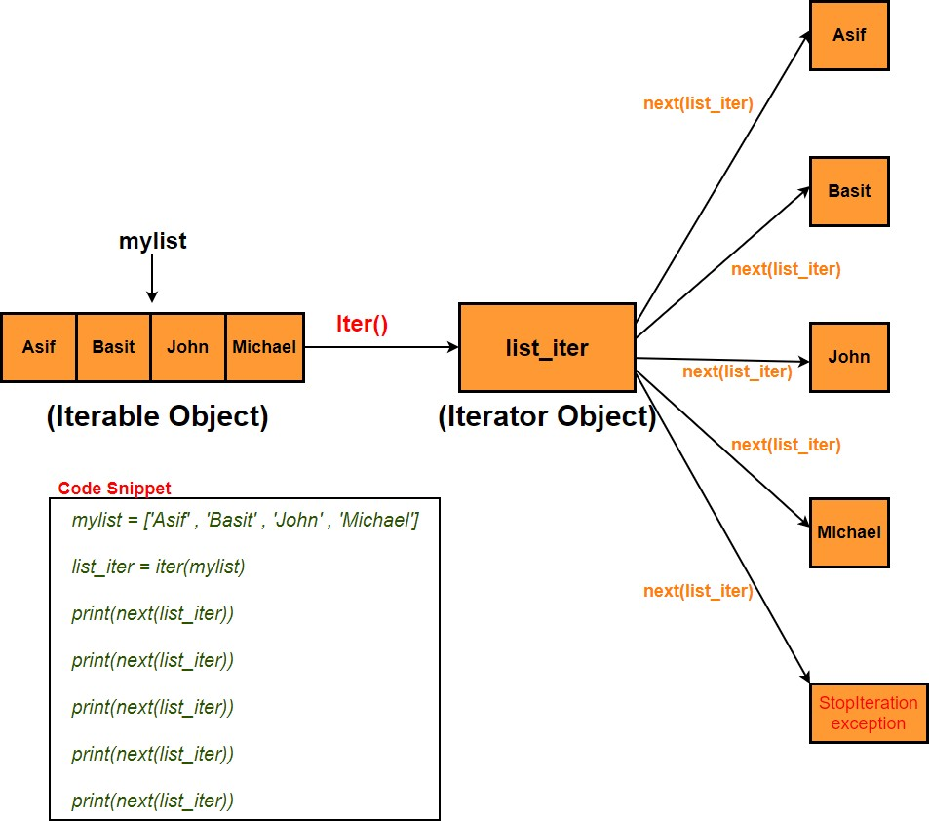

In [236]:

mylist **=** ['Asif' , 'Basit' , 'John' , 'Michael']

list_iter **=** iter(mylist) *# Create an iterator object using iter()*

print(next(list_iter)) *# return first element in the iterator stream* print(next(list_iter)) *# return next element in the iterator stream* print(next(list_iter))

print(next(list_iter)) print(next(list_iter))

Asif Basit John

Michael

#### ---------------------------------------------------------------------------

**StopIteration** Traceback (most recent call last)

**<ipython-input-236-a2095e242a65>** in <module>

1. print**(**next**(**list_iter**))**
2. print**(**next**(**list_iter**))**

**----> 7** print**(**next**(**list_iter**)) StopIteration**:

In [238]:

mylist **=** ['Asif' , 'Basit' , 'John' , 'Michael']

list_iter **=** iter(mylist) *# Create an iterator object using iter()*

print(list_iter. next ()) *# return first element in the iterator stream* print(list_iter. next ()) *# return next element in the iterator stream* print(list_iter. next ())

print(list_iter. next ())

Asif Basit John

Michael

In [247]:

mylist **=** ['Asif' , 'Basit' , 'John' , 'Michael']

list_iter **=** iter(mylist) *# Create an iterator object using iter()*

**for** i **in** list_iter: print(i)

Asif Basit John

Michael

In [241]:

*# Looping Through an Iterable (list) using for loop*

mylist **=** ['Asif' , 'Basit' , 'John' , 'Michael']

**for** i **in** mylist: print(i)

Asif Basit John

Michael

In [242]:

*# Looping Through an Iterable (tuple) using for loop*

mytuple **=** ('Asif' , 'Basit' , 'John' , 'Michael')

**for** i **in** mytuple: print(i)

Asif Basit John

Michael

In [243]:

*# Looping Through an Iterable (string) using for loop*

mystr **=** "Hello Python"

**for** i **in** mystr: print(i)

H

e l l o

P

y t h o n

In [255]:

*# This iterator produces all natural numbers from 1 to 10.*

**class** myiter:

**def** init (self):

self.num **=** 0

**def** iter (self):

self.num **=** 1

**return** self

**def** next (self):

**if** self.num **<=** 10: val **=** self.num self.num **+=** 1 **return** val

**else**:

**raise** StopIteration

mynum **=** myiter()

iter1 **=** iter(mynum)

**for** i **in** iter1: print(i)

1

2

3

4

5

6

7

8

9

10

In [256]:

*# This iterator will produce odd numbers*

**class** myiter:

**def** init (self):

self.num **=** 0

**def** iter (self):

self.num **=** 1

**return** self

**def** next (self):

**if** self.num **<=** 20 : val **=** self.num self.num **+=** 2 **return** val

**else**:

**raise** StopIteration

myodd **=** myiter()

iter1 **=** iter(myodd)

**for** i **in** iter1: print(i)

1

3

5

7

9

11

13

15

17

19

In [257]:

*# This iterator will produce fibonacci numbers*

**class** myfibonacci:

**def** init (self):

self.prev **=** 0

self.cur **=** 0

**def** iter (self):

self.prev **=** 0

self.cur **=** 1

**return** self

**def** next (self):

**if** self.cur **<=** 50: val **=** self.cur

self.cur **+=** self.prev self.prev **=** val

**return** val

**else**:

**raise** StopIteration

myfibo **=** myfibonacci() iter1 **=** iter(myfibo)

**for** i **in** iter1: print(i)

1

1

2

3

5

8

13

21

34

# Generator

Python generators are easy way of creating iterators. It generates values one at a time from a given sequence instead of returning the entire sequence at once.

It is a special type of function which returns an iterator object.

In a generator function, a **yield** statement is used rather than a **return** statement.

The generator function cannot include the return keyword. If we include it then it will terminate the execution of the function.

The difference between **yield** and **return** is that once yield returns a value the function is paused and the control is transferred to the caller.Local variables and their states are

remembered between successive calls. In case of the return statement value is returned and the execution of the function is terminated.

Methods like **iter**() and **next**() are implemented automatically in generator function.

Simple generators can be easily created using **generator expressions**. Generator expressions create anonymous generator functions like lambda.

The syntax for generator expression is similar to that of a list comprehension but the only difference is square brackets are replaced with round parentheses. Also list comprehension produces the entire list while the generator expression produces one item at a time which is more memory efficient than list comprehension.

In [258]:

*# Simple generator function that will generate numbers from 1 to 5.*

**def** mygen(): n **=** 1

**yield** n

n **+=** 1

**yield** n

n **+=** 1

**yield** n

n **+=** 1

**yield** n

n **+=** 1

**yield** n

mygen1 **=** mygen()

print(next(mygen1)) print(next(mygen1)) print(next(mygen1)) print(next(mygen1))

print(next(mygen1)) *#Function will terminate here as all 5 values have been retu*

print(next(mygen1)) *# As function is already terminated, StopIteration is raised*

1

2

3

4

5

#### ---------------------------------------------------------------------------

**StopIteration** Traceback (most recent call last)

**<ipython-input-258-4c1c399db6dd>** in <module>

1. print**(**next**(**mygen1**))**
2. print**(**next**(**mygen1**))**

**---> 26** print**(**next**(**mygen1**)) StopIteration**:

In [272]:

*# Simple generator function that will generate natural numbers from 1 to 20.*

**def** mygen():

**for** i **in** range(1,20):

**yield** i

mygen1 **=** mygen()

**for** i **in** mygen1: print(i)

1

2

3

4

5

6

7

8

9

10

11

12

13

14

15

16

17

18

19

In [274]:

num **=** list(mygen()) *# Store all values generated by generator function in a list*

num

Out[274]: [1, 2, 3, 4, 5, 6, 7, 8, 9, 10, 11, 12, 13, 14, 15, 16, 17, 18, 19]

In [275]:

*# Simple generator function that will generate even numbers from 1 to 20.*

**def** mygen():

**for** i **in** range(1,20):

**if** i**%**2 **==** 0:

**yield** i

mygen1 **=** mygen()

**for** i **in** mygen1: print(i)

2

4

6

8

10

12

14

16

18

In [276]:

*# This Generator function will generate ten numbers of fibonacci series.*

**def** myfibo():

num1 , num2 **=** 0,1 count **=** 0

**while** count **<** 10:

**yield** num1

num1,num2 **=** num2,num1**+**num2 count**+=**1

fibo **=** myfibo()

**for** i **in** fibo: print(i)

0

1

1

2

3

5

8

13

21

34

In [277]:

list1 **=** list(myfibo()) *# Store the fibonacci series in a list*

list1

Out[277]: [0, 1, 1, 2, 3, 5, 8, 13, 21, 34]

In [283]:

list2 **=** [i**\*\***2 **for** i **in** range(10)] *# List comprehension*

list2

Out[283]: [0, 1, 4, 9, 16, 25, 36, 49, 64, 81]

In [280]:

gen2 **=** (i**\*\***2 **for** i **in** range(10)) *# Generator expression*

gen2

Out[280]: <generator object <genexpr> at 0x000001EF4B639848>

In [282]:

print(next(gen2)) print(next(gen2)) print(next(gen2)) print(next(gen2)) print(next(gen2))

1

4

9

16

25

In [288]:

gen2 **=** (i **for** i **in** range(40) **if** i**%**2 **==** 0) *# Generator expression to generate eve*

gen2

**for** i **in** gen2: print(i)

0

2

4

6

8

10

12

14

16

18

20

22

24

26

28

30

32

34

36

38

# Decorator

**Decorator** is very powerful and useful tool in Python as it allows us to wrap another function in order to extend the behavior of wrapped function without permanently modifying it.

In Decorators functions are taken as the argument into another function and then called inside the wrapper function.

#### Advantages -

Logging & debugging

Access control and authentication

In [2]:

**def** subtract(num1 , num2): res **=** num1 **-** num2

print('Result is :- ', res)

subtract(4,2) subtract(2,4)

Result is :- 2 Result is :- -2

In [6]:

''' We now want subtract() function to always subtract lower number from higher So when we pass (2,4) it should perform 4-2 not 2-4. To acheive this we will

**def** sub_decorator(func):

**def** wrapper(num1,num2):

**if** num1 **<** num2:

num1,num2 **=** num2,num1

**return** func(num1,num2)

**return** wrapper

sub **=** sub_decorator(subtract) sub(2,4)

Result is :- 2

In [20]:

@sub_decorator *# we can use @ syntax for decorating a function in one step*

**def** subtract(num1 , num2): res **=** num1 **-** num2

print('Result is :- ', res) subtract(2,4)

Result is :- 2

In [60]:

**def** InstallLinux():

print('Linux installation has started \n')

**def** InstallWindows():

print('Windows installation has started \n')

**def** InstallMac():

print('Mac installation has started \n')

InstallLinux() InstallWindows() InstallMac()

print()

''' Now suppose if we want to print message :- "Please accept terms & conditions then easy way will be to create one decorator function which will present th

**def** InstallDecorator(func):

**def** wrapper():

print('Please accept terms & conditions')

**return** func()

**return** wrapper()

@InstallDecorator *# we can use @ syntax for decorating a function in one step*

**def** InstallLinux():

print('Linux installation has started \n')

@InstallDecorator

**def** InstallWindows():

print('Windows installation has started \n ')

@InstallDecorator

**def** InstallMac():

print('Mac installation has started \n')

Linux installation has started

Windows installation has started Mac installation has started

Please accept terms & conditions Linux installation has started

Please accept terms & conditions Windows installation has started

Please accept terms & conditions Mac installation has started

In [69]:

*# Apply multiple decorator on a single function*

**def** InstallDecorator1(func):

**def** wrapper():

print('Please accept terms & conditions...\n') func()

**return** wrapper

**def** InstallDecorator2(func):

**def** wrapper():

print('Please enter correct license key...\n')

**return** func()

**return** wrapper

**def** InstallDecorator3(func):

**def** wrapper():

print('Please enter partitioning choice...\n')

**return** func()

**return** wrapper

@InstallDecorator1 @InstallDecorator2 @InstallDecorator3 **def** InstallLinux():

print('Linux installation has started \n')

InstallLinux()

Please accept terms & conditions... Please enter correct license key... Please enter partitioning choice... Linux installation has started

# File Management

### Python has several built-in modules and functions for creating, reading, updating and deleting files.

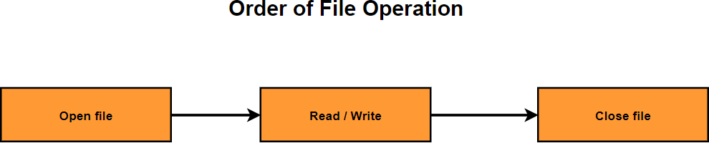

**Open File**

In [69]:

fileobj **=** open('test1.txt') *# Open file in read/text mode*

In [70]:

fileobj **=** open('test1.txt', 'r') *# Open file in read mode*

In [71]:

fileobj **=** open('test1.txt', 'w') *# Open file in write mode*

In [72]:

fileobj **=** open('test1.txt', 'a') *# Open file in append mode*

### Close File

In [73]:

fileobj.close()

### Read File

In [84]:

fileobj **=** open('test1.txt')

In [85]:

fileobj.read() *#Read whole file*

Out[85]:

'Python generators are easy way of creating iterators. It generates values one at a time from a given sequence instead of returning the entire sequence at onc e.\nIt is a special type of function which returns an iterator object.\nIn a ge nerator function, a yield statement is used rather than a return statement.\nTh e generator function cannot include the return keyword. If we include it then i t will terminate the execution of the function.\nThe difference between yield a nd return is that once yield returns a value the function is paused and the con trol is transferred to the caller.Local variables and their states are remember ed between successive calls. In case of the return statement value is returned and the execution of the function is terminated.\nMethods like iter() and _

_next() are implemented automatically in generator function.\nSimple generato rs can be easily created using generator expressions. Generator expressions cre ate anonymous generator functions like lambda.\nThe syntax for generator expres sion is similar to that of a list comprehension but the only difference is squa re brackets are replaced with round parentheses. Also list comprehension produc es the entire list while the generator expression produces one item at a time w hich is more memory efficient than list comprehension.'

In [86]:

fileobj.read() *#File cursor is already at the end of the file so it won't be abl*

Out[86]: ''

In [87]:

fileobj.seek(0) *# Bring file cursor to initial position.*

fileobj.read()

Out[87]: 'Python generators are easy way of creating iterators. It generates values one at a time from a given sequence instead of returning the entire sequence at onc e.\nIt is a special type of function which returns an iterator object.\nIn a ge nerator function, a yield statement is used rather than a return statement.\nTh e generator function cannot include the return keyword. If we include it then i t will terminate the execution of the function.\nThe difference between yield a nd return is that once yield returns a value the function is paused and the con trol is transferred to the caller.Local variables and their states are remember ed between successive calls. In case of the return statement value is returned and the execution of the function is terminated.\nMethods like iter() and _

_next() are implemented automatically in generator function.\nSimple generato rs can be easily created using generator expressions. Generator expressions cre ate anonymous generator functions like lambda.\nThe syntax for generator expres sion is similar to that of a list comprehension but the only difference is squa re brackets are replaced with round parentheses. Also list comprehension produc es the entire list while the generator expression produces one item at a time w hich is more memory efficient than list comprehension.'

In [88]:

fileobj.seek(7) *# place file cursor at loc 7*

fileobj.read()

Out[88]: 'generators are easy way of creating iterators. It generates values one at a ti me from a given sequence instead of returning the entire sequence at once.\nIt is a special type of function which returns an iterator object.\nIn a generator function, a yield statement is used rather than a return statement.\nThe genera tor function cannot include the return keyword. If we include it then it will t erminate the execution of the function.\nThe difference between yield and retur n is that once yield returns a value the function is paused and the control is transferred to the caller.Local variables and their states are remembered betwe en successive calls. In case of the return statement value is returned and the execution of the function is terminated.\nMethods like iter() and next()_

_ are implemented automatically in generator function.\nSimple generators can b e easily created using generator expressions. Generator expressions create anon ymous generator functions like lambda.\nThe syntax for generator expression is similar to that of a list comprehension but the only difference is square brack ets are replaced with round parentheses. Also list comprehension produces the e ntire list while the generator expression produces one item at a time which is more memory efficient than list comprehension.'

In [89]:

fileobj.seek(0)

fileobj.read(16) *# Return the first 16 characters of the file*

Out[89]: 'Python generator'

In [90]:

fileobj.tell() *# Get the file cursor position*

Out[90]: 16

In [91]:

fileobj.seek(0)

print(fileobj.readline()) *# Read first line of a file.* print(fileobj.readline()) *# Read second line of a file.* print(fileobj.readline()) *# Read third line of a file.*

Python generators are easy way of creating iterators. It generates values one a t a time from a given sequence instead of returning the entire sequence at onc e.

It is a special type of function which returns an iterator object.

In a generator function, a yield statement is used rather than a return stateme nt.

In [92]:

fileobj.seek(0)

fileobj.readlines() *# Read all lines of a file.*

Out[92]: ['Python generators are easy way of creating iterators. It generates values one at a time from a given sequence instead of returning the entire sequence at onc e.\n',

'It is a special type of function which returns an iterator object.\n',

'In a generator function, a yield statement is used rather than a return state ment.\n',

'The generator function cannot include the return keyword. If we include it th en it will terminate the execution of the function.\n',

'The difference between yield and return is that once yield returns a value th e function is paused and the control is transferred to the caller.Local variabl es and their states are remembered between successive calls. In case of the ret urn statement value is returned and the execution of the function is terminate d.\n',

'Methods like iter() and next() are implemented automatically in gener ator function.\n',

'Simple generators can be easily created using generator expressions. Generato r expressions create anonymous generator functions like lambda.\n',

'The syntax for generator expression is similar to that of a list comprehensio n but the only difference is square brackets are replaced with round parenthese

s. Also list comprehension produces the entire list while the generator express ion produces one item at a time which is more memory efficient than list compre hension.']

In [93]:

*# Read first 5 lines of a file using readline()*

fileobj.seek(0)

count **=** 0

**for** i **in** range(5):

**if** (count **<** 5):

print(fileobj.readline())

**else**:

**break**

count**+=**1

Python generators are easy way of creating iterators. It generates values one a t a time from a given sequence instead of returning the entire sequence at onc e.

It is a special type of function which returns an iterator object.

In a generator function, a yield statement is used rather than a return stateme nt.

The generator function cannot include the return keyword. If we include it then it will terminate the execution of the function.

The difference between yield and return is that once yield returns a value the function is paused and the control is transferred to the caller.Local variables and their states are remembered between successive calls. In case of the return statement value is returned and the execution of the function is terminated.

In [94]:

*# Read first 5 lines of a file using readlines()*

fileobj.seek(0)

count **=** 0

**for** i **in** fileobj.readlines():

**if** (count **<** 5): print(i)

**else**:

**break**

count**+=**1

Python generators are easy way of creating iterators. It generates values one a t a time from a given sequence instead of returning the entire sequence at onc e.

It is a special type of function which returns an iterator object.

In a generator function, a yield statement is used rather than a return stateme nt.

The generator function cannot include the return keyword. If we include it then it will terminate the execution of the function.

The difference between yield and return is that once yield returns a value the function is paused and the control is transferred to the caller.Local variables and their states are remembered between successive calls. In case of the return statement value is returned and the execution of the function is terminated.

### Write File

In [95]:

fileobj **=** open('test1.txt', 'a')

fileobj.write('THIS IS THE NEW CONTENT APPENDED IN THE FILE') *# Append content t*

fileobj.close()

fileobj **=** open('test1.txt') fileobj.read()

Out[95]: 'Python generators are easy way of creating iterators. It generates values one at a time from a given sequence instead of returning the entire sequence at onc e.\nIt is a special type of function which returns an iterator object.\nIn a ge nerator function, a yield statement is used rather than a return statement.\nTh e generator function cannot include the return keyword. If we include it then i t will terminate the execution of the function.\nThe difference between yield a nd return is that once yield returns a value the function is paused and the con trol is transferred to the caller.Local variables and their states are remember ed between successive calls. In case of the return statement value is returned and the execution of the function is terminated.\nMethods like iter() and _

_next() are implemented automatically in generator function.\nSimple generato rs can be easily created using generator expressions. Generator expressions cre ate anonymous generator functions like lambda.\nThe syntax for generator expres sion is similar to that of a list comprehension but the only difference is squa re brackets are replaced with round parentheses. Also list comprehension produc es the entire list while the generator expression produces one item at a time w hich is more memory efficient than list comprehension.THIS IS THE NEW CONTENT A PPENDED IN THE FILE'

In [96]:

fileobj **=** open("test1.txt", "w")

fileobj.write("NEW CONTENT ADDED IN THE FILE. PREVIOUS CONTENT HAS BEEN OVERWRIT

fileobj.close()

fileobj **=** open('test1.txt') fileobj.read()

Out[96]: 'NEW CONTENT ADDED IN THE FILE. PREVIOUS CONTENT HAS BEEN OVERWRITTEN'

In [114]:

fileobj **=** open("test2.txt", "w") *# Create a new file*

fileobj.write("First Line\n") fileobj.write("Second Line\n") fileobj.write("Third Line\n") fileobj.write("Fourth Line\n") fileobj.write("Fifth Line\n") fileobj.close()

fileobj **=** open('test2.txt') fileobj.readlines()

Out[114]: ['First Line\n',

'Second Line\n', 'Third Line\n', 'Fourth Line\n', 'Fifth Line\n']

### Delete file

In [115]:

os.remove("test3.txt") *# Delete file*

In [116]:

os.remove("test3.txt")

#### ---------------------------------------------------------------------------

**FileNotFoundError** Traceback (most recent call last)

**<ipython-input-116-fecc9f240170>** in <module>

**----> 1** os**.**remove**("test3.txt")**

**FileNotFoundError**: [WinError 2] The system cannot find the file specified: 'tes t3.txt'

In [117]:

os.rmdir('folder1/') *# Delete folder*

In [118]:

os.rmdir('folder1/')

#### ---------------------------------------------------------------------------

**FileNotFoundError** Traceback (most recent call last)

**<ipython-input-118-e9e89c9edbf0>** in <module>

**----> 1** os**.**rmdir**('folder1/')**

**FileNotFoundError**: [WinError 2] The system cannot find the file specified: 'fol der1/'

# Error & Exception Handling

Python has many built-in exceptions (ArithmeticError, ZeroDivisionError, EOFError, IndexError, KeyError, SyntaxError, IndentationError, FileNotFoundError etc) that are raised when your program encounters an error.

When the exception occurs Python interpreter stops the current process and passes it to the calling process until it is handled. If exception is not handled the program will crash.

Exceptions in python can be handled using a **try** statement. The **try** block lets you test a block of code for errors.

The block of code which can raise an exception is placed inside the try clause. The code that will handle the exceptions is written in the **except** clause.

The **finally** code block will execute regardless of the result of the try and except blocks.

We can also use the **else** keyword to define a block of code to be executed if no exceptions were raised.

Python also allows us to create our own exceptions that can be raised from the program using the **raise** keyword and caught using the **except** clause. We can define what kind of error to

raise, and the text to print to the user.

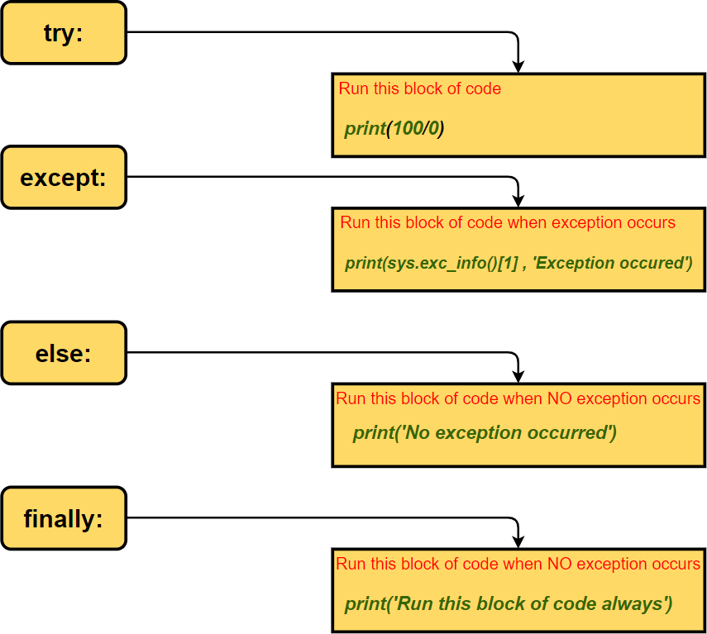

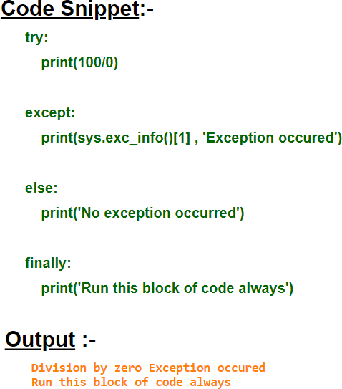

In [130]:

**try**:

print(100**/**0) *# ZeroDivisionError will be encountered here. So the control wi*

**except**:

print(sys.exc_info()[1] , 'Exception occured') *# This statement will be exec*

**else**:

print('No exception occurred') *# This will be skipped as code block inside t*

**finally**:

print('Run this block of code always') *# This will be always executed*

division by zero Exception occured Run this block of code always

In [134]:

**try**:

print(x) *# NameError exception will be encountered as variable x is not def*

**except**:

print('Variable x is not defined')

Variable x is not defined

In [137]:

**try**:

os.remove("test3.txt") *# FileNotFoundError will be encountered as "test3.txt*

**except**:

*# Below statement will be executed as exception occu*

print("BELOW EXCEPTION OCCURED")

print(sys.exc_info()[1])

**else**:

print('\nNo exception occurred')

**finally**:

print('\nRun this block of code always')

BELOW EXCEPTION OCCURED

[WinError 2] The system cannot find the file specified: 'test3.txt' Run this block of code always

In [141]:

*# Handling specific exceptions*

**try**:

x **=** int(input('Enter first number :- '))

y **=** int(input('Enter first number :- ')) *# If input entered is non-zero th*

print(x**/**y)

os.remove("test3.txt")

**except** NameError:

print('NameError exception occurred')

**except** FileNotFoundError:

print('FileNotFoundError exception occurred')

**except** ZeroDivisionError:

print('ZeroDivisionError exception occurred')

Enter first number :- 12 Enter first number :- 13 0.9230769230769231

FileNotFoundError exception occurred

In [142]:

*# Handling specific exceptions*

**try**:

x **=** int(input('Enter first number :- '))

y **=** int(input('Enter first number :- ')) *# If the input entered is zero the*

print(x**/**y)

os.remove("test3.txt")

**except** NameError:

print('NameError exception occurred')

**except** FileNotFoundError:

print('FileNotFoundError exception occurred')

**except** ZeroDivisionError:

print('ZeroDivisionError exception occurred')

Enter first number :- 10 Enter first number :- 0

ZeroDivisionError exception occurred

In [144]:

**try**:

x **=** int(input('Enter first number :- '))

**if** x **>** 50:

**raise** ValueError(x) *# If value of x is greater than 50 ValueError except*

**except**:

print(sys.exc_info()[0])

Enter first number :- 100

<class 'ValueError'>

### Built-in Exceptions

In [149]:

*# OverflowError - This exception is raised when the result of a numeric calculat*

**try**:

**import** math

print(math.exp(1000))

**except** OverflowError:

print (sys.exc_info())

**else**:

print ("Success, no error!")

(<class 'OverflowError'>, OverflowError('math range error'), <traceback object at 0x000002B2B12EFB88>)

In [150]:

*# ZeroDivisionError - This exception is raised when the second operator in a div*

**try**:

x **=** int(input('Enter first number :- ')) y **=** int(input('Enter first number :- ')) print(x**/**y)

**except** ZeroDivisionError:

print('ZeroDivisionError exception occurred')

Enter first number :- 100 Enter first number :- 0

ZeroDivisionError exception occurred

In [152]:

*# NameError - This exception is raised when a variable does not exist*

**try**:

print(x1)

**except** NameError:

print('NameError exception occurred')

NameError exception occurred

In [155]:

*# AssertionError - This exception is raised when an assert statement fails*

**try**:

a **=** 50

b **=** "Asif"

**assert** a **==** b

**except** AssertionError:

print ("Assertion Exception Raised.")

Assertion Exception Raised.

In [157]:

*# ModuleNotFoundError - This exception is raised when an imported module does no*

**try**:

**import** MyModule

**except** ModuleNotFoundError:

print ("ModuleNotFoundError Exception Raised.")

ModuleNotFoundError Exception Raised.

In [160]:

*# KeyError - This exception is raised when key does not exist in a dictionary*

**try**:

mydict **=** {1:'Asif', 2:'Basit', 3:'Michael'} print (mydict[4])

**except** KeyError:

print ("KeyError Exception Raised.")

KeyError Exception Raised.

In [162]:

*# IndexError - This exception is raised when an index of a sequence does not exi*

**try**:

mylist **=** [1,2,3,4,5,6] print (mylist[10])

**except** IndexError:

print ("IndexError Exception Raised.")

IndexError Exception Raised.

In [165]:

*# TypeError - This exception is raised when two different datatypes are combined*

**try**:

a **=** 50

b **=** "Asif" c **=** a**/**b

**except** TypeError:

print ("TypeError Exception Raised.")

TypeError Exception Raised.

In [171]:

*# AttributeError: - This exception is raised when attribute reference or assignm*

**try**:

a **=** 10

b **=** a.upper() print(b)

**except** AttributeError:

print ("AttributeError Exception Raised.")

AttributeError Exception Raised.

In [ ]:

**try**:

x **=** input('Enter first number :- ')

**except**:

print('ZeroDivisionError exception occurred')

# END