**BACKUP PLAN FOR PRODUCTION SERVERS**

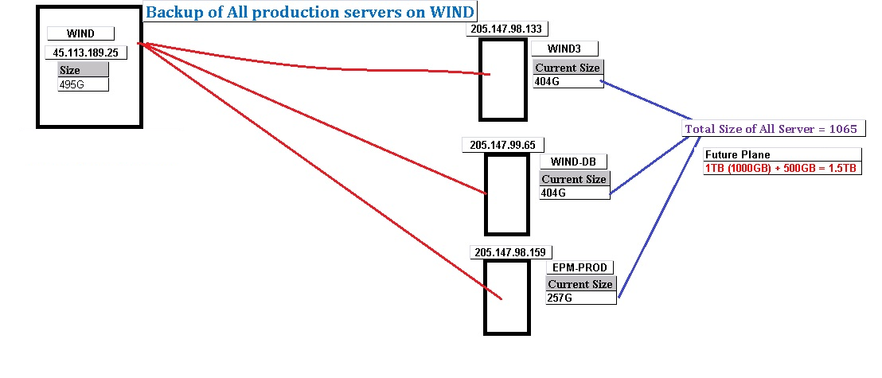

**Backup Plan: -**

1. We have a new server on cloud - WIND (45.113.189.25) with disk space of 500GB in current.

2. Database backup is being on WIND currently, and rest of the space we can use for other production servers backup.

3. Rest of the production servers – WIND-DB, WIND3, EPM-PROD with space of mentioned following.

WIND3 – 404GB

WIND-DB – 404GB

EPM-PROD – 257GB

4. We would be need extra 1TB space for complete backup of all production servers.

5. We have received the quotation from the vender as following.

5Rs/per CB

5 x 1000 = 5000 + Taxes.