**C#:**

.NET is a framework to develop software applications. It is designed and developed by Microsoft and the first beta version released in 2000.

C# works on the basis of .NET framework.

The software programs written in .NET are executed in the execution environment, which is called CLR (Common Language Runtime).

CLR: It is a program execution engine that loads and executes the program. It converts the program into native code

Feature of C#:

* C# is a simple language
* Object oriented programing language
* C# is a structured programming language in the sense that we can break the program into parts using functions.
* C# provides a lot of inbuilt functions that makes the development fast

# C# Data Types:

VALUE DATATYPE: 1: Predefined data types

2: User defined data types

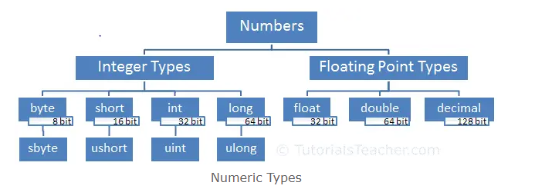

1. Integer type numbers are positive or negative whole numbers without decimal point
2. Floating point type numbers are positive or negative whole numbers with decimal point

Short s1 = -32768;

Short s2 = 32767;

Ushort us1 = 65535;

Ushort us2 = -32000; //Compile-time

Byte b1 = 255;

Byte b2 = -128; // compile-time

Sbyte sb1 = -128;

Sbyte sb2 = 127;

long s1 = -32768;

long s2 = 32767;

Ulong us1 = 65535;

Ulong us2 = -32000; //Compile-time

int i1 = 255;

int i2 = -128;

uint sb1 = -128;// compile-time

uint sb2 = 127;

1. The uint type stores only positive numbers
2. The ushort type stores only positive numbers
3. The ulong type stores only positive numbers
4. The Byte type stores only positive numbers

**STRUCTURE:**

1. Struct is be used to hold small data values.
2. A structure is declared using struct keyword. The default modifier is internal for the struct and its members.
3. Struct is by default non static
4. EX:

struct Coordinate

{

Public int x;

Public int y;

}

Coordinate point = new Coordinate ();

;

Console. Write(point.x); // Compile time error

Point.x = 10;

point.y = 20;

Console.Write(point.x); //output: 10

Console.Write(point.y); //output: 20

**ENUM:**

1. In C#, an ENUM (or enumeration type) is used to assign constant names to a group of numeric integer values.
2. Enum is by default static.
3. EX:

enum Weekdays

{

Monday,

Tuesday,

Wednesday,

Thursday,

Friday,

Saturday,

Sunday

}

Console.WriteLine(Weekdays.Friday); //output: Friday

int day = (int) Weekdays.Friday; // enum to int conversion

Console.WriteLine(day); //output: 4

var wd = (WeekDays) 5; // int to enum conversion

Console.WriteLine(wd); //output: Saturday