ISYE 7406 Homework5

Introduction
The airline industry has the potential to be one of the most lucrative industries , and at the same time also comes with high capital requirements. To ensure maximum profits, it is imperative to cater to the number one aspect which can guarantee success, which is none other than customer satisfaction. For any business to be profitable, it must ensure that its customers are satisfied to ensure growth. Major Airlines in the world such as Emirates, Etihad, Qatar Airways, Delta Airlines, and American Airlines are some of the most successful airlines that the world has seen till date and they are still continuing to grow their customer base exponentially. This is because they pay immense detail to customer satisfaction. If customers are satisfied with their flying experience, they are likely to fly with the same airline next time, and can even go to the extent of advertising for it. Airlines also have to be mindful of the budget in enhancing various features of the flying experience such as booking, facilities such as wifi in the aircraft, food, etc and it is important to analyse where to invest money to ensure maximum returns. In this homework, I aim to analyse a variety of features that are potential factors in resulting in satisfied customers and draw conclusions as to which aspects are the most important for certain demographics. I will analyze an airline satisfaction dataset, which will contain reviews of travelers and their ratings about different aspects about their experience flying. The response variable is a variable indicating whether the customer was either satisfied or neutral/dissatisfied. I will be applying ensemble methods such as random forest , adaboost and compare it against more baseline machine learning models such as logistic regression, and Naïve Bayes Classifier. I will be analyzing the performance of each of these classifiers in this report.

Problem Statement/Data Sources
The dataset for this homework was obtained from Kaggle and the url to the dataset is https://www.kaggle.com/datasets/teejmahal20/airline-passenger-satisfaction . The data set is of size 15.23 MB and consists of a training and test dataset. Following are the data columns available in the data set with their description:

Attribute name | Description | Datatype | Units
Gender | Gender of the passengers | Categorical | (Female, Male)
Customer Type | The customer type | Categorical | (Loyal customer, disloyal customer)
Age | The actual age of the passengers | Numerical | Years
Type of Travel | Purpose of the flight of the passengers | Categorical | (Personal Travel, Business Travel)
Class | Travel class in the plane of the passengers | Categorical | (Business, Eco, Eco Plus)
Flight distance | The flight distance of this journey | Numerical | Miles
Inflight wifi service | Satisfaction level of the inflight wifi service | Numerical | Rating (0: Not Applicable;1-5)
Departure/Arrival time convenience | Satisfaction level of departure/arrival time to the passengers | Numerical | Rating (1-5)
Ease of Online booking | Satisfaction level of online booking | Numerical | Rating (1-5)
Gate location | Satisfaction level of Gate location | Numerical | Rating (1-5)
Food and drink | Satisfaction level of Food and drink | Numerical | Rating (1-5)
Online boarding | Satisfaction level of online boarding | Numerical | Rating (1-5)
Seat comfort | Satisfaction level of Seat comfort | Numerical | Rating (1-5)
Inflight entertainment | Satisfaction level of inflight entertainment | Numerical | Rating (1-5)
On-board service | Satisfaction level of On-board service | Numerical | Rating (1-5)
Leg room service | Satisfaction level of Leg room service | Numerical | Rating (1-5)
Baggage handling | Satisfaction level of baggage handling | Numerical | Rating (1-5)
Check-in service | Satisfaction level of Check-in service | Numerical | Rating (1-5)
Inflight service | Satisfaction level of inflight service | Numerical | Rating (1-5)
Cleanliness | Satisfaction level of Cleanliness | Numerical | Rating (1-5)
Departure Delay | Minutes delayed when departure | Numerical | Minutes
Arrival Delay | Minutes delayed when Arrival | Numerical | Minutes
Satisfaction | Airline satisfaction level | Categorical | (Satisfaction, neutral or dissatisfaction)

Using ensemble methods, I aim to be able to predict if a given customer is satisfied given his/her satisfaction ratings and flight information such as Departure/Arrival Delay and flight distance. I will be leveraging Random Forest and Adaboost for this. I will compare my accuracies with baseline models such as basic logistic regression and the Naïve Bayes Classifier. The hyperparameter tuning for each machine learning model was done through K-fold cross validation on the training dataset, and obtaining the final accuracies using the hyperparameters derived on the test dataset.
There are several categorical variables such as Gender, Customer Type, Class, etc which cannot be directly used in the machine learning models or exploratory data analysis to derive correlation between different features of this dataset. Therefore, One-Hot encoding was used to separate out the categorical variables into different features and the response variable, satisfaction levels, was label encoded to 1 and 0. The value 1 for the response represents the customer was satisfied with his/her experience whereas a value of 0 signifies neutrality or unsatisfaction.
After cleaning up the dataset to accommodate categorical variables, I visualized a correlation matrix to understand which features are correlated with each other and what features contribute most to the response variable satisfaction. The correlation matrix is given below:

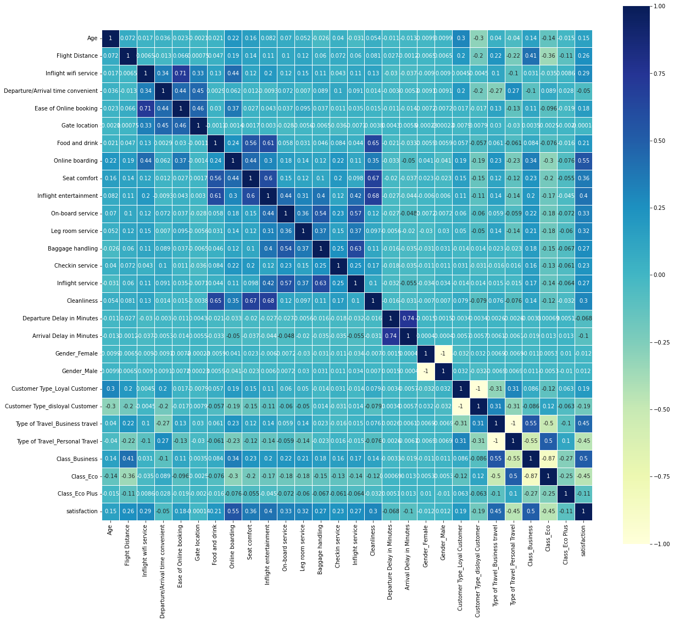

As seen from the above correlation matrix , Business class passengers seem to have the highest satisfaction levels. A large number of satisfied passengers also seem to have a good online booking experience. In flight entertainment and seat comfort also seem to be playing a large role in shaping customer satisfaction. Another notable observation is that departure delay is highly correlated with arrival delay. Cleanliness also is highly correlated with seat comfort and food and drinks.
Arrival Delays had some missing values in the dataset, and they were imputed using KNN imputation technique which assumes the value of K nearest features which actually have the value of the attribute.

Methodology
After doing basic exploratory analysis and processing the dataset, I performed KNN imputation for the Arrival Delay Missing values. This method of imputation takes into account similar datapoints and using the average delay provided in those datapoints to impute the value. In this case, I have tuned to consider 5 nearest datapoints to perform the imputation for the missing values for Arrival Delays feature.
Scaling
After imputing, I have scaled the values using the StandardScaler module in sklearn. Scaling is important in this case, since we have a lot of features that hold ratings from 1-5,but also metrics like age which can significantly skew our results by giving weight to higher age. Also, features like departure delay
I have considered 4 models for this analysis; 2 ensemble models and 2 baseline models to compare against. For the ensemble models, I have chosen Random Forest Classifier and Adaboost Classifier. For the baseline models, I have leveraged Logistic Regression and Naïve Bayes Classifier.
Parameter Tuning
For the random forest classifier and adaboost classifier , there are many tuning parameters to consider to be able to get the most optimal fit and accuracy of the test dataset. This would involve trial and error, and figuring out the tuning hyperparameter values for the model. I have leveraged the K-fold cross validation technique to achieve this. In the sklearn package in python, there is function called RandomizedSearchCV, which performs the necessary cross validation required to obtain the best performing model when tuning parameters. I have used 5 folds in the cross validation technique.
For the Random Forest Classifier, I tuned the following parameters:
- Number of Estimators or trees in the forest. I varied this from 50 to 300 trees.
- Max Features which represents the number of features to consider when looking at the best split. This takes values of square root, or log2.
- Minimum Samples split of the minimum samples required to split a node.
There were 50 iterations of fitting the model and obtaining the best performing model using cross validation .
For the Adaboost Ensemble Classifier, I have tuned the following hyperparameters:
- Number of Estimators- the maximum number of estimators at which boosting is terminated . I varied this between 20 and 80.
- The Learning Rate- this represents the weight applied to each classifier at each boosting iteration. It is said that a higher learning rate increases the contribution of each classifier.
I believe the above 2 hyperparameters should be varied as there is a tradeoff between the learning rate and the number of estimators. Therefore, it is imperative that the optimal values for both tuning parameters must be considered to ensure the best accuracy.
Ensemble methods use a number of weak classifiers and combine them to be able to create a strong classifier for the use case we would like. This offers plenty of flexibility into being able to predict against very different and versatile datasets. Random forest is very powerful also in this sense, because it generates a wide variety of trees that can be used and selects the best set or combination that gives the best performance. Therefore, the bulk of the work actually lies in tuning the hyperparameters to values that actually would guarantee us a good performance on the testing dataset.
The base models that were leveraged were logistic regression and naïve bayes classifier. These models are not as flexible as ensemble methods and are not that customizable. However, through basic tuning, we can boost the testing accuracy.
Some of the basic hyperparameters used in logistic regression are given below:
- L2 Penalty Term
- Lbfgs Solver algorithm
For the naïve bayes classifier, I have not used any prior probabilities of the classes, and used the default variable smoothing parameter which is 1*10^-9.
Once the hyperparameters are tuned, the models which gave the best accuracy in cross validation were selected and the testing accuracies for the ensemble methods were obtained using the models with the optimal hyperparameters for random forest and adaboost.
Similarly, the testing accuracies of logistic regression and naïve bayes classifier were obtained. The results for each classifier were obtained and insights were drawn from these accuracies which are presented in the next section.

Results
After tuning the hyperparameters using k fold cross validation for the ensemble methods, the following models were used:
Random Forest
- Number of Estimators -300
- Max Features- Sqrt
- Minimum Samples Split- 2
Adaboost
- Number of Estimators-80
- Learning Rate- 1.0

The accuracies of the Random Forest, Adaboost, Logistic Regression and Naïve Bayes Classifier are below:
Model | Accuracy
Random Forest | 96.3%
Boosting | 92.8%
Logistic Regression | 87.21%
Naïve Bayes Classifier | 84.42%

Of all the models, the random forest model seems to have the best accuracy on the testing dataset.

Conclusion
From the results above, Random forest Classifier was the best performing model with 96.3% accuracy on the testing dataset. This is because there were a lot of features that were considered, and random forest considers almost every possibility with the number of trees it considers to arrive at the final class. This is followed by Adaboost, which also combines a set of weak classifiers to make a strong classifier customizable to the structure and dynamics of this dataset. Hence, we see the next highest accuracy for adaboost. Following Adaboost, we see logistic regression and naïve bayes classifier. Random forest generates many possible trees and finds the best combination which can give us the best testing accuracy, and this really ties into the importance of tuning our hyperparameters. Through K-fold cross validation techniques, I was able to find the best set of hyperparameters to get the best set of trees and combinations of trees for the best testing accuracy.
From the above analysis, we also find that ensemble methods tend to have a better testing accuracy because they are more customizable to our dataset and offer a lot of flexibility into parameter tuning. The training dataset and testing dataset were relatively of a good size 15.23 MB, which offers a good comprehensive result. Given a set of passengers ratings, we could accurately predict the satisfiability of the customer given his set of ratings.
Some things to be considered during future development is PCA, which breaks down the dataset into a lower dimension, while preserving the variance of the datapoints. Running the machine learning models on the PCA components could potentially be tested.
As compared to baseline methods, ensemble methods offer a lot more in terms of being able to tune models effectively and result in better accuracies with datasets containing a lot of features. Another potential model to consider are neural networks, and how they compare to ensemble methods. This is up for further exploration as part of my project.

