CS634-Final Term Project Report

Student Name: Rajeev Kumar Alahari
Course: CS634-Data Mining
Instructor: Dr. Yasser Abduallah
Project Title: Binary Classification of Red vs. White Wine Using Random Forest, KNN, and Conv1D
Date: 11-16-2025

1 Introduction
The goal of this project is to build, evaluate, and compare data-mining models for a binary classification task. Specifically, we predict whether a wine sample is red or white based only on its physicochemical properties (acidity, sugar, sulfur dioxide, alcohol, etc.).

Binary classification is a core problem in data mining and machine learning where each instance is assigned to one of two classes (yes or no).

2 Dataset Creation
Name: Wine Type Classification Dataset
Source: Kaggle dataset “Wine Type Classification Dataset” (originally from UCI Wine Quality datasets)
Link: https://www.kaggle.com/datasets/ehsanesmaeili/red-and-white-wine-quality-merged
Description:
Number of rows: The dataset contains 6,497 wine samples.
Features: It includes 11 physicochemical numeric features and 1 numeric quality score used as an additional feature(So total 12 Features).
Target variable: The binary target is wine type (`red` vs `white`).
Preprocessing Steps:
Missing values: Dataset has no missing values, so no imputation was required.
Normalization/Standardization: All numeric features were standardized using StandardScaler to improve model performance.
Label encoding: The categorical target `type` (“red”, “white”) was label-encoded into 0/1 for machine learning models.
Class balance: Class distribution is moderately imbalanced (nearly 25% red, 75% white), but both classes are sufficiently represented for training.

3. Algorithms Overview
3.1 Random Forest
Random Forest is an ensemble learning method that builds many decision trees on random subsets of the data and features, and then averages their predictions (for classification, using majority vote). It is robust to noise, can model nonlinear decision boundaries, and typically works well out-of-the-box with minimal tuning. In this project, a Random Forest with around 200 trees and default depth settings was used. Random Forest is expected to perform very well here because the classes are well separated and the number of features is modest.
3.2 Conv1D Neural Network
The Conv1D model is a 1-D convolutional neural network that treats the 11 numeric features as a short 1D sequence. Convolutional layers learn local patterns (combinations of nearby features), followed by pooling and fully connected layers to produce a final binary output via a sigmoid activation.
The architecture used:
Input shape: (n_features, 1)
One or two Conv1D layers (e.g., 64 and 32 filters, kernel size 3)
Global max pooling
Dense hidden layer(s) with ReLU
Output layer: 1 neuron with sigmoid activation
Conv1D was chosen as the deep learning model because it is simple, efficient for tabular sequences, and compatible with Keras/TensorFlow. It can capture interactions between neighboring features and potentially achieve performance comparable to or better than classical methods.
3.3 K-Nearest Neighbors (KNN)
KNN is a classic instance-based machine learning method. To classify a new sample, it finds the k most similar training examples (here, using Euclidean distance on standardized features) and predicts the majority class among them.
In this project:
k = 13 neighbors
Distance: Euclidean
Features standardized beforehand
KNN is simple and intuitive. It can perform well on datasets where same-class points are clustered in feature space, which we expect here because red and white wines have distinct ranges of acidity, sulfur, and sugar levels. However, KNN can be sensitive to the choice of k and to class imbalance.
4 Implementation
Programming language: Python
Development environment: Jupyter Notebook and .py scripts.
Required Python packages and installation instructions
pip install numpy pandas scikit-learn tensorflow keras matplotlib seaborn
Screenshots:
Dataset loading/preview
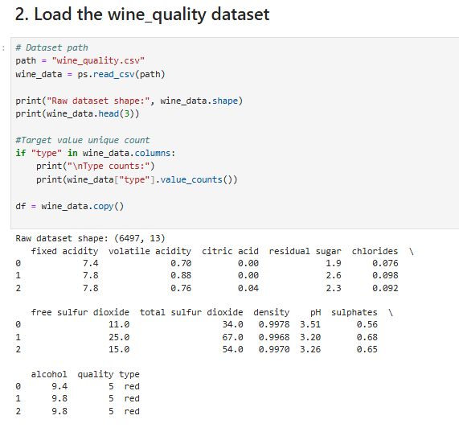
The dataset is successfully loaded and description can be seen.

Per-fold evaluation outputs/results
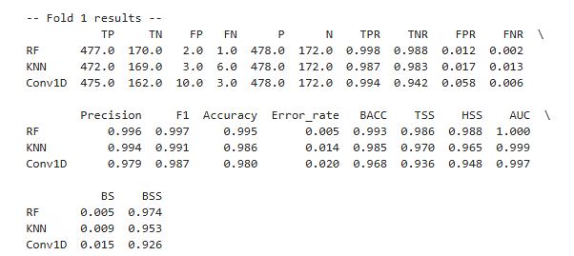
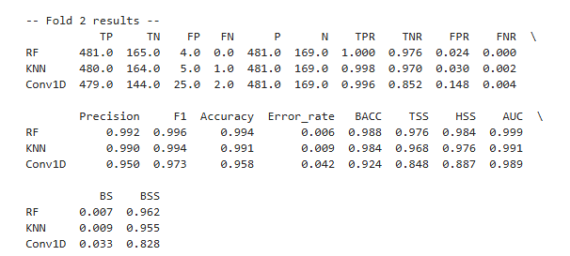
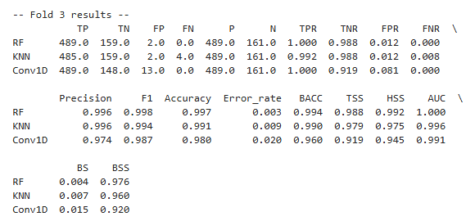
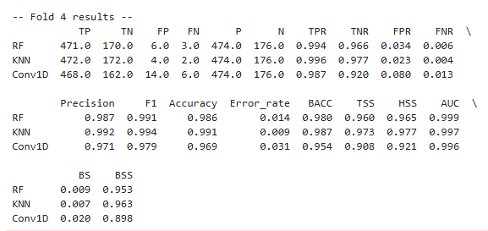
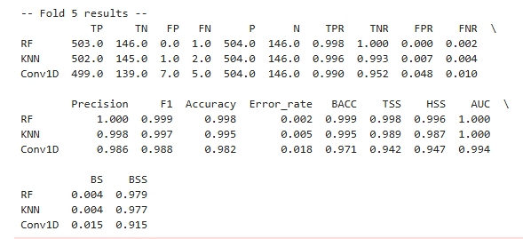
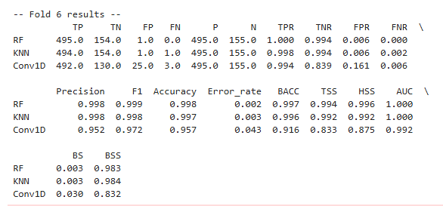
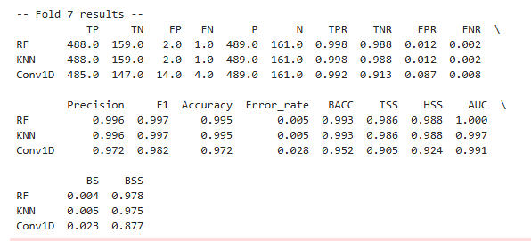
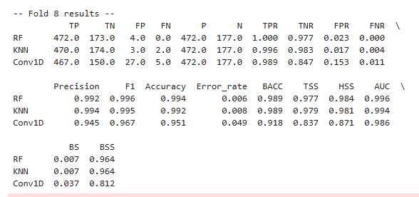
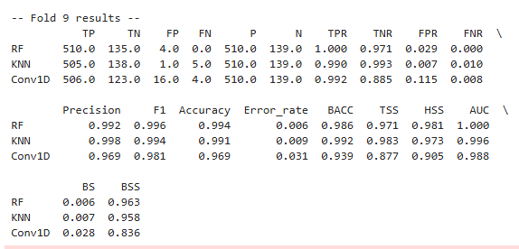
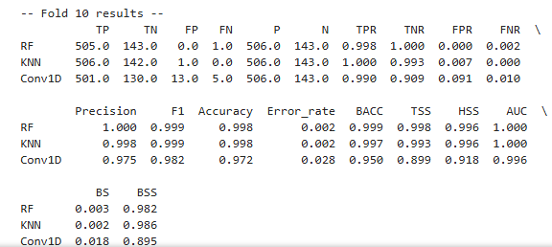
5 Evaluation Setup
Method: 10-fold cross-validation.
Metrics to report for each fold and overall averages: TP, TN, FP, FN, Accuracy, Precision,
Recall, F1, FPR, FNR, Specificity, Balanced Accuracy, TSS, HSS, ROC, AUC, BS, BSS.

6 Results
Per Fold Results for all three Algorithms
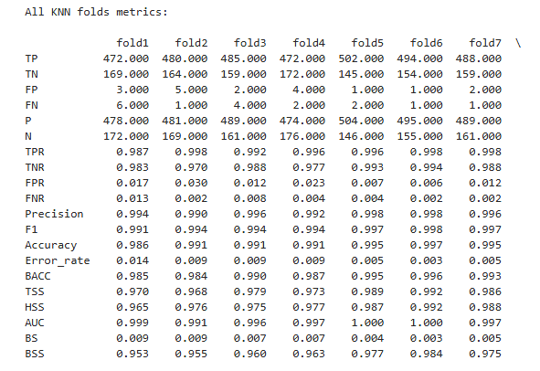
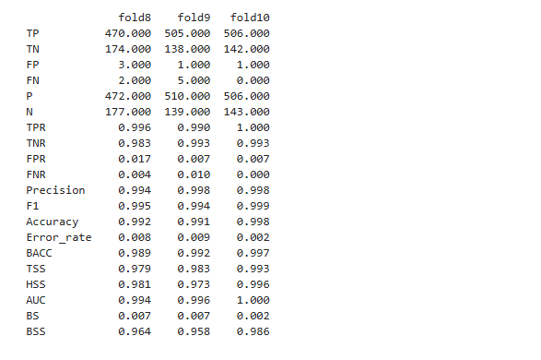
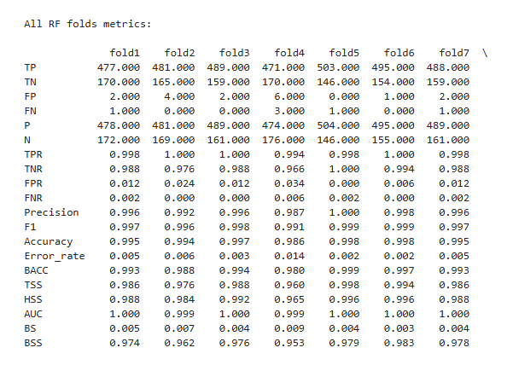
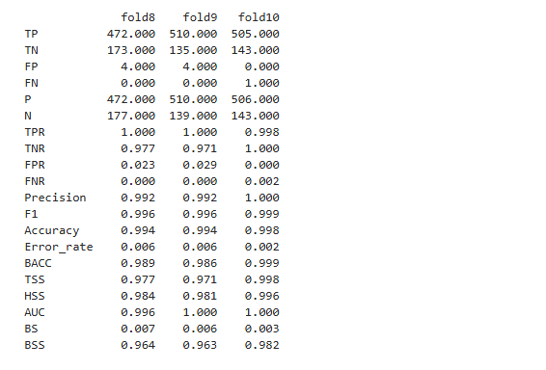
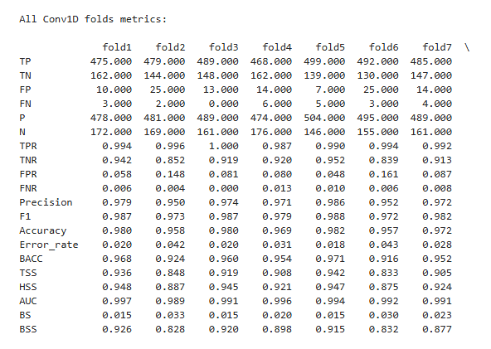

Mean Average Results of all three algorithms of all 10 folds
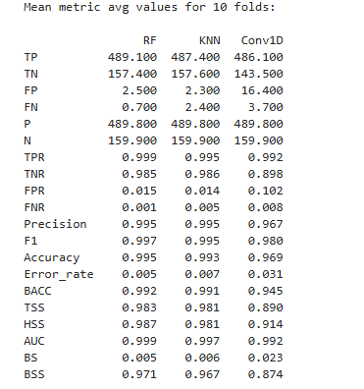
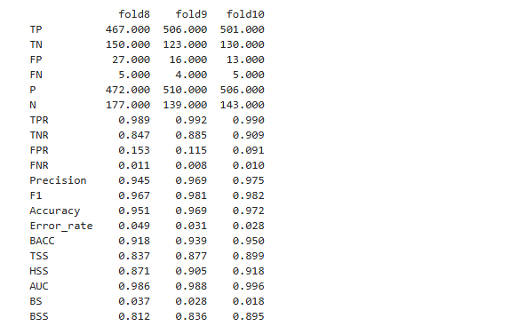
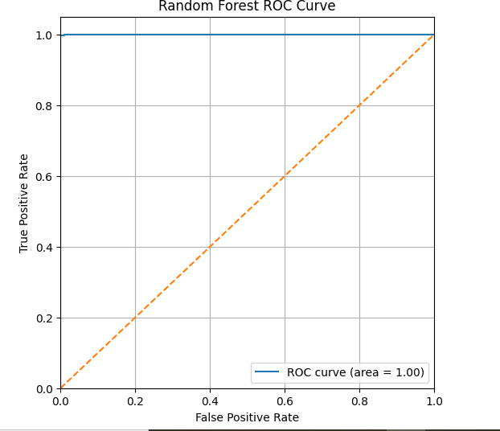
The ROC curve for Random Forest almost hugs the top-left corner with an AUC of 1.00. which means it separates red and white wines almost perfectly. It keeps the true positive rate very close to 1.0 even when the false positive rate is near zero.
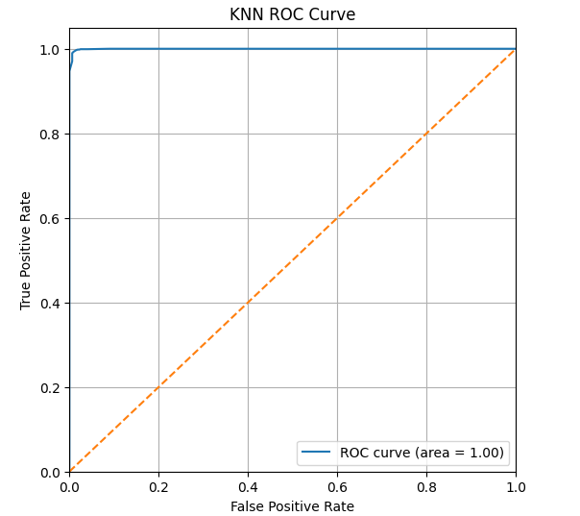
The KNN ROC curve is also very close to the top-left corner with AUC of 1.00, showing that it is nearly as strong as Random Forest. There is a tiny bit more curvature near the start, but it still maintains a very high TPR for low FPR values.
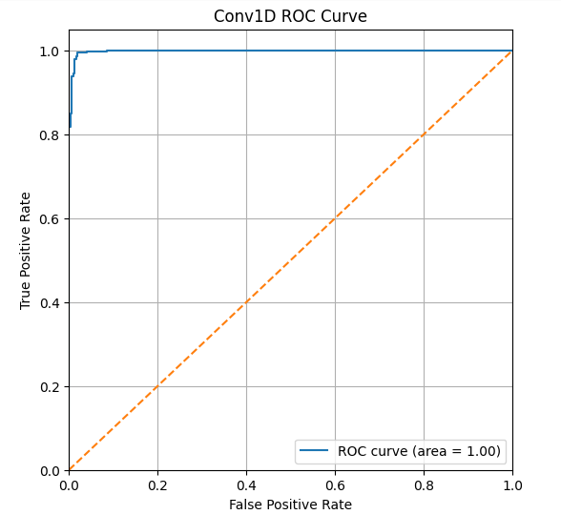
The Conv1D ROC curve rises quickly and stays high, with an AUC close to 1.00 as well, indicating excellent discriminative power. However, compared to RF and KNN, it dips slightly lower near the beginning, which matches its slightly higher false positive rate.

7 Discussion
Overall, all three models – Random Forest, KNN, and Conv1D – performed extremely well on the wine type classification task. The average accuracies over 10 folds are 0.995 for RF, 0.993 for KNN, and 0.971 for Conv1D, with RF having the best scores on almost every metric. Random Forest also reaches the highest recall (TPR = 0.999) and specificity (TNR = 0.985), meaning it almost never misses red wines and rarely mislabels white wines. Its F1 score (0.997), Balanced Accuracy (0.992), and skill scores (TSS = 0.983, HSS = 0.987) show that it is very reliable even with the moderate class imbalance. KNN is only slightly behind RF with very similar precision, F1, and BACC values, while Conv1D has noticeably lower TNR (0.904) and higher FPR (0.096), and its Brier Score (0.023) indicates less accurate probability estimates compared to RF and KNN (BS ≈ 0.005–0.006).

The ROC and AUC results support these observations. All three models have AUC values above 0.99 (RF = 0.999, KNN = 0.997, Conv1D = 0.991), which means they separate red and white wines almost perfectly. In the ROC plots, the curves for RF and KNN stay very close to the top-left corner, showing a high true positive rate even when the false positive rate is low. The Conv1D curve is still strong but slightly lower, matching its weaker TNR and higher FPR. These results suggest that the dataset is highly separable and that classical machine-learning methods, especially Random Forest and KNN, are able to capture the patterns in the physicochemical features more efficiently than the deeper Conv1D model in this case.
8 Conclusion
In this project I used the merged red and white wine dataset from Kaggle to build a binary classifier that predicts whether a wine is red or white based on its physicochemical properties. After encoding the wine type, standardizing the numerical features, and applying 10-fold cross-validation, I compared three algorithms: Random Forest, KNN, and a Conv1D neural network. The experiments showed that all three models achieved very high accuracy and AUC, but Random Forest consistently delivered the best overall performance, with the highest accuracy, F1 score, balanced accuracy, and the lowest error and Brier scores. KNN was a close second, while Conv1D, although still strong, did not outperform the simpler models.

These findings suggest that for structured tabular data like this wine dataset, traditional machine learning models are not only simpler but also highly effective. A well-tuned Random Forest could realistically be used in a real lab or production setting to automatically verify wine type from chemical measurements. In the future, this work could be extended by predicting wine quality levels instead of just type, performing more systematic hyperparameter tuning, and trying additional ensemble methods such as Gradient Boosting or XGBoost. This would help to see whether any further gains are possible beyond the already very strong results obtained in this study.
9 References
Link: https://www.kaggle.com/datasets/ehsanesmaeili/red-and-white-wine-quality-merged

10 GitHub Repository
Link: https://github.com/rajeevalahari/alahari_rajeevkumar_finalproject

[OPTIONAL]
For Supporting notes or clarifications and instructions to run the code visit github readme.

