Git Push:

1. Create account in <https://github.com/>
2. Create Repository

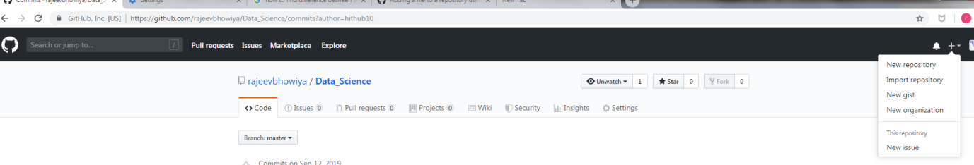

1. Fill the details

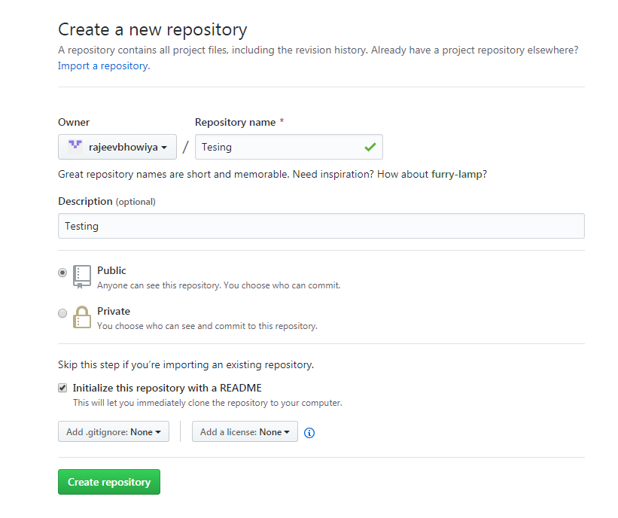

1. Download git Bash



1. Right click in folder (Where file is kept, which user want to upload) and select “Git Bash here”
2. Type below commands