Site to site vpn

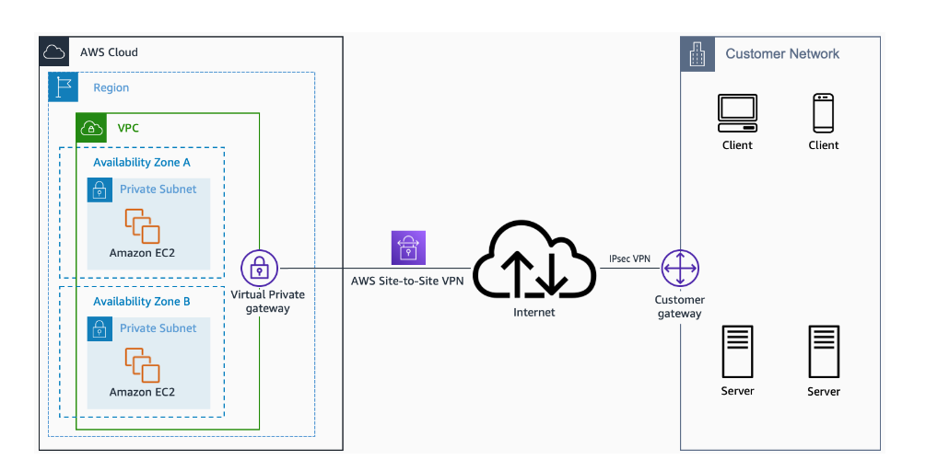

Transit Gateway + Site-to-site vpn

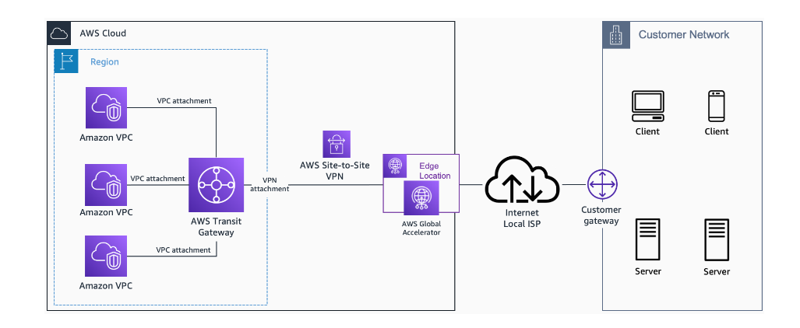

Direct Connect

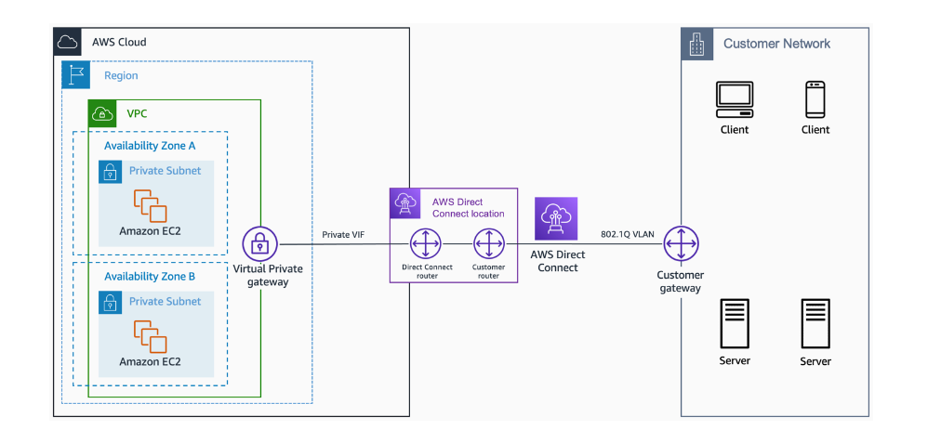

Redundancy

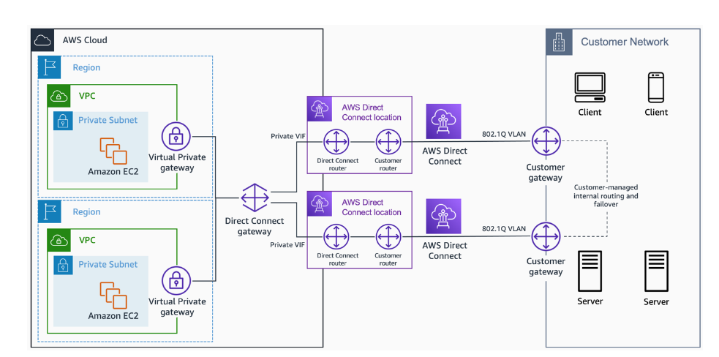

Direct Connect + Transit Gateway

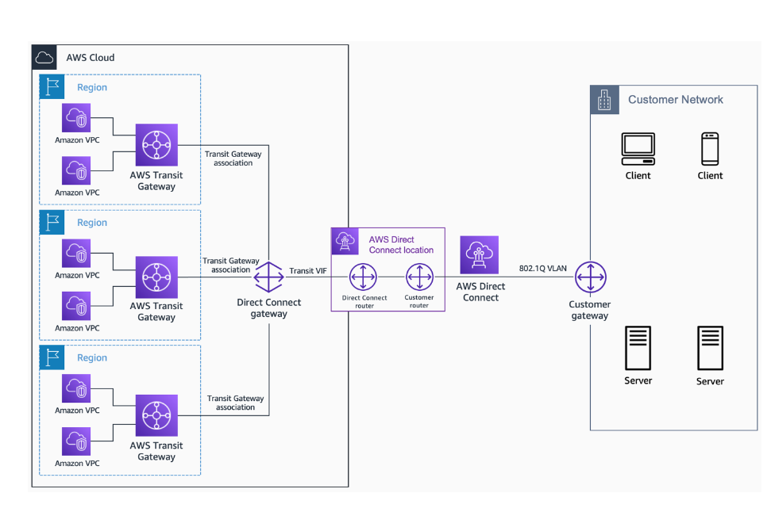

TG+ DC + S2S

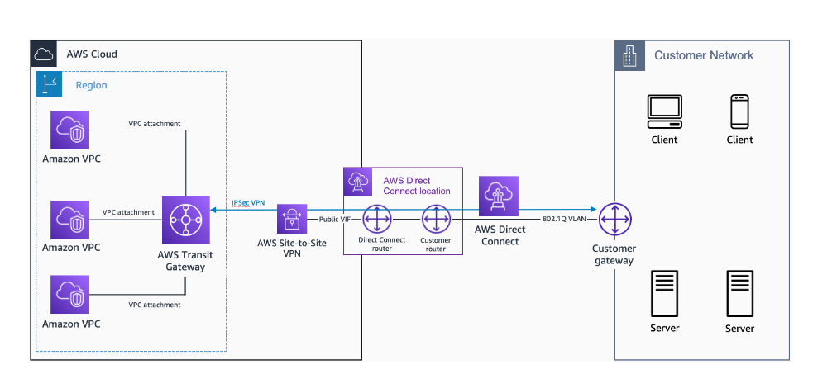

AWS Cloudhub

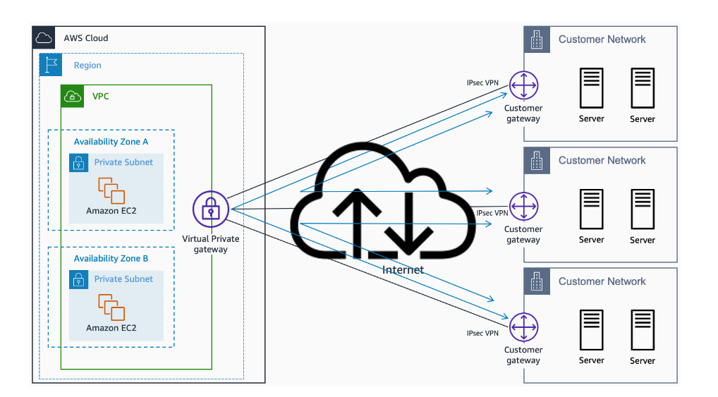

Vpc connectivities

TG

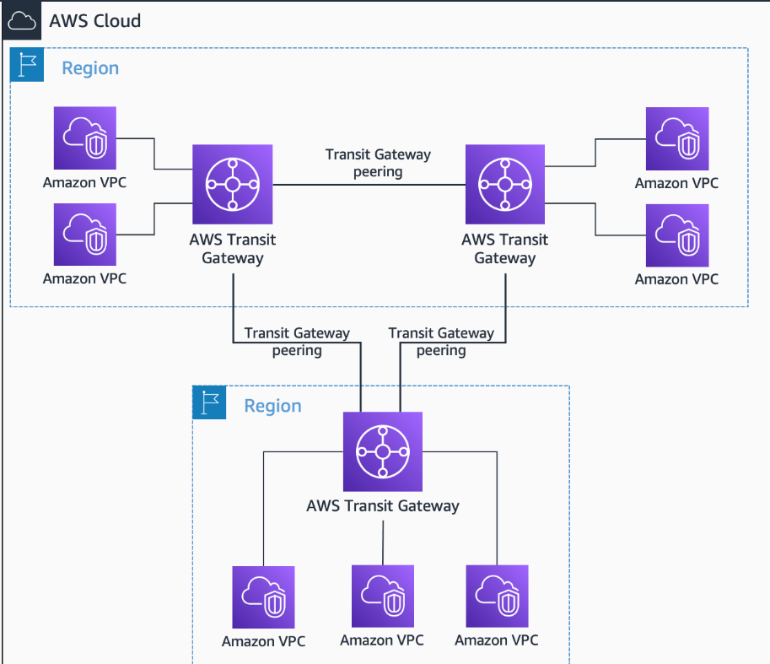

VPC Peering

PrivateLink

