**Lab Steps**

Task 1: Sign in to AWS Management Console

1. Click on the  button, and you will get redirected to AWS Console in a new browser tab.
2. On the AWS sign-in page,

* Leave the Account ID as default. Never edit/remove the 12 digit Account ID present in the AWS Console. otherwise, you cannot proceed with the lab.
* Now copy your **User Name** and **Password** in the Lab Console to the **IAM Username and Password** in AWS Console and click on the **Sign in** button

     3. Once Signed In to the AWS Management Console, Make the default AWS Region as **US East (N. Virginia) us-east-1.**

Task 2: Launching two EC2 Instance using a Bash script

1. Make sure you are in the **US-East (N.Virginia) us-east-1** Region.
2. Navigate to EC2 by clicking on the  menu in the top, then click on **EC2** in the **Compute** section.
3. Navigate to  on the left panel and click on 
4. Enter Name as ***MyEC2Server.***
5. Choose an Amazon Machine Image (AMI): Search for **Amazon Linux 2 AMI** in the search box and click on the **select** button.

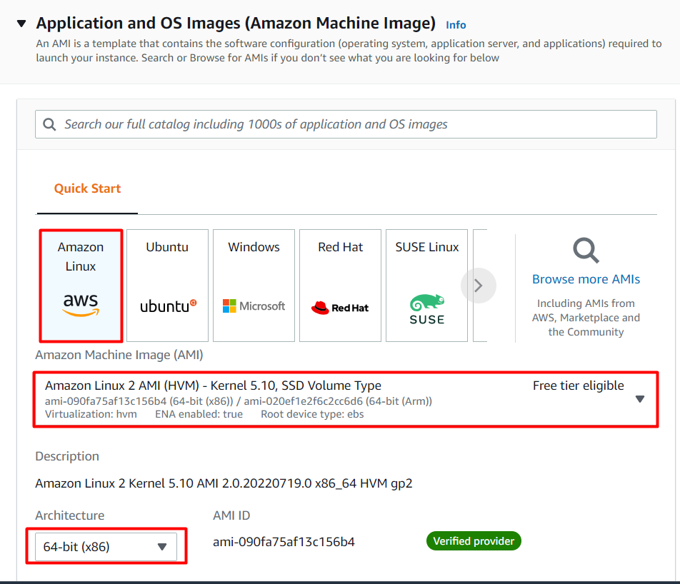

1. Choose an Instance Type: Enter **t2.micro**

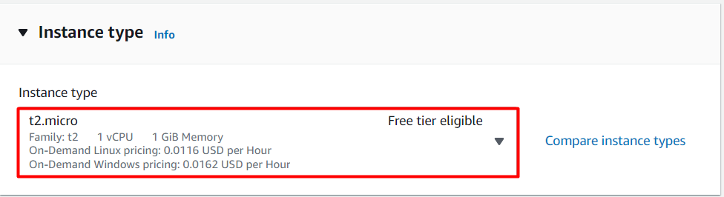

     6. Key Pair (login): Choose **Proceed without a key pair.**

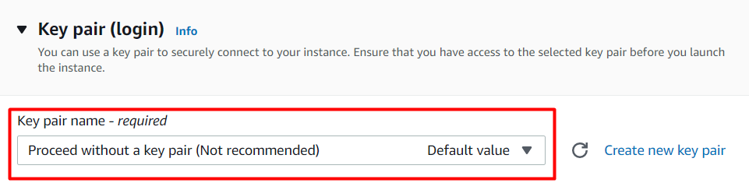

7. Under Network Settings , choose **Create New Security group.**

* **Check**the Allow SSH traffic from
* **Check**the Allow HTTP traffic from the internet.
* **Check**the Allow HTTPs traffic from the internet.

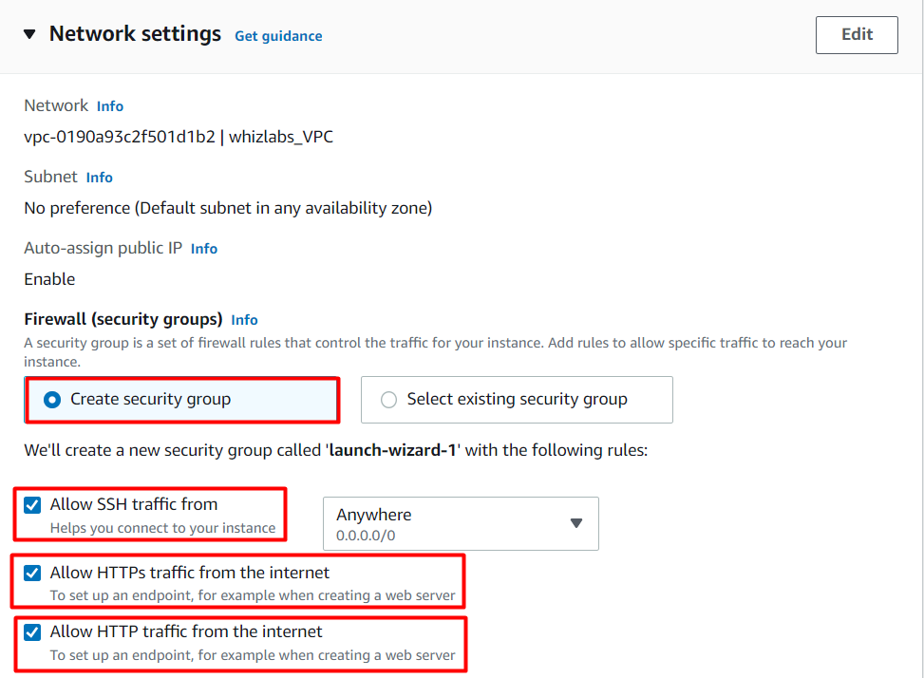

**8.** Under  , **User data:** section, copy and paste the script to install Apache webserver and php and copy the php file from S3 bucket to the server path.

|  |
| --- |
| #!/bin/bash      sudo su      yum update -y      yum install httpd php -y      systemctl start httpd      systemctl enable httpd      cd /var/www/html/      wget https://labresources.whizlabs.com/782219928fd66465d245779da7b2f055/index.php      systemctl restart httpd |

9. Under **Summary ,**Enter number of instances as **2.**

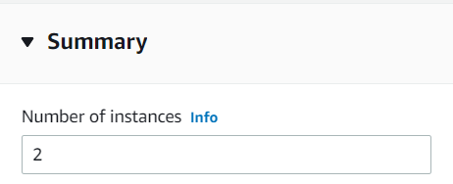

    10. Click on **Launch Instance**button.

   11. Your instances are now launching, wait for complete initialization of instance till status change to .

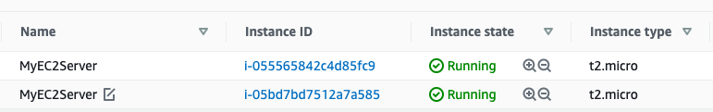

   12. Now click on the first **instance id** and copy the IPv4 Public IP of this instance.

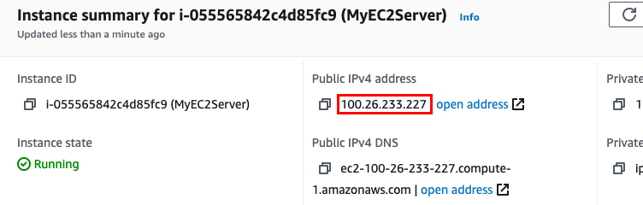

    13. View the PHP file in the webserver :

* Syntax : http://**<IPv4 public IP>**/index.php
* Example : **http://100.26.233.227/index.php**

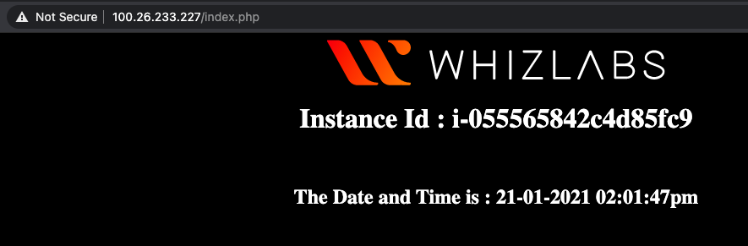

     14. You can pass a query string parameter **id** and the value will be displayed in the page.

* Syntax : http://**<IPv4 public IP>**/index.php?id=AWS
* Example : **http://100.26.233.227/index.php?id=AWS**

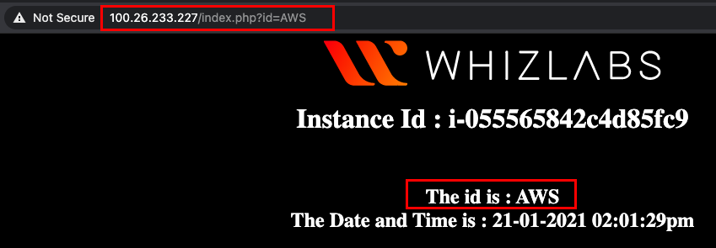

       15. Now you can check the second instance also.

**Note** : Both servers will display its instance id and if you keep refreshing the page the time will keep incrementing.

Task 3: Create a Target Group

1. In the left side menu, scroll down to the bottom and click on **Target Groups** under 
2. Click on the 
3. Under **Basic Configuration**:
   * Choose a target type : Select **Instances**
   * Target group name : Enter ***MyCloudFrontTargetGroup***
   * Protocol : **HTTP**
   * Port  : **80**
   * VPC : Select **default VPC**. (scroll down)
4. Under **Health check settings** :
   * Health check protocol : Select **HTTP** (default)
   * Path :Enter ***/index.php***
5. Click on **Advanced health check settings** to expand it:
   * **Healthy threshold:**Enter***3***
   * **Unhealthy threshold:** **2** (Default)
   * **Timeout:** **5** seconds (Default)
   * **Interval:** Enter***6***seconds
   * **Success codes:** 200 (Default)
6. Click on 
7. **Register Targets :**
   * Under Instances, select the **two EC2 instances** which you created in the above step and click on **Include as pending below.**

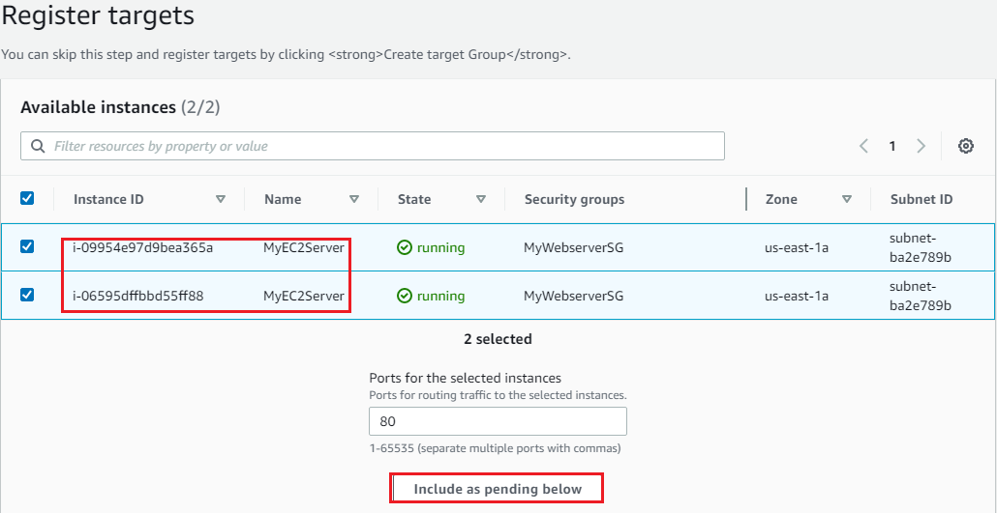

1. **Review targets:**Review everything and click on 

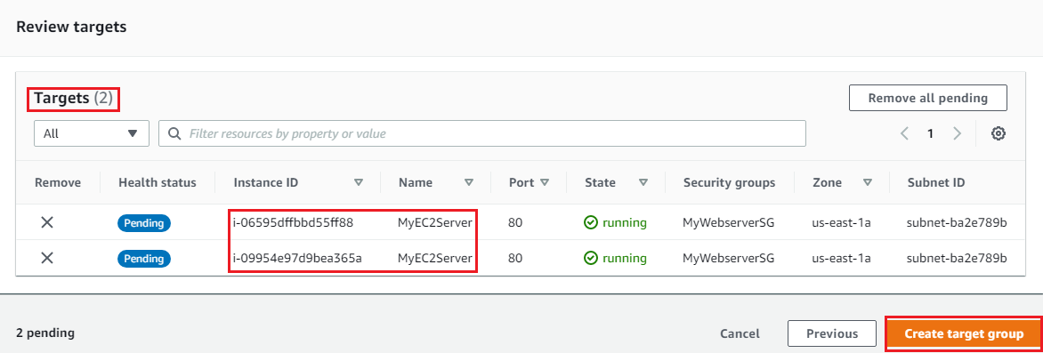

     9. You have successfully created a target group.



Task 4: Create an application Load Balancer

1. In the left side menu, scroll down to the bottom and select  under .
2. Click on the 
3. **Select Load Balancer Type**: Under the **Application Load Balancer**, click on **Create**button.
4. The next five screens will require some custom configurations. If a field is not mentioned, leave it as default or empty.
   * Scroll down to **Basic Configuration:**
     + Load balancer name : Enter ***MyCloudFrontLoadBalancer***
     + Scheme : Select 
     + IP address type : Select **IPv4**
5. **Network mapping:**
   * **VPC:**Select **Default VPC**
   * **Mappings:**Select all available zones using the checkbox.
6. **Security groups:**
   * Remove the default security and **Select** the security group you created while launching an EC2 instancefrom the drop-down menu.
7. **Listeners and routing:**
   * Protocol : **HTTP**
   * Port  : **80**
   * **Default action(forward to):**Select the target group ***MyCloudFrontLoadBalancer*** from the drop-down menu.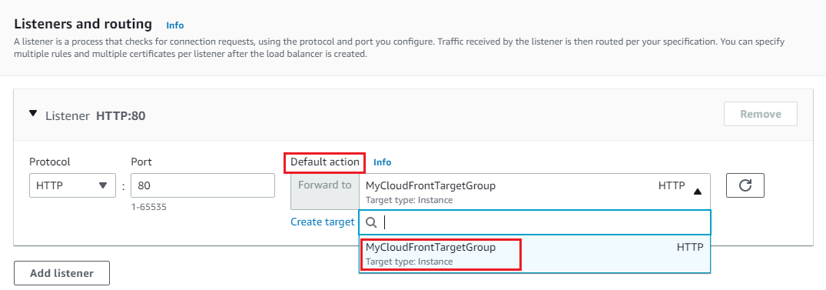
8. Scroll down and click on 
9. You have successfully created an application load balancer.



1. Now Navigate to the  in the left side menu, under .
2. Click on the Target Group name **MyCloudFrontTargetGroup**.
3. Now select the  tab, and wait for the targets to become **Healthy**.

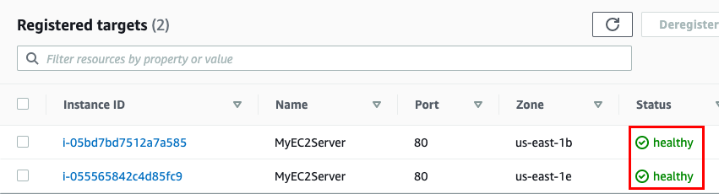

1. Again navigate to the   under .
2. Notice that the state of ELB is **active.** Copy the **DNS name** of the  ELB under **Description** section and paste it in the your **browser**.
   * Sample DNS : **MyCloudFrontLoadBalancer-190908156.us-east-1.elb.amazonaws.com**

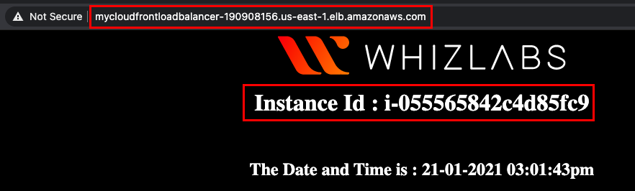

1. Now keep Refreshing the page, and you can observe the ELB is equally splitting the traffic between the two instances. (Note the instance id and time changes each time you refresh the page.)

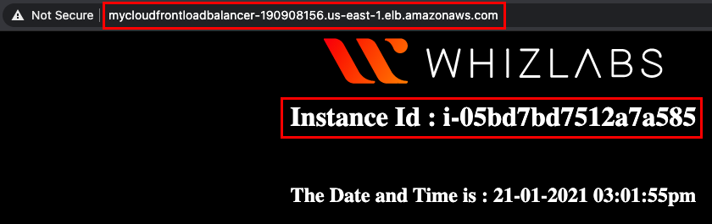

Task 5: Create the CloudFront Distribution

1. Navigate to **CloudFront** by clicking on the **Services** menu in the top, then click on **CloudFront** in the **Network and Content Delivery**section.
2. Click on the 
3. Origin Settings :
   * Origin Domain Name : Select the **Load balancer** that you created

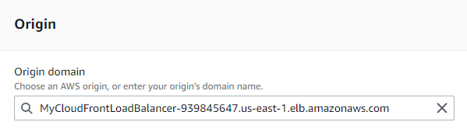

* **Note** : If **The load balancer is not listed** in the list (**Loading Origins**):
  + please **wait** for a few minutes to **load the origins** and keep the list open.
  + Don’t refresh the page.
  + It may **take a few minutes to update it in the AWS backend**.
* Leave all other options as **default.**

1. Default Cache behavior Settings :
   * Scroll down to **Cache key and origin requests** : Select **Legacy cache settings**
   * Query String: Select **All**
   * Cookies : Select **All**
   * **Note** : We are enabling the query string forwarding because our server can accept the query string parameter **id**
   * Object Caching : Select **Customize**
   * Maximum TTL : Enter ***0***
   * Default TTL : Enter ***0***

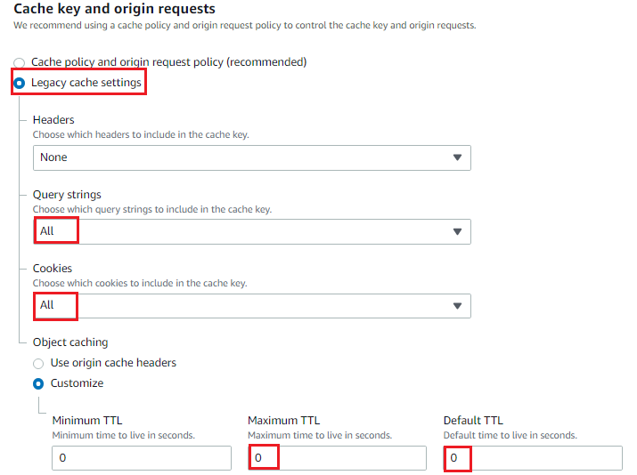

**Note** : The TTL option will be in disabled for dynamic contents by setting it as **0**.

* Scroll down to **Settings.**
* Price Class : Select 
* Leave all other options as default.
* Click on the 

1. You can see the **Status** column shows  for your distribution. After Amazon CloudFront has created your distribution, the  **Status** for your distribution will change to . At this point, it will be ready to process requests.

**Note** : This process will take around 15 - 20 minutes.

     6. The domain name that Amazon CloudFront assigns to your distribution appears in the list of distributions. It will look similar to **d209xud1ujbyj1.cloudfront.net**

Task 6: Test the distribution

1. Copy the CloudFront distribution Domain name and paste it in the browser and hit [enter].
2. You will be able to see the instance id and time.

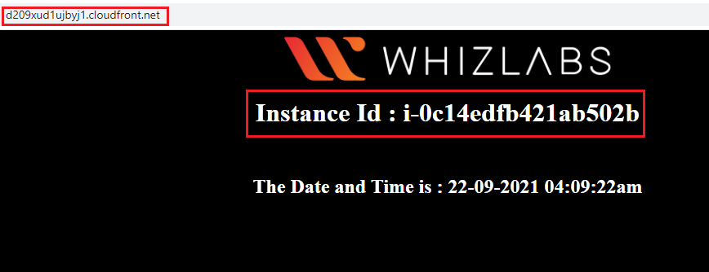

1. Now refresh the page and see the instance id change and the time will keep incrementing.

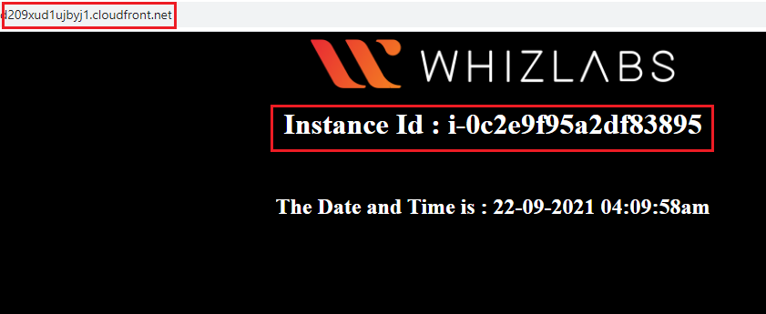

1. Now pass the query string parameter to CloudFront domain.
   * Syntax : http://**<domain name>**/?id=CloudFront
   * Example : http://d1pvucra50tk5z.cloudfront.net/?id=CloudFront

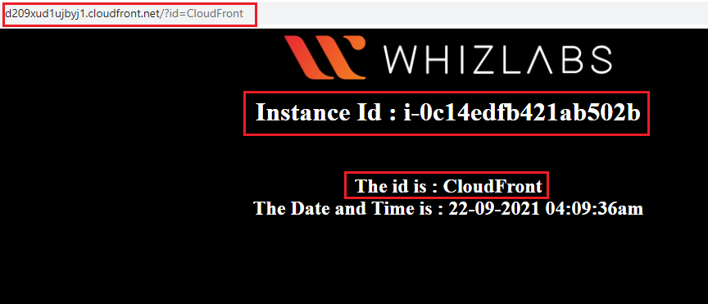

Task 7: Validation Test

1. Once the lab steps are completed, please click on the A green and white sign

   Description automatically generated with low confidence button on the left side panel.
2. This will validate the resources in the AWS account and displays whether you have completed this lab successfully or not.
3. Sample output :

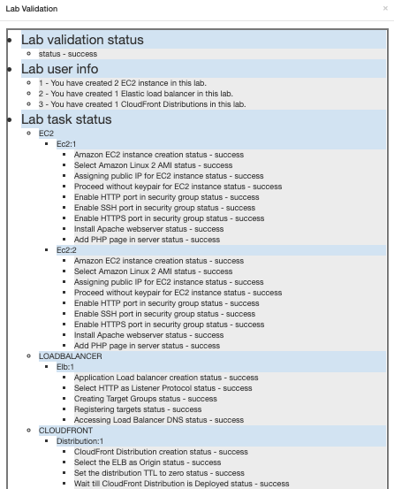

Task 8: Delete AWS Resources

Delete EC2 Instance

1. Make sure you are in the **US East (N. Virginia)** Region.
2. Navigate to EC2 by clicking on the **Services** menu in the top, then click on under **Compute** section.
3. Now select the EC2 instance that you have created, click on the **Instance State** and click on the **Terminate instance** option.
4. Click on the Terminate button and your EC2 will start terminating.

Delete Load Balancer

1. In the left side menu, scroll down to the bottom and select   under .
2. Select the Application load balancer that you created ie, **MyCloudFrontLoadBalancer**.
3. Click on  and then select **Delete**.
4. In the popup window, click on 
5. Now your Load balancer will get deleted.
6. In the EC2 console, navigate to  in the left-side panel.
7. **MyCloudFrontTargetGroup** will be listed here.  
   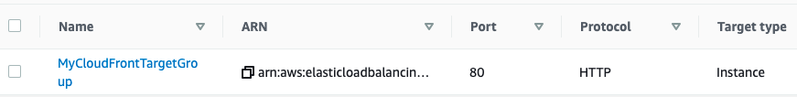
8. To delete the **target group**, need to perform the following actions:
   * **Select** the target group,
   * Click on the **Actions** button,
   * select the **Delete** option  
     A screenshot of a computer

     Description automatically generated with medium confidence
9. Now click on the   to confirm deletion.
10. **MyCloudFrontTargetGroup**will be deleted immediately.

Delete CloudFront Distribution

1. Navigate to **CloudFront** by clicking on the **Services** menu in the top, then click on **CloudFront** in the **Networking and Content Delivery** section.
2. Select the CloudFront **distribution** that you have created and click on 
3. In Order to delete the distribution first you need to disable the distribution. It will take **15 to 20 Minutes** to complete this process.
4. Once disabled, Select the distribution again and click on the **Delete** button.
5. Now again it will take a few minutes to **delete** the distribution.

**Completion and Conclusion**

1. You have successfully created two EC2 instances with a bash script that installed Apache servers and created sample html pages and published them.
2. You have successfully created a **Load Balancer**and **Target group**.
3. You have successfully created the CloudFront Distribution.
4. You have tested the cloudFront distribution.

**End Lab**