**Lab Steps**

Task 1: Sign in to AWS Management Console

1. Click on the  button, and you will get redirected to AWS Console in a new browser tab.
2. On the AWS sign-in page,

* Leave the Account ID as default. Never edit/remove the 12 digit Account ID present in the AWS Console. otherwise, you cannot proceed with the lab.
* Now copy your **User Name** and **Password** in the Lab Console to the **IAM Username and Password** in AWS Console and click on the **Sign in** button.

1. Once Signed In to the AWS Management Console, Make the default AWS Region as **US East (N. Virginia) us-east-1.**

**Note :**If you face any issues, please go through [**FAQs and Troubleshooting for Labs**](https://www.whizlabs.com/labs/support-document/faqs-and-troubleshooting).

Task 2: Create DynamoDB Table

1. Make sure you are in the **US East (N. Virginia) us-east-1** Region.
2. Navigate to **DynamoDB** page by clicking on the menu at the top. DynamoDB is available under the **Database** section.
3. Click on 

* Table Name     : Enter ***mydynamodbtable***
* Primary key     : Enter ***companyid*** and select **Number**
* Add sort key     : Enter ***name*** in the respective field and select **String**.

* The combination of a Primary Key and a Sort Key uniquely identifies each item in a DynamoDB table.  
  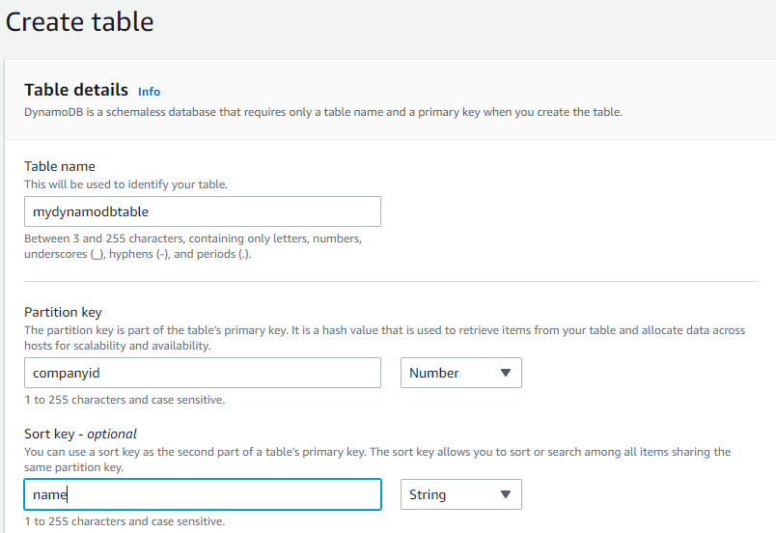
* Leave all the other settings as default and then click on **Create table**.

1. Your table will be created within 2-3 minutes.

Task 3 : Inserting Data into DynamoDB Table

1. Next, we are inserting data in the table we created.
2. Select **mydynamodbtable** and then Click on the EXPLORE items tab .
3. Now click on Create Items .
4. Add new primary key and sort key values.
   * companyid     : Enter ***1***
   * name        :Enter ***John***
5. After entering the data, click on the  button, present on the right bottom corner.
6. For testing purposes, add 4-5 items as shown in the above step and click on the   button.

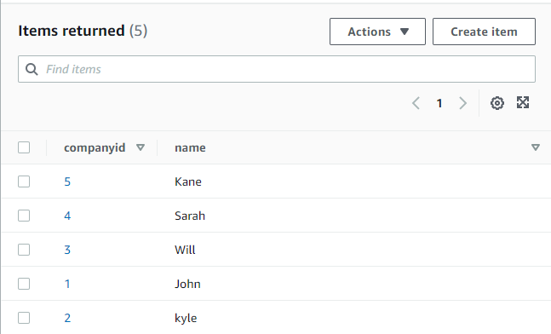

Task 4 : Search for Items in the Table

1. We will query the items in our table by using **scan**.
2. Select **Query**

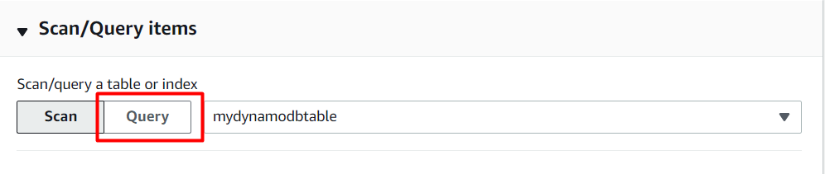

1. In the query window, enter the partition key and sort key which you want to search.
   * Partition Key     =    Enter ***4***
   * Sort Key           =    Enter ***Sarah  
     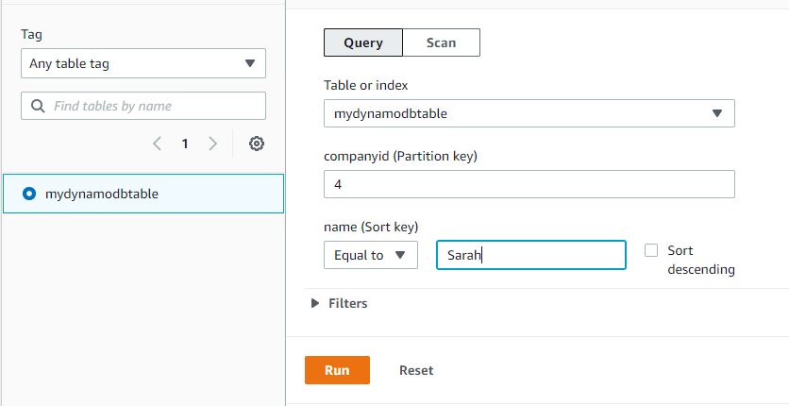***
   * Click on **Run**.
2. You will be able to see a result table with your filtered records. A sample screenshot is given below:

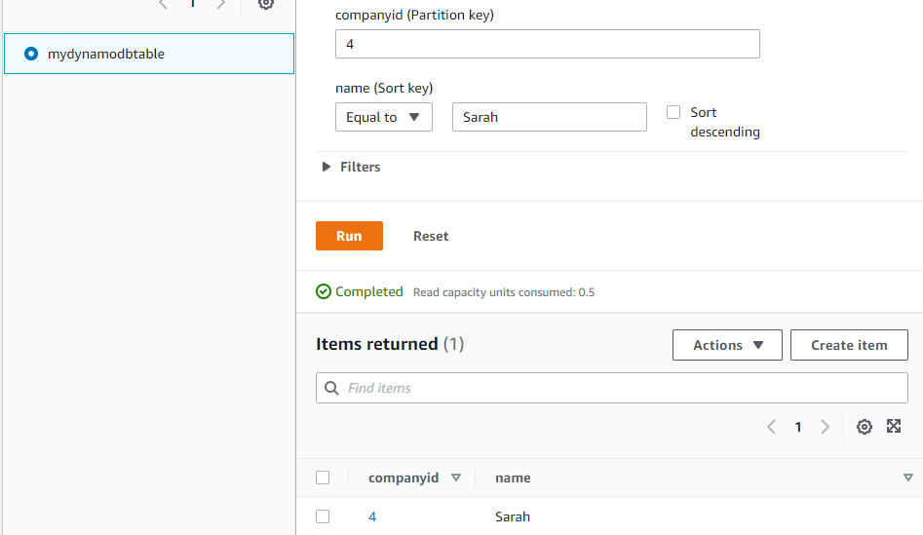

1. You can search with the Partition Key and the Sort Key. Try some additional test cases yourself to become more familiar with these keys.

Task 5 : Validation Test

1. Once the lab steps are completed, please click on the  button on the left side panel.
2. This will validate the resources in the AWS account and displays whether you have completed this lab successfully or not.
3. Sample output :

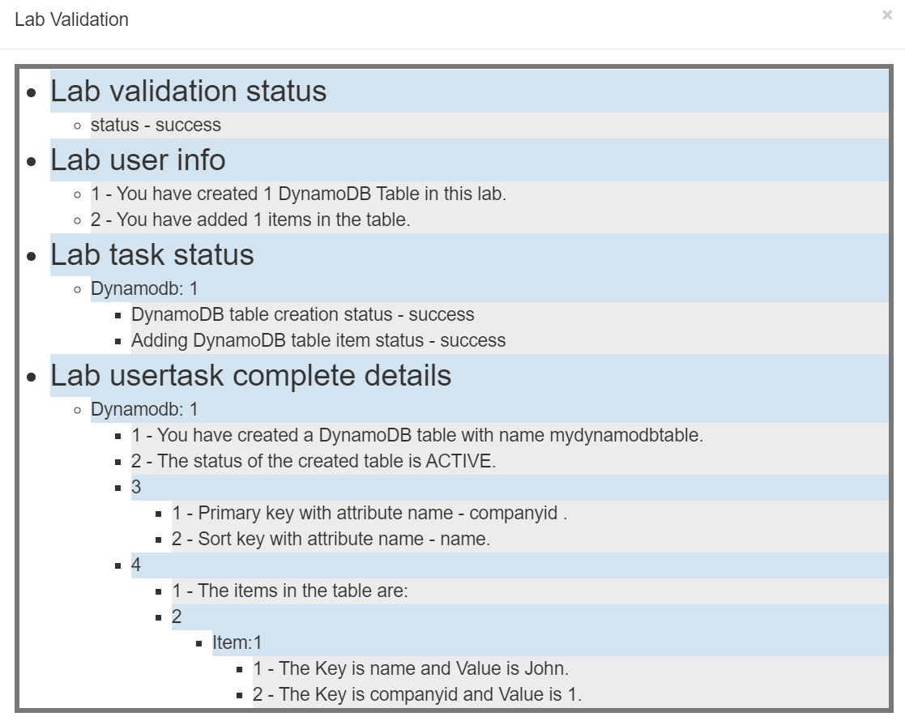

**Completion and Conclusion**

1. You have successfully created an Amazon DynamoDB table.
2. You have inserted multiple items into the table using a partition key and sort key.
3. You have successfully searched for items in the table using the partition and sort keys.

**End Lab**