**Lab Steps**

Task 1: Sign in to AWS Management Console

1. Click on the  button, and you will get redirected to AWS Console in a new browser tab.
2. On the AWS sign-in page,
   * Leave the Account ID as default. Never edit/remove the 12 digit Account ID present in the AWS Console. otherwise, you cannot proceed with the lab.
   * Now copy your **User Name** and **Password** in the Lab Console to the **IAM Username and Password** in AWS Console and click on the **Sign in** button.
3. Once Signed In to the AWS Management Console, Make the default AWS Region as **US East (N. Virginia) us-east-1.**

**Note :**If you face any issues, please go through [**FAQs and Troubleshooting for Labs**](https://www.whizlabs.com/labs/support-document/faqs-and-troubleshooting).

Task 2: Create a DynamoDB Table

1. Make sure you are in the **US East (N. Virginia) us-east-1** Region.
2. Click on 
3. On the DynamoDB Dashboard, click on Create table and then provide the following values:

* Table Name: Enter ***whizlabs_students_table***
* Partition Key:Enter ***id***, click the drop-down, select **string**, and then click on **Create**button
* Your table will be created within 2-3 minutes.

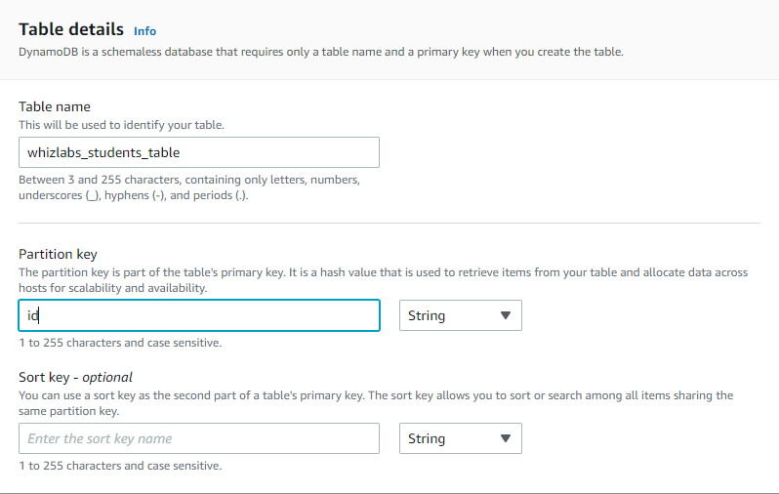

1. The DynamoDB Table will be ready to use when the **Status**changes to**Active.** You can verify the status of the table by navigating to the **Tables** menu in the Dynamodb dashboard.

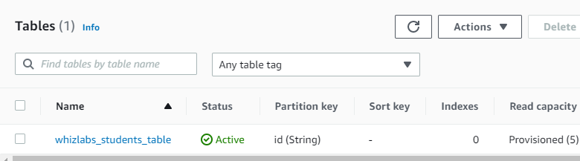

Task 3: Create an S3 bucket and upload a CSV File

1. Make sure you are in the **N.Virginia** Region.
2. Navigate to **S3** under **Storage**.
3. Click on 
4. Enter a unique **Bucket Name** and click on **Create bucket**button
   * Name of S3 bucket : ***csvs3dynamo***
   * Make sure the bucket is created in the **N.Virginia** region.
5. Once the bucket is created, click on the bucket.
6. Download the [students.csv](https://labresources.whizlabs.com/a4cc1b9ba6d12ca8dda8b27e6623c1a9/students.csv) file to your local machine. Open the file to see the data provided. This data will be imported to DynamoDB Table.
7. This CSV file contains the comma separate values of students.
8. Upload the **students.csv** file to the **csvs3dynamo**S3 Bucket by going to your bucket **(csvs3dynamo)** > Upload.
9. Once the file has uploaded successfully, you will be able to see the file inside the bucket.

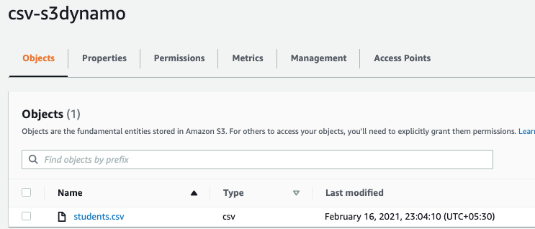

1. The CSV file is now ready to be imported to the DynamoDB table.

Task 4: Creating Lambda Function

1. Navigate to **Services** and click on **Lambda**service under **Compute**.
2. Make sure you are in the **N.Virginia** region.
3. Click on 

* Select **Author from Scratch**
* Function Name    : Enter ***csv_s3_dynamodb***
* Runtime        : Select **Python 3.7** (Choose from the drop-down)
* Click on **Change default execution role** and then select **Use an existing Role**
  + Choose role starting with name **whizlabs** from the drop-down menu
* Click on **Create function** button

1. Once the function is created, it will open the main page of the Lambda function.
2. Download the [Zip file](https://labresources.whizlabs.com/a4cc1b9ba6d12ca8dda8b27e6623c1a9/csv_s3_dynamodb.zip) and Unzip it and open it locally on your machine..
   * The **csv_s3_dynamodb.zip** contains Python code which uses boto3 APIs for AWS.
3. The python code above does the following:
   * Imports the CSV file from S3 bucket.
   * Splits the CSV data into multiple strings.
   * Uploads data to the DynamoDB table.
4. Remove the existing code in the function code environment window.
5. Copy and paste the code from the python file you downloaded into the **lambda_function.py** under the**Code Source**.
6. Within the code, make the following changes:
   * Line 13 - Update the DynamoDB table name to the following:
     + table = dynamodb.Table("***whizlabs_students_table***")
7. After updating the code, Click on **Deploy** button to save the code.
8. Change the function timeout as follows:
   * Navigate to the **Configuration**
   * click on **General configuration,** then click on **Edit**
9. In the **Edit Basic setting** and change the **Timeout** value to **1 min.** Click on **Save** button, present below.

Task 5: Test the CSV Data Import using a mock test in Lambda

1. In the **csv_s3_dynamodb**lambda functionpage, click on the **Test**tab.
2. Configure mock data as follows:
   * Template     : Select **Amazon S3 Put,** Upon selection, it will be displayed as **s3-put**
   * Name        : Enter ***csv***
   * Below in the JSON code:
     + Under S3 ? bucket ? name ?  Enter ***csvs3dynamo***
     + Under S3 ? object ? Key ? Enter ***students.csv***
     + Click on **Create**and then **Save**to save the changes.

**Note :** Make sure the S3 bucket name and file name are correct in the JSON.

1. Click on **Test** in top-right Corner to trigger the lambda function.
2. Once the lambda function is successfully executed, you will be able to see a detailed success message.

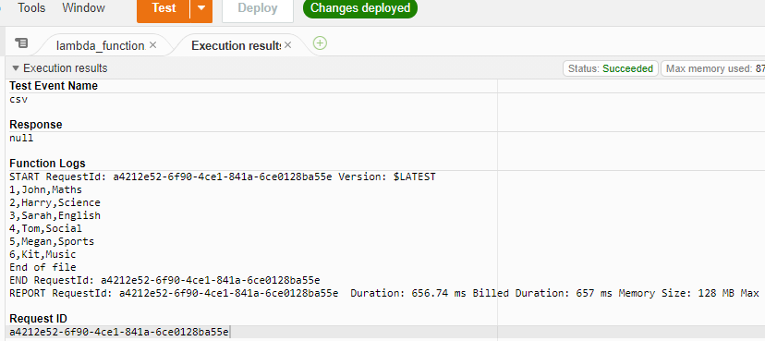

1. Navigate to the **DynamoDB** table and then select the **whizlabs_student_table** and click on 

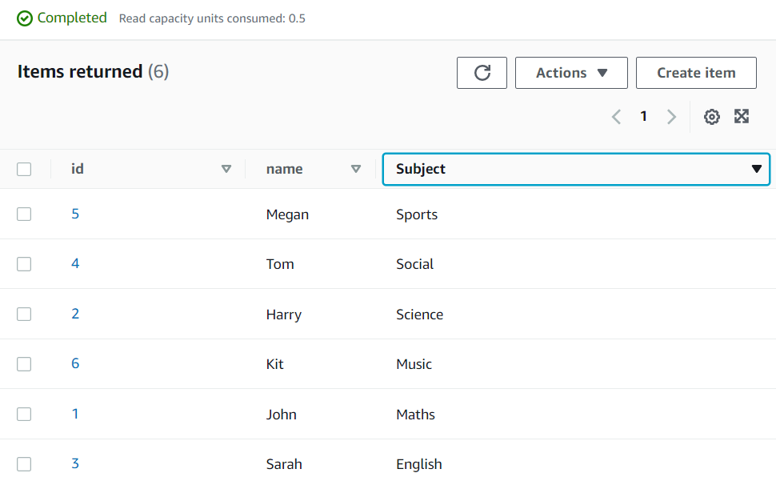

Task 6: Adding Event Triggers to the S3 Bucket

1. Navigate back to S3.
2. Click on the s3 bucket named **csvs3dynamo**.
3. Click on the **Properties** tab and scroll down to **Event notifications**.
4. Click on **Create event notification**button
5. Enter the details below:
   * Name                : Enter ***csv_upload***
   * Suffix                : Enter ***.csv***
   * All Object create events    : **check**
   * Destination            : Select **Lambda Function**
   * Lambda            : Select **csv_s3_dynamodb**
   * Click on **Save changes**button

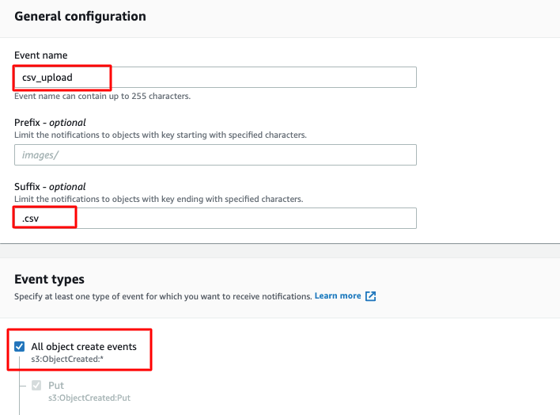

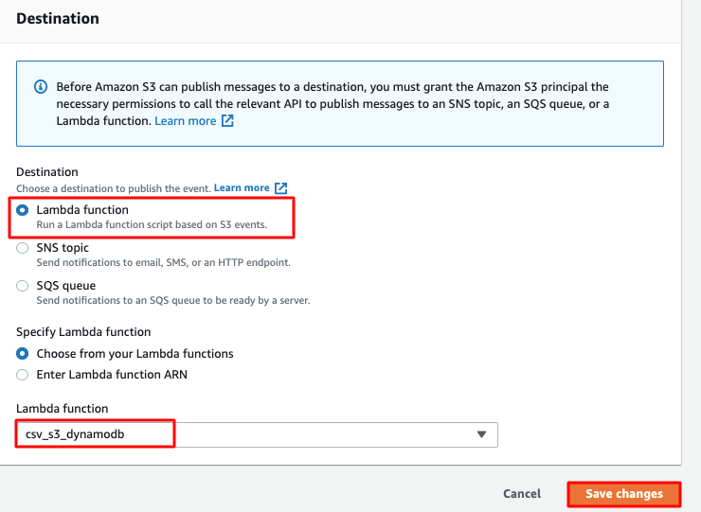

1. Now every time a CSV file is uploaded to our S3 bucket, it will trigger the lambda to import the CSV data into the DynamoDB table.

Task 7: Test the S3 Event Trigger to Import Data into DynamoDB

1. Download this updated version of our students.csv file: [Download CSV](https://labresources.whizlabs.com/a4cc1b9ba6d12ca8dda8b27e6623c1a9/students1.csv).
2. Upload the **students1.csv**file to the **csvs3dynamo**S3 bucket.

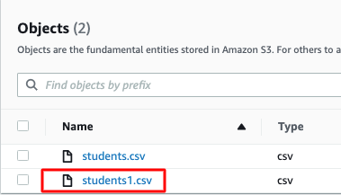

1. This upload event should have triggered our Lambda function **csv_s3_dynamodb**to import the CSV data into the DynamoDB table **whizlabs_students_table**.
2. Navigate to the DynamoDB table **whizlabs_students_table**to see the changes. Click on the refresh button if items have not yet changed.
3. You can see that CSV data has been successfully imported into the DynamoDB table.

Task 8: Validation of the lab

1. Once the lab steps are completed, please click on the A picture containing text

   Description automatically generated button on the left side panel.
2. This will validate the resources in the AWS account and displays whether you have completed this lab successfully or not.
3. Sample output :

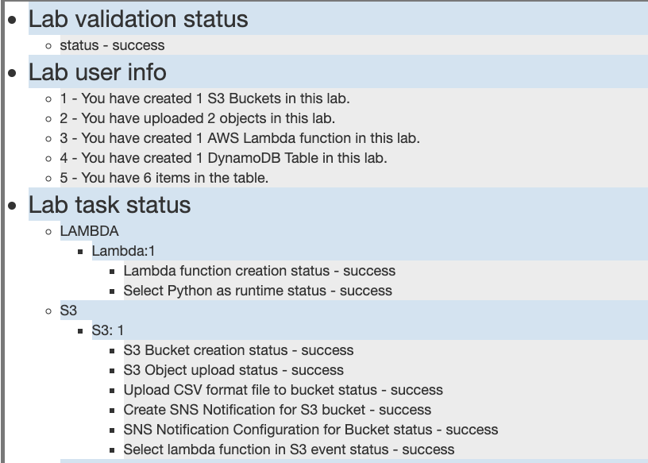

**Completion and Conclusion**

* You have successfully created an Amazon DynamoDB Table.
* You have successfully created a Lambda function and configured it to import CSV data from S3 into DynamoDB.
* You have created an S3 event to trigger our Lambda function.
* You have tested the import of a CSV file to the DynamoDB table.

**End Lab**