**Lab Steps**

Task 1: Sign in to AWS Management Console

1. Click on the  button, and you will get redirected to AWS Console in a new browser tab.
2. On the AWS sign-in page,

* Leave the Account ID as default. Never edit/remove the 12 digit Account ID present in the AWS Console. otherwise, you cannot proceed with the lab.
* Now copy your **User Name** and **Password** in the Lab Console to the **IAM Username and Password** in AWS Console and click on the **Sign in** button

     3. Once Signed In to the AWS Management Console, Make the default AWS Region as **US East (N. Virginia) us-east-1.**

Task 2: Create a Cloudwatch log group

1. Make sure you are in the **US East (N. Virginia)** Region.
2. Navigate to **CloudWatch** by clicking on the  menu in the top, then click on **Cloudwatch** under **Management and Governance**.
3. Select  form the left side menu.
4. Click on the 
   * Log group name : Enter ***EC2-session-manager***
   * Leave other options as default.

1. Click on the 
2. You have successfully created the CloudWatch Log group.

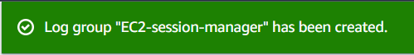

Task 3: Launch an EC2 Instance

1. Make sure you are in the **US East (N. Virginia)** Region.
2. Navigate to **EC2** by clicking on the  menu in the top, then click on **EC2** under **Compute** section.
3. Navigate to **Instances** on the left panel and click on 
4. Name : Enter ***MyEC2Server***
5. Choose an Amazon Machine Image (AMI): Select **Amazon Linux 2 AMI** in the drop-down.

* Choose **architecture** as **64-bit(x86)**

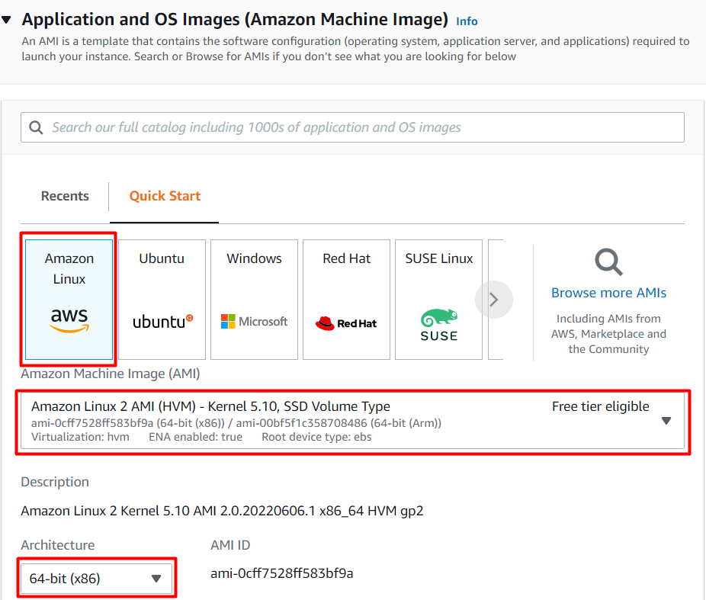

     6. Choose an**Instance Type**: Select ***t2.micro*.**

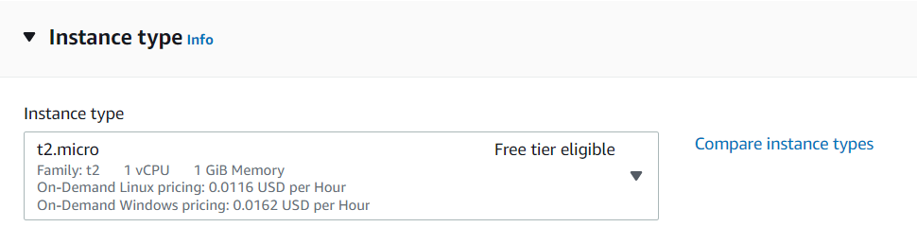

**7**. Key Pair: Select **Proceed without a Key Pair**

**8**.  Under **Network Settings ,** click on **Create security group.**

* **Uncheck**the **Allow SSH traffic from.**
* **Check**the **Allow HTTP traffic from the internet.**

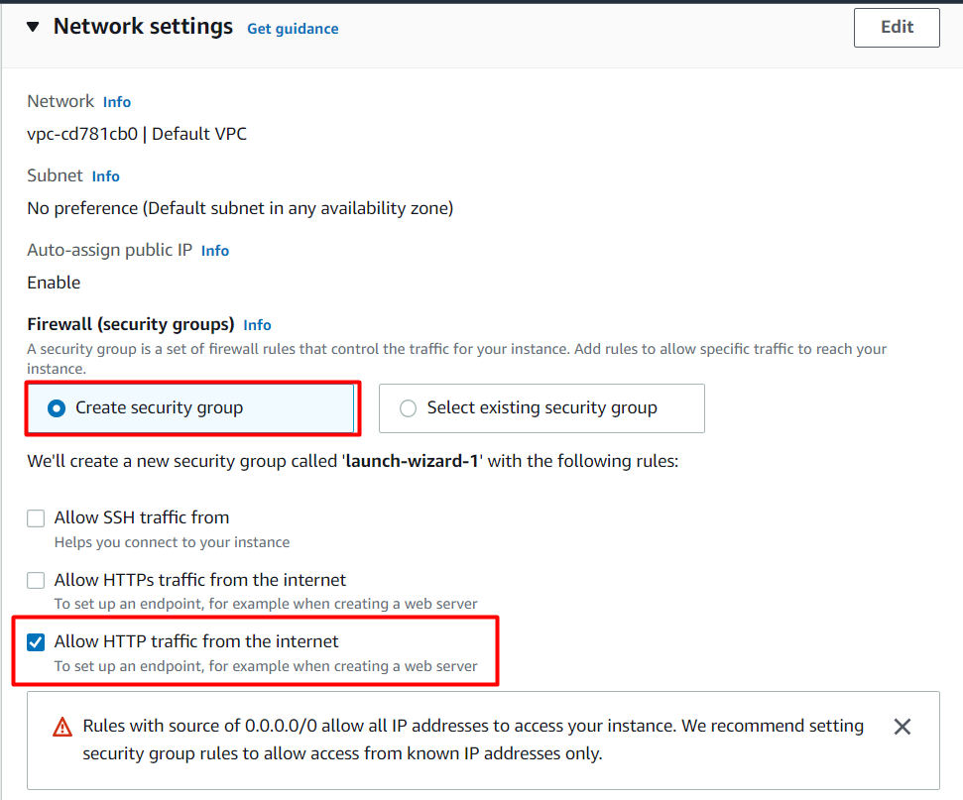

   9. Under **Advanced Details,**choose IAM Instance profile as **task168_profile_<RANDOM_NUMBER>.**This role has been already created for you.

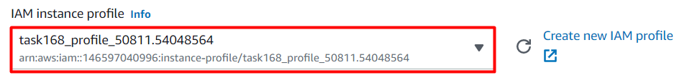

   10. Click on **Launch Instances** button.

   11. Launch Status: Your instance is now launching, Click on the instance ID to view the newly launched EC2 instances and wait till status change to **Running**.

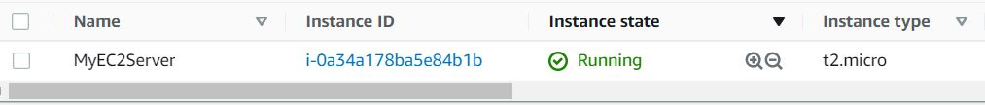

Task 4: Configure Session Manager

1. Make sure you are in the **US East (N. Virginia)** Region.
2. Navigate to **Systems Manager** by clicking on the  menu in the top, then click on **Systems Manager** under **Management and Governance** section.
3. On the left menu, scroll down and click on **Session Manager** under **Node Management**.
4. if you see the following page, then click on the  button.

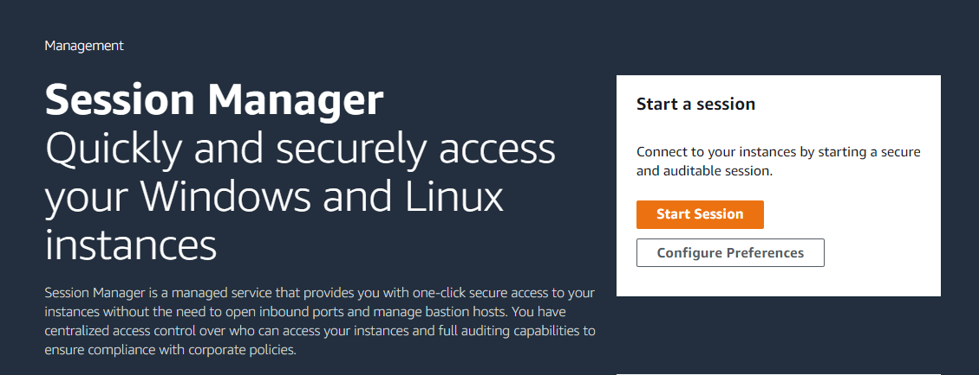

1. if you see this page instead , Select   tab and click on the  button.

1. **CloudWatch logging** :

**Note : if your session manager cloudwatch logging show has already been configured, then also make sure the below configuration is selected.**

* CloudWatch logging : Check **Enable**
* Choose your preferred logging option : Select **Upload session logs**
* Enforce encryption : **uncheck** Allow only encrypted CloudWatch log groups
* CloudWatch log group :
  + Select **Enter a log group in the text box**
  + Enter ***EC2-session-manager*** in the textbox.

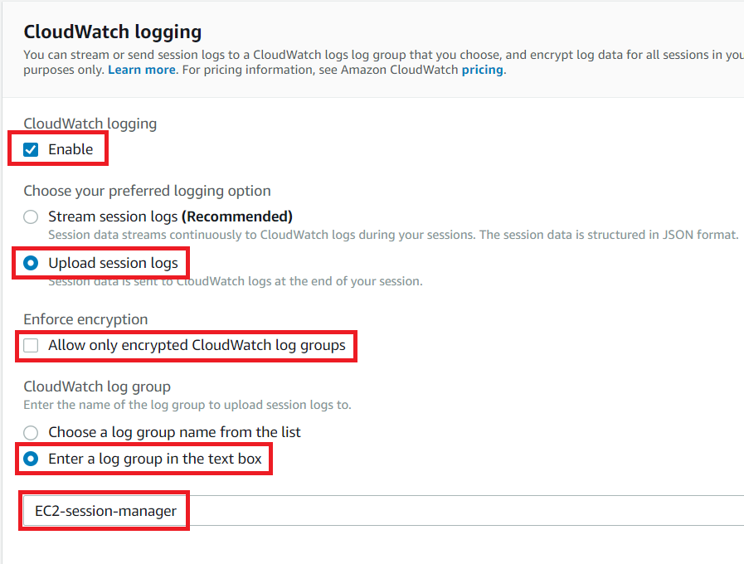

1. Now scroll down and select .

Task 5: Start and terminate a session in Session Manager

1. Select  and click on 
2. You will be able to see the EC2 instance which you have created above in the list.



**Note** : If your instance does not appear in the list, that may be because you didn't attach the IAM Role to EC2 or you have selected wrong IAM Policy while creating IAM Role.

1. Select the EC2 instance and click on the 
2. A new tab will be opened in your browser, so Navigate to the new tab.

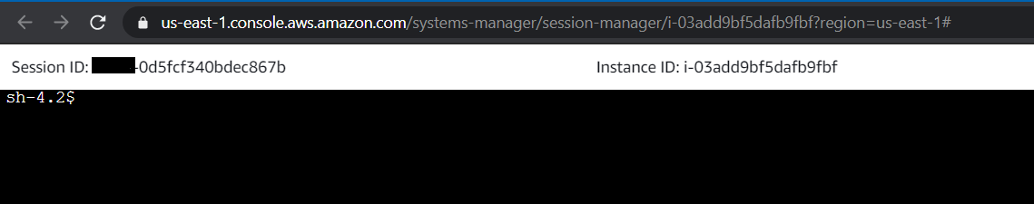

1. Note down the Session ID and instance ID in your text editor.
2. Perform the following commands :
   * bash
   * sudo yum update -y
   * cd /home
   * ls

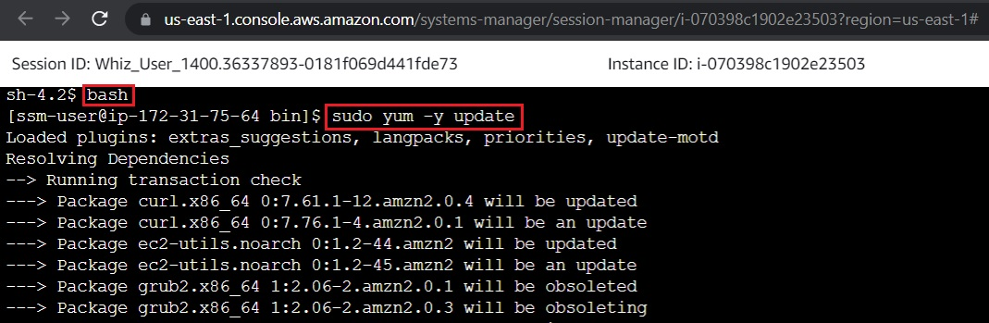

1. Now click on the   on the right top side and again click on  to confirm.
2. The new browser tab will automatically close, so now navigate to the Session Manager tab.

Task 6: View the logs in Cloudwatch

1. In the session manager page, click on  tab.
2. You will be able to see all the sessions.
3. Now compare your **session Id**, **Instance Id** and also you can check the date and time.

1. Scroll to the right side and **right click** on  button and open the **CloudWatch Logs** in a **new tab.**
2. Click on the log and you will be able to see all the SSH commands that you ran and also the corresponding outputs also.

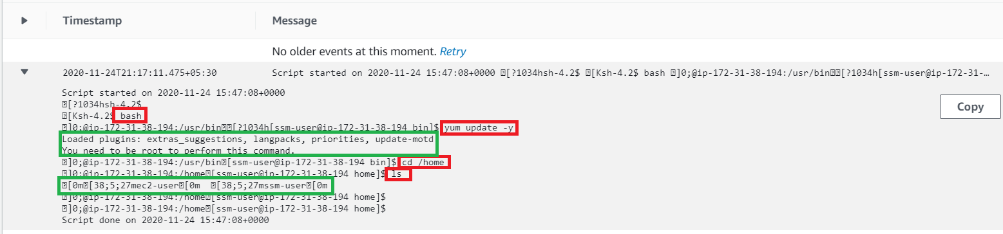

1. If you're not able to see the logs please wait for a few minutes and refresh the page.

Task 7: Delete AWS Resources

Deleting CloudWatch Logs

1. Make sure you are in the **US East (N. Virginia)** Region.
2. Navigate to **CloudWatch** by clicking on the  menu in the top, then click on **Cloudwatch** under **Management and Governance**section.
3. Select  form the left side menu.
4. Select the CloudWatch log group **EC2-session-manager** and click on  and then click on .

1. Now click on the  to confirm the deletion.
2. You will get a success message as shown below.

Deleting EC2 Instance

1. Make sure you are in the **US East (N. Virginia)** Region.
2. Navigate to **EC2** by clicking on the  menu in the top, then click on **EC2** under **Compute** section.
3. Now select the EC2 instance that you have created, click on **Instance state** and click on the **Terminate instance** option.

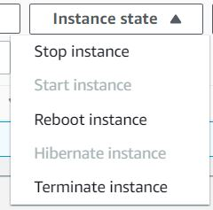

    4. Click on **Terminate** button and your EC2 will start terminating.

Deleting CloudWatch Configuration from Session manager

1. Make sure you are in the **US East (N. Virginia)** Region.
2. Navigate to **Systems Manager** by clicking on the  menu in the top, then click on **Systems Manager** under **Management and Governance** section.
3. On the left menu, scroll down and click on **Session Manager** under **Node Management**.
4. Select  and click on the  button.
5. **CloudWatch logging** :
   * CloudWatch log group :
     + Select **Enter a log group in the text box**
     + Remove **EC2-session-manager** from the textbox.

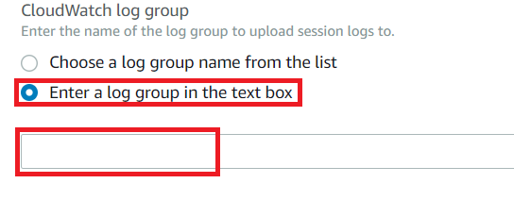

* CloudWatch logging : Uncheck **Enable**

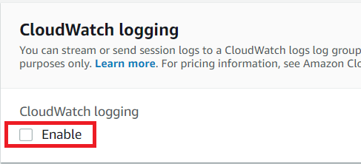

1. Now scroll down and select .

**Completion and Conclusion**

1. You have successfully Created a CloudWatch Log group.
2. You have successfully created an EC2 instance.
3. You have successfully configured Session Manager.
4. You have successfully Started and Terminated a session.
5. You have successfully viewed the logs in CloudWatch.

**End Lab**