**Lab Steps**

Task 1: Sign in to AWS Management Console

1. Click on the  button, and you will get redirected to AWS Console in a new browser tab.
2. On the AWS sign-in page,

* Leave the Account ID as default. Never edit/remove the 12 digit Account ID present in the AWS Console. otherwise, you cannot proceed with the lab.
* Now copy your **User Name** and **Password** in the Lab Console to the **IAM Username and Password** in AWS Console and click on the **Sign in** button

     3. Once Signed In to the AWS Management Console, Make the default AWS Region as **US East (N. Virginia) us-east-1.**

Task 2: Create Parameter Store and store the data

1. Make sure you are in**US East (N. Virginia) us-east-1**Region.
2. Navigate to **Systems Manager** by clicking on the  menu in the top, then click on **Systems Manager** under **Management and Governance** section.
3. On the left panel, scroll down to the **Application Management** and click on the **Parameter Store**.  
   Graphical user interface, text, application

   Description automatically generated
4. On the home page of the AWS Systems Manager Parameter store, Click on the A picture containing shape

   Description automatically generated
5. You will be storing two parameters, **db-endpoint as String** and **db-password as SecureString.**
6. Enter the following details about Parameter **db-endpoint**:
   * Name: Enter ***/whiz-app/dev-env/db-endpoint***
   * Description: Enter ***Endpoint of the database for the development environment***
   * Tier: Select **Standard**

* + Type: Select **String**
  + Data type: Select **text**
  + Value: Enter ***mysqlinstance1-k82h.123456789012.us-east-1.rds.amazonaws.com:3306***

* + To create, click on the A picture containing shape

    Description automatically generated

1. Click on **Create parameter**button again.
2. Enter the following details about Parameter **db-password**:
   * Name: Enter ***/whiz-app/dev-env/db-password***
   * Description: Enter ***Password of the database for the development environment***
   * Tier: Select **Standard**
   * Type: Select **SecureString**

* + KMS key source: Select **My current account**
  + KMS Key ID: Select **alias/aws/ssm**
  + Value: Enter ***Eh9x6E!RGHa8zYM***

* + To create, click on the A picture containing shape

    Description automatically generated

1. Both **db-endpoint** and **db-password**, parameters are now created.  
   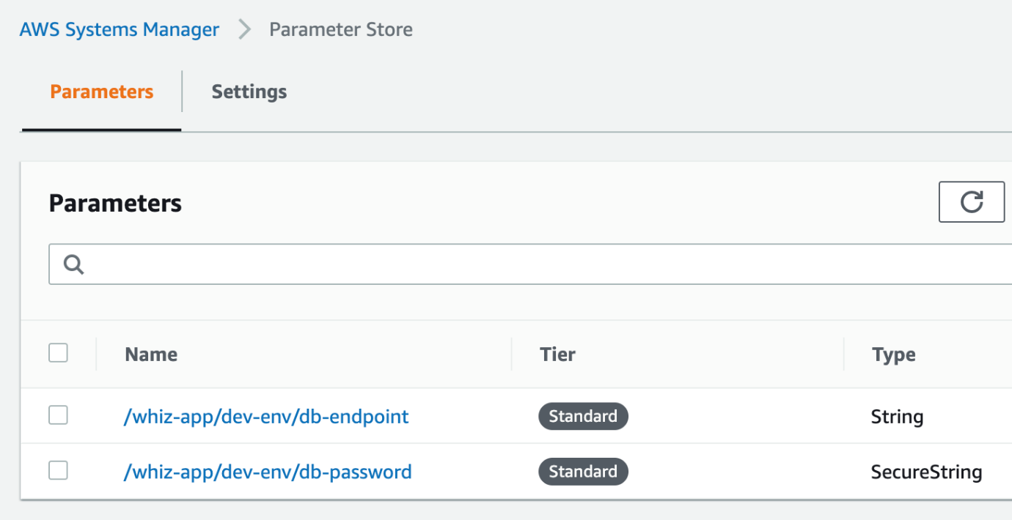

Task 3: Create an Environment in CloudShell

1. Navigate to **CloudShell** by clicking on the  menu in the top, then click on **Cloudshell** under **Developer Tools** section.
2. Optionally, you can start **CloudShell** by Clicking on the  icon (CloudShell) on the top right AWS menu bar.
3. A new tab in your browser opens and if you see a welcome message to cloud shell then click on the  button in that message.
4. You will see a creating environment message on the screen.

1. Wait for a few minutes to complete the environment creation. Once the environment is created, You are ready to use the terminal.       
   Text

   Description automatically generated

Task 4: View the data from CloudShell using get-parameters

1. To view the db-endpoint, which is stored in String format, run the following command:
   * **aws ssm get-parameters --names /whiz-app/dev-env/db-endpoint**  
     Text

     Description automatically generated
2. To view the db-password, which is stored in SecureString format, run the following command:
   * **aws ssm get-parameters --names /whiz-app/dev-env/db-password**

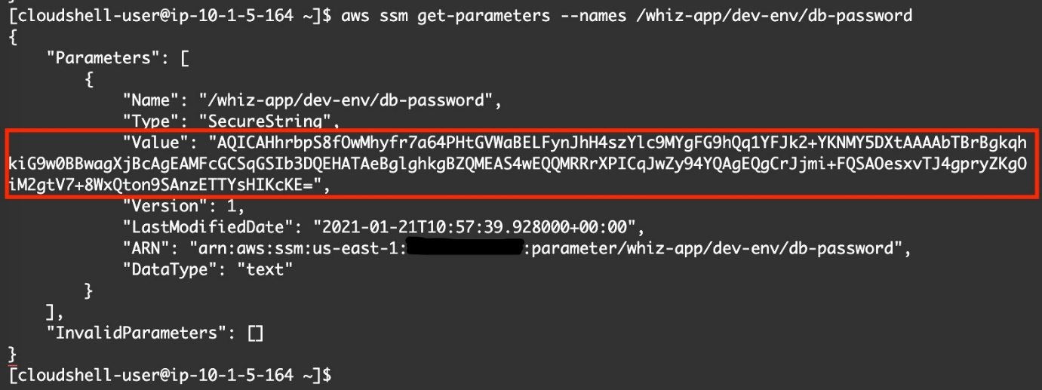

1. Oh, looks like this is encrypted, let's decrypt it. To view the db-password, in decrypted format, run the following command:
   * **aws ssm get-parameters --names /whiz-app/dev-env/db-password --with-decryption**

1. To view both db-endpoint and db-password with a single command, run the below CLI command:
   * **aws ssm get-parameters --names /whiz-app/dev-env/db-endpoint /whiz-app/dev-env/db-password**

1. Oh, Looks like db-password is still in encrypted format, let's decrypt it with **--with-decryption**parameter
   * **aws ssm get-parameters --names /whiz-app/dev-env/db-endpoint /whiz-app/dev-env/db-password --with-decryption**

Task 5: View the data from CloudShell CLI using get-parameters-by-path

1. To view both the parameters of the development environment, run the following command:
   * **aws ssm get-parameters-by-path --path /whiz-app/dev-env  
     Text

     Description automatically generated**
2. You can decrypt the above **SecureString** by adding **--with-decryption**parameter
   * **aws ssm get-parameters-by-path --path /whiz-app/dev-env --with-decryption**
3. Alternatively, you can view the parameters of **/whiz-app path** by adding **--recursive** parameter.

* **aws ssm get-parameters-by-path --path /whiz-app --recursive --with-decryption**