**Lab Steps**

Task 1: Sign in to AWS Management Console

1. Click on the  button, and you will get redirected to AWS Console in a new browser tab.
2. On the AWS sign-in page,

* Leave the Account ID as default. Never edit/remove the 12 digit Account ID present in the AWS Console. otherwise, you cannot proceed with the lab.
* Now copy your **User Name** and **Password** in the Lab Console to the **IAM Username and Password** in AWS Console and click on the **Sign in** button

     3. Once Signed In to the AWS Management Console, Make the default AWS Region as **US East (N. Virginia) us-east-1.**

Task 2 : Launch 2 EC2 Instances

1. Make sure you are in the **US East (N. Virginia)**Region.
2. Navigate to **EC2** by clicking on the  menu in the top, then click on **EC2** under **Compute** section.
3. Navigate to **Instances** on the left panel and click on 
4. Name : Enter ***EC2_SSM***
5. Choose an Amazon Machine Image (AMI): Select **Amazon Linux 2 AMI** in the drop-down.

* Choose **architecture** as **64-bit(x86)**

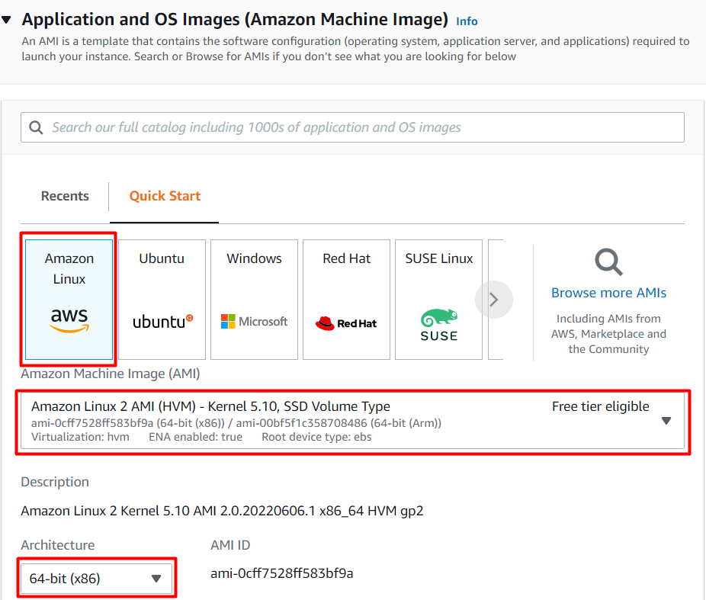

     6. Choose an**Instance Type**: Select ***t2.micro*.**

**7**. Key Pair: Select **Proceed without a Key Pair**

**8**.  Under **Network Settings ,** click on **Create security group.**

* **Uncheck**the **Allow SSH traffic from.**
* **Check**the **Allow HTTP traffic from the internet.**

   9. Under **Advanced Details,**choose IAM Instance profile as **task168_profile_<RANDOM_NUMBER>.**This role has been already created for you.

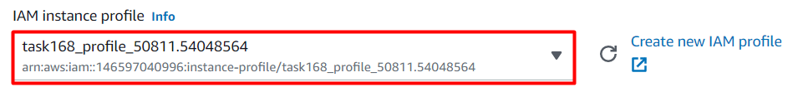

   10. At the top right, Enter number of instances as **2.**

   11.Click on **Launch Instances** button.

   12. Launch Status: Your instances are now launching, Click on the instance ID to view the newly launched EC2 instances and wait till status change to .

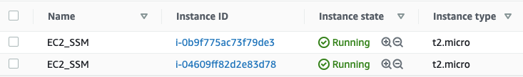

Task 3: Create a Resource Group

1. Navigate to **Resource Groups & Tag Editor** by clicking on the **Services** menu in the top, then click on **Resource Groups and Tag Editor** under **Management and Governance** section.
2. Click on the .
3. Enter a **Group name** and **Group description** and click on 

* Group details: Enter ***EC2_SSM_Group***
* *Group description:*Enter ***Creating a New Resource Group***

* Group Type: Select **Tag based**
* Grouping Criteria: Select **AWS::EC2::Instance**
* Tags :
  + Key: Enter ***Name***
  + Value: Enter ***EC2_SSM***
* **Note**: Since we are creating Group resources by specifying Tags that are shared by the resources, Enter the Tag’s key and value the same as the EC2 Instances or select from the drop-down list.

       4. Click on **Preview group resources**. As soon as you click on the option, you’ll see the Instances displayed according to the tags selected.

1. The Resource Group has been created successfully.



Task 4 : Create Command Document and Run the Command

1. Navigate to **Systems Manager** by clicking on the **Services** menu in the top, then click on **Systems Manager** under **Management and Governance** section.
2. On the left panel, scroll down to the **Shared Resources** and click on the **Documents**.

1. Select **Owned by me** and click on **Create command or session**.

1. Under **Document details** give the name as **InstallApache**.

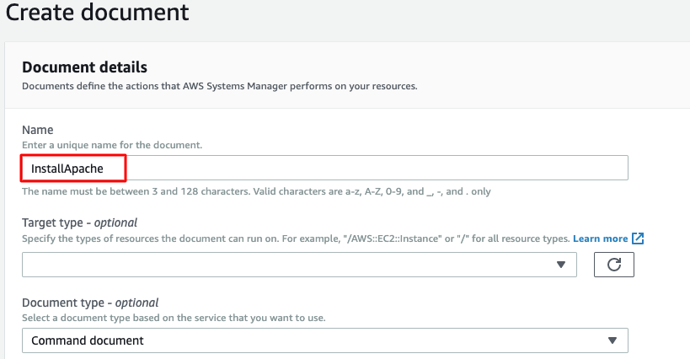

1. Under the **content**, select **YAML** and paste the following script as it is and click on .

|  |
| --- |
| ---  schemaVersion: '2.2'  description: Sample YAML template to install Apache  parameters:  Message:  type: "String"  description: "Welcome Message"  default: "Hello World"  mainSteps:  - action: aws:runShellScript  name: configureApache  inputs:  runCommand:  - 'sudo yum update -y'  - 'sudo yum install -y httpd'  - 'sudo systemctl start httpd.service'  - 'sudo systemctl enable httpd.service'  - 'echo "{{Message}} from $(hostname -f)" > /var/www/html/index.html' |

1. Once the document is created, click on the tab **Owned by me**. Search for the document created by you and click on it.  
   Graphical user interface, application, email

   Description automatically generated
2. Click on the **Run Command** option on the top right corner. A new window will be opened.

1. In the **Run a Command** page, scroll down and choose the **Targets** as **Choose a Resource Group** and select the Resource group created earlier from the dropdown list.

1. Leave all other options as default and click on .
2. Wait for about a minute. The command ID will be successfully created and executed. If it is **In Progress**, click on Refresh.

Task 5: Testing the command

1. The command ID has been created and is successfully executed.
2. To test whether the command is executed, let us copy the Public IP’s in the browser and check the response.
3. Navigate to the **Instances** on the left panel of **EC2**. Copy and paste the Instances Public IP in the browser.
4. You will see the output as entered in the script.

**Note:** If you are not able to open in the same browser, copy and paste the instances Public IP in a different browser.

Task 6: Delete AWS Resources

Delete EC2 Instance

1. Make sure you are in the **US East (N. Virginia)**Region.
2. Navigate to EC2 by clicking on the **Services** menu in the top, then click on **EC2** under **Compute** section.
3. Now select the EC2 instance that you have created, click on the  and click on the **Terminate Instance** option.

1. To confirm , click on the **Terminate** button and your EC2 will start terminating.

Delete Resource Group

1. Search for **Resource Groups and Tag Editor** in the **Services** menu in the top  and select it.

1. Select the **Resource Group** we created earlier and click on **View Details**.
2. On the top-right corner, choose **delete** and confirm the deletion.

1. The Resource Group is deleted successfully.



Delete Command Document

1. Navigate to **Systems Manager** by clicking on the **Services** menu in the top, then click on **Systems Manager** under **Management and Governance** section.
2. On the left panel, under **Shared Resources** click on the **Documents**.

1. Under **Owned by me**, search andselect the document created by you.
2. Under **Actions**, click on **Delete document** and confirm the delete.

1. Your document is deleted successfully.



**Completion and Conclusion**

1. You have successfully launched 2 EC2 instances.
2. You have successfully created a Resource Group.
3. You have created a Command document and run the command.
4. You have tested the command and checked the configurations.

**End Lab**