**Lab Steps**

Task 1: Sign in to AWS Management Console

1. Click on the  button, and you will get redirected to AWS Console in a new browser tab.
2. On the AWS sign-in page,
   * Leave the Account ID as default. Never edit/remove the 12 digit Account ID present in the AWS Console. otherwise, you cannot proceed with the lab.
   * Now copy your **User Name** and **Password** in the Lab Console to the **IAM Username and Password** in AWS Console and click on the **Sign in** button.
3. Once Signed In to the AWS Management Console, Make the default AWS Region as **US East (N. Virginia) us-east-1.**
4. Select Maybe later in New AWS Console Home page pop-up

Task 2: Creating Security group for Load balancer

1. Navigate to the EC2 Dashboard and scroll down to **Security Groups**. In the left menu, click on 
2. **Configure the security** group as follows:

* Security group name: Enter ***LoadBalancer-SG***
* Description : Enter ***Security group for Load balancer***
* VPC : **Leave as default**
* In **Inbound rules**, Click on **Add Rule** and add the port as follow.
* Type**:** Select **HTTP**
* Protocol    : **TCP**
* Port range**: 80**
* Source    : Select **Custom**, and enter ***0.0.0.0/0***
* Once you provide the above details, click on Create and the security group for the load balancer will be created.

Task 3: Steps to create the Web-servers

1. Make sure you are in the **US East (N. Virginia)**Region.
2. Navigate to **Instances** on the left panel and click on 
3. Name : Enter ***webserver-A***
4. **For Amazon Machine Image (AMI):** Search for **Amazon Linux 2 AMI** in the search box and click on the **select** button

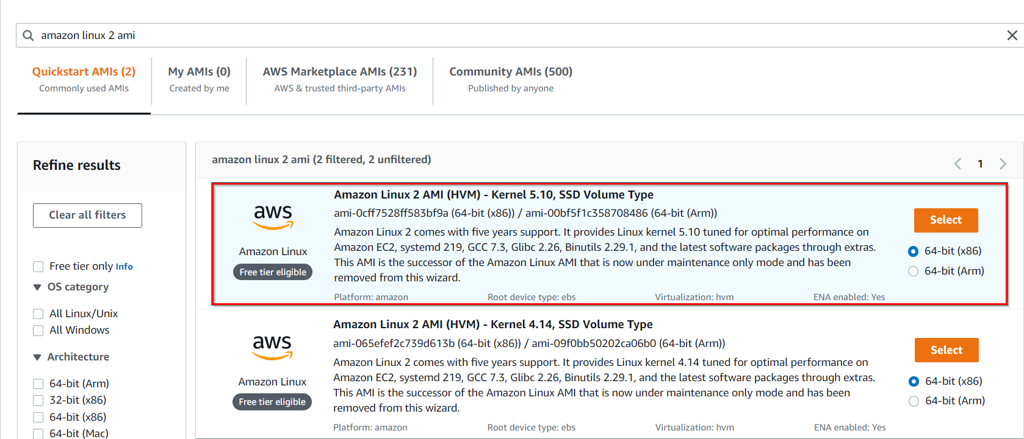

1. Instance Type: Select **t2.micro**

1. **For Key pair:** Select **Create a new key pair** Button
   1. Key pair name: **WhizKey**
   2. Key pair type: **RSA**
   3. Private key file format: **.pem**
2. Select **Create key pair** Button.
3. In Network Settings Click on **Edit button**:

* Auto-assign public IP: **Enable**
* Choose **Create security group**
  + Name  :  Enter ***webserver-SG***
  + Description    : Enter ***security group for webserver***
* To add **HTTP** Click on **Add security group rule**
  + Choose Type**:** Select **HTTP**
  + Source Type          : **Custom**
  + Source        : Choose **LoadBalancer-SG**
* To add **SSH**
  + Choose Type    : Select **SSH**
  + Source        : Choose **Anywhere**

1. Click on **Advanced Details.**
2. Under the **User data** section, enter the following script to create an HTML page served by an Apache HTTPD web server.

|  |
| --- |
| #!/bin/bash  sudo su  yum update -y  yum install -y httpd  systemctl start httpd  systemctl enable httpd  echo "Response coming from server A" > /var/www/html/index.html |

1. Click on **Launch Instances**.
2. After a few minutes, you will see a new instance named **webserver-A** running.
3. Repeat the above steps to create **Webserver-B** by selecting the existing security group **webserver-SG** providing the following details:

|  |
| --- |
| #!/bin/bash  sudo su  yum update -y  yum install -y httpd  systemctl start httpd  systemctl enable httpd  echo "Response coming from server B" > /var/www/html/index.html |

1. Navigate to the EC2 Dashboard to find the two instances (webserver-A and webserver-B) running.

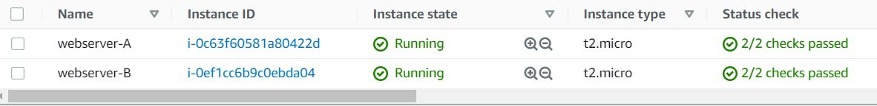

Task 4: Creating a Load balancer

1. In the **EC2** Console, Navigate to **Target Groups**, present in the left panel under **Load Balancing**.
2. Click on the 

1. For **Step 1, Specify group details**

* Under Basic configurations,
  + Choose a target group:  Choose **Instances**
  + Target group name:  Enter ***web-server-TG***
* **Keep all the settings as default.**
* Health check protocol: HTTP
* Health check path: Enter ***/index.html***
* Scroll to the end of the page and click on the **Next** button.

1. For **Step 2, Register targets**
   * Select both instances and click on the **Include as pending below** button.  
     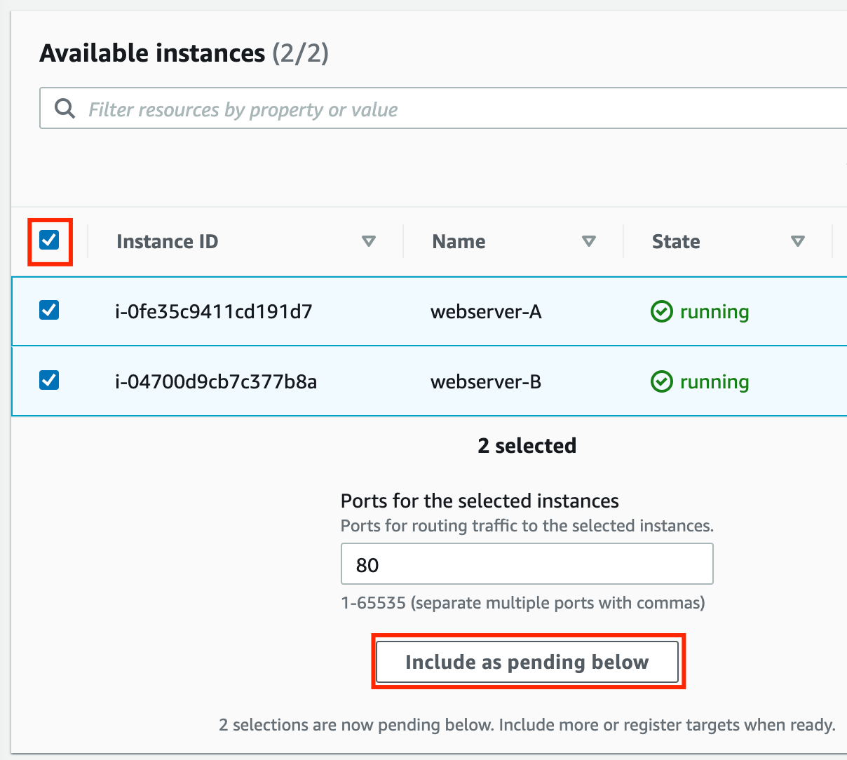
   * Instances will be present in the Review targets part, having health status as **Pending**.
   * Click on the **Create target group** button.
2. **The Target group is now created.**
3. In the EC2 console, navigate to **Load balancers** in the left-side panel.
4. Click on at the top-left to create a new load balancer for our web servers.
5. **Select Load Balancer Type**: Under the **Application load balancer**, click on **Create** button.
6. To create an Application load balancer, **configuring the load balancer** as below
   * For the **Basic configuration** section,
     + Name: Enter ***Web-server-LB***
     + Scheme: Select**Internet-facing**
     + IP address type: Choose **IPv4**
   * For the **Network mapping** section:
     + VPC: Select **Default**
     + Mappings:**Select all the Availability zone present**
   * For the Security groups section,
     + Select the ***LoadBalancer-SG* Security group** from the dropdown and **remove the default security group**.
   * For the **Listeners and routing** section,
   * The listener is already present with Protocol HTTP and Port 80.
     + **Select the target group *web-server-TG* for the Default action forwards to option.**
7. Keep the tags as default and click on the **Create load balancer** button.
8. **You** **have successfully created the Application Load balancer.**Click on the**View load balancers button.**
9. Wait for 2 to 3 minutes for the load balancer to become **Active**.

Task 5: Testing the Load Balancer

1. Navigate to**Load Balancers** and selectthe**load balancer** that you created. Click on**Description ,** **copy the DNS name**and paste it in the browser

1. Refresh the browser a few times and you will see the request is serving from both servers. You will see the output as **RESPONSE COMING FROM SERVER A & RESPONSE COMING FROM  SERVER B.** This showsthat load is shared between the two web servers via Application Load Balancer.

Task 6: Creating an IP set

1. Click on  and select **WAF & Shield** under the **Security, Identity, & Compliance** section.
2. Select **IP sets** in the right side menu and click on 
3. On the next screen, fill out the following details under **Create IP set.**

* **IP set details:**
  + IP set name    : Enter ***MyIPset***
  + Description    : Enter ***IP set to block my public IP***
  + Region           : Select **US EAST (N.Virginia )**
  + IP Version      : Select **IPv4**
  + IP address     : Enter ***IP of your local network/32*** from <https://www.whatismyip.com/>.
  + Note: You have to give /32 after the IP is pasted or else you won't be able to create an IP set.
* Once you have provided the above details, click on **Create IP set**

Task 7: Creating a web ACL

1. **Web ACL details**

* Navigate to the **AWS WAF** dashboard and select **Web ACLs** . Click on  to create a new web ACL.
* Configure the ACL as below:
  + **Web ACL details**
* Name : Enter ***MywebACL***
* Description: Enter ***ACL to block my public IP***
* Resource type:Select **Regional resources  (Application Load Balancer and API Gateway)**
* Region: Select **US EAST (N.Virginia)**

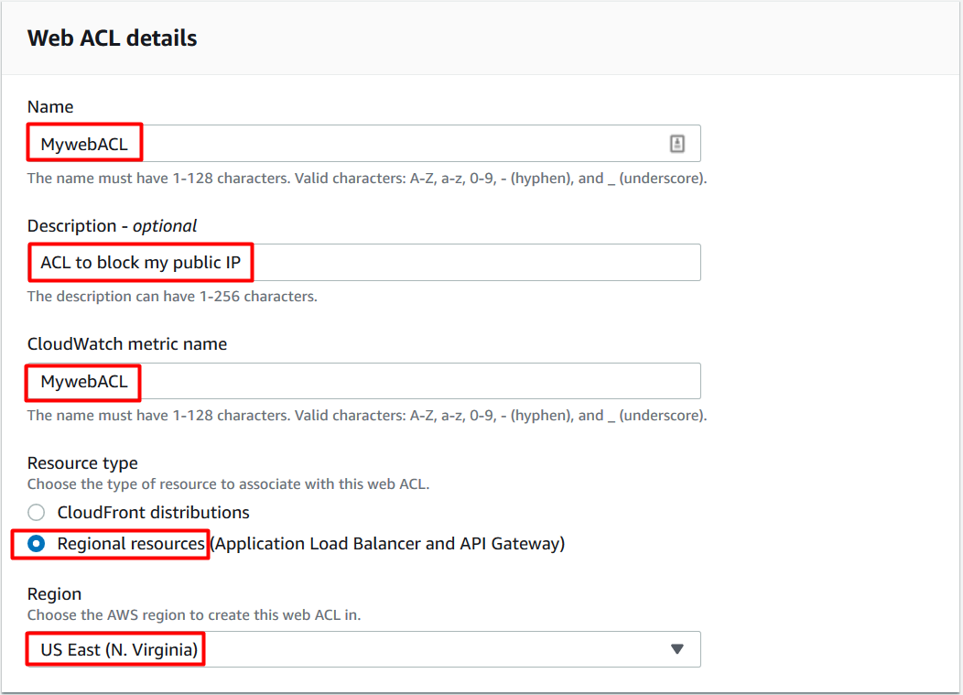

* To associate an AWS resource, click on **Add AWS resources**
* In Add AWS resources select **Application Load Balancer**and select the name of **ALB**. Click on **Add**

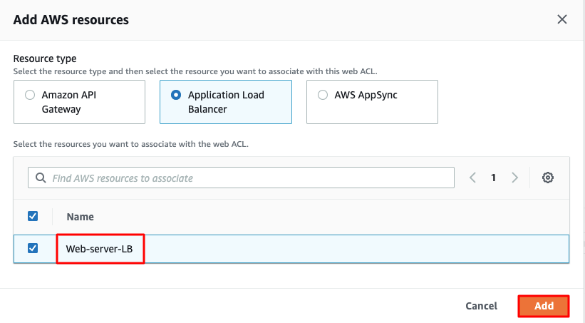

* Lastly click on **Next**button

1. **Add rules and rule groups**

* Under **Rules** click on **Add rule** and select  **Add my own rules and rule groups** in the drop-down menu.
* In **Rule type**select**IP set** as shown below and fill the details as given below:
  + Rule type    : Select **IP set**
  + Name          : Enter ***MywebACL-rule***
  + IP set           :  **select the IP set created Above ( MyIPset )**
  + IP address to use as the originating address**: Source IP address**
  + Action          : Select **Block**
* Once you provide the above details, click on **Add rule**.
* Lastly click on **Next**button

1. **Set rule priority**

* Leave as default and click on **Next**.

1. **Configure metrics**

* Leave as default and click on **Next.**

1. **Review and create web ACL**

* Review all your inputs and click on **Create web ACL**

1. Wait for 1 or 2 minute until you will see that your web ACL is successfully created.



1. You have successfully created a web ACL for ALB with the help of an IP set created with your public IP.

Task 8: Testing the working of the WAF

1. To test the WAF, navigate  to **Load Balancers** from the EC2 left menu under the sub-heading **Load balancing**
2. Under the Load balancer section, select the Application load balancer**Web-server-LB.**
3. Copy the DNS name under Description and paste it in your desired browser.

* **Example**: web-server-lb-1903855210.us-east-1.elb.amazonaws.com

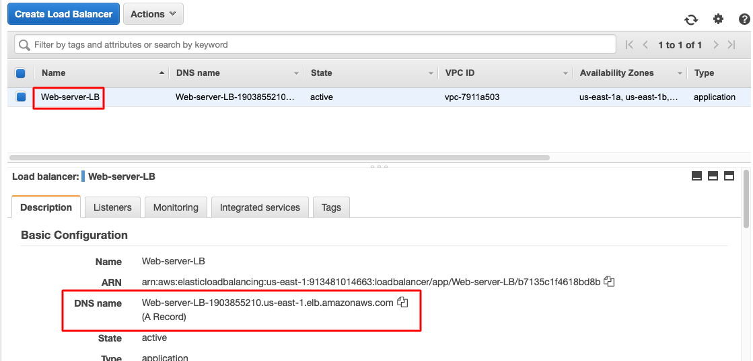

1. You will get a **403 forbidden error** showing that WAF blocked your connection to ALB.

Task 9: Unblocking the IP

1. To unblock the IP, navigate to **IP sets** and click on **MyIPset.**Select your public IP and then click on **Delete**

1. Type **delete**in the confirmation box and click on **Delete**.
2. You have successfully removed the IP from WAF.
3. Wait for a few minutes.
4. Navigate **toLoad Balancers** from EC2 left menu under the sub-heading **Load balancing**
5. Under the Load balancer section, select the Application load balancer**Web-server-LB.**
6. Copy the DNS name under Description and paste it in your desired browser.

* **Example**: web-server-lb-1903855210.us-east-1.elb.amazonaws.com

1. You will get the response from the web servers either stating **RESPONSE COMING FROM SERVER 1** or **RESPONSE COMING FROM SERVER 2** as shown below:

Task 10: Validation Test

1. Once the lab steps are completed, please click on the A picture containing text

   Description automatically generated button on the leftside panel.
2. This will validate the resources in the AWS account and displays whether you have completed this lab successfully or not.
3. Sample output :

**Completion and Conclusion**

1. You have successfully created an IP set using your public IP.
2. You have successfully created a web ACL rule using an IP set and application load balancer (ALB).
3. You have successfully tested the working of the ALB after implementing a WAF, blocking the web request to the ALB from your local network.
4. You deleted the IP set and tested the working of the ALB.

**End Lab**