**Lab Steps**

Task 1: Sign in to AWS Management Console

1. Click on the  button, and you will get redirected to AWS Console in a new browser tab.
2. On the AWS sign-in page,

* Leave the Account ID as default. Never edit/remove the 12 digit Account ID present in the AWS Console. otherwise, you cannot proceed with the lab.
* Now copy your **User Name** and **Password** in the Lab Console to the **IAM Username and Password** in AWS Console and click on the **Sign in** button

     3. Once Signed In to the AWS Management Console, Make the default AWS Region as **US East (N. Virginia) us-east-1.**

Task 2: Setup Visual Studio Code

   1. Open the visual studio code.

   2.  If you have already installed and using Visual studio code, open a new window.

   3. A new window will open a new file and release notes page (only if you have installed or updated Visual Studio Code recently). Close the Release notes tab.

   4. Open Terminal by selecting View from the Menu bar and choose Terminal.

   5. It may take up to 2 minutes to open the terminal window.

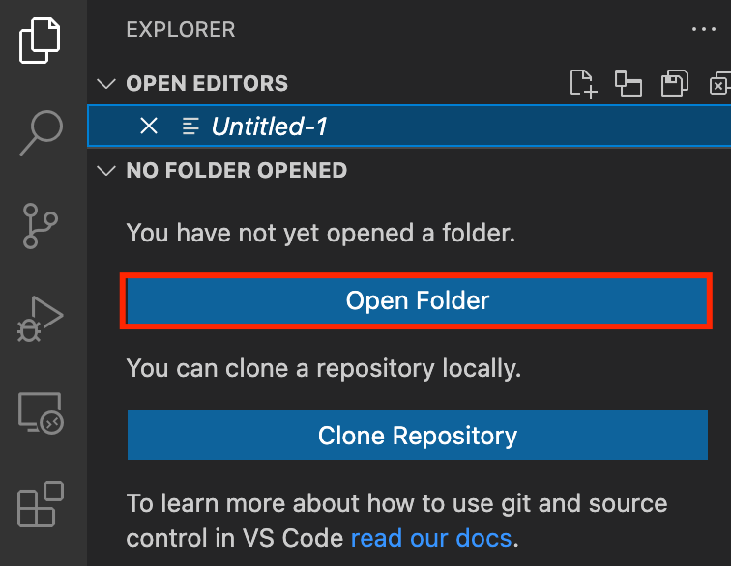

    6. Once the terminal is ready, let us navigate to the Desktop.

cd Desktop

    7. Create a new folder by running the below command.

mkdir task_10094_sns

    8. Change your present working directory to use the newly created folder by running the below command:

cd task_10094_sns

    9. Get the location of the present working directory by running the below command:

pwd

  10. Note down the location, as you will open the same in the next steps.

  11. Now click on the first icon Explorer present on the left sidebar.

  12. Click on the button called Open folder and navigate to the location of folder **task_10094_sns**.

  13. (Optional) Click on Authorize button for allowing Visual Studio Code to use the task_10001_ec2 folder. This will only be asked when you have been using Visual Studio code for a while as you are allowing a new folder to be accessed by VSC.

  14. Visual Studio Code is now ready to use.

Task 3: Create a variables file

In this task, you will create variable files where you will declare all the global variables with a short description and a default value.

  1. To create a variable file, expand the folder **task_10094_sns** and click on the **New** **File** icon to add the file.

  2. Name the file as **variables.tf** and press **Enter** to save it.

  3. **Note:** Don't change the location of the new file, keep it default, i.e. inside the **task_10094_sns**folder**.**

  4. Paste the below contents in **variables.tf**file.

|  |
| --- |
| variable "access_key" {  description = "Access key to AWS console"  }  variable "secret_key" {  description = "Secret key to AWS console"  }  variable "region" {  description = "AWS region"  }  variable "sns_subscription_email" {  type = string  description = "Email endpoint for the SNS subscription"  } |

  5. In the above content, you are declaring a variable called, access_key, secret_key, and region with a short description of all 3.

  6. After pasting the above contents, save the file by pressing **ctrl + S**.

  7. Now expand the folder**task_10094_sns**and click on the **New File** icon to add the file.

  8. Name the file as**terraform.tfvars** and press **Enter** to save it.

  9. Paste the below content into the **terraform.tfvars** file.

|  |
| --- |
| region = "us-east-1"  access_key = "<YOUR AWS CONSOLE ACCESS ID>"  secret_key = "<YOUR AWS CONSOLE SECRET KEY>" |

 10. In the above code, you are defining the dynamic values of variables declared earlier.

 11. Replace the values of access_key and secret_key by copying from the lab page.

 12. After replacing the values of access_key and secret_key, save the file by pressing Ctrl + S.  
        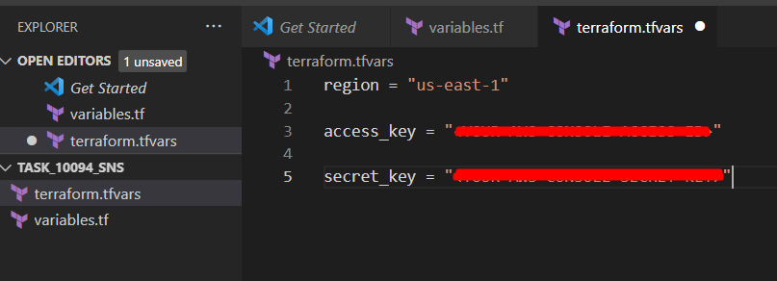

Task 4: Create SNS topic and its components in main.tf file

 In this task, you will create a **main.tf** file where you will add details of the provider and resources.

  1. To create a **main.tf** file, expand the folder **task_10094_sns** and click on the **New** **File** icon to add the file.

  2. Name the file as **main.tf** and press **Enter** to save it.

  3. Paste the below content into the **main.tf** file.

|  |
| --- |
| provider "aws" {      region     = "${var.region}"      access_key = "${var.access_key}"      secret_key = "${var.secret_key}"  } |

  4. In the above code, you are defining the provider as aws.

  5. Next, we want to tell Terraform to create a SNS topic named as **whiz-topic**.

  6. Paste the below content into the main.tf file after the provider.

|  |
| --- |
| resource "aws_sns_topic" "sns_topic" {    name = "whiz-topic"  } |

   7. Finally, to complete the main.tf file, let's add another set of code after sns topic creation where you will create a SNS subscription  
           .  1.  **topic_arn** - This property allows to associate the subscription with the topic arn.

              2.  **protocol -** This property is used to tell which protocol we would use to confirm the subscription

              3. **endpoint -** In this lab , we will be using endpoint as email. Therefore, we have used a variable declared in the variables.tf file. While applying terraform ,terraform will ask the email id.

|  |
| --- |
| resource "aws_sns_topic_subscription" "sns_subscription" {    topic_arn = aws_sns_topic.sns_topic.arn    protocol= "email"    endpoint= var.sns_subscription_email    } |

   8. Save the file by pressing Ctrl + S.

Task 5: Create an Output file

In this task, you will create an **output.tf** file where you will add details of the provider and resources.

    1. To create an **output.tf** file, expand the folder **task_10094_sns** and click on the **New** **File** icon to add the file.

    2. Name the file as **output.tf** and press **Enter** to save it.

    3. Paste the below content into the **output.tf** file.

|  |
| --- |
| output "topic_arn1" {      value = aws_sns_topic.sns_topic.arn      description = "Topic created successfully"  }  output "subscription_arn1" {      value = aws_sns_topic_subscription.sns_subscription.arn      description = "Subscription created successfully. Confirm the subscription on your mail"  } |

    4. In the above code, we will extract the topic arn and subscription arn to confirm that they are created.

Task 6: Confirm the installation of Terraform by checking the version

   1. In the Visual Studio Code, open Terminal by selecting **View** from the Menu bar and choose **Terminal**.

   2. If you are not in the newly created folder change your present working directory by running the below command.

cd task_10094_sns

   3. To confirm the installation of Terraform, run the below command to check the version:

terraform version

   4. If you are getting output as command not found: terraform, this means that terraform is not installed on your system, To install terraform follow the official guide link provided in the Prerequisite section above.

Task 7: Apply terraform configurations

   1. Initialize Terraform by running the below command,

terraform init

**Note:** terraform init will check for all the plugin dependencies and download them if required, this will be used for creating a deployment plan  
  2. To generate the action plans run the below command,

terraform plan

  3. Enter the value as your **email-id** and review the whole generated plan.  
      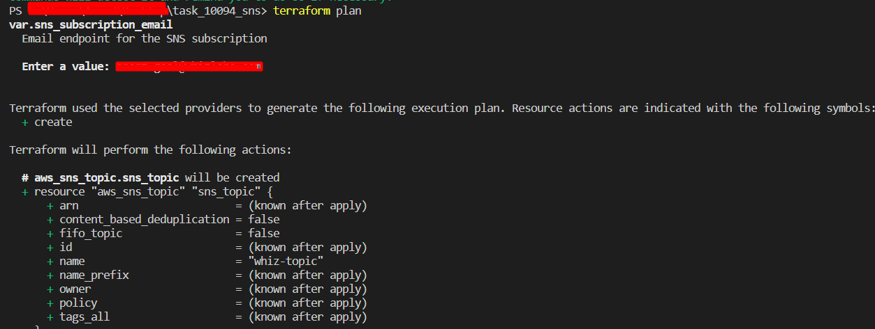

  4. To create all the resources declared in main.tf configuration file, run the below command,

terraform apply

  5. Enter the value as your **email-id and y**ou will be able to see the resources which will be created, approve the creation of all the resources by entering **yes**.

  6. It may take up to 2 minutes for the terraform apply command to create the resources.

  7. Id’s of all the resources created by terraform will be visible there.

  8. Enter a value : Enter **yes**  
        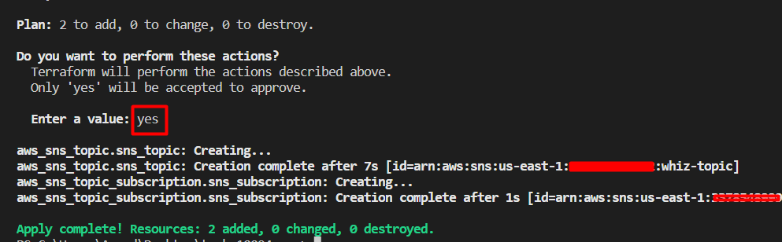

Task 8: Confirm the subscription on your email id

    1. You will receive an email in your mailbox from SNS.  
         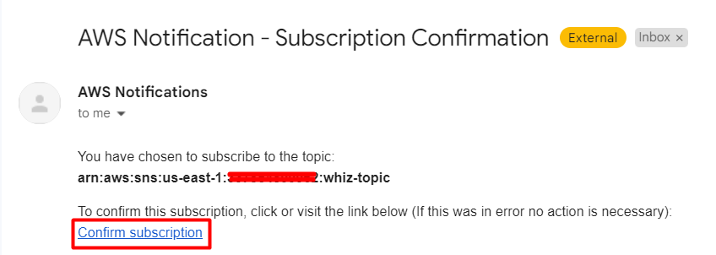

     2. Click on **Confirm subscription**.

     3. Your email address is now subscribed to SNS Topic **whiz-topic***.*

     4. You can unsubscribe to the SNS Topic at any time.

     5. We can use this to subscribe to S3 events, CloudWatch events and more.

Task 9: Check the resources in AWS Console

     1. Make sure you are in the **US East (N. Virginia) us-east-1** Region.

     2. Navigate to **SNS** by clicking on **Services** on the top, then click on **SNS** in the **Application Integration** section.

     3. Click on the **Topics** on the left navigation panel and select the topic created. You can see that the topic is created successfully.

   4. Scroll down and you can see the subscription being created and confirmed successfully.  
            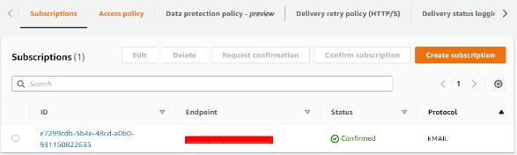

Task 10: Validation of the lab

  1. Once the lab steps are completed, please click on the  button on the left side panel.

  2. This will validate the resources in the AWS account and displays whether you have completed this lab successfully or not.

  3. Sample output:   
  
       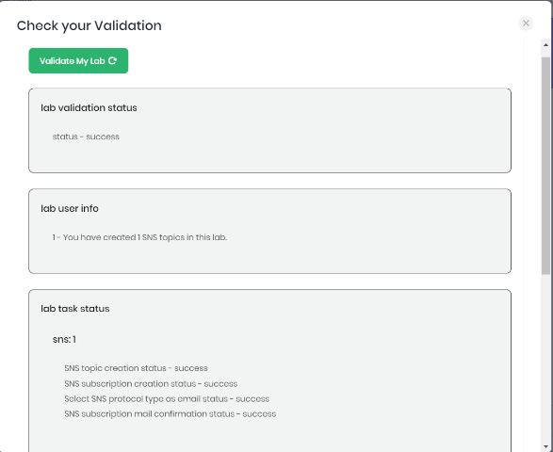

Task 11: Delete AWS Resources

   1. To delete the resources, open Terminal again.

   2. Run the below command to delete all the resources.

terraform destroy

   3. Enter your **email-id** as the endpoint and then enter **yes** to confirm the deletion. You can see the **Destroy complete!**message.  
        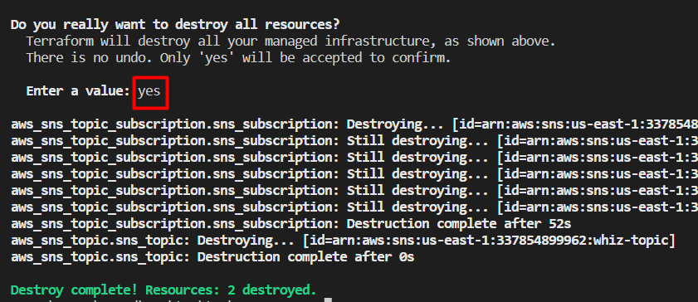

**Completion and Conclusion**

* You have set up the Visual Studio Code editor.
* You have created variables.tf and terraform.tfvars files.
* You have created a main.tf file.
* You have executed the terraform configuration commands to create the resources.
* You have checked all the resources created by opening the Console.
* You have deleted all the resources.

**End Lab**