1 . Search Function(For both user and admin) :

* Enter username and password and then click log in button

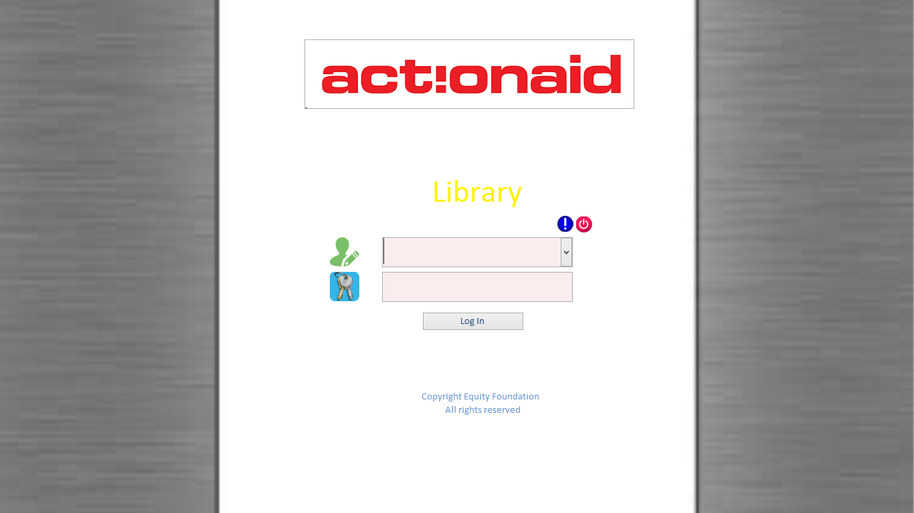

* Select Reader button

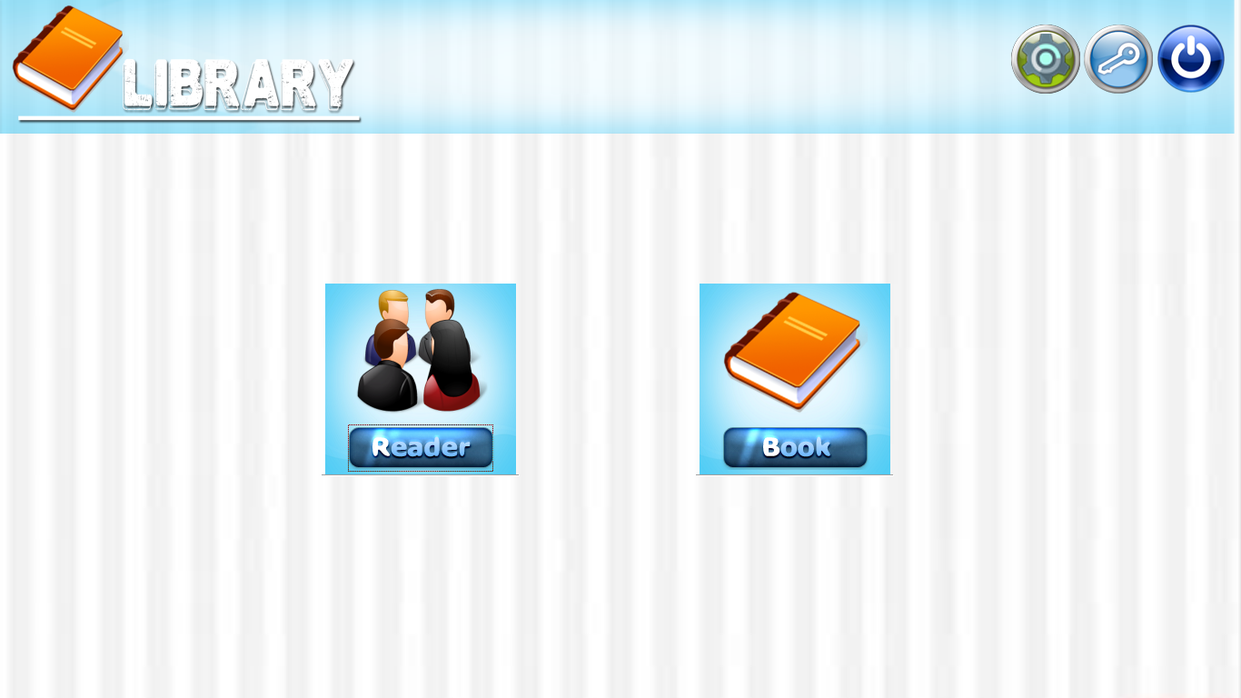

* Type Title or Author or Book_shelf or Category or Subcategory in search field then you

will get desired result.

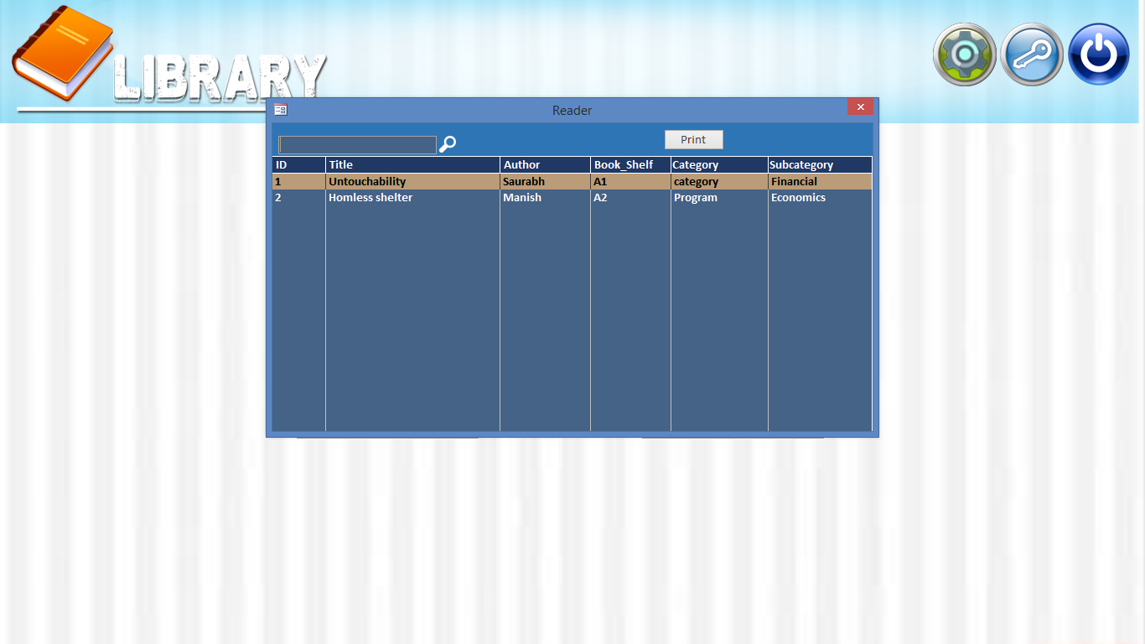

2 . Add entries (Only for Admin) :

* Enter admin’s username and password



* Select Book button



* For editing exiting entry :

1. Click on Edit button
2. Edit details
3. Finally click on Save button.

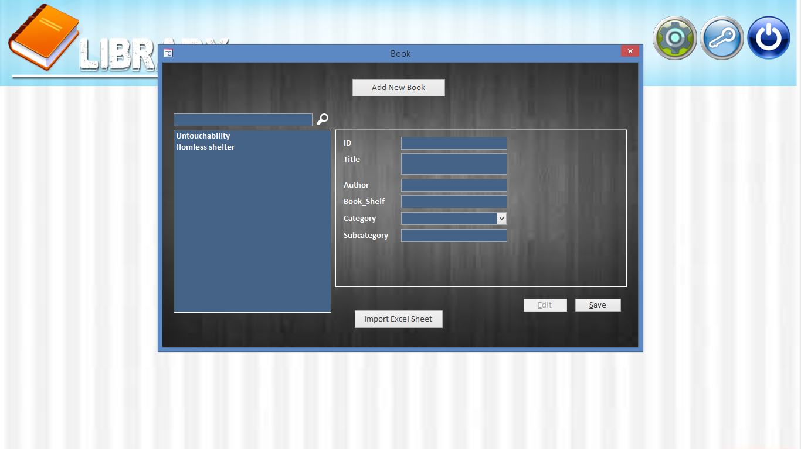

* Add new resource entry :

1. Click on Add New Book button
2. Fill all book details
3. Click on Add button
4. Finally click on Save button

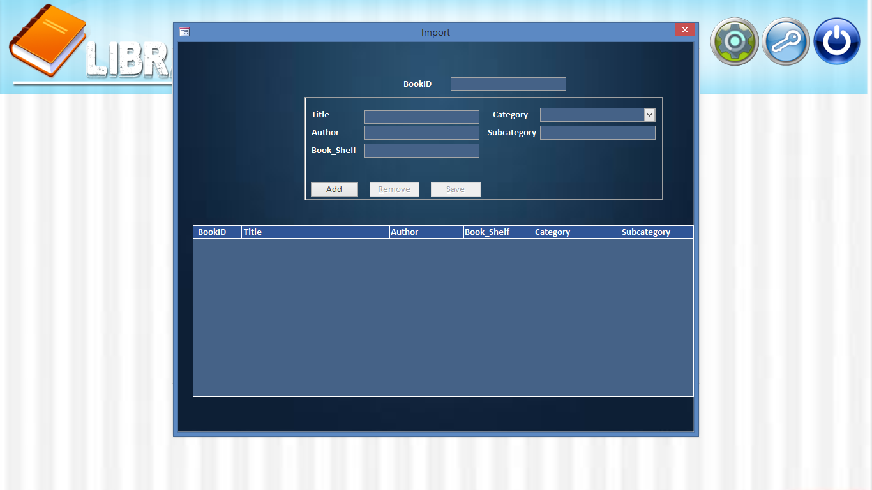

* Add new resource entry through Excel Sheet :

1. Click on Import Excel Sheet button



1. Click on Browse button

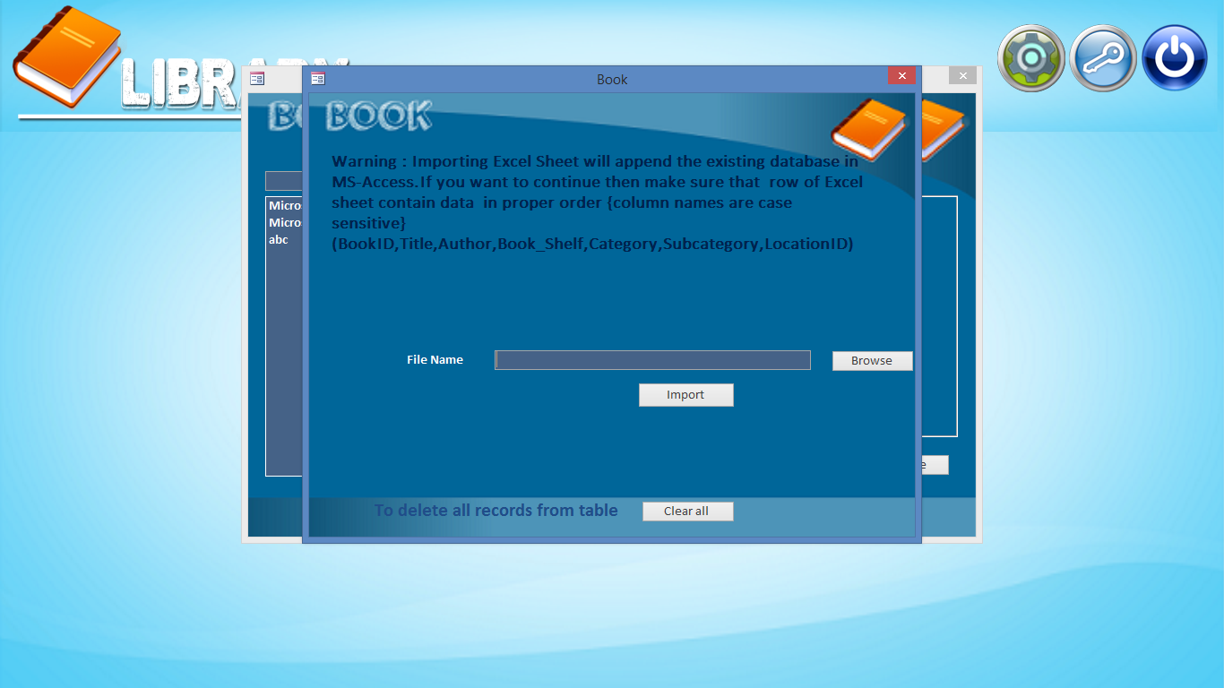

1. Select Excel file
2. Click on Open button

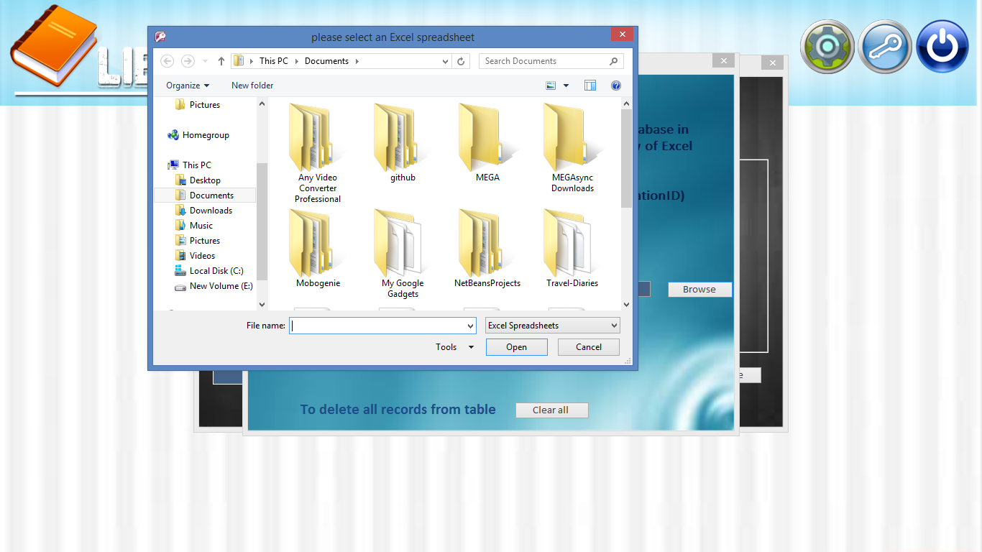

1. Finally click Import button

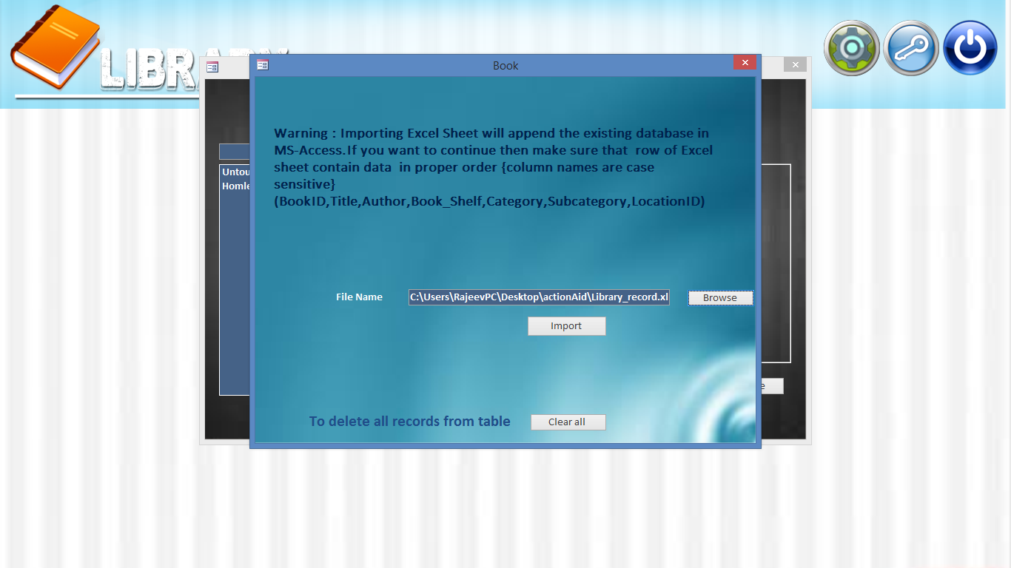

1. And your job is done ! , you will see this window.

