analyzing population data for various countries, focusing on understanding population behavior, patterns, and trends over time.

Work within the Total Population sheet and input your final answers in the Solution sheet.

**Step 1: Assess Population Behavior Over Time**

For each country, populate the following:

1. **Typical Population Size:** Calculate the Mean population.
2. **Central Value of Population:** Calculate the Median population.
3. **Most Common Population Size:** Calculate the Mode. If no value repeats, mark this as "None."
4. **Smallest and Largest Populations:** Calculate Minimum and Maximum Population
5. **Population Spread:** Calculate range using the minimum and maximum population
6. **Population Consistency (Deviation from Typical Size)**: Calculate Standard Deviation
7. **Population Variability Over Time:** Calculate Variance

Organize the results into the summary table given in the solution sheet with the following structure:

|  |  |  |  |  |  |  |  |  |
| --- | --- | --- | --- | --- | --- | --- | --- | --- |
| Country Name | Typical Population | Central Population Value | Most Common Population Size | Smallest Population | Largest Population | Population Spread | Population Consistency | Population Variability |
| Country 1 | Value | Value | Value (if any) | Value | Value | Value | Value | Value |
| Country 2 | Value | Value | Value (if any) | Value | Value | Value | Value | Value |
| ... | ... | ... | ... | ... | ... | ... | ... | ... |

**Note: List country/region names alphabetically.** For countries where no most common population size exists, fill with "None." If any of the other statistics cannot be calculated, handle errors by filling with NA.

**Step 2: Interpret Population Trends and Stability**

In this step, you'll fill the column titled **Population Trend** of the summary table. Populate this column by interpreting the results based on the following guidelines:

1. **Stable Population**: If standard deviation is less than 10% of the average population, mark as **"Stable Population."**
2. **High Population Fluctuation**: If the range exceeds 20% of the average or variance > 1000, mark as **"High Population Fluctuation."**
3. **Extreme Population Fluctuation**: If the max population > 1.5× average or min population < 0.5× average, mark as **"Extreme Population Fluctuation."**
4. **Increasing Population Trend**: If the median population (sorted) is higher than the average, mark as **"Increasing Population Trend."**
5. **Decreasing Population Trend**: If the median population is lower than the average, mark as **"Decreasing Population Trend."**
6. **No Trend**: If conditions aren’t met or errors occur, mark as **"No Trend."**

Example of the final result

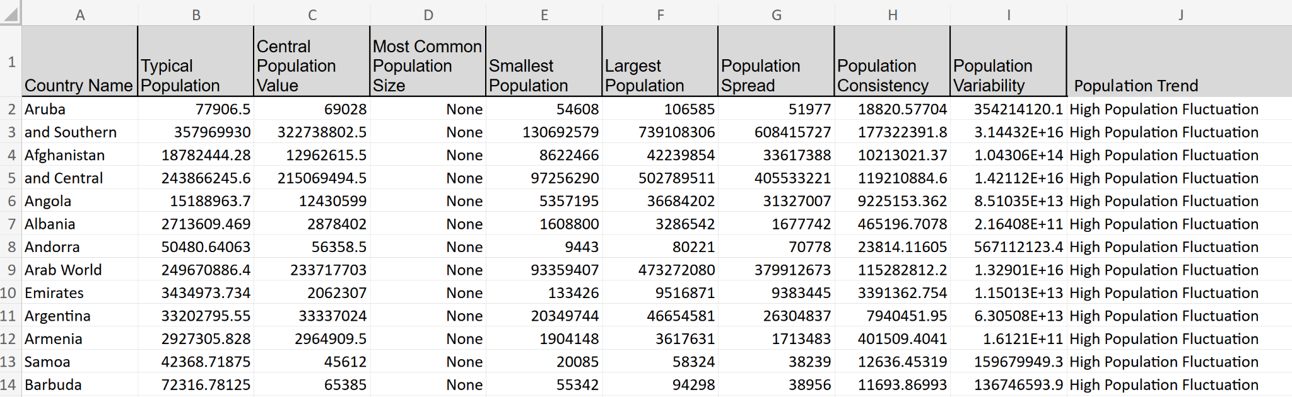

NOTE: Do not modify any of the given columns and rows in the dataset.