**Adding and Editing Contacts in LEAD Transactions**

In many types of transactions in LEAD, you will be asked to ensure that your list of Contacts is correct.

In most types of transactions, such as Renewal, or Change of Designation of Administrative Authority, when you arrive at the Ownership / Administrator Information page in the transaction, all of the Contacts that LEAD has on file for your program will be listed.

For some transactions, such as a BRC transaction, no contacts will be listed; you will enter the contact that you need to request the BRC form for.

For the transactions where you see a list of contacts, we ask that you do the following:

1. Please verify that anyone who is listed is a current employee, or marked with a Term (termination) Date if they no longer work at your program.
2. Please verify that anyone who is listed has their correct (legal) name showing, and that their BRC role is correct if they have one. Their legal name needs to be listed since this is the name that will appear on their BRC form.
3. For any contact who has a BRC role, please verify that their email address is accurate, since they will be receiving their BRC form electronically at this email address.

**BRC Roles**

BRC Roles are defined as follows:

A BRC program administrator is the person designated by a program to submit candidate information during the BRC process, including BRC requests, cnsent forms for candidates, employment and affiliation decisions, and any other information requested by EEC’s BRC unit.

A licensee BRC applicant is the person responsible for the administration of the program or facility and is the duly authorized agent of the individual, partnership, corporation, association, organization or trust, department, agency, or institution of the federal government or of the Commonwealther or any political subdivision thereof who is applying for licensure or approval.

Let’s go through an example involving Contacts:

Below is an example of the Ownership / Administrator Information page for a Renewal transaction. This program has several contacts that are already store in LEAD.

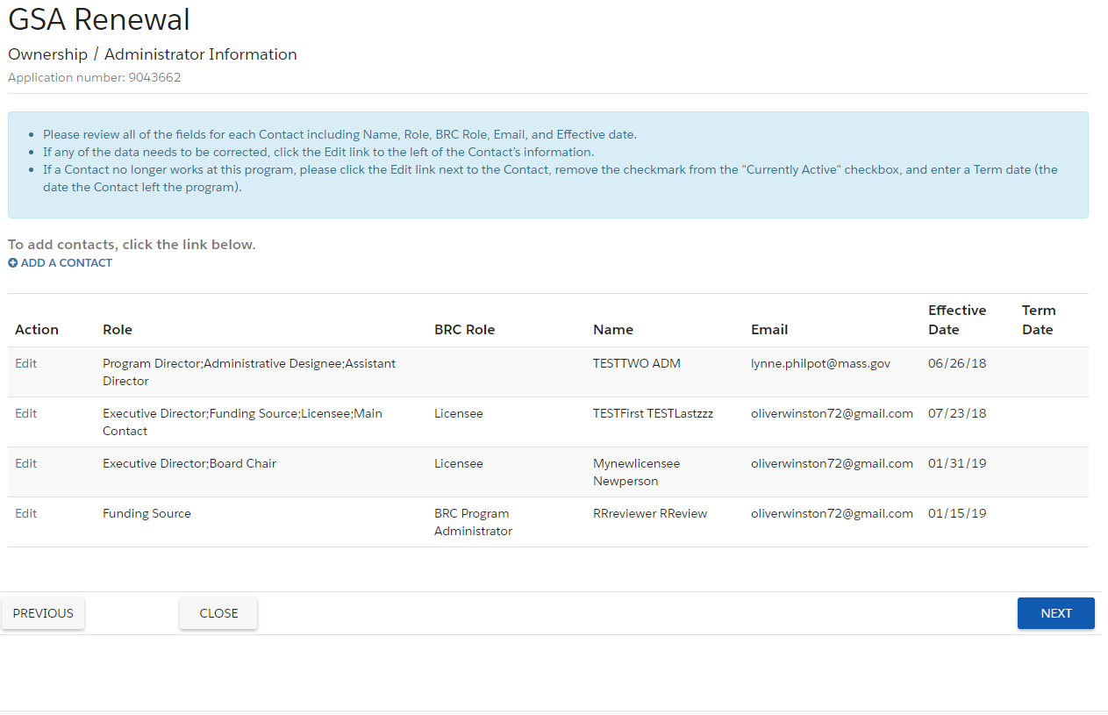

The “minimum requirements” as to who needs to be listed on this page are:

* There must be someone who has the Role of Program Director
* There must be someone who has the Role of Licensee
* There must be someone who has the BRC Role of Licensee

Other than that, you may decide who you wish to list here.

As you can see in this list, a contact can have multiple Roles. If your contact has multiple roles, please list them all on the same contact record. Do not add the person to this list multiple times.

**If you need to add someone new to your list of contacts** click the blue “Add a Contact” link.

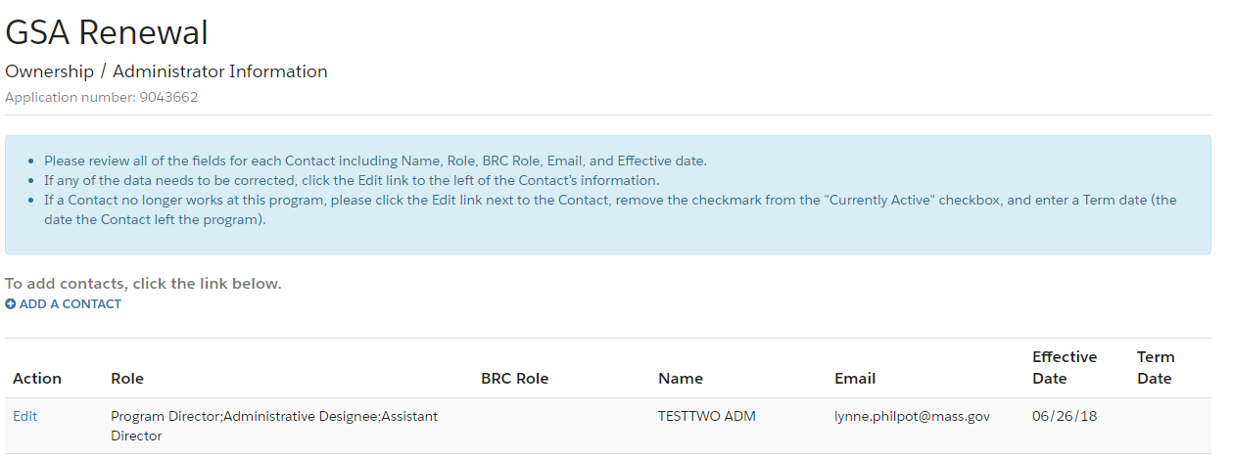

You will then come to this page:

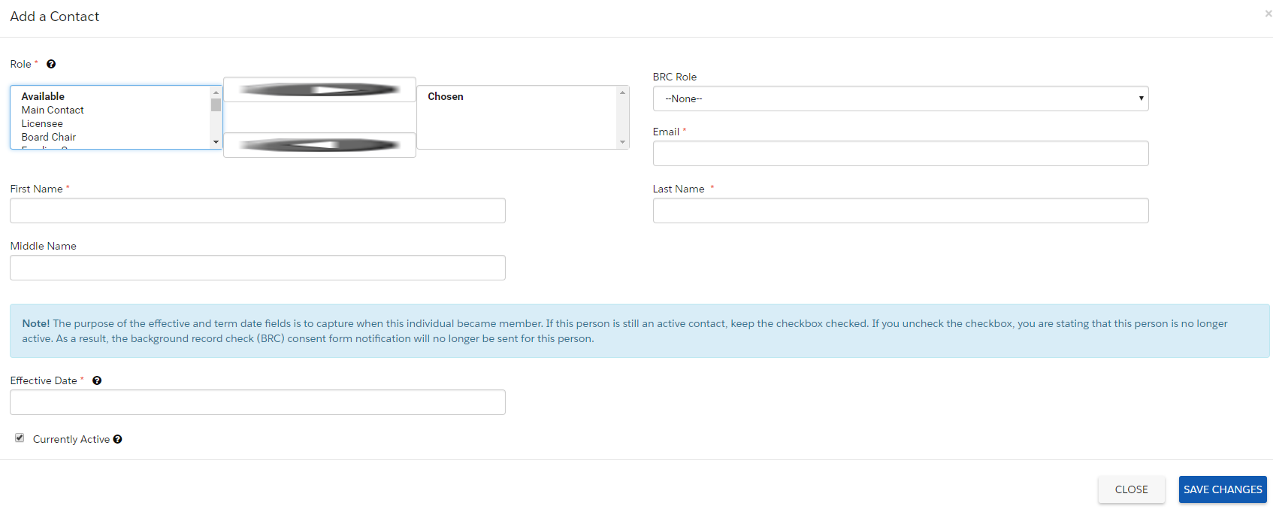

You will be required to enter:

* At least one Role
* First Name
* Last Name
* Effective Date

BRC Role is not a required field. But if the person is a BRC Reviewer or Licensee, you must specify that here by choosing a BRC role.

You can add Roles for a contact by either double-clicking on the name of the role from the list in the left-hand column, or by clicking on the role, and then clicking the right-pointing arrow. As mentioned earlier, a person may have multiple roles.

The Effective Date is defined as the date this person began working at this program. If you don’t know the exact date, LEAD only cares that the date is today or earlier, in order to make this contact active.

If the contact has a role of Program Director or Assistant Director, two additional fields will appear, for you to enter their scheduled administrative and teaching hours.

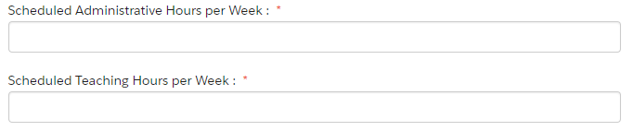

**If you need to edit a contact’s information** click the blue Edit link to the left of their name



LEAD will then display their information on the screen.

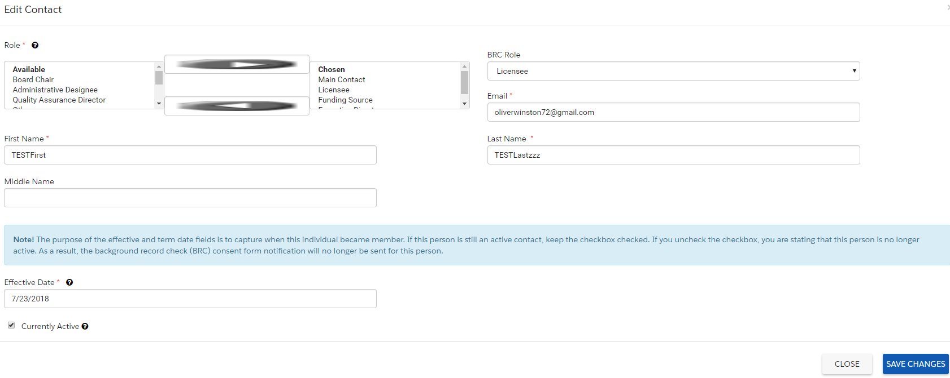

You can make changes to any of these fields. You can also edit a contact’s name to correct it in case of error, misspelling, marriage, divorce, etc. However, it is very important that you DO NOT change one person’s name to another person.

If, for example, you have a new program director, you would need to make the current program director’s contact record inactive, and create a new record for the new director using the “Add a Contact” link.

**Making a Contact Inactive**

When one of your contacts has left your program, their contact record needs to be made inactive.

To do this, click the blue edit button to the left of their name on the Ownership / Administrative Information screen.

When their contact information is displayed, un-check the “Currently Active” checkbox at the bottom of the screen.

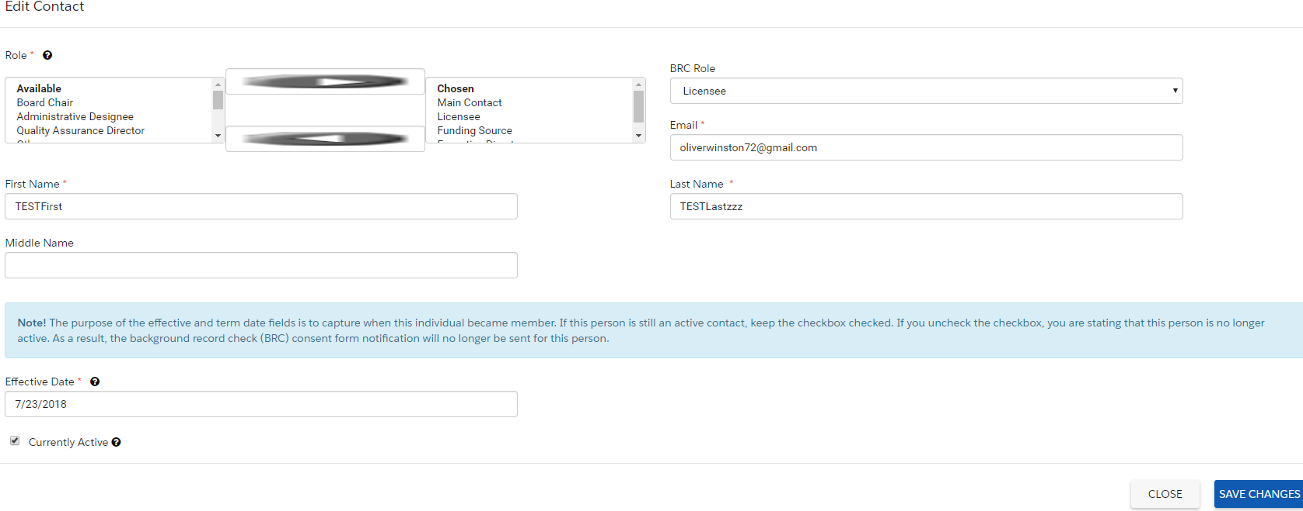

Once this box is un-checked, a Term Date field will appear to the right. Please enter the date that the person left your program. This will make your contact inactive. If they had a BRC role, they will no longer receive BRC forms related to your program.

