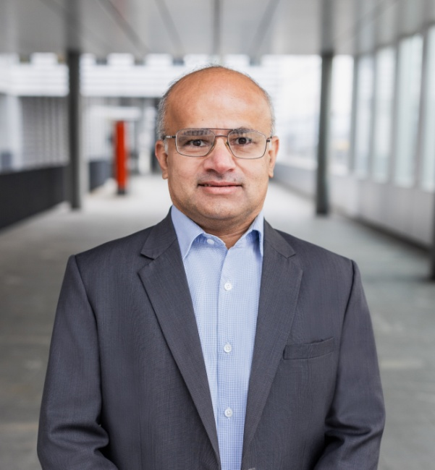


Arisdörferstrasse 7
4414 Füllinsdorf
+41 79 928 86 70
Rajeev.sharma@mail.ch
LinkedIn
PERSONAL
Date of birth: 16.12.1976
Nationality: India
Marital status: married
Work Authorization: C
LANGUAGES
English
Hindi
German
IT-SKILLS
ServiceNow, SAP, Oracle
Microsoft Power BI, Python,
React native, Flutter, Java
SQL, NoSQL, Mongo DB
Mobile &Web Development, Google AI studio, Crew AI, Gemini, Visual Studio
SKILLS / STRENGTHS
- IT service management (ServiceNow, BMC etc)
- Agile (SCRUM) methodology
- Business relationship management
- Leadership & team development
- Business case preparation
- Strategy design & execution
- Vendor negotiations &offshore development
- Process consolidation and optimization
- Organizational change management
- Post-merger integrations
- Training and people management
- ERP implementation
REFERENCES
Gladly on request





Rajeev Sharma
Senior AI Product Manager | Digital Transformation & Governance Leader

PROFESSIONAL SUMMARY

Visionary Product Leader with over 27 years of experience bridging the gap between complex technical capabilities and business strategy. Currently focused on Agentic AI and Fintech Product Management, combining deep technical knowledge of LLMs, specializing in the Google Cloud AI ecosystem (Gemini, Vertex AI, AI Studio) with a robust background in Enterprise Data Strategy and IT Governance.
Uniquely qualified to lead AI initiatives in regulated Swiss industries (Finance/Retail/Pharma) with a C-level background in Risk Management (CGEIT), Post-Merger Data Integration, and ROI-driven Digital Transformation. Proven track record of delivering CHF 120Mn+ in synergies and orchestrating global teams.

CORE COMPETENCE
AI & Product Strategy: Generative AI (LLMs), Agentic Workflows (CrewAI), VS, Antigravity, Langchain, RAG Pipelines, Product Lifecycle Management (MVP to Scale), Agile/Scrum, User Story Mapping.
Data & Analytics: Data Harmonization, Quantitative Financial Analysis, Process Mining (Celonis), KPI Definition, SQL, Python for Data Science.
Enterprise Governance: AI Governance & Ethics, Risk Management (CGEIT), Regulatory Compliance, Vendor Negotiation, IT Cost Optimization.
Enterprise Platforms: Google AI Studio, ServiceNow, SAP S/4 HANA, AWS, Google Cloud, Microsoft Power BI, Azure/Cloud Infrastructure.
PROFESSIONAL EXPERIENCE
FINTECH STARTUP | Switzerland AI Product Manager & Architect |
2024 – Present : Leveraging cutting-edge Agentic AI to democratize financial reasoning.
- Product Vision & Execution: Defined the roadmap and orchestrated the development of a multi-agent AI system capable of autonomous financial reasoning, moving from concept to functional MVP.
- Technical Implementation: Designed Chain-of-Thought (CoT) prompting strategies and Retrieval-Augmented Generation (RAG) pipelines to enable the LLM to solve complex, multi-step financial problems with high accuracy.
- Agentic Workflow Design: Architected a CrewAI system where specific agents (Researcher, Analyst, Critic) collaborate to perform technical and fundamental analysis on >2,000 stocks daily.
- Optimization: Balanced token costs vs. performance by fine-tuning prompts for Gemini and CrewAI frameworks, ensuring a commercially viable business model.





Arisdorferstrasse 7 / 4414 Fullinsdorf +41 79 928 86 70 Rajeev.sharma@mail.ch

MSC CRUISES (via Infosys Consulting) | Switzerland Program Manager – Strategic PMO & Governance | 2024
- Portfolio Optimization: Analyzed the application landscape and established a new PMO governance framework, identifying a synergy realization path of 15% optimization over three years.
- Data-Driven Governance: Redefined risk trackers and financial dashboards to provide real-time transparency on program health, enabling data-backed executive decision-making
INFOSYS CONSULTING AG | Zurich, Switzerland Project Manager – M&A Strategy |
2023 – 2024

- Merger Methodology: Developed the strategic methodology for Mergers, Acquisitions, and Divestitures, creating the artifacts and data migration playbooks necessary for seamless IT integration.
BRITISH AMERICAN TOBACCO (via Infosys Consulting) | UK Product Owner – Intelligent Automation & Supplier Platforms | 2022 – 2023
- Digital Product Strategy: Owned the "Global Supplier Portal" product vision, managing the backlog and coordinating sprint teams to enhance engagement for 13,000+ global suppliers.
- AI & Analytics Integration: Leveraged Process Mining (Celonis) and early AI-based chat solutions to analyze procurement data, identify bottlenecks, and improve User Experience (UX).
- ROI Delivery: Achieved 300k GBP in annual efficiency savings by automating supplier interaction workflows and streamlining financial data exchange.
RASOL SOLUTIONS | Switzerland Entrepreneur & Product Owner | 2019 – 2022
- Developed and launched a bespoke ERP/CRM web application for small businesses, enabling structured, data-driven management and mobile curriculum delivery during the COVID pandemic.
DUFRY AG (Now AVOLTA) | Switzerland Head of IT Governance & Data Strategy | 2014 – 2019
A period of rapid growth involving the integration of Nuance and WDFG, focusing on data harmonization and process automation.
- Global Process Maturity (2016 – 2019):
  - Standardized global data consumption processes for Capex/Opex, establishing a "Single Source of Truth" for IT spending.
  - Implemented rigorous governance aligned with COBIT & CGEIT, creating the control frameworks that are now essential for AI/Data compliance.
  - Data Insight: Enabled real-time quantitative tracking of process performance, moving the organization from manual reporting to automated, system-driven insights.
- Post-Merger Integration Lead (2014 – 2018):
  - Data Harmonization: Led the IT integration for the WDFG ($3.5Bn) and Nuance ($1.5Bn) acquisitions. Successfully rationalized the application portfolio, consolidating disparate data silos into unified enterprise systems.
  - Synergy Realization: Delivered CHF 120Mn in IT synergies and reduced operational costs by CHF 70Mn+ in the first year through aggressive vendor consolidation and infrastructure optimization.

Strasse / PLZ Ort +41 790000000 E-Mail
Strasse / PLZ Ort +41 790000000 E-Mail



Arisdorferstrasse 7 / 4414 Fullinsdorf +41 79 928 86 70 Rajeev.sharma@mail.ch
DUFRY AG (Now AVOLTA) | Switzerland Head of IT Governance & Data Strategy | 2014 – 2019
- ServiceNow Product Owner (2014 – 2019):
  - Workflow Automation: Led the enterprise-wide implementation of ServiceNow (ITSM/ITOM/ITBM), automating 20+ key business processes across IT, HR, and Finance.
  - Cost Transparency: Achieved 100% visibility into IT service costs, enabling a 30%
  - Reduction in operational spending through data-driven resource allocation.
PREVIOUS EXPERIENCE
- Dufry AG (now AVOLTA) Switzerland Project Manager (ERP Rollout), (2012–2014) – Oracle Finance & Retail implementation.
- Novartis (via Infosys) Switzerland Service Delivery Manager (SAP), (2008–2010) – Managed strategic SAP accounts across 5 European countries.
- Johnson Controls (via Infosys) USA & UK Engineering Manager, (2000–2008) – Global Product design and launches, Engineering head, Six Sigma design optimization.

EDUCATION & CERTIFICATIONS
- Diploma in Digital Excellence | IMD Business School, Lausanne (Ongoing)
- Master of Business Administration (MBA) | Copenhagen Business School (2012)
- Bachelor of Engineering | Pune University, India (1998)
Certifications:
- CGEIT (Certified in the Governance of Enterprise IT) – Critical for AI Risk/Compliance
- SAFe 6.0 Agilist
- PMP (Project Management Professional)
- ITIL V3 Professional

