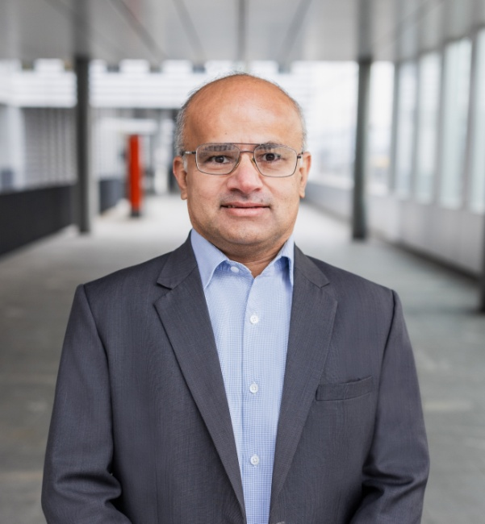
Rajeev Sharma
Senior AI & technology architect | Digital Transformation &
Governance Leader


Ask for demo of my AI work

What I Offer

With over 27 years of experience across Manufacturing, Consulting, Retail, and Pharmaceuticals, I offer strategic thinking driven by customer value and emerging industry trends. I act as a change agent for organization-level transformations, refining business models to establish new product lines and drive digital excellence. My approach combines hands-on execution with the realization of synergies, specifically focusing on team transition in alignment with corporate strategies. I have driven key initiatives in Data-driven business operations, Governance, M&A , Finance Management and Enterprise platforms such as ERPs. As a proponent of leveraging technology to enable change, I am currently pivoting toward Agentic AI, having personally developed products to demonstrate how industries can leverage this revolutionary technology for tangible impact.
I have a proven track record of transforming global organizations to deliver millions in synergies and value adds. In recent years, I have been part of IT function with close alignment with business functions.

What I look for

I am seeking a consulting or permanent position with an organization that embraces change and views AI technologies as future frontiers. I am passionate about process and data-driven initiatives, where I can review existing workflows and enhance effectiveness through technology, platforms, and people change management. I look for a role with direct exposure to business functions that impact bottom-line growth. Beyond the digital space, my interests extend to financial analysis, real estate, and investments, reflecting a holistic mindset geared toward value creation and optimization.

Who I am

With a career spanning India, the USA, the UK, and Switzerland, I have built a diverse global perspective on Business, technology and leadership. I am a lifelong learner with passion to solve problems, I consider myself to be critical thinker with optimistic outlook. In addition to my professional career, I have also been an entrepreneur in Ed-Tech, IT consulting and Fin-Tech domains. Few of the key areas I have worked professionally include 1) Product Design, development and launches, 2) Business Development and Offshore setups 3) Business Process optimization 4) ERP program management 5) PMO & IT service Management 6) IT governance for Process and Finance 7) PMO for post M&A 8) Customized ERP & CRM application 9) Digital Transformation consolation 10) IT Project Management and Service management platforms ownership 11) Gen AI, AI development, and Agentics AI.
PROFESSIONAL EXPERIENCE
2024 – Present AI Advisor & Architect – Fin-Tech
2023 – 2024 Program Manager-CRL - Infosys Consulting AG (CH)

- Consulting, Sales, PMO & Governance - MSC Cruises (CH)
- Product Owner - British American Tobacco (UK)
2019 – 2022 Founder & Product Owner - Rasol Solutions GMBH (CH)
2014 – 2019 Head of IT Governance & Data Strategy - Dufry AG (Now Avolta)
2012–2014 Project Manager (ERP Rollout) - Dufry AG (Now Avolta)
2008–2010 Service Delivery Manager (SAP) Novartis (via Infosys) (CH)
2000–2008 Engineering Manager - Johnson Controls (via Infosys) USA & UK,
1998–2000 Process Engineer– Bosch India

EDUCATION & CERTIFICATIONS
- Diploma in Digital Excellence - IMD Business School, Lausanne (2019)
- Master of Business Administration (MBA) - Copenhagen Business School (2012)
- Bachelor of Engineering - Pune University, India (1998)
Certifications:
- CGEIT (Certified in the Governance of Enterprise IT)
- SAFe 6.0 Agile
- PMP (Project Management Professional)
- ITIL V3 Professional

