Status Report Template

For Development Period: | Starting | 02/07/2026 | Ending | 02/38/2026

Project Name | EnviraLog: A Real-Time Campus Environmental Monitoring and Predictive Analytics Platform Utilizing IoT Sensor Networks, MQTT, Node.js, and React
Student Name(s) | Manis Khatri and Rajeev Patel

Project status for this development period

Rajeev Patel: Configured and initialized the Raspberry Pi Pico 2 W development environment using the Arduino IDE to support sensor integration and wireless communication. Installed required board packages and libraries necessary for IoT device programming and testing. Successfully established connectivity between the Raspberry Pi Pico 2 W and the local system to enable serial monitoring and hardware communication.

Manis Khatri: Performed hardware setup and sensor integration for the EnviraLog environmental monitoring system. Connected and configured multiple sensors including the DHT22 temperature and humidity sensor, flame sensor, air quality sensor, and buzzer with the Raspberry Pi Pico 2W. Developed and tested embedded programs using the Arduino IDE to collect environmental readings and validate sensor functionality. Verified the accuracy of sensor outputs through serial monitoring and conducted multiple calibration tests to ensure stable and reliable readings.

Check points met for this development period – Include Artifacts
- Successfully purchased and assembled required hardware components including Raspberry Pi Pico 2W, DHT22 temperature and humidity sensor, flame sensor, air quality sensor, and buzzer module.

- Configured Raspberry Pi Pico 2W using the Arduino IDE and verified proper microcontroller operation through serial communication testing.

- Integrated environmental sensors with the microcontroller.

- Developed and executed embedded programs to collect temperature, humidity, air quality, and flame detection readings from connected sensors

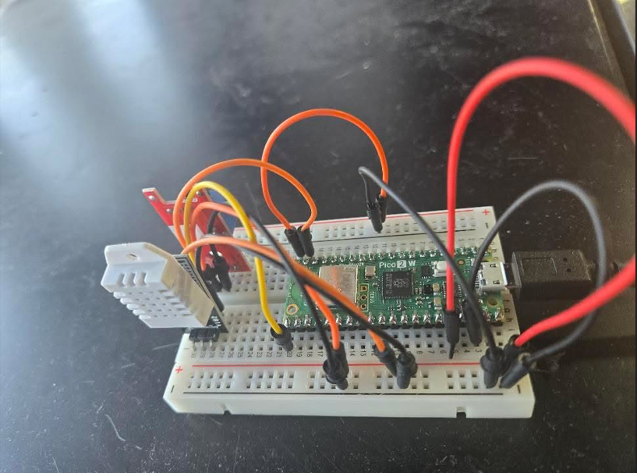

Raspberry Pico Pi W with Integrated Sensors

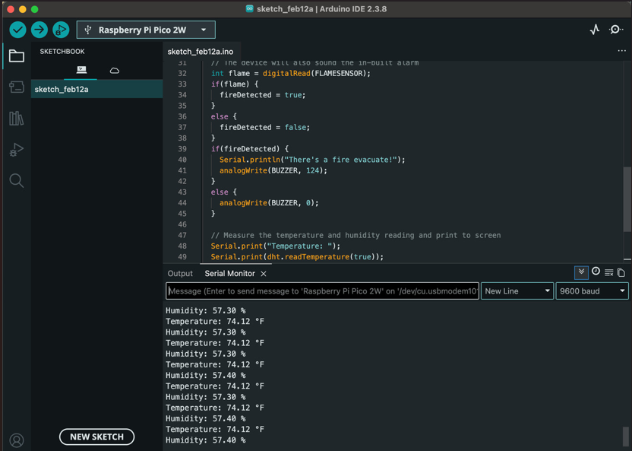

Output of the Sensor Readings

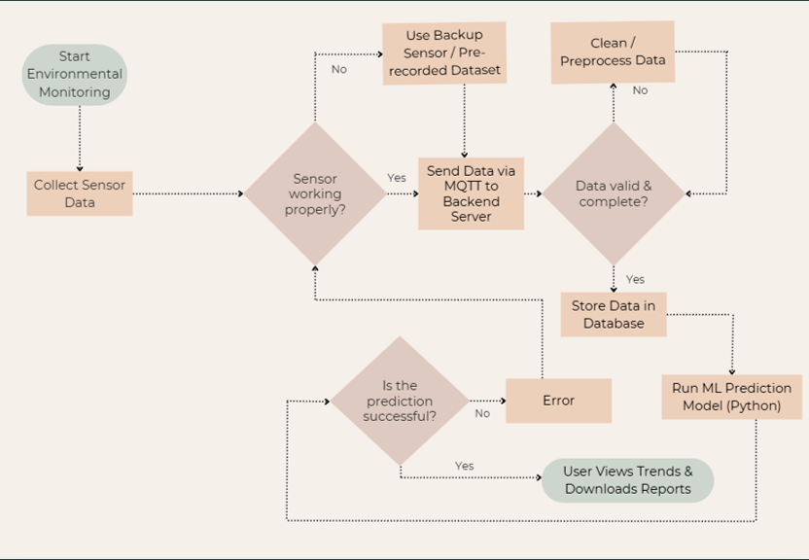
Flowchart

Summation of materials studied – Add more rows as needed
Concept Learned | Medium | Where applied in project
Raspberry Pi Pico 2W microcontroller setup and configuration. | Raspberry Pi Documentation, Arduino IDE Documentation, and Online Tutorials. | Used to initialize and program the microcontroller for EnviraLog hardware operation.
Environmental sensor interfacing (DHT22, Flame Sensor, Air Quality Sensor) | Arduino libraries documentation, YouTube technical tutorials | Applied while connecting sensors and collecting environmental data readings
Embedded programming using Arduino IDE | Arduino Official Documentation and Embedded Systems Tutorials | Developed programs to read sensor values and control buzzer alerts

Changes in proposal – With justification
No changes in proposal.

Check points for next meeting

- Research MQTT communication protocols and configure the MQTT broker environment to enable device communication (Rajeev Patel).
- Implement MQTT-based data transmission from the Raspberry Pi Pico W and verify successful real-time sensor data communication (Both).
- Develop backend services using Node.js and configure the project database for storing environmental sensor readings (Both).
- Design and implement a dashboard interface to display real-time environmental sensor data collected from the system (Manis Khatri).

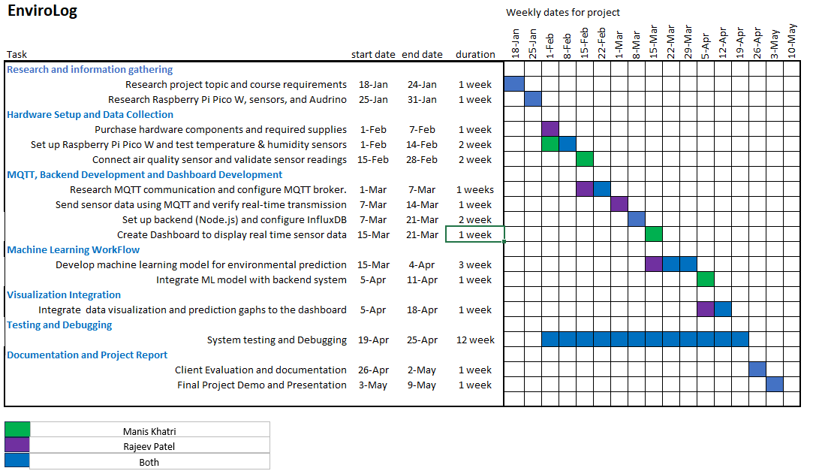

Topics to be studied | Medium | Where applied in project
MQTT communication for real-time IoT data transmission | Mosquitto Documentation, MQTT Tutorials, Online Technical Resources | Used to transmit sensor readings from Raspberry Pi Pico W to backend server
Backend development using Node.js | Node.js Official Documentation | Applied to process incoming sensor data and create API endpoints
Database integration and data storage | InfluxDB / Database Documentation, Online Tutorials | Used to store environmental sensor readings for dashboard visualization
Real-time dashboard development using React | React Documentation, FreeCodeCamp Tutorials | Applied to display live environmental monitoring data
API integration between backend and frontend | REST API Documentation and Web Development Resources | Enables dynamic updating of sensor readings on the dashboard

Projected status of development for next meeting
By the next report meeting, MQTT-based communication between the Raspberry Pi Pico W and the backend system will be complete, enabling real-time transmission of environmental sensor data. The backend application will be developed to receive and store sensor readings within the project database.
A functional dashboard prototype will also be implemented to display live environmental data such as temperature, humidity, air quality, and flame detection status. Integration between sensors, backend services, database storage, and dashboard visualization will demonstrate end-to-end system functionality.

References
- Raspberry Pi Foundation. (n.d.). Raspberry Pi Pico W documentation. https://www.raspberrypi.com/documentation/microcontrollers/pico-series.html
- Arduino. (n.d.). Arduino IDE getting started guide. https://docs.arduino.cc/software/ide-v2/tutorials/getting-started/ide-v2
- Adafruit Learning System. (n.d.). DHT22 temperature and humidity sensor guide. https://learn.adafruit.com/dht
- SparkFun Electronics. (n.d.). Air quality and gas sensor overview. https://learn.sparkfun.com/tutorials/gas-sensors
- Arduino. (n.d.). Serial communication. https://docs.arduino.cc/language-reference/en/functions/communication/serial/
- GeeksforGeeks. (n.d.). Introduction to internet of things (IoT). https://www.geeksforgeeks.org/introduction-to-internet-of-things-iot-set-1/
- Arduino Project Hub. (n.d.). Sensor interfacing projects and tutorials. https://projecthub.arduino.cc/

