**C Sc 335 Analysis and Design Artifacts for the Final Project 20 pts (TEAM)**

Each team begin analysis and design for your final project (analysis and design will continue throughout the project). Have one team member turn in this document to the D2L Assignment "Final Project Analysis and Design".

**1. Team Name:**  GeniusOverflowError

**2. Project:** Pokémon

**3. Team Members** 1: Alan Deitz 2: Paria Khamsehzadeh

3: Rajeev Ram 4: Samantha Felzien

**4. Find the objects and describe the responsibility(ies) of each**

|  |  |
| --- | --- |
| **Candidate Object** | **Responsibility(ies) in 1 or 2 sentences. What would it do and remember?** |
| Controller | The main GUI for the game. This controls all the activity among the other objects in the game: BuldingView, TownView, SafariView, BattleView. Contains the event handlers for user input. |
| Trainer | move(), throwRock(), throwBait(), runaway(), throwSafariBall(), stepCount,  currentItems. Possible child class: boy, girl. |
| BuildingView | One of the subpanes (views). Inherits from an abstract view class. The game always starts here after the user picks their player. |
| TownView | One of the subpanes (views). Inherits from an abstract view class. When player walks outside, but not yet in the Safari Zone Quest. Contains NPCs to talk to and battle. |
| SafariView | One of the subpanes (views). Inherits from an abstract view class. When player requests to start the safari zone quest. Contains different regions. |
| BattleView | One of the subpanes (views). Inherits from an abstract battle class. When player encountered Pokémon in the safari zone (this is different from a trainer battle!) |
| Pokémon | This is the abstract class. Child classes contain individuals: sprites, rarities, run and catch probabilities, HPs, moves, etc. |
| Terrain | Stores information on sprites, types. Will be implemented with flyweight design pattern. |
| Items | This is an abstract class. Child classes include: safari ball, bicycle, fishing rod, potions, berries, etc. |
| NPCs | Contains a message and a sprite for user interaction. One class could be a trainer to battle in the town. |

**5. Sequence Diagram:** Write a UML Sequence Diagram should show the most important scenario you can think of. Your sequence diagram should show most of your candidate objects you listed above and how they communicate with each other.

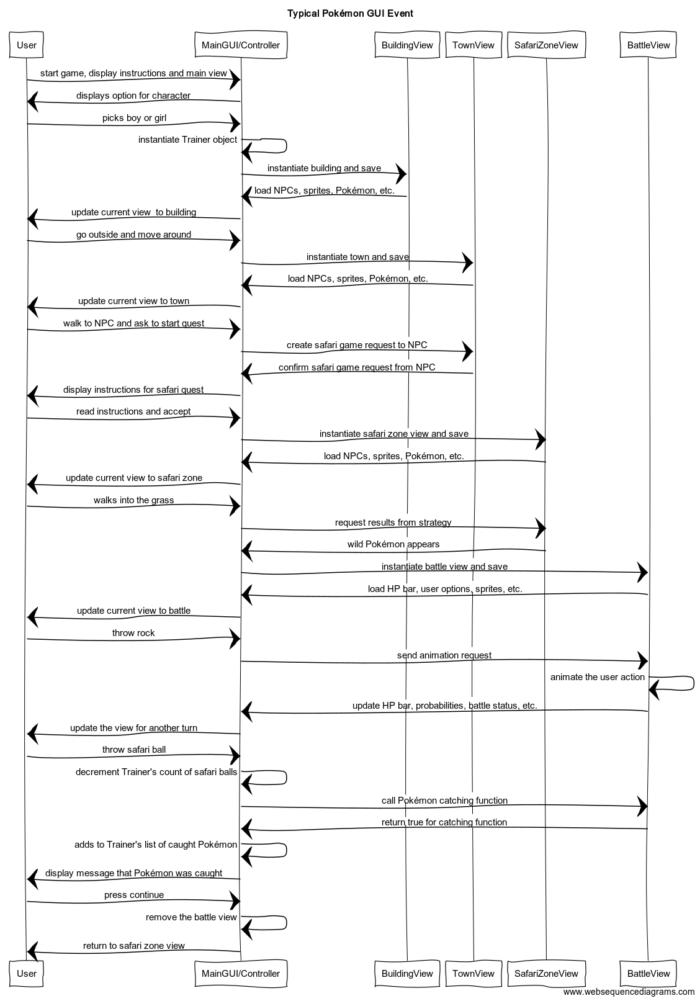

**6. Class Diagram:** Write a UML Class Diagram that shows all of your candidate objects from above. Show any relationships between them the classes such as inheritance or interface implementation. Draw general associations such as dependency or aggregation. Label some to help explain things. Add any multiplicity adornments that seem appropriate. Use notes to explain things if you feel it will help. Each UML class must show the class name. For full credit, each class must have an average of at least one attribute per class. There must be an average of about 1.5 methods per class.

