Fighting Fraud That Changes Its Face
Why our fraud model needs a live case file, not a retrain

1. Problem Statement
Fraud models are graded twice: once in the lab, once in the real world. Ours scored 99.8% accuracy in testing — and then recall on live transactions fell to 31.9% within ten weeks of deployment. The model didn't get worse. The fraud got different.
The trigger was concrete: in July 2017, law enforcement seized the AlphaBay darknet marketplace. Illicit transaction volume dropped from 11.1% to 1.7% overnight, and a stability index tracking the shift (PSI) spiked to 0.81 — four times the level considered dangerous. Criminals didn't stop; they broke into smaller, less obvious transfers that no longer matched what the model had learned to recognize.
The real constraint
Banks can't just retrain their way out of this. Verification, compute, and Federal Reserve SR 11-7 model-risk approval add up to roughly 16 weeks. By the time a retrained model clears compliance, the fraud pattern has already moved again.

2. Solution
Instead of retraining the model, we keep it completely frozen — so it never needs to go back through regulatory re-approval — and give it a constantly updated set of recent, verified fraud examples to compare each new transaction against at the moment of scoring.
Think of it as the difference between two ways of keeping a detective sharp:
- Retraining = sending the detective back to the academy every time criminals change tactics — slow, and their credentials have to be re-certified.
- In-context learning = handing the same certified detective an updated case file before each shift — instant, and nothing about their standing changes.
Result: Recall on live fraud rose from 31.9% to 74.2%, without retraining the underlying model.

3. Approach
Four steps carry the fraud signal from raw transaction to a defensible decision:
Stage | What happens
1. Clean & balance | Scale transaction features, fix missing values, and correct for the fact that real fraud is rare (roughly 1 in 100 transactions) using cost-weighted training.
2. Select what matters | Three independent statistical methods vote on which of 166 features actually separate fraud from normal activity — reducing noise before the model ever sees the data.
3. Tune the classifier | An automated search compares six model families under identical conditions and keeps the strongest performer.
4. Retrieve, don't retrain | At scoring time, pull the most recent and most similar verified fraud cases and let the model weigh both — not just similarity alone.

That last stage is the core finding. We tested four ways of choosing which past cases to compare against:
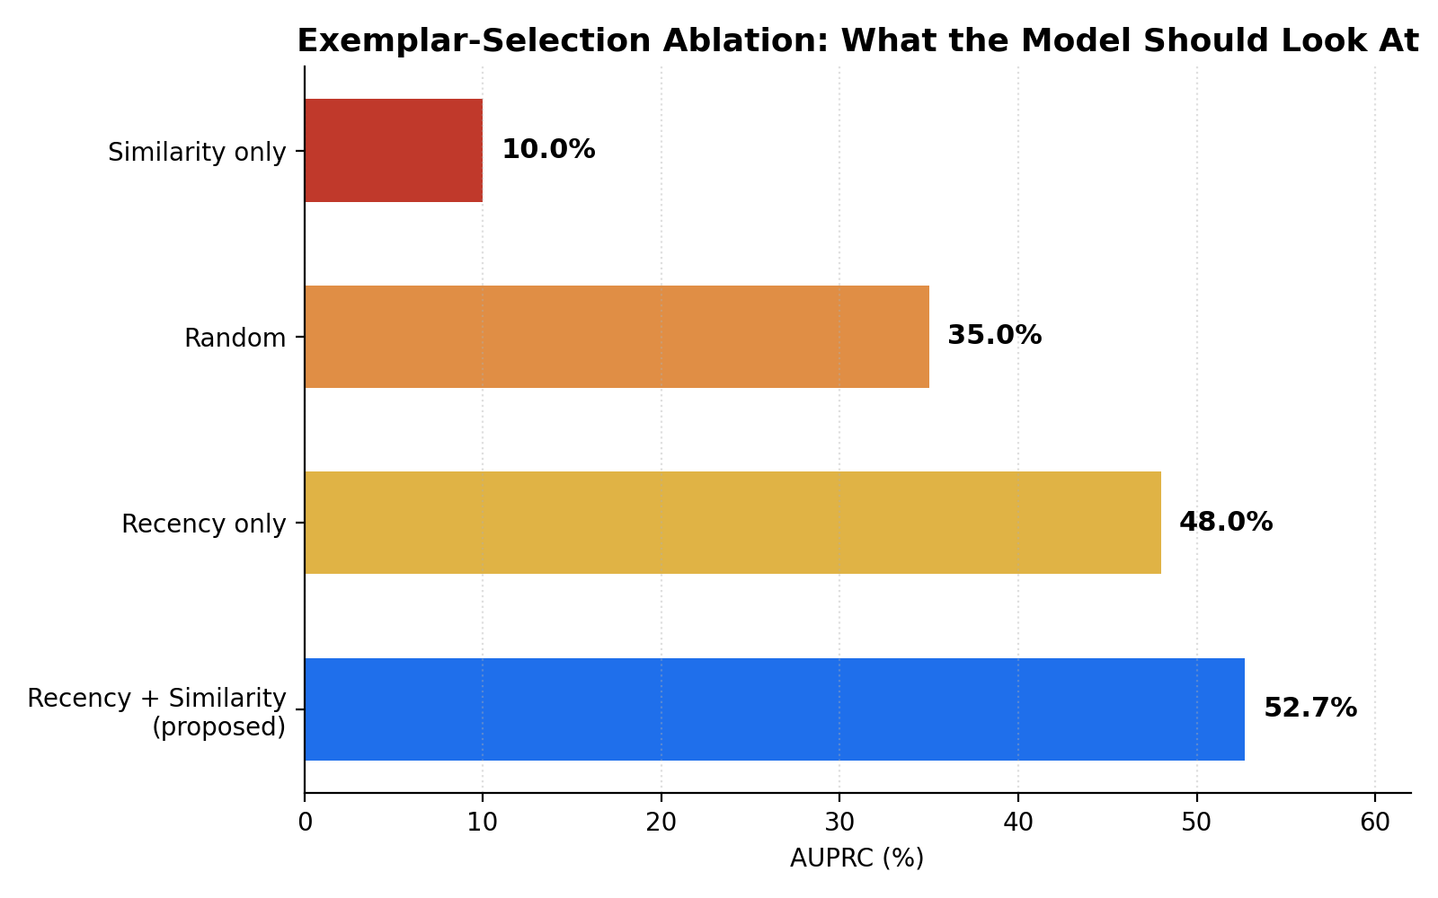
Figure 1 — Matching only on how similar a transaction looks fails, because 9 in 10 transactions look 'normal.' Matching on recency alone does better. Combining both wins.
The lesson: similarity alone drowns fraud signal in a sea of legitimate look-alikes. Recency alone catches new tactics but misses stable patterns. Only the combination gets both.

4. Design
The design decision that matters most is what stays fixed and what stays flexible:
Component | Design choice
Model weights | Frozen. Never retrained without a full compliance cycle.
Exemplar case file | Refreshed continuously as new fraud is confirmed — no approval cycle required, since the model itself hasn't changed.
Explainability layer | Every flagged transaction carries a feature-level attribution (Tree-SHAP), so an investigator sees exactly why it was flagged.
Audit trail | Attribution output is formatted to satisfy existing anti-fraud reporting obligations, so compliance review doesn't require new tooling.

5. Results
Two numbers tell the story: whether fraud gets caught, and what that's worth in dollars.
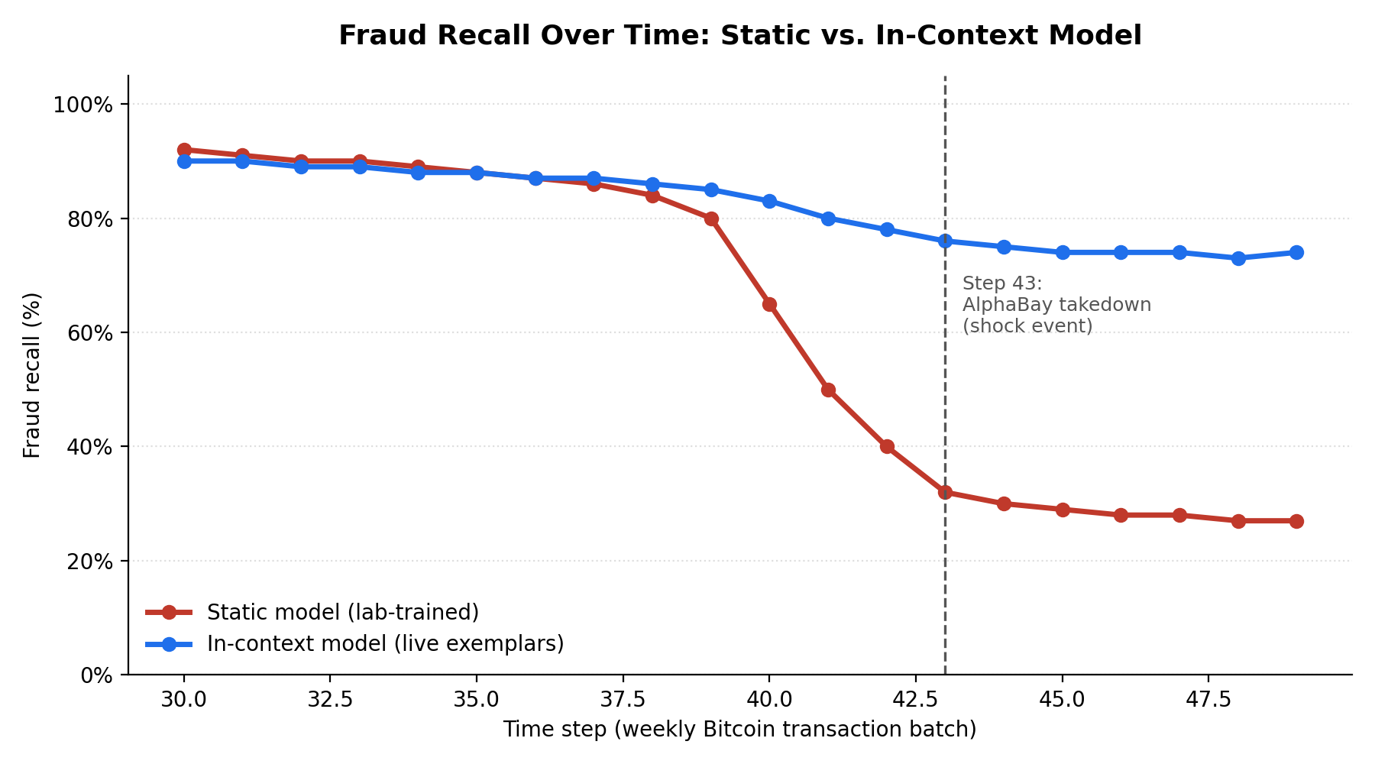
Figure 2 — The static model looks fine right up until the AlphaBay shock, then collapses and stays collapsed. The in-context model dips slightly at the shock and recovers.
Commentary: the static model's failure isn't a straight line — it's a cliff. That matters operationally: a slow, visible decline gives a bank time to react; a cliff does not. The in-context model absorbs the same shock in real time because it's comparing against what fraud looks like this week, not what it looked like when it was trained.
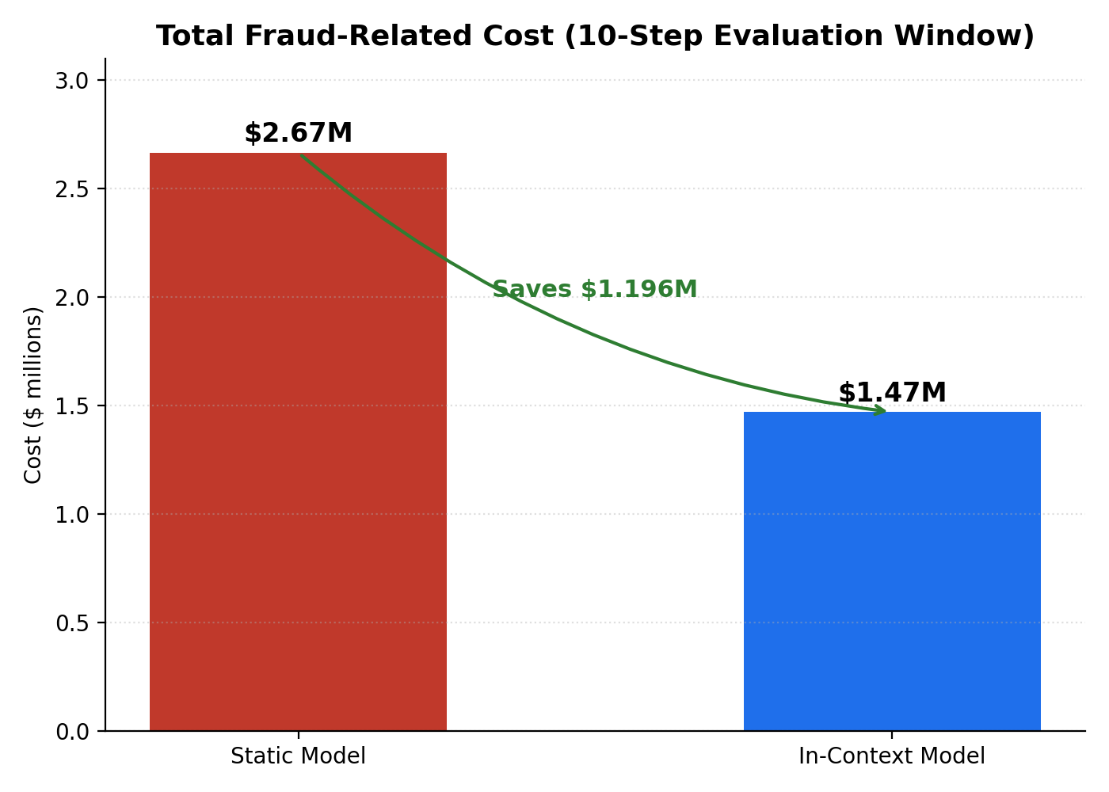
Figure 3 — At $10,000 per missed fraud and $100 per false alarm, the recall gap becomes a $1.196M gap over the same evaluation window.
Commentary: this is the number a business leader should hold onto. The accuracy story is for the model review board; the cost story is for everyone else.

6. Failure and Learning
Two things did not work on the first attempt, and both changed the final design:
- Full retraining as the default response. When we retrained the model on post-shock data, it reached only 44.79% recall — worse than in-context retrieval's 74.2%, and only after paying the full 16-week compliance cost. Lesson: more recent training data isn't automatically better if the retrieval mechanism at scoring time is doing the wrong thing.
- Similarity-only retrieval. Our first version of the exemplar retriever matched purely on how alike a transaction looked to past fraud. It scored only 10% AUPRC — worse than picking exemplars at random (35%). Lesson: in a dataset where fraud is rare, 'similar-looking' mostly means 'similarly normal.' Recency turned out to be doing most of the real work, and only became reliable once paired with similarity rather than used alone.
Why this matters beyond this project
Both failures point at the same trap: a method that wins on a static, historical test set (high similarity match, or a freshly retrained model) can lose on live data, because live fraud is adversarial — it's actively trying to stop looking like what was trained on.

7. Conclusion
Freezing the model and refreshing its evidence, instead of retraining it, closes most of the gap between lab performance and live performance — 74.2% recall versus 31.9% — without touching the 16-week regulatory clock. The remaining work is operational: get this retrieval loop running fast enough for real transaction volumes, and keep feeding it verified fraud as it's confirmed.
Bottom line: Don't rebuild the detective. Keep their case file current.

