Indian Equity Investor
Architecture & Design Document
June 2026 · v1.0

1. What the System Is
A production Python package that runs a 10-step, AI-assisted value-investing pipeline over Indian equities (NSE/BSE), targeting 15%+ CAGR ideas. Claude is the reasoning engine for qualitative judgments only; everything that can be arithmetic is deterministic Python. Live data comes from NSE, BSE, Screener.in, Trendlyne and Yahoo Finance, and every completed analysis is persisted to a local SQLite database that also powers watch-listing, surveillance, portfolio tax tracking and backtesting.
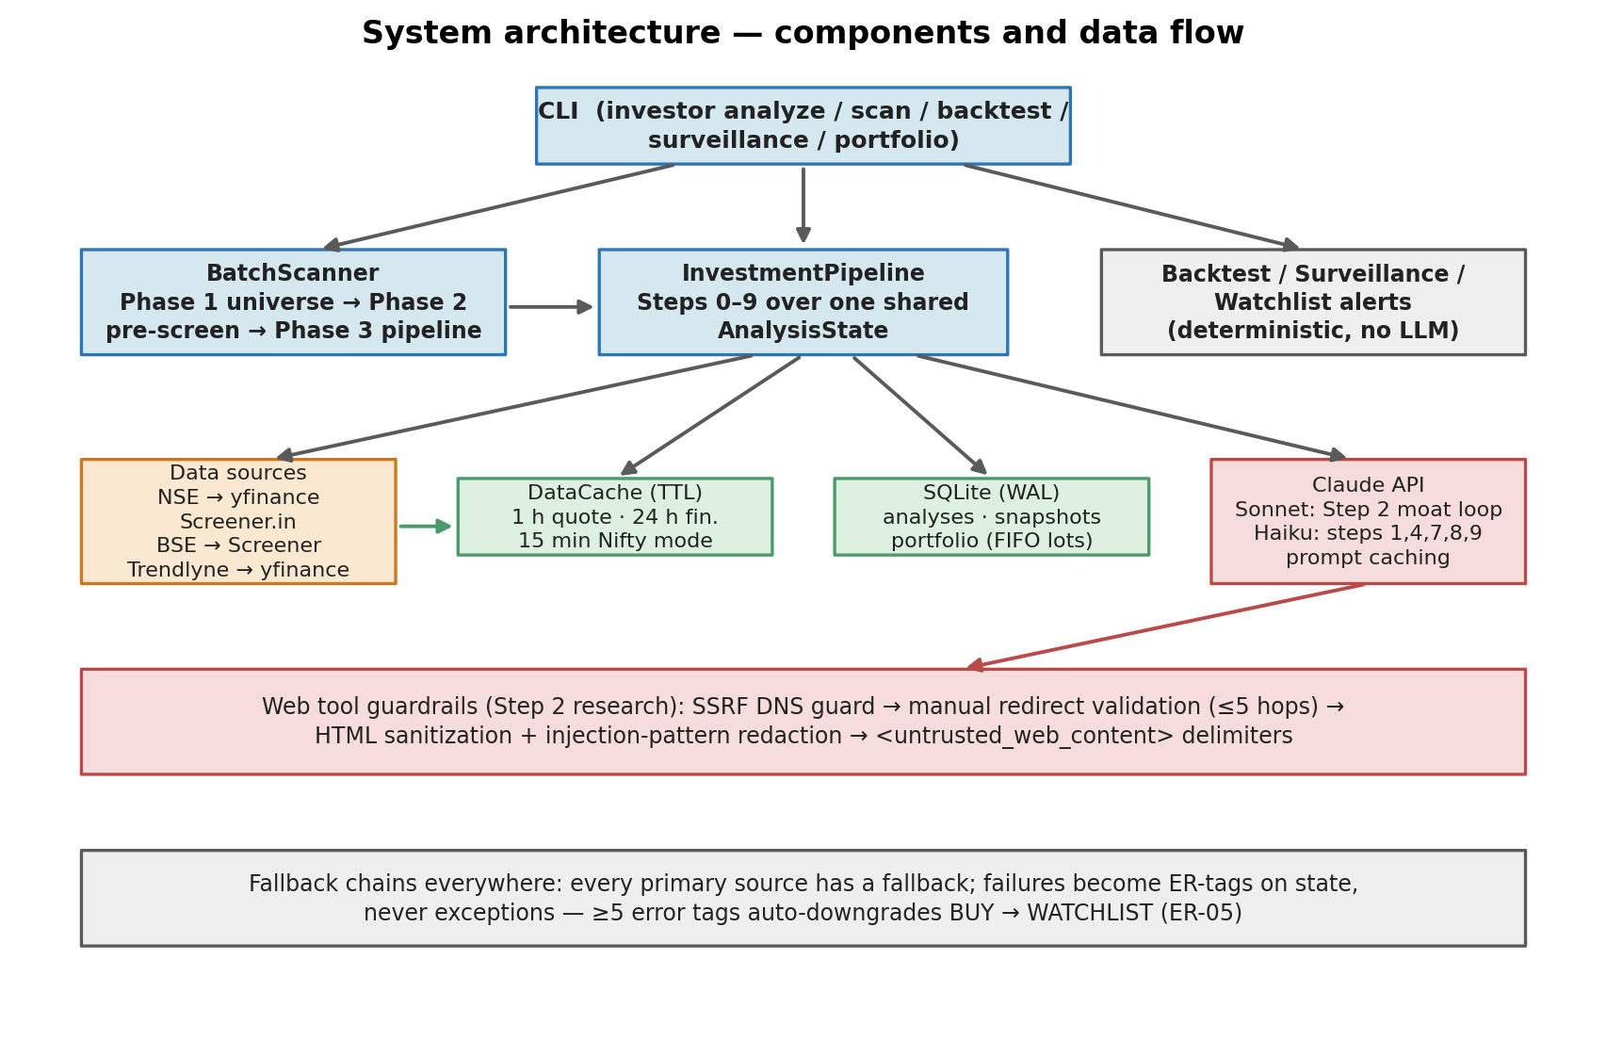

2. The Pipeline and Its Gates
The core design idea is a funnel of cheap-to-expensive checks. A single mutable AnalysisState flows through ten steps; three steps are hard gates that terminate the run early (governance failures can never be rescued by a good valuation — the hierarchy is Governance > Business Quality > Financials > Valuation). A valuation failure deliberately does not terminate: the stock continues through technical, peer and premortem analysis so the resulting WATCHLIST entry is actionable later without paying for a re-run.
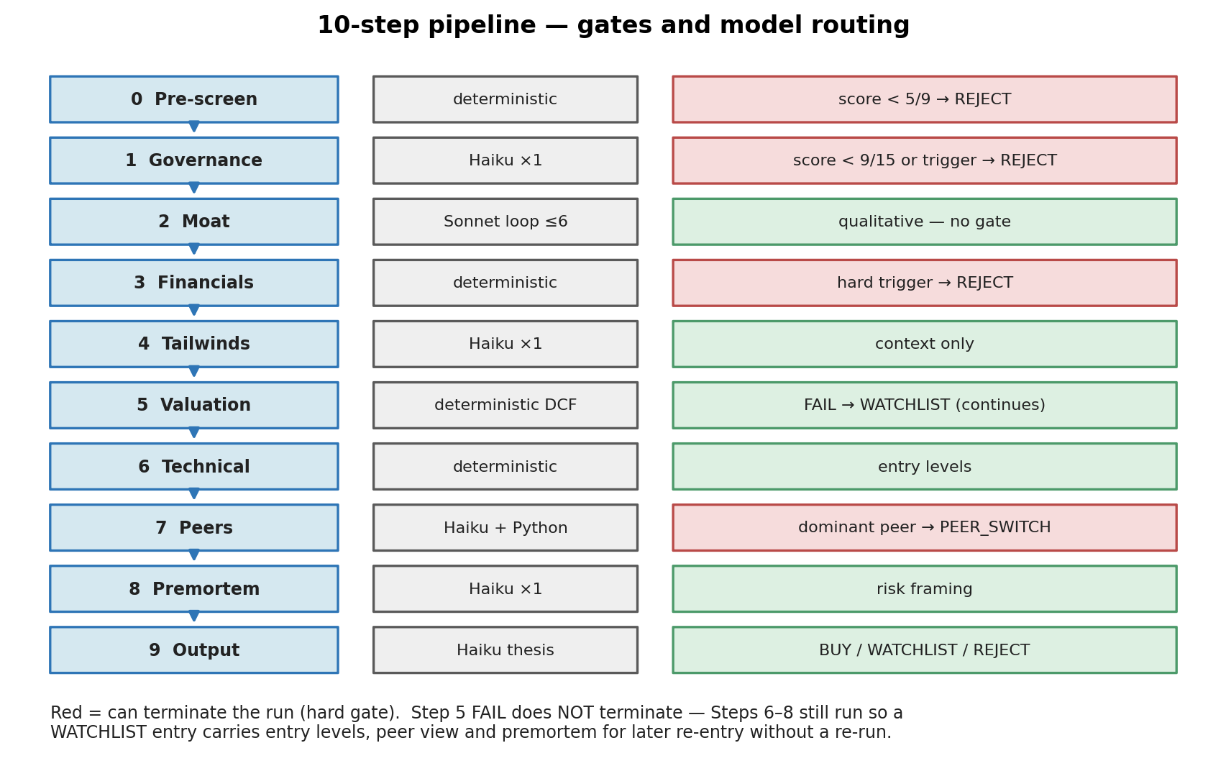

3. Cost Optimization
LLM spend is treated as a first-class architectural constraint. The batch scanner is built as a two-phase funnel so Claude tokens are spent on roughly 2% of the universe:
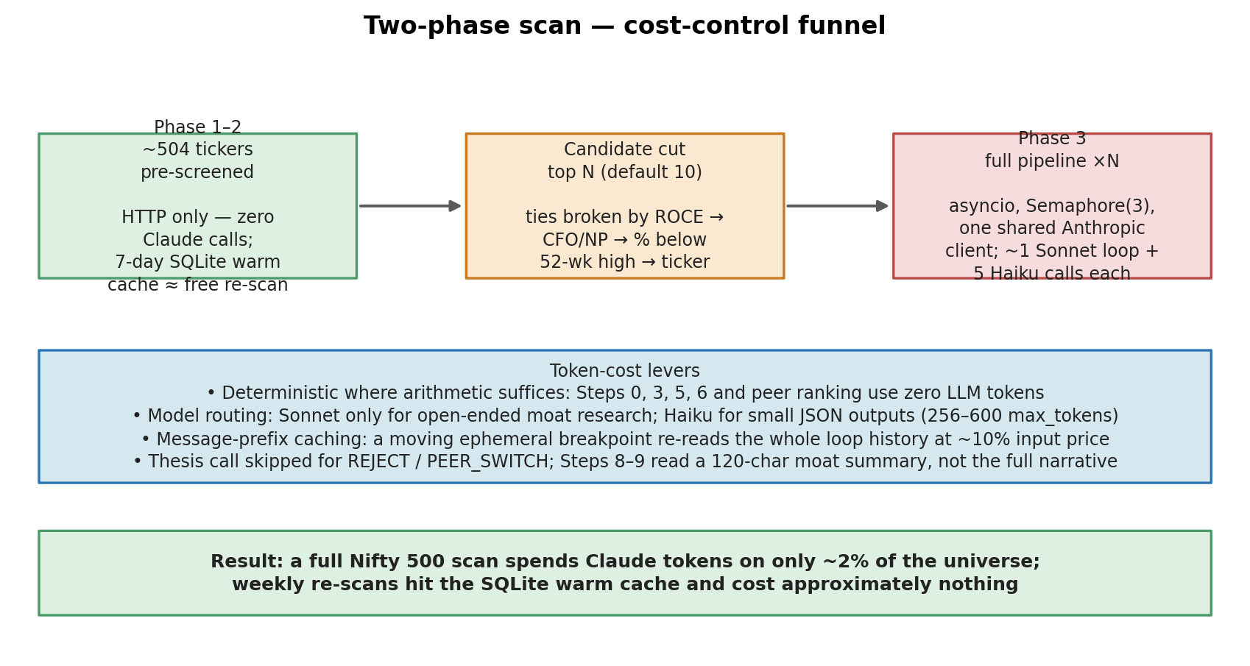
Decision | Why
Deterministic Steps 0, 3, 5, 6 + peer ranking | Pure arithmetic needs no LLM — auditable, free, reproducible (also enables backtesting)
Sonnet only for Step 2 moat research | The single open-ended research task; all other LLM steps are small-JSON Haiku calls (256–600 max_tokens)
Message-prefix prompt caching | A moving ephemeral cache breakpoint lets each agentic-loop iteration re-read the conversation at ~10% input price — chosen over the Batch API’s flat 50% discount
Thesis call skipped for REJECT / PEER_SWITCH | Those templates show no thesis, so the call would be wasted
7-day SQLite warm cache for scans | Repeated weekly index scans skip HTTP and LLM work almost entirely

4. Performance & Concurrency
- Async everywhere: httpx.AsyncClient HTTP clients, aiosqlite persistence, asyncio.gather pipelines.
- Bounded concurrency: pre-screen capped by Semaphore(8); full analyses by Semaphore(3); a module-level Semaphore(2) shared across all ScreenerClient instances prevents thundering-herd 429s.
- Two cache layers: an in-process TTL DataCache (quote 1 h, financials 24 h, Nifty mode 15 min) plus the SQLite snapshot warm cache (7 days) — data fetched in scan Phase 2 is reused free in Phase 3.
- SQLite in WAL mode (synchronous=NORMAL) so concurrent batch-scan writers never block readers.
- One shared AsyncAnthropic client across all Phase 3 pipelines; tenacity retry (3 attempts, exponential 5–60 s) wraps every Claude call and HTTP client.

5. Security
Step 2 gives Claude web tools, which makes fetched pages an attack surface. Defenses are layered:
- SSRF guard: URLs must be http/https; the host is DNS-resolved and rejected if any address is non-global (loopback, RFC1918, link-local/cloud-metadata, CGN, decimal-encoded IPs). Redirects are followed manually (max 5 hops) and re-validated per hop, so a public page cannot bounce the agent onto an internal endpoint.
- Prompt-injection hardening: BeautifulSoup strips all HTML (script/style included); a regex pass redacts injection patterns (“ignore all previous instructions”, “system prompt:”, …); raw HTML never reaches the model.
- Untrusted-content delimiters: all web output is wrapped in <untrusted_web_content> tags (escaped copies inside page text are redacted so a page cannot close the region early); the system prompt declares that content inside is data, never instructions.
- Data integrity rules: metrics are never fabricated — estimates are labelled [ESTIMATE], unverified data [DATA UNVERIFIED]; a SEBI record only counts as clean when the check actually ran.

6. Reliability & Optimum Flow
- Fallback chains per source: NSE→yfinance (quotes), NSE→BSE→Screener (shareholding), Trendlyne→yfinance (valuation), NSE JSON→archives CSV→bundled list (universe). Failures become ER-01…ER-08 tags on state instead of exceptions. A module-level circuit breaker skips BSE for the remainder of the process after 10 consecutive infrastructure failures — one summary warning instead of two per ticker, with shareholding falling straight through to Screener.
- Graceful degradation: ≥5 accumulated error tags auto-downgrades a BUY to WATCHLIST (ER-05) — a thin-data run can lower conviction but never crash or silently pretend the data was fine.
- DB writes are non-fatal: every save is wrapped in try/except; persistence problems never break analysis output.
- Sector-aware scoring: seven sector profiles override gate thresholds (e.g. D/E waived for lenders, mid-cycle FCF normalization for cyclicals); edge-case handlers (EC-01 pre-profit, EC-02 cyclical, EC-04 conglomerate, EC-06 MNC, EC-11 illiquidity) fire automatically.
- Closed feedback loop: raw data snapshots are stored on every run, so the backtest command can replay the deterministic gates against history and validate thresholds against forward returns vs the Nifty — with zero LLM cost.

7. Key Design Decisions at a Glance
Decision | Alternative rejected | Driver
Deterministic DCF in Python | LLM-computed valuation | Auditability, zero cost, backtestability
Haiku for 5 of 6 LLM steps | Sonnet everywhere | ~10× cheaper for small JSON outputs
Prompt caching in agentic loop | Batch API (50% discount) | Cache-read price (~10%) beats batch
Step 5 FAIL → continue, not terminate | Terminate on FAIL | WATCHLIST entries stay actionable
SQLite + WAL, single file | Postgres / cloud DB | Single-user tool; zero ops overhead
DNS-resolution SSRF guard | Regex IP blocklist | Blocks decimal IPs & DNS rebinding
FIFO lot consumption for sells | Average-cost accounting | Matches Indian LTCG/STCG tax rules
Snapshot-first persistence | Store only final verdicts | Enables drift surveillance + backtests

Source of truth: CLAUDE.md and src/ in the repository. This document summarizes the architecture as of June 2026.

