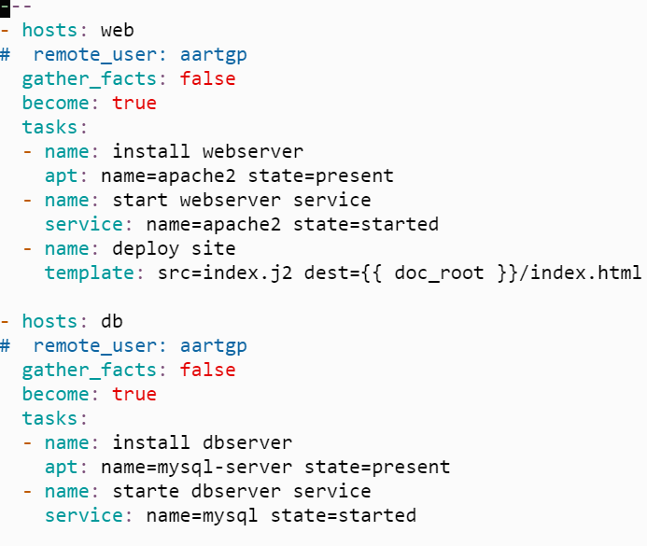

Copy to user.yml in tasks in db role

Copy to main.yml in tasks in db role

Copy to main.yml in tasks in web role

