VIRTUAL MEDICAL HOME

A

Project Report

Submitted in Partial fulfillment of the Requirements

For the award of Master of Computer Application Degree

RAJIV GANDHI PROUDYOGIKI VISHWAVIDYALAYA
BHOPAL (M.P.)


MAJOR PROJECT REPORT

Submitted by
Pradeep Mehta
Enroll. No. 0103CA071062

Under the Guidance of

Prof. T. Hirwani Mr. G. Varma



MASTER OF COMPUTER APPLICATION
LAKSHMI NARAIN COLLEGE OF TECHNOLOGY
BHOPAL (M.P.)
SESSION – 2007-10

LAKSHMI NARAIN COLLEGE OF TECHNOLOGY, BHOPAL

MASTER OF COMPUTER APPLICATION

CERTIFICATE

This is to certify that the work embodied in this dissertation entitled “Virtual Medical Home” has been satisfactorily completed by Pradeep Mehta (0103CA071062). It is a bonafide piece of work, carried out under our / my guidance in the Master Of Computer Application, Lakshmi Narain College of Technology, Bhopal for the partial fulfillment of the Master of Computer Application degree during the academic year.

Prof. T.Hirwani Mr. G. Varma
Project Guide Project Guide

Approved By
Prof. & Head

Forwarded by
Director(MCA)
Lakshmi Narain College of Technology, Bhopal

Lakshmi Narain College of Technology, Bhopal

Master of Computer Application

CERTIFICATE OF APPROVAL

This foregoing dissertation work is hereby approved as a creditable study of an Computer Application subject carried out and presented in a manner satisfactory to warranty its acceptance as a prerequisite to the degree for which it has been submitted. It is understood that by this approval the undersigned do not necessarily endorse or approve any statement made, opinion expressed or conclusion drawn therein, but approve the thesis only for the purpose for which it has been submitted.

(Internal Examiner) (External Examiner)

Lakshmi Narain College of Technology, Bhopal

Master Of Computer Application

DECLARATION

I,Pradeep Mehta, a student of Master of Computer Application, Lakshmi Narain College of Technology, Bhopal hereby declare that the work presented in this Major Project is outcome of my own work, is bonafide, correct to the best of my knowledge and this work has been carried out taking care of Engineering Ethics. The work presented does not infringe any patented work and has not been submitted to any University for the award of any degree or any professional diploma.

Pradeep Mehta
Enroll. No. 0103CA071062

Date : 19-05-2010

ACKNOWLEDGEMENT

At every outset I express my gratitude to almighty lord for showering his grace and blessings upon me to complete this project.

Although our name appears on the cover of this book, many people had contributed in some form or the other form to this project Development. We could not done this project without the assistance or support of each of the following we thank you all.

I wish to place on my record my deep sense of gratitude to my project guide, Mr. G. Varma, Chaithanya IT Solutions, Hyderabad, for his constant motivation and valuable help through the project work. Express my gratitude to The Director of Lakshmi Narain College of Technology, Bhopal for his valuable suggestions and advices throughout the MCA course. I also extend my thanks to other Faculties for their Cooperation during my Course.

Finally I would like to thank my friends for their cooperation to complete this project.

Pradeep Mehta
Enroll. No. 0103CA071062

.

INDEX

Title page no

1. Project Synopsis
1.1 Objectives 09
1.2 Introduction 11
1.3 Tools / Environment Used 14

2. System Analysis
2.1 System Requirement Specification 21

3. System Design
3.1 Data Flow Diagram 31
3.2 E-R Diagram 40
3.3 Structure of Tables 42
3.4 Uml Diagram 46
3.5 Sample I / O Screen 56

4. Testing
4.1 Review and Completion 67
4.2 Security Measures 69
4.3 Limitations of the Project 70
4.4 Future Scope of the Application 72

5. Bibliography
5.1 Bibliography 73

Objectives

Nowadays, every field wants a computerized system for the better performance of their work. The computerized system consists of all the information which will be carried out in the same way as the manual system but with so many aspects.
The manual system is time consuming because of less work efficiency comparatively to machine and also it needs a lots of paper work i.e. a big problem and possibilities of beneficial more powerful, having accuracy and speed and it removes the problems related with manual system.
The main aim of these Website are :-

To provide essential medical services online to everyone.
- Security of the data is maintained so that nobody other than the authorized user can manipulate the database i.e. theft cannot be occurred.
- Computerized generated bill as well as automatically duplicate bill is saved in the database without any extra effort.
- It is developed in effective Graphics User Interface (GUI). So, that any user can easily works on this software. Only the requirements is that he/she must know about to work on the computer. There is no need to give special training.
- As it is fully secured software, so it can be also hosted on the website.
- Records can be very easily traced at any time which can be helpful at the time of inspection is going on.

Introduction

Objective is to provide essential medical services online to everyone hardly matters you live in metro or a remotely located village. Users can connect through their home internet to get these services. What motivate to build this system
Are:
1. Very few or no doctors at remote locations
2. Limited hour services and lack of sophisticated medical equipment
3. No patients history/lab data management

PURPOSE OF THE PROJECT
The project is fully integrated with Customer Relationship Management (CRM) solution and developed in a manner that is easily manageable, time saving and relieving one form semi automated.
Virtual Medical Home delivers quality healthcare through innovative services. Using secure, web-based technologies provided by Medical Web, our physicians provide advice and treatment for a variety of healthcare conditions.
- Our services include:
- Treatment of Non-emergent Conditions
- Mental Health
- Naturopathic Advice & Remedies
- Physician Advice
- Laboratory Interpretations
All of our services are provided through the Internet in a secure and confidential manner. A secure communication portal is established between the patient and a Virtual Medical Home provider to allow one-on-one interaction. Physicians can discuss treatment options with patients and patients can respond. By building a trusting relationship, Virtual Medical Home can effectively provide a direct benefit to each and every patient.
PROBLEM IN EXISTING SYSTEM
- The existing system is a manual system. Here the User of the system needs to save his information in the form of excel sheets or Disk Drives.
- There is no sharing is possible if the data is in the form of paper or Disk drives.
- There is no online appointment facility.
- The manual system gives us very less security for saving data; some data may be lost due to mismanagement.
- There is no rich user interface.

- It’s a limited system and fewer users friendly.
- There is no email facility.
- Searching of particular information is very critical it takes lot of time.
- The users cannot able to restrict the information.
- There is no report generation.

SOLUTION OF THESE PROBLEMS

The development of the new system objective is to address the solutions for the drawbacks of existing problem domain. Using this new system the patient can register for making online appointment with doctor. For interaction between patient and doctor chatting has provided. By this facility patient would chat with doctor.
The development of this new system contains the following activities, which try to automate the entire process keeping in the view of database integration approach.
- User Friendliness is provided in the application with various controls provided by system Rich User Interface.
- This system provides online appointment facility.
- The system makes the overall project management much easier and flexible.
- It can be accessed over the Intranet.
- It provides email facility.
- The user information files can be stored in centralized database which can be maintained by the system.
- This can give the good security for user information because data is not in client machine.
- Authentication is provided for this application only registered users can access.
- It provides search facility.
- There is no risk of data management at any level while the project development is under process.
- Report generation features is provided to generate different kind of data reports.

Tools / Environment Used

This application namely “Virtual Medical Home” is developed by the help of ASP.NET 3.5, C#.NET and SQL SERVER 2005.
All the Data-entry and output forms as the Front End are designed in ASP.Net with C#. On the other hand, this application relies on the Database object creation and Stocks provided by SQL SERVER 2005 as the Back End..

INTRODUCTION TO .NET FRAMEWORK

The Microsoft .NET Framework is a software technology that is available with several Microsoft Windows operating systems. It includes a large library of pre-coded solutions to common programming problems and a virtual machine that manages the execution of programs written specifically for the framework. The .NET Framework is a key Microsoft offering and is intended to be used by most new applications created for the Windows platform.
The pre-coded solutions that form the framework's Base Class Library cover a large range of programming needs in a number of areas, including user interface, data access, database connectivity, cryptography, web application development, numeric algorithms, and network communications. The class library is used by programmers, who combine it with their own code to produce applications.
Programs written for the .NET Framework execute in a software environment that manages the program's runtime requirements. Also part of the .NET Framework, this runtime environment is known as the Common Language Runtime (CLR). The CLR provides the appearance of an application virtual machine so that programmers need not consider the capabilities of the specific CPU that will execute the program. The CLR also provides other important services such as security, memory management, and exception handling. The class library and the CLR together compose the .NET Framework.
VERSIONS

Microsoft started development on the .NET Framework in the late 1990s originally under the name of Next Generation Windows Services (NGWS). By late 2000 the first beta versions of .NET 1.0 were released.

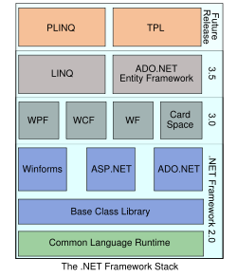
ASP.NET :

To create dynamic Web pages by using server side scripts, Microsoft has introduced ASP. The.NET version of ASP is ASP.NET. It is a standard HTML file that contains embedded server side scripts. ASP.NET provides the following advantages of server side scripting:

ASP.NET enables you to access information from data sources such as back-end databases and text files that are stored on a Web server or a computer that is accessible to a Web server.

ASP.NET enables you to use a set of programming code called templates to create HTML documents. The advantage of using templates is that you can dynamically insert the content retrieved from data sources, such as back-end databases and text files, into an HTML document before the HTML document is displayed to users. For this reason, the information need not be changed manually as and when the contents retrieved from the data source change.

ASP.NET also enables you to separate HTML design from the data retrieval mechanism. As a result, changing the HTML design does not affect the programs that retrieve data from the databases. Similarly, server side scripting ensures that changing data sources does not require a change in HTML documents.

In addition to these advantages, ASP.NET has a number of advanced features that help you to develop robust Web applications. The advanced features of ASP.NET are based on the

.NET Framework.
ASP.NET in .NET Framework

ASP.NET, which is the .NET version of ASP, is built on the Microsoft .NET Framework.
Microsoft introduced the .NET Framework to help developers create globally distributed
software with Internet functionality and interoperability.

FEATURES OF ASP.NET :

In addition to hiding script commands, ASP.NET has the following advanced features that
help develop robust Web applications:

COMPILED CODE: The code written in ASP.NET is compiled and not interpreted.This makes ASP.NET applications faster to execute than other server side scripts that are interpreted,such as the scripts written in a previous version of ASP.

ENRICHED TOOL SUPPORT: The ASP.NET Framework is provided with a rich tool- box and designer in the Visual Studio .NET IDE. Some of the features of this powerful tool are the "what you see is what you get" (WYSIWYG) editor, drag-and-drop server controls,and automatic deployment.

POWER AND FLEXIBILITY: ASP.NET applications are based on CLR. As a result, the power and flexibility of the .NET platform is available to ASP.NET application developers.

ASP.NET applications enable you to ensure that the .NET Framework class library, messaging, and data access solutions are seamlessly accessible on the Web. ASP.NETis also language-independent. As a result, you can choose any .NET language todevelop your application.

SIMPLICITY: ASP.NET enables you to build user interfaces that separate application logic from presentation content. In addition, CLR simplifies application development by using managed code services, such as automatic reference counting and garbage collection. For this reason, ASP.NET makes it easy to perform common tasks ranging from form submission and client authentication to Web site configuration and deployment.

MANAGEABILITY: ASP.NET enables you to manage Web applications by storing the configuration information in an Extensible Markup Language (XML) file. You can open the XML file in the Visual Studio .NET IDE.

SCALABILITY: ASP.NET has been designed with scalability in mind. It has features that help improve performance in a multiprocessor environment.

SECURITY: ASP.NET provides a number of options for implementing security and restricting user access to a Web application. All these options are configured within the configuration file.

EXTENSIBILITY: ASP.NET provides a number of options to create an extensible Web application. For example, you can create custom controls; extend the default Hypertext Markup Language (HTTP) pipeline. Note that the path through which the data flows from the client to the server is called the HTTP pipeline

C#.NET:

ADO.NET OVERVIEW

ADO.NET is an evolution of the ADO data access model that directly addresses user requirements for developing scalable applications. It was designed specifically for the web with scalability, statelessness, and XML in mind.

ADO.NET uses some ADO objects, such as the Connection and Command objects, and also introduces new objects. Key new ADO.NET objects include the Dataset, Data Reader, and Data Adapter.

The important distinction between this evolved stage of ADO.NET and previous data architectures is that there exists an object -- the DataSet -- that is separate and distinct from any data stores. Because of that, the DataSet functions as a standalone entity. You can think of the DataSet as an always disconnected recordset that knows nothing about the source or destination of the data it contains. Inside a DataSet, much like in a database, there are tables, columns, relationships, constraints, views, and so forth.

A DataAdapter is the object that connects to the database to fill the DataSet. Then, it connects back to the database to update the data there, based on operations performed while the DataSet held the data. In the past, data processing has been primarily connection-based. Now, in an effort to make multi-tiered apps more efficient, data processing is turning to a message-based approach that revolves around chunks of information. At the center of this approach is the DataAdapter, which provides a bridge to retrieve and save data between a DataSet and its source data store. It accomplishes this by means of requests to the appropriate SQL commands made against the data store.

The XML-based DataSet object provides a consistent programming model that works with all models of data storage: flat, relational, and hierarchical. It does this by having no 'knowledge' of the source of its data, and by representing the data that it holds as collections and data types. No matter what the source of the data within the DataSet is, it is manipulated through the same set of standard APIs exposed through the DataSet and its subordinate objects.

While the DataSet has no knowledge of the source of its data, the managed provider has detailed and specific information. The role of the managed provider is to connect, fill, and persist the DataSet to and from data stores. The OLE DB and SQL Server .NET Data Providers (System.Data.OleDb and System.Data.SqlClient) that are part of the .Net Framework provide four basic objects: the Command, Connection, DataReader and DataAdapter. In the remaining sections of this document, we'll walk through each part of the DataSet and the OLE DB/SQL Server .NET Data Providers explaining what they are, and how to program against them.
The following sections will introduce you to some objects that have evolved, and some that are new. These objects are:

- Connections. For connection to and managing transactions against a database.
- Commands. For issuing SQL commands against a database.
- DataReaders. For reading a forward-only stream of data records from a SQL Server data source.
- DataSet. For storing, Remoting and programming against flat data, XML data and relational data.
- DataAdapters. For pushing data into a DataSet, and reconciling data against a database.

When dealing with connections to a database, there are two different options: SQL Server .NET Data Provider (System.Data.SqlClient) and OLE DB .NET Data Provider (System.Data.OleDb). In these samples we

will use the SQL Server .NET Data Provider. These are written to talk directly to Microsoft SQL Server. The OLE DB .NET Data Provider is used to talk to any OLE DB provider (as it uses OLE DB underneath).

SQL SERVER 2005:
Microsoft SQL Server is a relational model database server produced by Microsoft. Its primary query languages are T-SQL and ANSI SQL.
SQL Server 2005 (codenamed Yukon), released in October 2005, is the successor to SQL Server 2000. It included native support for managing XML data, in addition to relational data. For this purpose, it defined an

xml data type that could be used either as a data type in database columns or as literals in queries. XML columns can be associated with XSD schemas; XML data being stored is verified against the schema. XML is converted to an internal binary data type before being stored in the database. Specialized indexing methods were made available for XML data. XML data is queried using XQuery; SQL Server 2005 added some extensions to the T-SQL language to allow embedding XQuery queries in T-SQL. In addition, it also defines a new extension to XQuery, called XML DML, that allows query-based modifications to XML data. SQL Server 2005 also allows a database server to be exposed over web services using TDS packets encapsulated within SOAP (protocol) requests. When the data is accessed over web services, results are returned as XML.[1]

For relational data, T-SQL has been augmented with error handling features and support for recursive queries. SQL Server 2005 has also been enhanced with new indexing algorithms and better error recovery systems. Data pages are checksummed for better error resiliency, and optimistic concurrency support has been added for better performance. Permissions and access control have been made more granular and the query processor handles concurrent execution of queries in a more efficient way. Partitions on tables and indexes are

supported natively, so scaling out a database onto a cluster is easier. SQL CLR was introduced with SQL Server 2005 to let it integrate with the .NET Framework.[2]
SQL Server 2005 introduced "MARS" (Multiple Active Results Sets), a method of allowing usage of database connections for multiple purposes.[3].

Environment used
(For the better execution of this application)

HARDWARE REQUIREMENTS:

- THE CPU SHOULD BE P-IV OR HIGHER FOR BETTER PERFORMANCE.
- 108 KEYS KEYBOARD.
- 512 MB OR MORE RAM.
- HARD DISK AND FLOPPY DISK DRIVE.

SOFTWARE REQUIREMENTS:

- WINDOW-2000
- XP/2003 Server
- MICROSOFT VISUAL STUDIO 2008 ENTERPRISE EDITION
(ASP.NET 3.5 + C#.NET + SQL SERVER 2005)
- INTERNET INFORMATION SERVICE 5.0(IIS)
- VISUAL STUDIO .NET FRAMEWORK (MINIMAL FOR DEPLOYMENT) VERSION 3.5

System Requirement Specification

PURPOSE OF THE SYSTEM
Virtual Medical Home is committed to helping patients take control of their health. This system is virtual, but our physicians and their dedication is real.
Using secure, web-based technologies provided by Medical Web, our health-care providers offer advice and treatment for a variety of conditions. Patients can communicate securely and confidentially with our physicians throughout the treatment process using our messaging system. As a physician-owned company, we are committed to helping our patients receive the utmost care and medical attention.
Our services include:
- Treatment of Non-emergent Conditions
- Mental Health
- Naturopathic Advice & Remedies
- Physician Advice
- Laboratory Interpretations
.
THE EXISTING SYSTEM
- The existing system is a manual system. Here the User of the system needs to save his information in the form of excel workbook or Disk Drives.
- The users cannot able to restrict the information .
- There is no online appointment facility.
- The manual system gives us very less security for saving data; some data may be lost due to mismanagement.
- There is no rich user interface.
- There is no communication facility between users.
- In this system searching of particular information is very critical it takes lot of time.
- There is no sharing is possible if the data is in the form of paper or Disk drives.
- There is no report generation.
PRPOSED SYSTEM
The development of the new system objective is to address the solutions for the drawbacks of existing problem domain. Using this new system the patient can register for making online appointment with doctor. For interaction between patient and doctor chatting has provided. By this facility patient would chat with doctor.

The development of this new system contains the following activities, which try to automate the entire process keeping in the view of database integration approach.
- User Friendliness is provided in the application with various controls provided by system Rich User Interface.
- This system provides online appointment facility.
- The system makes the overall project management much easier and flexible.
- It can be accessed over the Intranet.
- It provides communication facility through email and chating.
- The user information files can be stored in centralized database which can be maintained by the system.
- This can give the good security for user information .
- Authentication is provided for this application only registered users can access.
- It provides search facility.
- There is no risk of data management at any level while the project development is under process.
- Report generation features is provided to generate different kind of data reports.
Advantages for Patients
For Patient of virtual Medical home, advantages primarily concern access, time, and cost factors compared to those incurred from attending the doctor as manual.
Patient can able to see his health card details and also he can view the prescription details that given by doctor. The patient would have one facility he can raise the complaints based wrong medicine or prescription given by doctor. That complaint will be goes to admin. Admin assign the doctor to answer that complaint.
Mailing and chat can be archived in this system for instant reviewing, which is another advantage to patient.
STUDY OF THE SYSTEM
In the flexibility of uses the interface has been developed a graphics concepts in mind, associated through a browser interface. The GUI’s at the top level has been categorized as follows
- Administrative User Interface Design
- The Operational and Generic User Interface Design

The administrative user interface concentrates on the consistent information that is practically, part of the organizational activities and which needs proper authentication for the data collection. The Interface helps the administration with all the transactional states like data insertion, data deletion, and data updating along with executive data search capabilities.
The operational and generic user interface helps the users upon the system in transactions through the existing data and required services. The operational user interface also helps the ordinary users in managing their own information helps the ordinary users in managing their own information in a customized manner as per the assisted flexibilities.
NUMBER OF MODULES
The system after careful analysis has been identified to be presented with the following modules:
- Administrator
- Managers
- Doctors
- Patients
- General Public
- Web Registration
- Search
- Reports
- Authentication
Administrator
Administrator is treated as a super user in this system. He can have all the privileges to do anything in this system. He is the person who received the Profile of a Doctor and accept/reject the registration.
- He is the person who receives the Complaints from the Patient and redirects to respective Doctor for response.
- He should have a facility to communicate using chat, email facility with other stakeholders.
- He should take care of Backup of Patient, Doctor details and maintain history.

Another tasks done by the administrator is he can generates reports, log files, backup, recovery of data any time.
Doctors
- He should able to see a Patient’s appointment details on a particular date.

- Also if the Patient is already visited, able to see the previous Prescription given the Patient, Disease History, Visiting details, etc.
- They should be able to see the Feedback given by the Patient.
- They should be able to see the Complaints given by the Patient and must provide the Response for that.
- He should have a facility to communicate using chat, email facility with other stakeholders.

Patients
- They should have a facility to register to the site with their Personal data along with Health details Height, Weight, Family inherited Diseases, Blood Group, etc.
- Being a Patient (after registration) should able to take an Appointment of a Doctor visit.
- They should have a facility to give Complaints about Kiosk Manager or Doctor service.
- They should able to Search for a Doctor and can see the Doctor’s Profile for an appointment.
Managers
- He should be able to provide an Appointment of a Doctor to a Patient on request (based on Doctor’s available timings).
- They should be able to see the Complaints given by the Patient and must provide the Response for that.
- He should have a facility to communicate using chat, email facility with other stakeholders.
- They should have a Search facility to find a Patient or Doctor and can check their Profile or History details.

General Public
- General Public (i.e. Guest visitors) should able to access the site Home page, Registration Page, etc. common pages of the site.
- This user should able to see the Doctors Schedules, Contact details, Specialization details, etc.
- They should able to Search for a Doctor.

Web Registration
The system has a process of registration. Every User need to submit his complete details in the form of registration. Whenever a User registration completed automatically he/she can get a user id and password. By using that user id and password he/she can log into the system.
Search:
This system provides search facility to the patients. Patient can search for Doctors and their available timings for take appointments

Reports
Different kind of reports is generated by the system.
- Patients History and prescriptions
- Doctors list
- Lab reports
- Daily & Monthly Reports, Appointment list of Patients for Kiosk Managers
Authentication:
Authentication is nothing but providing security to the system. Here every must enter into the system throw login page. The login page will restrict the UN authorized users. A user must provide his credential like user Id and password for log into the system. For that the system maintains data for all users.
Whenever a user enters his user id and password, it checks in the database for user existence. If the user is exists he can be treated as a valid user. Otherwise the request will throw back.
INPUTS AND OUTPUTS
The major inputs and outputs and major functions of the system are follows:
Inputs:
- Admin enter his user id and password for login
- Admin accept the Doctor registration.
- User enters his user id and password for login.
- Patient registers for the Appointment.
- New user gives his completed personnel, address and phone details for registration.
- Administrator giving information to generate various kinds of reports.
Outputs:
- Admin can have his own home page.
- Admin get all Doctors details.
- Admin can view all Patients details.
- Users enter their own home page.

- Admin will get the login information of a particular user.
- The new user’s data will be stored in the centralized database.
- Admin get the search details of different criteria.
- Different kind of reports is generated by administrator.
SDLC METHDOLOGIES
This document play a vital role in the development of life cycle (SDLC) as it describes the complete requirement of the system. It means for use by developers and will be the basic during testing phase. Any changes made to the requirements in the future will have to go through formal change approval process.
The following diagram shows how a spiral model acts like:
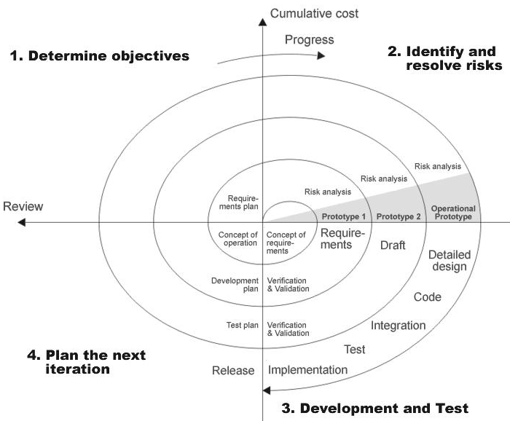

APPLICATION DEVELOPMENT:
N-Tier Applications:
Simply stated, an n-tier application helps us distribute the overall functionality into various tiers or layers:
- Presentation Layer
- Business Rules Layer
- Data Access Layer
- Database/Data Store
Each layer can be developed independently of the other provided that it adheres to the standards and communicates with the other layers as per the specifications.
This is the one of the biggest advantages of the n-tier application. Each layer can potentially treat the other layer as a ‘Block-Box’.
In other words, each layer does not care how other layer processes the data as long as it sends the right data in a correct format.
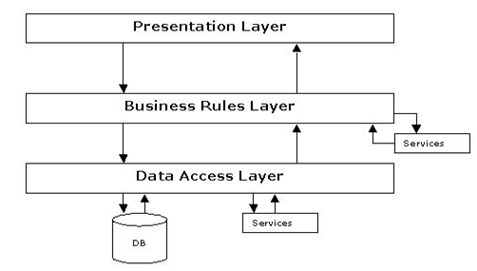
Fig 1.1-N-Tier Architecture
- The Presentation Layer:
Also called as the client layer comprises of components that are dedicated to presenting the data to the user. For example: Windows/Web Forms and buttons, edit boxes, Text boxes, labels, grids, etc.

- The Business Rules Layer:
This layer encapsulates the Business rules or the business logic of the encapsulations. To have a separate layer for business logic is of a great advantage. This is because any changes in Business Rules can be easily handled in this layer. As long as the interface between the layers remains the same, any changes to the functionality/processing logic in this layer can be made without impacting the others. A lot of client-server apps failed to implement successfully as changing the business logic was a painful process.
- The Data Access Layer:
This layer comprises of components that help in accessing the Database. If used in the right way, this layer provides a level of abstraction for the database structures. Simply put changes made to the
database, tables, etc do not affect the rest of the application because of the Data Access layer. The different application layers send the data requests to this layer and receive the response from this layer.
- The Database Layer:
This layer comprises of the Database Components such as DB Files, Tables, Views, etc. The Actual database could be created using SQL Server, Oracle, Flat files, etc.
In an n-tier application, the entire application can be implemented in such a way that it is independent of the actual Database. For instance, you could change the Database Location with minimal changes to Data Access Layer. The rest of the Application should remain unaffected
PERFORMANCE REQUIREMENTS:
Performance is measured in terms of the output provided by the application. Requirement specification plays an important part in the analysis of a system. Only when the requirement specifications are properly given, it is possible to design a system, which will fit into required environment. It rests largely in the part of the users of the existing system to give the requirement specifications because they are the people who finally use the system. This is because the requirements have to be known during the initial stages so that the system can be designed according to those requirements. It is very difficult to change the system once it has been designed and on the other hand designing a system, which does not cater to the requirements of the user, is of no use.
The requirement specification for any system can be broadly stated as given below:
- The system should be able to interface with the existing system
- The system should be accurate
- The system should be better than the existing system
- The existing system is completely dependent on the user to perform all the duties

Feasibility Study

Economical Feasibility:
This phase is mainly focused on the Economical aspect of the Proposed System as well as the environment in which it should be applied on. This study is known as ‘Cost Benefit Analysis’. This analysis involves study on tangible and intangible cost as well as benefit. It shows that if the proposed system suits the Economic capability of the organization or not.
Tangible Cost:
The cost which exists and the amount of which can be measured is known as Tangible Cost.

Intangible Cost:
The cost that also exists but the financial value of which is not measurable is known as Intangible Cost.

Tangible Benefit:
measurable benefit is called Tangible Benefit. It has a direct effect on The to organization.

Intangible Benefit:
These are difficult to analyze.

Technical Feasibility:
During this study, the following topics are considered………

- If the technology needed to implement the project are available are not.
- If the system can be customized or extended in the future or not.
- If the proposed system guaranteed for the reliable data security or not.

Operational Feasibility:
In this phase of feasibility study, it is tried to find out the acceptance of the proposed system by the people, which will directly or indirectly interact with it. Since, sometimes it is quite difficult for the people to a just with the new system.

Data Flow Diagram

CONTEXT LEVEL DIAGRAM (O LEVEL)

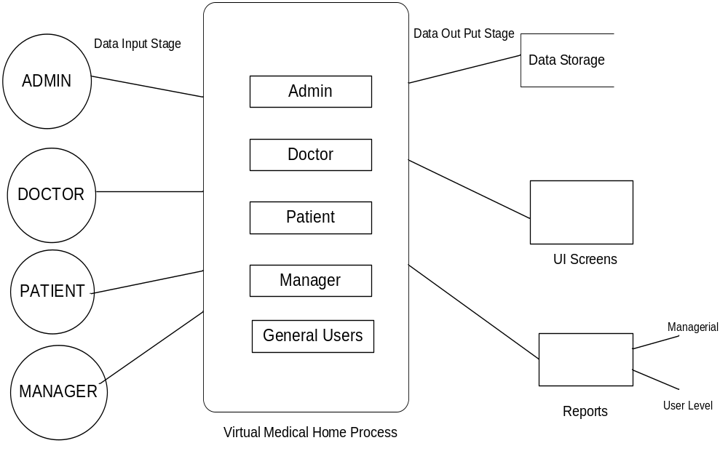

LOGIN DFD

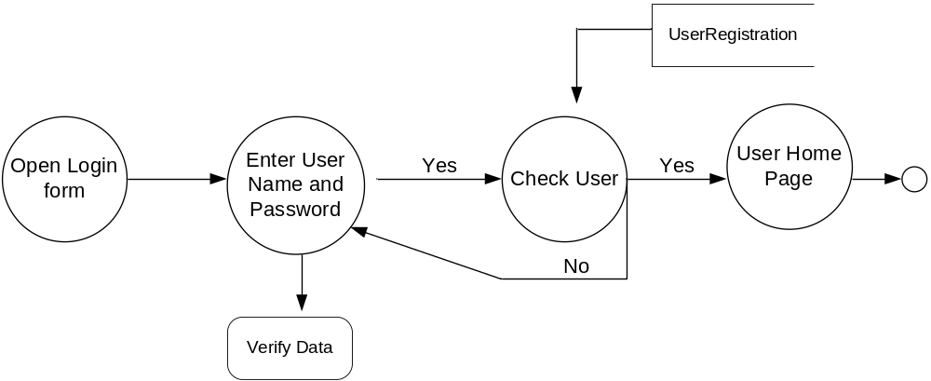

ADMIN ACTIVITIES DFD

1ST LEVEL

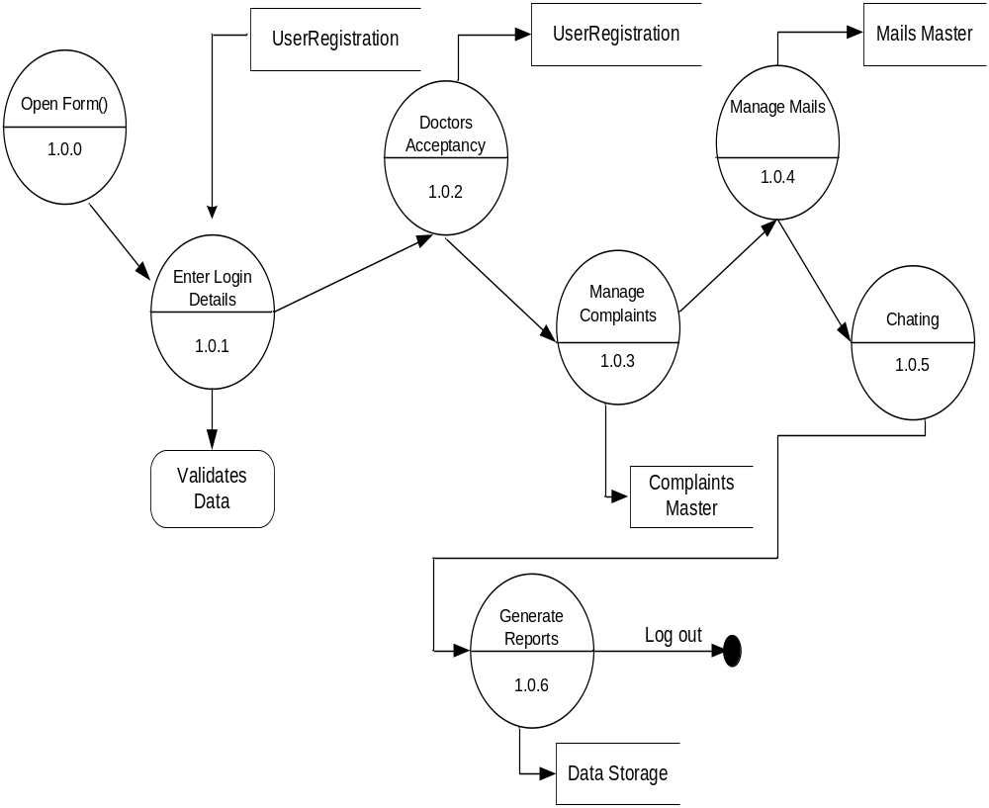

2ND LEVEL

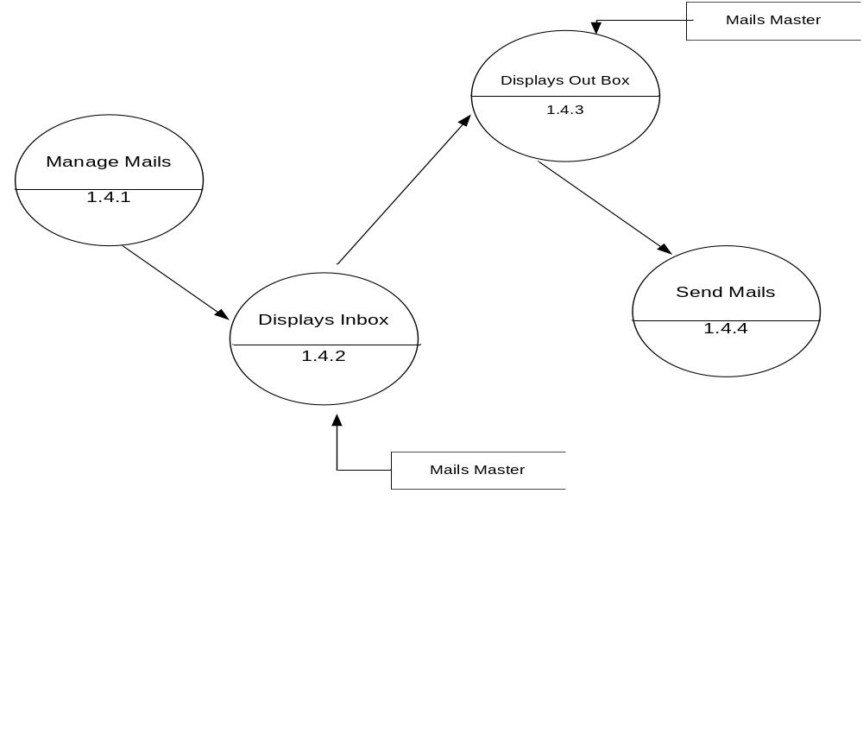

3RD LEVEL

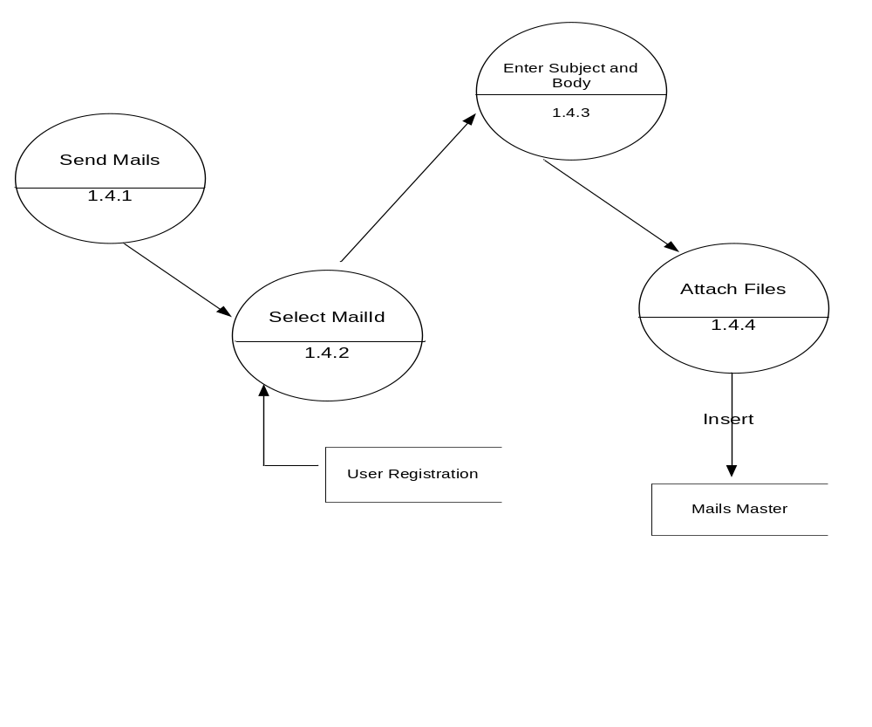

DOCTOR ACTIVITIES

1ST LEVEL

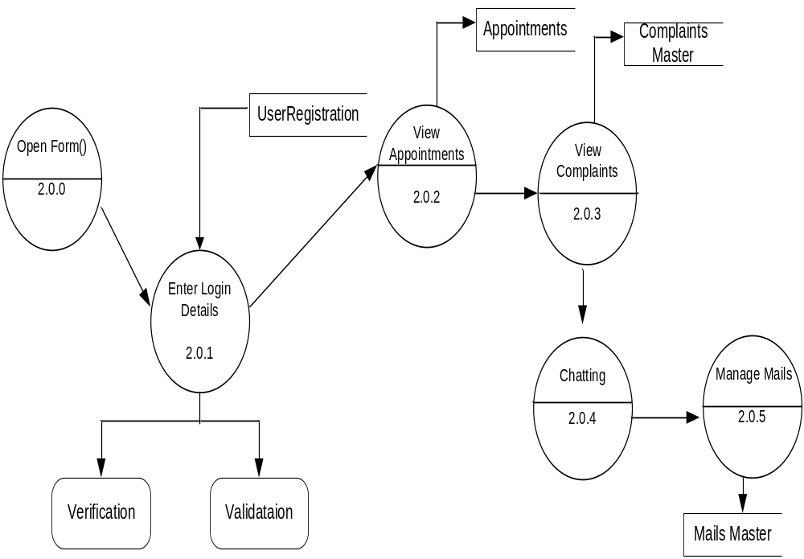

2ND LEVEL

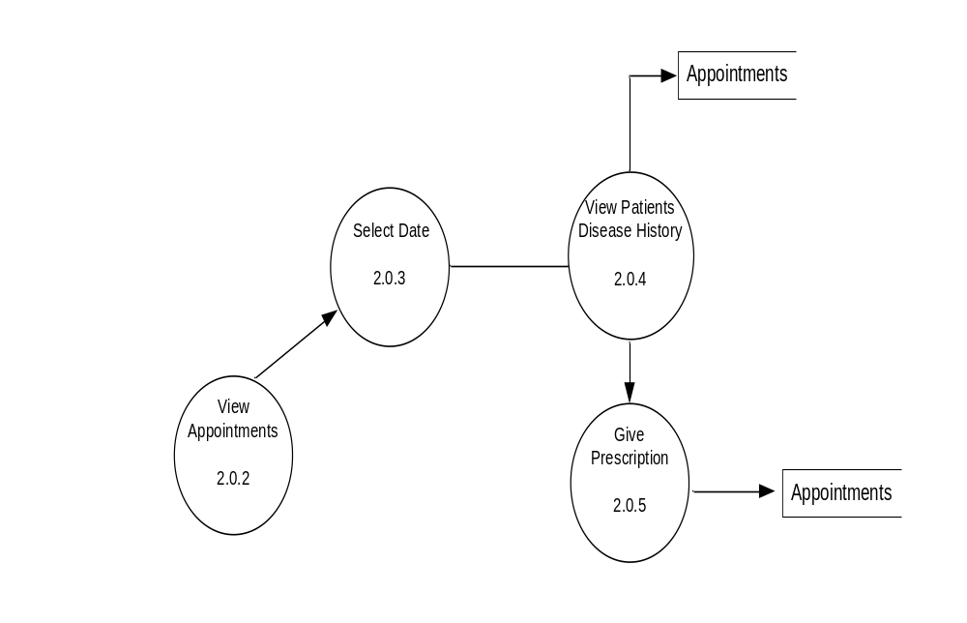

PATIENT ACTIVITIES

1ST LEVEL

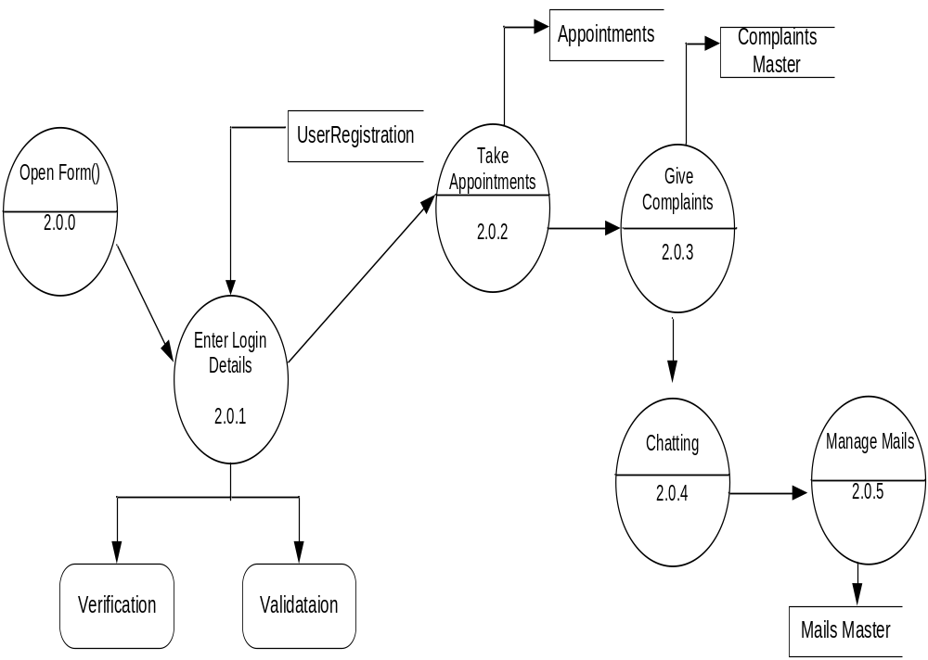

2ND LEVEL

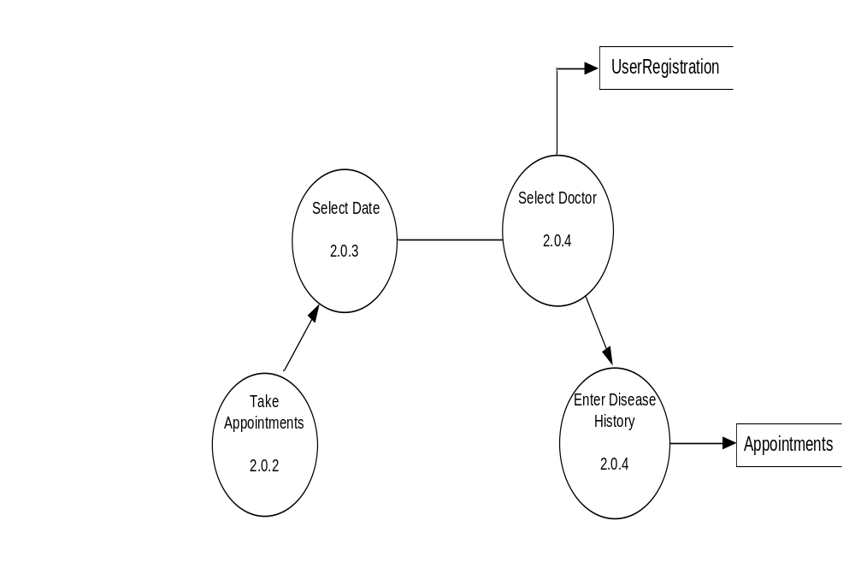

E-R DIAGRAM

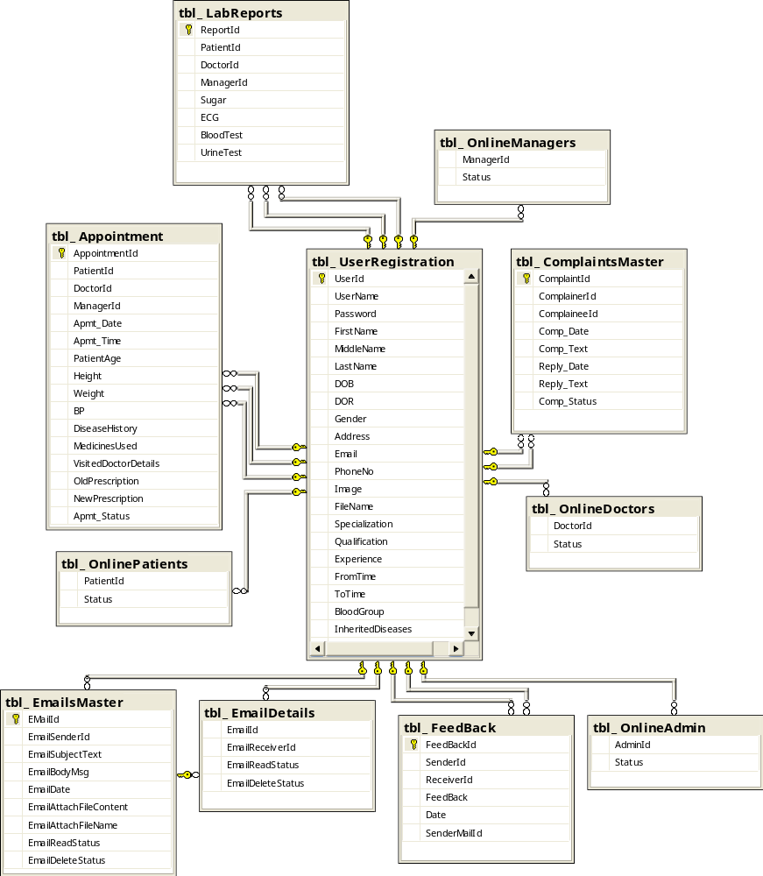

Structure of Tables

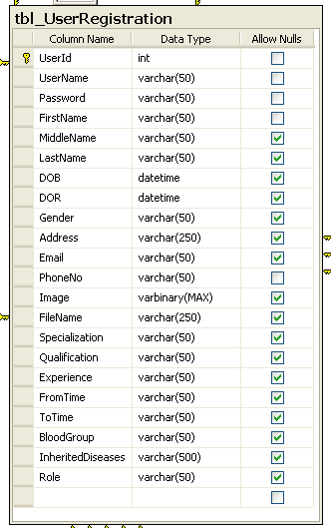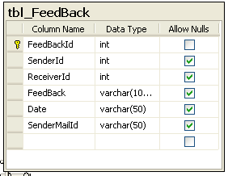

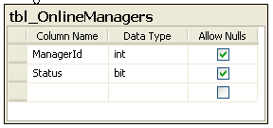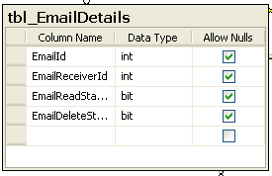

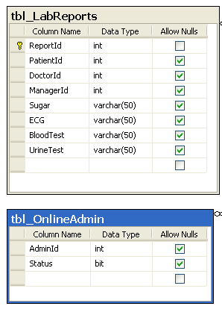

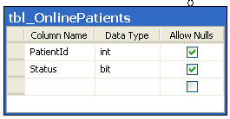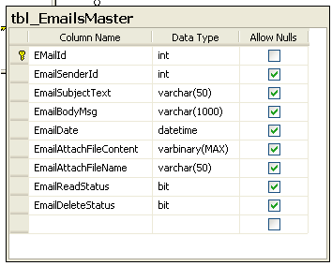
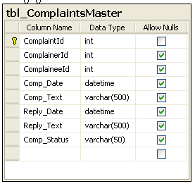

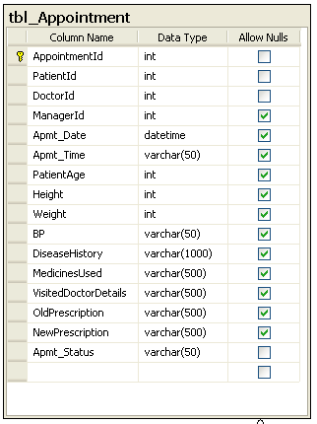

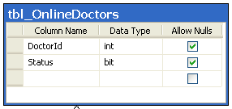

UML DIAGRAMS
ACTIVITY DIAGRAMS:

LOGIN ACTIVITY DIAGRAM:
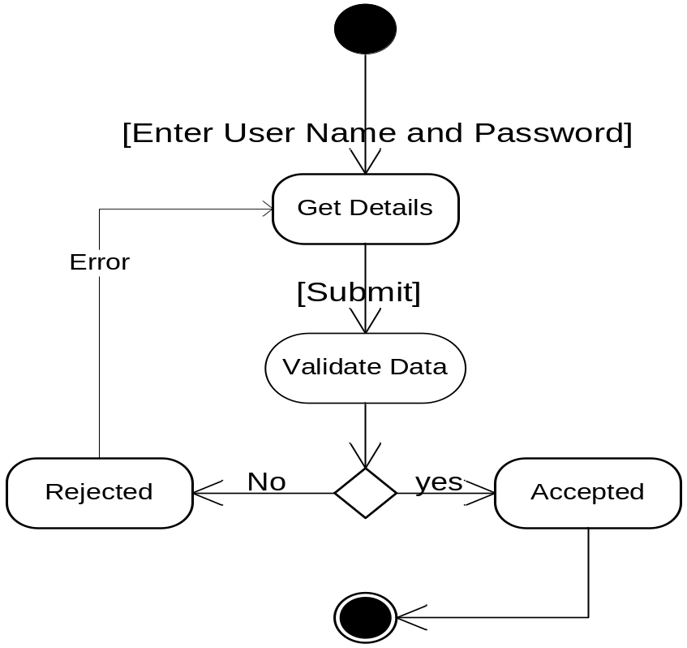

ADMIN ACTIVITY
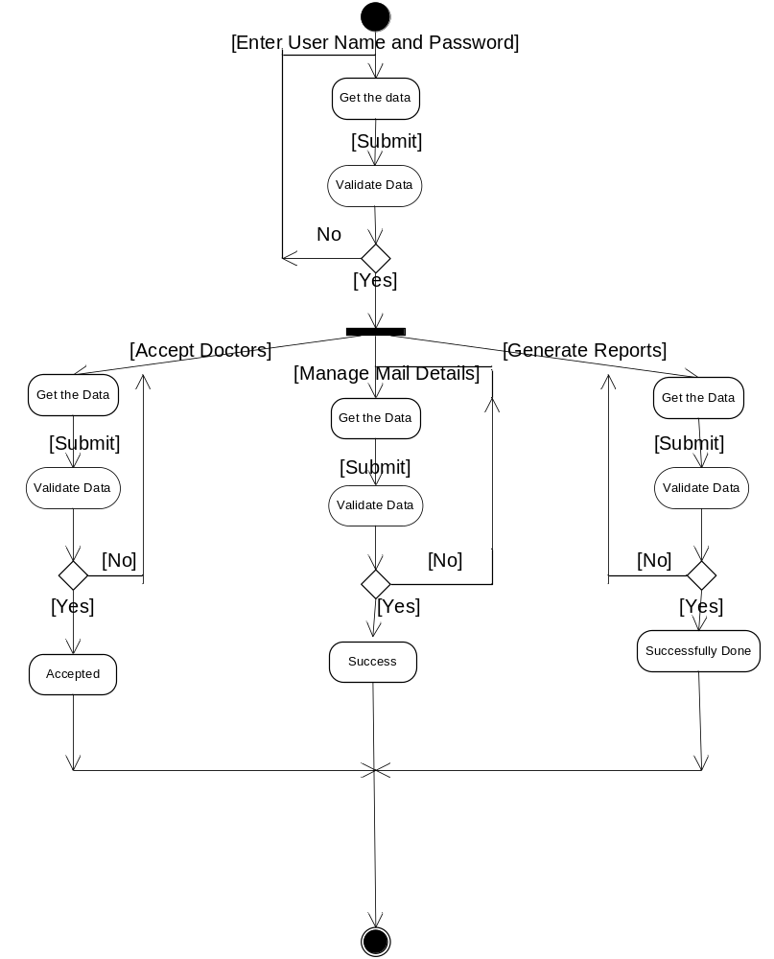

DOCTOR ACTIVITY

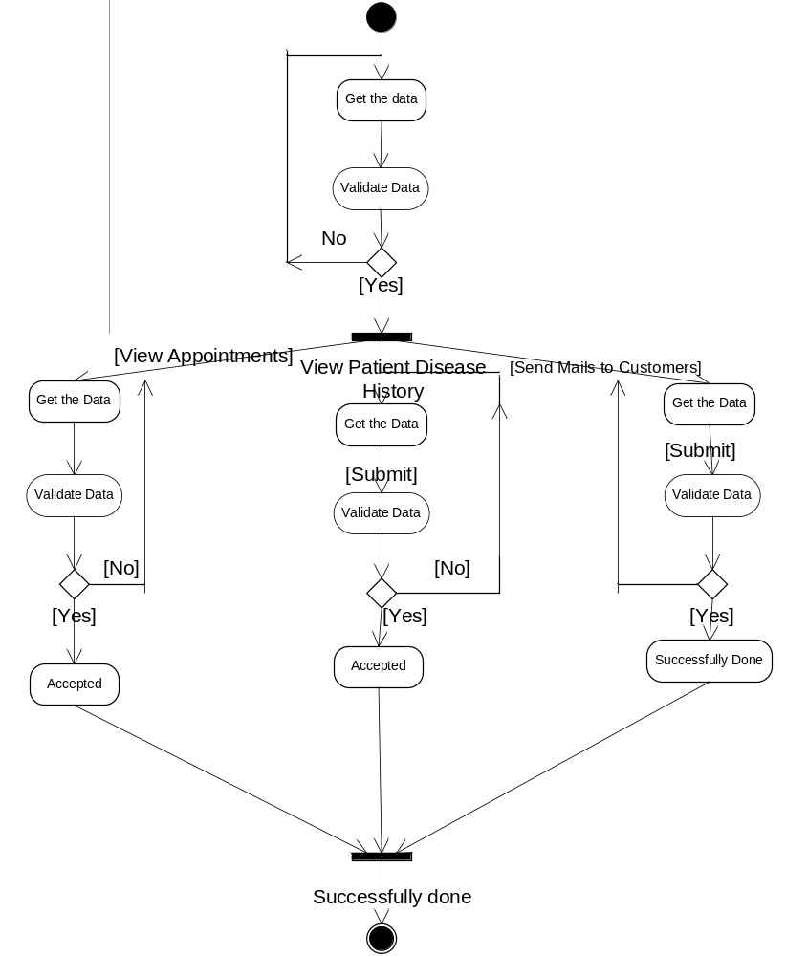

PATIENT ACTIVITY
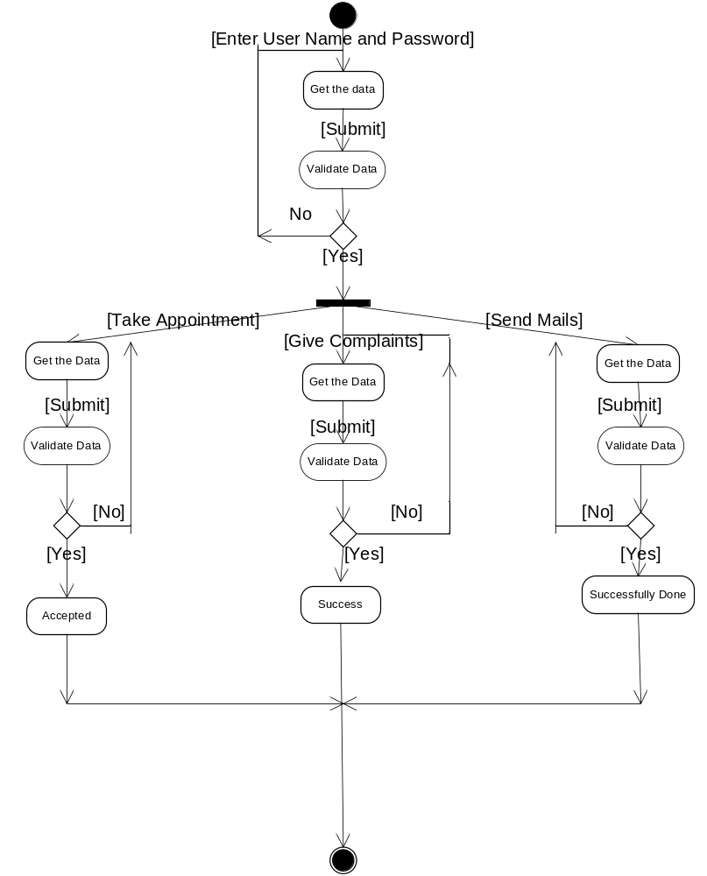

SEQUENCE DIAGRAMS:

USER REGISTRATION SEQUENCE
User
frmRegistration
BL:cls_User
DAL:cls_SqlHelper
Database
1 : Get Registration Form
2 : insertUserData ()
3 : ExecuteNonQuery ()
4 : ExecuteCommand()
6 : Response()
7 : Response for InsertUserData()
LOGIN SEQUENCE
User
LoginPage
BL:Cls_Login()
DAL:SqlHelper()
Database
1 : Open Login Form
2 : ValidateUser()
3 : ExecuteNonQuery()
4 : ExecuteComand()
5 : Return QueryResult()
6: ResponseForValidateUser()

ADMIN SEQUENCE TO APPROVE DOCTORS
Admin
frmDoctors Acceptacny
BAL:clsDoctor
DAL:clsSqlHelper

DataBase
1 : view Regd Doctors()
2 : Accept Doctors()
3 : ExecuteNonQuery()
4 : ExecuteNonQuery()
5 : Response()
6 : Show Result()
ADMIN SEQUENCE TO REDIRECT COMPLAINTS

Admin
frmViewComplaints
BAL:clscomplaints
DAL:clsSqlHelper

DataBase
1 : view Complaints()
2: Redirect Complaints()
3 : ExecuteNonQuery()
4 : ExecuteNonQuery()
5 : Response()
6 : Show Result()

DOCTORS SEQUENCE TO VIEW APPOINTMENTS
Doctor
frmViewAppointments
BAL:clsDoctor
DAL:clsSqlHelper

DataBase
1 : Get Appointments()
2 : Get Patients Disease History()
3 : ExecuteDataset()
4 : ExecuteNonQuery()
5 : Response()
6 : Show Result()

DOCTORS SEQUENCE TO MANAGE MAILS
Doctor
frmMails
BAL:clsMails
DAL:clsSqlHelper

DataBase
1 : View Inbox mails ()
2 : Compose Mails()
3 : ExecuteNonQuery()
4 : ExecuteNonQuery()
5 : Response()
6 : Show Result()

PATIENT SEQUENCE TO TAKE APPOINTMENT
Patient
frmAppointments
BAL:clsAppointment
DAL:clsSqlHelper

DataBase
1 : Enter Data
2 : Insert Appointment()
3 : ExecuteNonQuery()
4 : ExecuteNonQuery()
5 : Response()
6 : Show Result()

PATIENT SEQUENCT TO GIVE COMPLAINTS
Pant
frmComplaints
BAL:clsComplaints
DAL:clsSqlHelper

DataBase
1 : Enter Complaint
2 : Insert Complaint()
3 : ExecuteNonQuery()
4 : ExecuteNonQuery()
5 : Response()
6 : Show Result()

UNIFIED MODELING LANGUAGE DIAGRAMS

USE CASE FOR LOGIN PROCESS

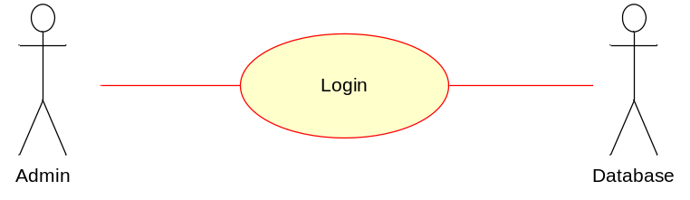

Over View Use Case Diagram
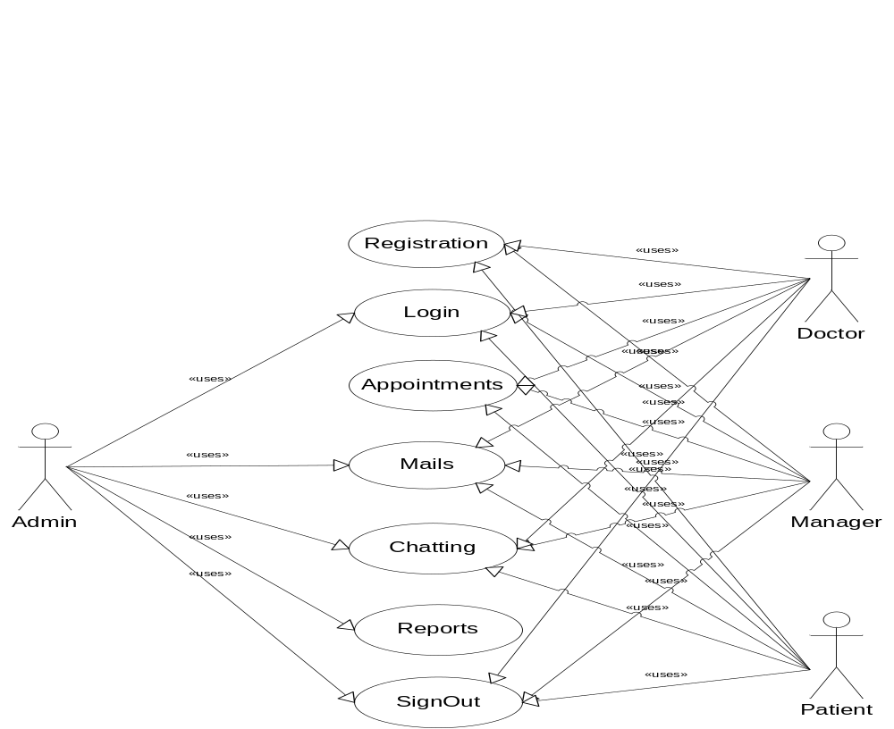

Sample I/O Screen

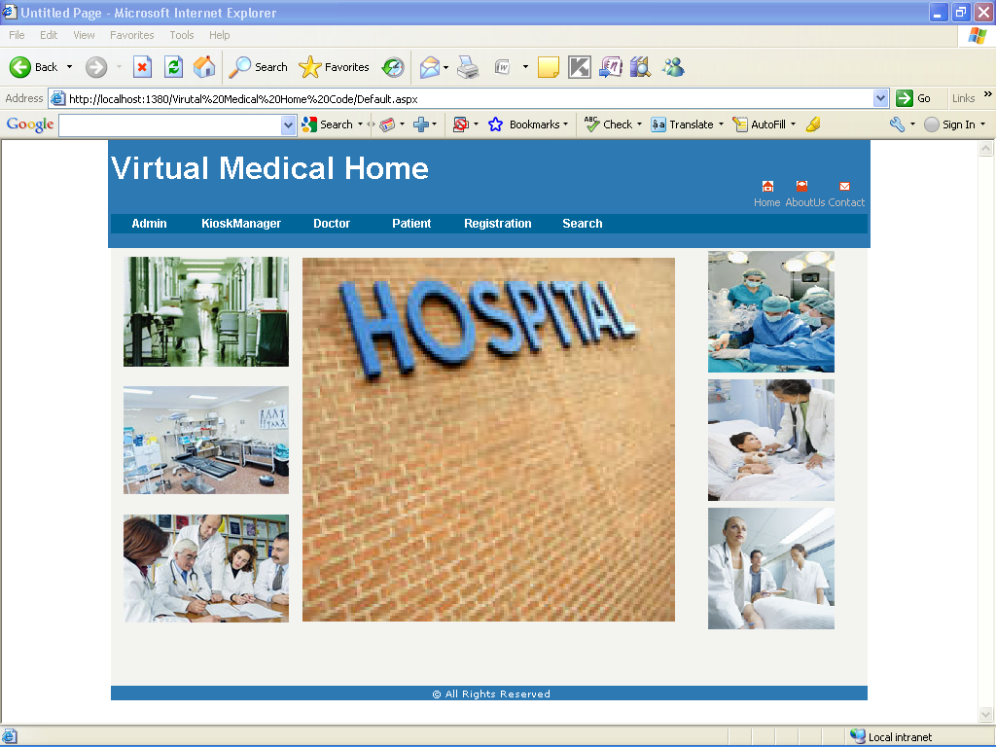

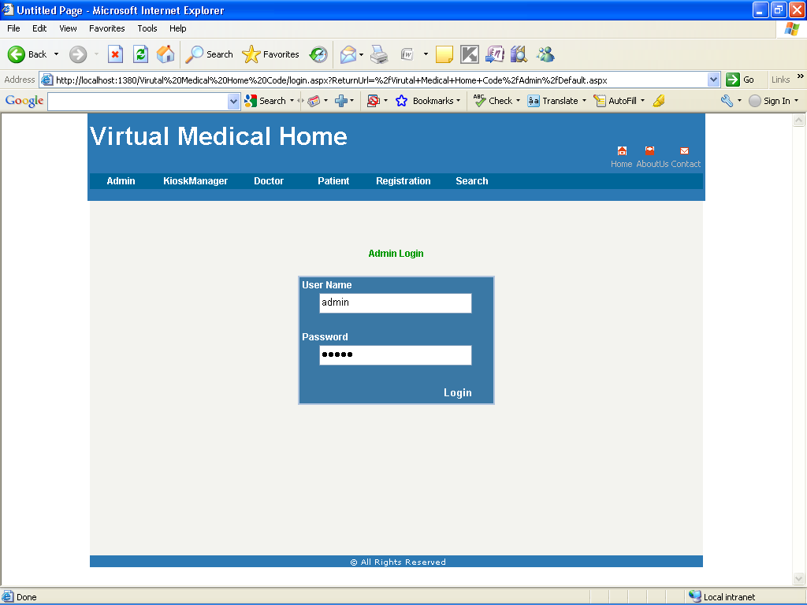

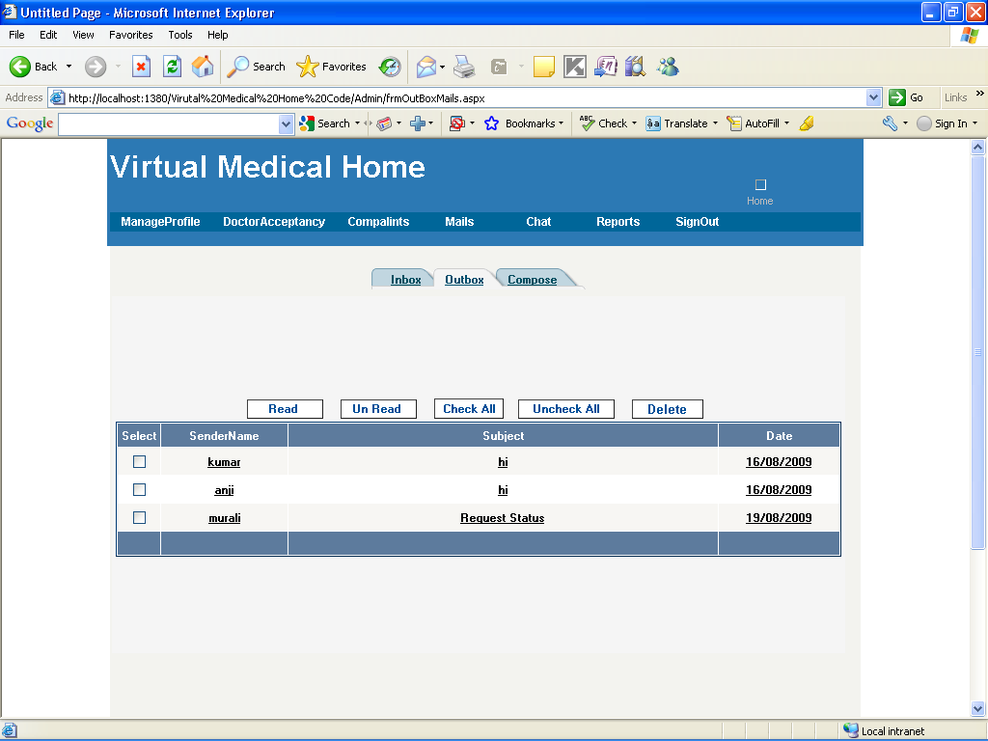

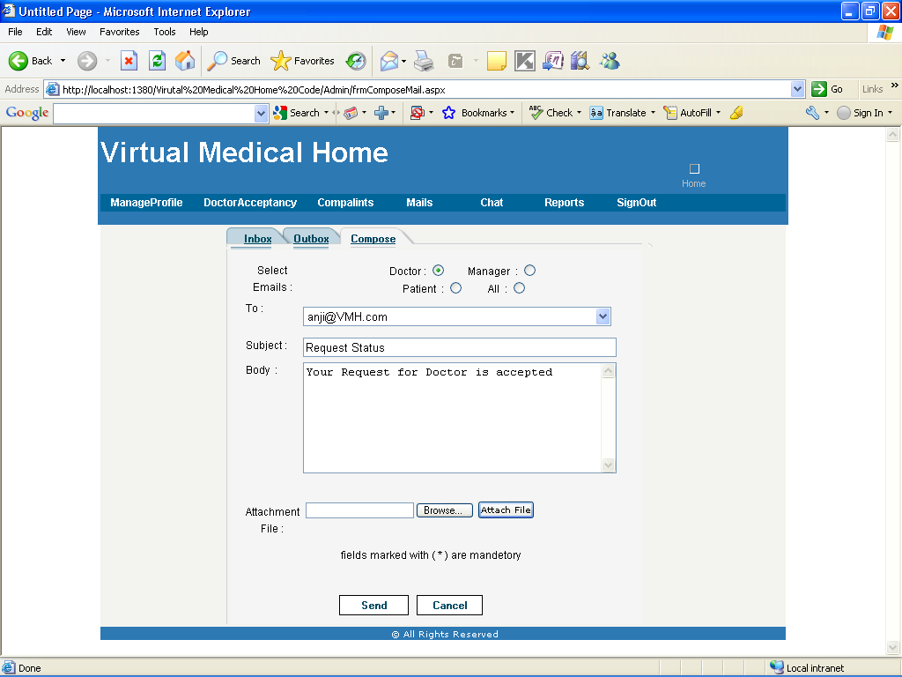

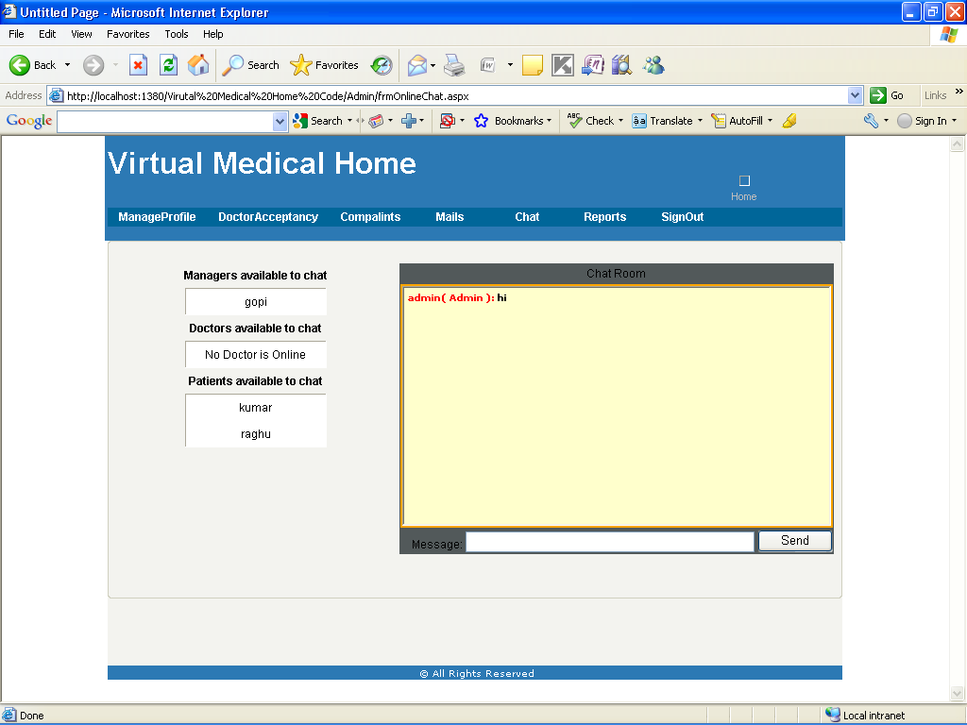

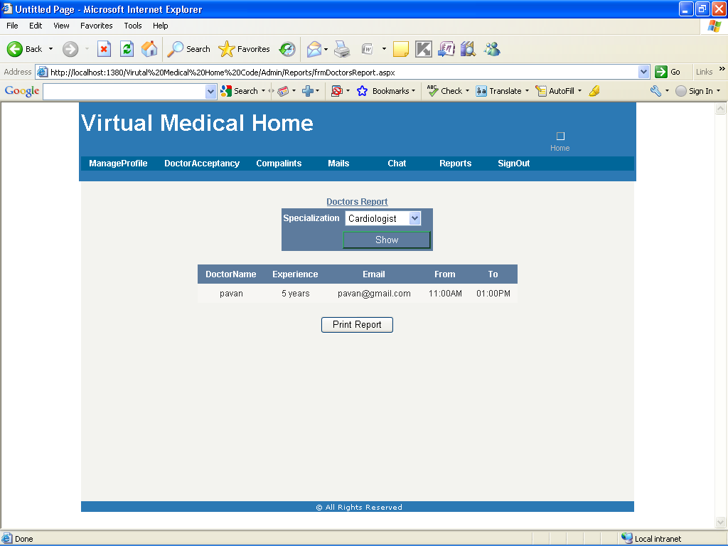

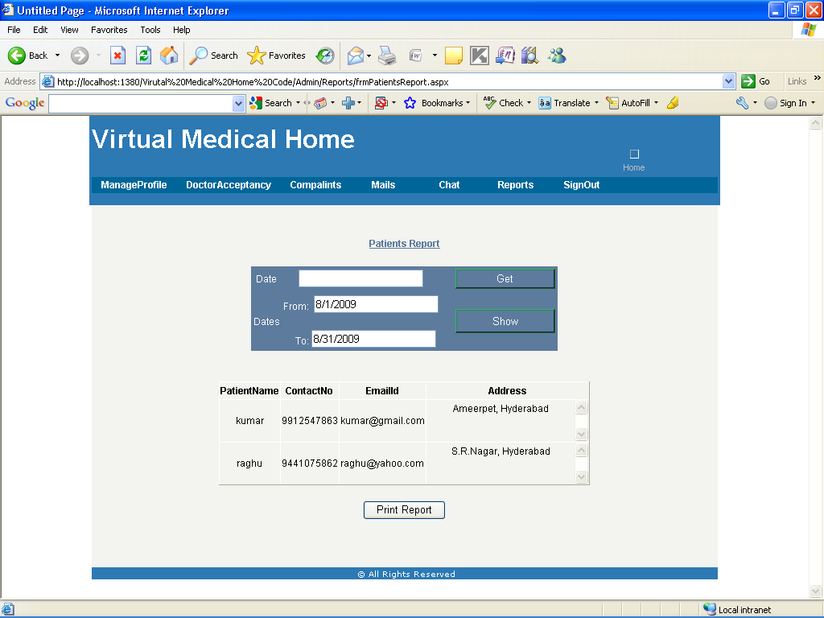

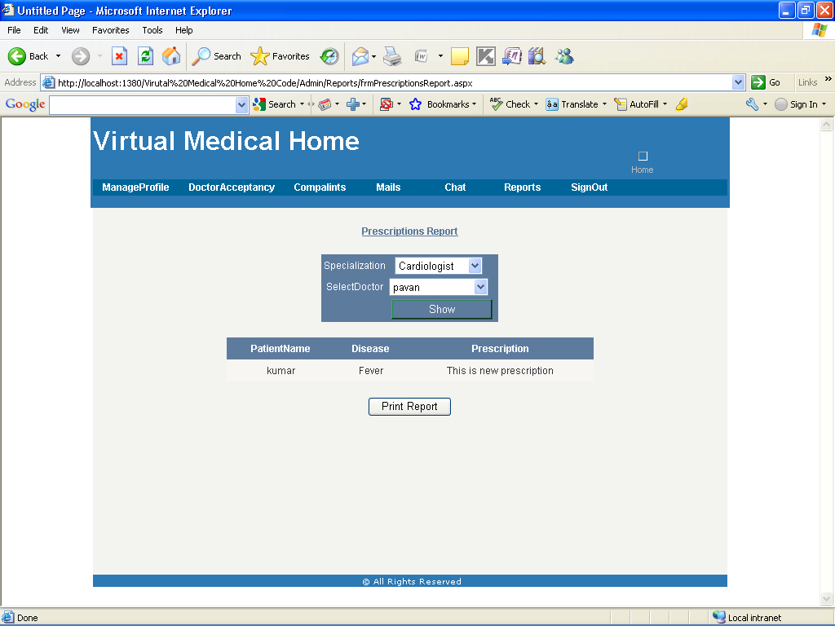

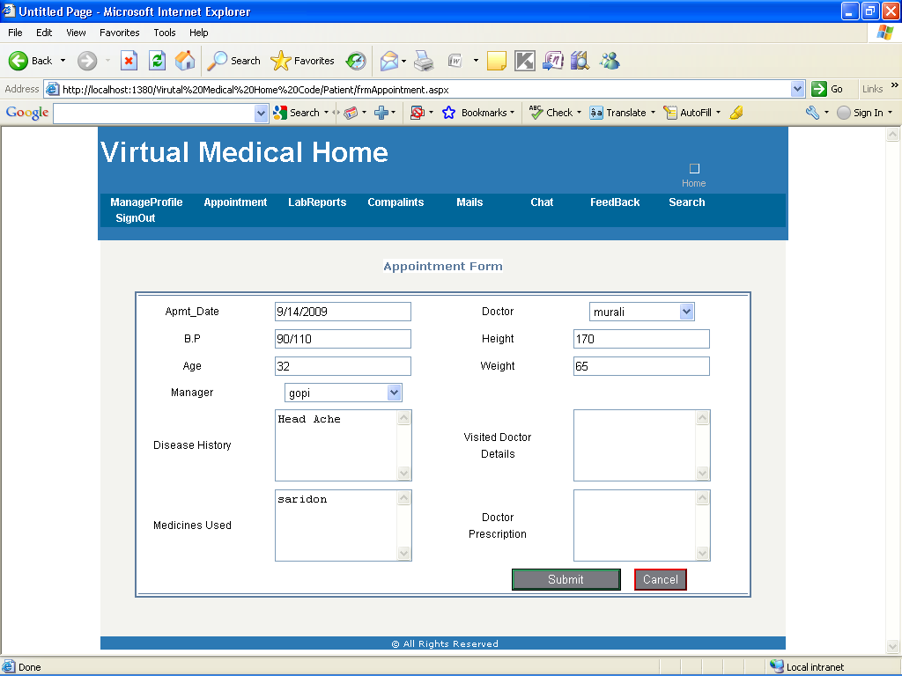

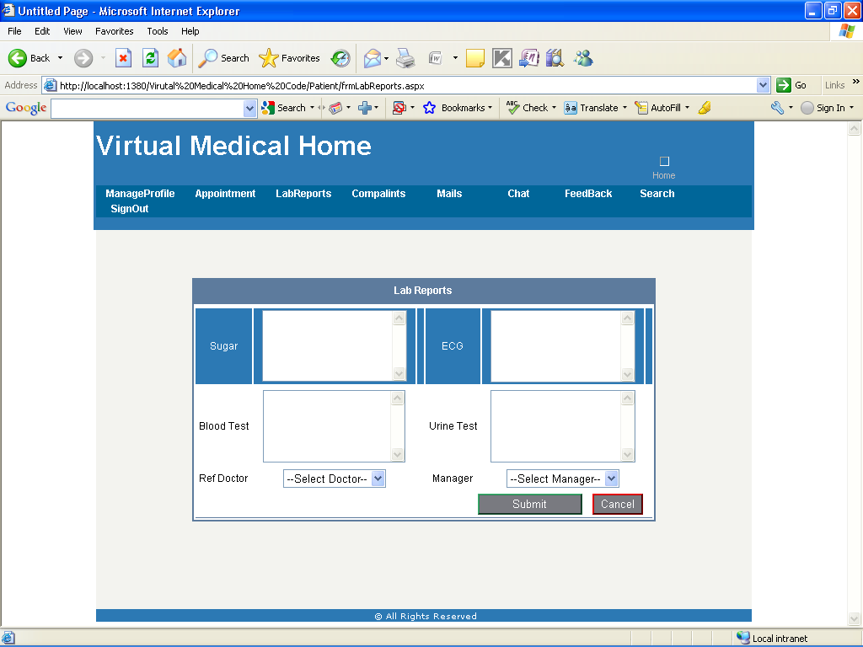

TESTING

Software testing is a critical element of software quality assurance and represents the ultimate review of specification, design and coding. In fact, testing is the one step in the software engineering process that could be viewed as destructive rather than constructive.
UNIT TESTING
Unit testing focuses verification effort on the smallest unit of software design, the module. The unit testing we have is white box oriented and some modules the steps are conducted in parallel.
TEST CASES
Test Case 1 – Login
Test 1:
- Incorrect input: An empty requirement field. (user name and password)
- Pass criteria: An appropriate error message should be displayed and the user shouldn’t be allowed to login.
- Correct input: Right user name and password.
- Pass criteria: The user should be directed to the secure web page which the user is requested.

Test 2:
- Incorrect input: Wrong user name and/or wrong password.
- Pass criteria: The user shouldn’t be allowed to login to the system and an appropriate error message should be displayed.
- Correct input: Right user name and password.
- Pass criteria: The user should be login to the system and directing to the requested secure web page.

Test Case 2 – New User Register
- Incorrect input: An empty requirement field. (first name, last name, middle name, Photo, address, Date Of Birth, phone number, user name, password, e-mail address)
- Pass criteria: An appropriate error message should be displayed and the user shouldn’t be allowed to create an account.
- Correct input: Fill in all requirement fields in correct format.
- Pass criteria: The user information should be added into the database.

Test Case 3 – Generate Report (Patient)
Test 1:
- Incorrect input: An empty requirement field. (Select Date)
- Pass criteria: An appropriate error message should be displayed and the user should not be able to generate a report.
- Correct input: Enter(Select) Correct Date
- Pass criteria: The user (admin) should be allowed to generate the report.

SECURITY MEASURES

The protection of computer based resources that includes hardware, software, data, procedures and people against unauthorized use or natural
Disaster is known as System Security.
System Security can be divided into four related issues:
- Security
- Integrity
- Privacy
- Confidentiality
SYSTEM SECURITY refers to the technical innovations and procedures applied to the hardware and operation systems to protect against deliberate or accidental damage from a defined threat.

DATA SECURITY is the protection of data from loss, disclosure, modification and destruction.

SYSTEM INTEGRITY refers to the power functioning of hardware and programs, appropriate physical security and safety against external threats such as eavesdropping and wiretapping.

PRIVACY defines the rights of the user or organizations to determine what information they are willing to share with or accept from others and how the organization can be protected against unwelcome, unfair or excessive dissemination of information about it.

CONFIDENTIALITY is a special status given to sensitive information in a database to minimize the possible invasion of privacy. It is an attribute of information that characterizes its need for protection
.
SECURITY SOFTWARE
System security refers to various validations on data in form of checks and controls to avoid the system from failing. It is always important to ensure that only valid data is entered and only valid operations are performed on the system. The system employees two types of checks and controls:

CLIENT SIDE VALIDATION

Various client side validations are used to ensure on the client side that only valid data is entered. Client side validation saves server time and load to handle invalid data.

SERVER SIDE VALIDATION

Some checks cannot be applied at client side. Server side checks are necessary to save the system from failing and intimating the user that some invalid operation has been performed or the performed operation is restricted..

LIMITATIONS OF THE PROJECT

- The size of the database increases day-by-day, increasing the load on the database back up and data maintenance activity.
- Training for simple computer operations is necessary for the users working on the system.

FUTURE SCOPE OF THE APPLICATION

However this application (Virtual Medical Home) has been developed by analyzing the current requirement of system for automation in an organization. But it is possible to customize this application in future, according to the changed need of system.

It is just because this application is made of modules and each module is responsible for performing a particular task. So, in future, it will be quite easy to add another module to the present software in order to include some features. On the other hand, if it is noted that any of the module in the present application is of no mean then it can be excluded from the application. It requires no or just a little change in the present codes.

Now there is no recovery management component, but we can add this facility in future. like Oracle ,MS Access etc.

We can add web cam facility to use this project effectively.

BIBLIOGRAPHY

- FOR .NET INSTALLATION
www.support.mircosoft.com
- FOR DEPLOYMENT AND PACKING ON SERVER
www.developer.com
www.15seconds.com
- FOR SQL
www.msdn.microsoft.com
- FOR ASP.NET
Asp.Net 3.5 Unleashed
www.msdn.microsoft.com/net/quickstart/aspplus/default.com
www.asp.net
www.fmexpense.com/quickstart/aspplus/default.com
www.asptoday.com
www.aspfree.com
www.4guysfromrolla.com/index.aspx
- Software Engineering (Roger’s Pressman)

