UI/UX Workflow and User Journey Document of CARE 2.0
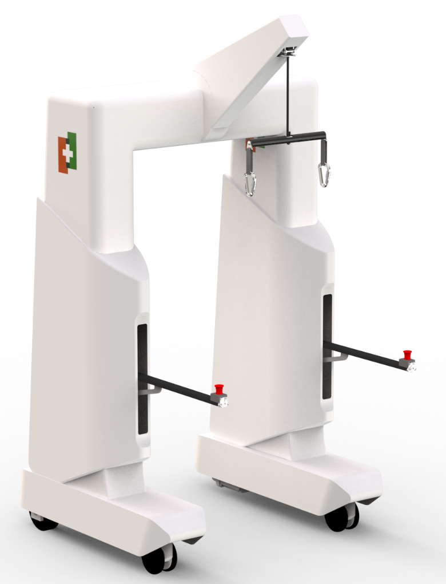
Submitted To

Charukesi Healthcare Pvt. Ltd.
P.O. No.: CHPL-2025-TT-PO-0001, Dated: 19/05/2025
Document No.: TTT-25-380-CHPL-CARE2.0-D0XX
Sep 25, 2026
Submitted By


 |  | Document No. TTT-25-380-CHPL-CARE2.0-D0XX  Issue No. 01  Amendment No. 00  Date Sep 25, 2026  No. of Pages 20
Timetooth Technologies Pvt. Ltd., 19A, New Industrial Estate, Peenya II Phase, Peenya Industrial Area, Bangalore, KA - 560058 |  | DOCUMENT CLASSIFICATION  RESTRICTED
PROJECT: Design and development of CARE 2.0
(Against Charukesi Project Order: CHPL-2025-TT-PO-0001, Dated: 19/05/2025)
TITLE: UI/UX Workflow and User Journey Document of CARE 2.0.
KEY WORDS: CARE, UI Software, UI & UX Flow, User Journey, Screen Navigation, Error Handling
SUMMARY: This document presents the UI/UX workflow and user journeys of the CARE 2.0 therapist UI (version 3)
 | NAME |  | SIGN/DATE
TIMETOOTH TECHNOLOGIES P L
PREPARED BY | Saro Ramasamy, Sai Rajendra
CHECKED BY | Randhir Swarnkar, Yogesh Agarwal
APPROVED BY | Girish Mudgal
CHARUKESI HEALTHCARE P L
APPROVED BY
Distribution: Timetooth, Charukesi - 2 copies
Disclaimer
THIS DOCUMENT AND THE INFORMATION IN IT ARE PROVIDED IN CONFIDENCE, FOR THE SOLE PURPOSE OF CHARUKESI HEALTHCARE PVT. LTD. AND MAY NOT BE REPRODUCED IN WHOLE, OR IN PART, NOR MAY ANY OF THE INFORMATION CONTAINED THEREIN BE DISCLOSED TO ANY THIRD PARTY OR USED FOR ANY OTHER PURPOSE WITHOUT THE EXPRESS WRITTEN PERMISSION OF DIRECTORS OF TIMETOOTH TECHNOLOGIES PVT. LTD.
Record of Revisions
The incorporation of each amendment to this document is to be recorded by filling the row against the issue / amendment number.
Issue No. | Amendment No. | Date | Description | Approved by
01 | 00 | Sep 25, 2026 | First issue
Table of Contents
1. Introduction 8
1.1. Purpose 8
1.2. Scope 8
1.3. Reference Documents 8
2. General Requirements 9
2.1. UI Characteristics 9
2.2. Computing Environment 9
3. Users and Roles 9
4. Screen Inventory and Navigation 10
4.1. Common Header 10
4.2. Navigation Map 11
4.3. Screen Inventory 11
5. User Journeys 12
5.1. J1 - Therapist Runs a Rehabilitation Session 12
5.2. J2 - Therapist Reviews Patient History 14
5.3. J3 - Registering a New Patient 14
5.4. J4 - Admin Assigns a Patient to a Therapist 15
5.5. J5 - Admin Checks the Device 15
6. Error Detection and Handling 15
6.1. Emergency Stop During a Session 15
6.2. Error and Safety Behaviours 16
6.3. Kiosk Mode 17
7. UX Observations and Recommendations 18
8. Open Questions for the Design Team 20

List of Figures
Figure 1: UI Navigation Map 11
Figure 2: Session States and Transitions 14

List of Tables
Table 1: Reference Documents 8
Table 2: User Roles in the UI 10
Table 3: Screen Inventory 11
Table 4: Therapist Session Journey (J1) 12
Table 5: Error and Safety Behaviours 16
Table 6: UX Observations and Recommendations 18
Table 7: Open Questions 20

List of Abbreviations
S/N | Terms | Description
1 | UI | User Interface
2 | UX | User Experience
3 | API | Application Programming Interface
4 | BWS | Body Weight Support
5 | NI | National Instruments
6 | cRIO | CompactRIO (NI real-time embedded controller)
7 | RT | RealTime
8 | HTTP | Hypertext Transfer Protocol
9 | JSON | JavaScript Object Notation
10 | BP | Blood Pressure
11 | HR | Heart Rate
12 | SpO2 | Peripheral Oxygen Saturation
13 | E-stop | Emergency Stop

1. Introduction

1.1. Purpose
Product Name: CARE 2.0
Category: Robotic Rehabilitation System
The purpose of this document is to describe the UI/UX workflow of the CARE 2.0 therapist user interface (version 3): the screens, how users move between them, the step-by-step user journeys for each role, and how the UI behaves on faults and emergency stops. It is written from the UI as built in the care-ui project.

1.2. Scope
The UI has 13 screens across two role-based flows. A therapist runs a rehabilitation session from login to a saved session report, and an admin manages patients, therapists and the device. This document covers both flows, the safety and error paths, UX observations and the open questions for the design team. The control software on the cRIO is described in the Software Design Document (D008).

1.3. Reference Documents
Table 1: Reference Documents
Document | Description
TTT-25-380-CHPL-CARE2.0-D007 | Software Requirement Specification Document of CARE 2.0
TTT-25-380-CHPL-CARE2.0-D008 | Software Design Document of CARE 2.0 (UI flow, roles and error handling)
P007 - User Interface Asset Details (04 Sep 2026) | UI source of truth: 1280 × 800 canvas, Open Sans, colours and assets
Care 2.0 2nd UI Iteration, UI Flow recording | Design iteration and screen flow video
care-ui/docs/CRIO_API.md | HTTP API between the UI and the device, and the server rules

2. General Requirements

2.1. UI Characteristics
- Code Language Used: JavaScript, React Native components rendered in the browser through react-native-web.
- Build Tool: Vite. The build is a static bundle of about 620 KB, fonts included, with no internet access needed.
- Display: Tablet browser. The UI is drawn on a fixed 1280 × 800 canvas and scaled to fit the screen.
- Kiosk Mode: Full screen is enforced and browser features (menus, developer tools, reload, zoom, Back) are blocked.
- Runtime Settings: public/config.js, editable on the target without rebuilding (mode, API address, poll rates, offloading and body-weight limits).

2.2. Computing Environment
- Production: The static bundle is served by a LabVIEW Web Service on the NI cRIO-9056, which also answers the UI API (/api/...).
- Development and testing: A Python API server (server/app.py, standard library only) answers the same API and stores data in an SQLite database (server/care.db) using the CARE 2.0 schema.
- Simulator: mode: 'mock' runs a built-in simulator in the browser, with no server or hardware.
- Connectivity: The tablet reaches the cRIO or the development PC over Wi-Fi / LAN.

3. Users and Roles
Two roles sign in from the same login screen; the role returned by the server decides the landing screen. D008 also defines a Maintenance role; the server accepts maintenance logins, but the UI has no maintenance screens yet (see sections 7 and 8).
Table 2: User Roles in the UI
Role | Lands on | Main goals | Can do in the UI
Therapist | Assigned Patients | Run a safe, recorded rehabilitation session for a patient | Find patient, record vitals, set up the device, run a Balance / Squat / Walk session, take breaks, end and save the report, view history, add a patient
Admin | Welcome Admin | Keep patient, therapist and device records in order | Browse all patients and session reports, view therapists and assign patients, check device status and jog the winch / movement

Accounts are managed on the controller; there is no self sign-up screen in the UI. Demo logins are preethi / 1234 (therapist) and admin / admin.

4. Screen Inventory and Navigation

4.1. Common Header
Every screen shares one header: the Charukesi logo, the therapist and patient name, the menu (Log out), Home, and the connection and battery icons. Home and Log out are locked while a session is active and on the Session Report screen. In kiosk mode there is no full-screen toggle, because full screen is enforced.

4.2. Navigation Map
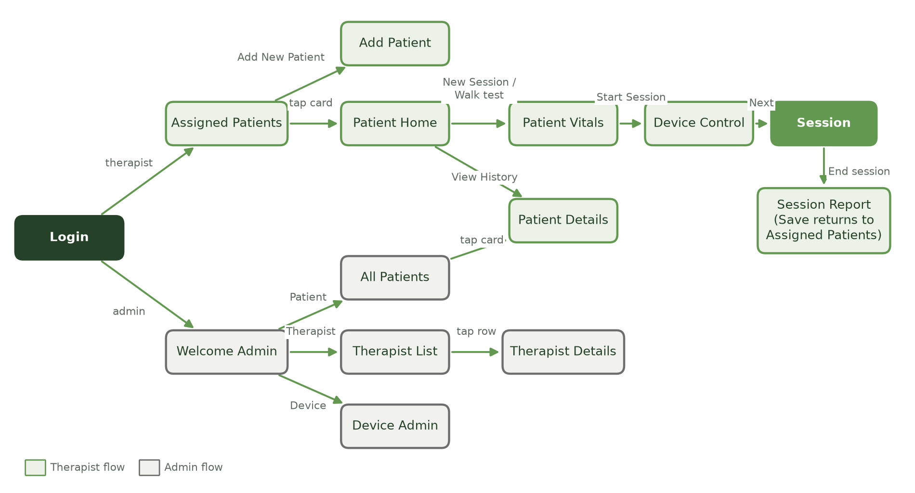
Figure 1: UI Navigation Map
Forward arrows open a new screen and Back returns one step. Saving a session report, logging in and logging out reset the navigation, so Back cannot return into a finished session.

4.3. Screen Inventory
Table 3: Screen Inventory
Screen | Role | Purpose | Main actions
Login | All | Sign in | Username, password (show / hide), Sign In
Assigned Patients / All Patients | Therapist / Admin | Find a patient | 3-column card grid, search by name or ID, tap a card, Add New Patient
Add Patient | Therapist, Admin | Register a patient | 5 tabs with a stepper: Patient Information, Medical, Cardiopulmonary, Orthopedic, Neurological; Save Patient
Patient Home | Therapist | Patient summary and entry to work | View History, New Session, Walk test
Patient Details | Therapist, Admin | Profile and session history | Sessions table (newest first), Get Report pop-up, Print
Patient Vitals | Therapist | Pre-session vitals; opens the session | Weight (max 136 kg), BP, SpO2, heart rate (required), notes; Start Session
Device Control | Therapist | Position the patient before exercise | Patient lift, offloading knob, device movement jog; Next
Session | Therapist | Select mode and run the exercise | Balance / Squat / Walk (+ Slow / Medium / Fast), Start Exercise, Break, Resume, End session, Emergency stop
Session Report | Therapist | Close out the session | Post-session vitals (with before values), session stats, comments, Save session
Welcome Admin | Admin | Admin hub | Patient, Therapist and Device tiles; Log Out
Therapist List | Admin | Find a therapist | Search by name, tap a row
Therapist Details | Admin | Therapist caseload | Assigned patients table, Assign New patient pop-up
Device Admin | Admin | Maintenance and status | Connection, state, E-stop, lift, offloading, battery; Engage / Release E-stop; winch and movement jog

5. User Journeys

5.1. J1 - Therapist Runs a Rehabilitation Session
The main journey takes 8 screens and 3 confirmation pop-ups from login to a saved report. The session can only be ended from a break, never while the patient is exercising.
Table 4: Therapist Session Journey (J1)
Step | Screen | User action | System response
1 | Login | Enters username and password, taps Sign In | Loader "Signing in…", then opens Assigned Patients
2 | Assigned Patients | Searches by name or ID, taps a patient card | Opens Patient Home for that patient
3 | Patient Home | Reviews the patient details; taps New Session (or Walk test) | Opens Patient Vitals; Walk test pre-selects Walk mode
4 | Patient Vitals | Enters weight, BP, SpO2, heart rate and optional notes; taps Start Session | Flags empty required fields, a BP not in 120/80 format and a weight above 136 kg. Opens the session on the device (session ID returned) and stores the vitals as "before" values
5 | Device Control | Raises or lowers the lift, sets offloading with the knob, jogs the device into position; taps Next | Device status is read every 250 ms from here on. Jog commands repeat while held and stop on release
6 | Session (Select Mode) | Picks Balance, Squat or Walk; for Walk picks Slow, Medium or Fast; adjusts offloading; taps Start Exercise | Opens the Confirm Mode pop-up with mode, speed and offloading (% and kg)
7 | Confirm Mode pop-up | Taps Confirm | Sends mode and start; timer runs; Home and Log out lock
8 | Session (running) | Watches the live tiles: fall arrests, breaks, offloading kg, squats, steps, speed, distance | Tiles not relevant to the mode show "---"; only Break is offered
9 | Break pop-up | Taps Break, then Confirm | Timer pauses, the device holds the patient, ON BREAK badge; set-up controls unlock
10 | Session (break) | Taps Resume Session or End session, then Confirm | Resume returns to step 8; End stops the session and opens the report
11 | Session Report | Enters BP, SpO2 and HR after the session (before values shown), reviews stats, adds comments; taps Save session, then Confirm | Saves the report to the device, clears the vitals and returns to Assigned Patients

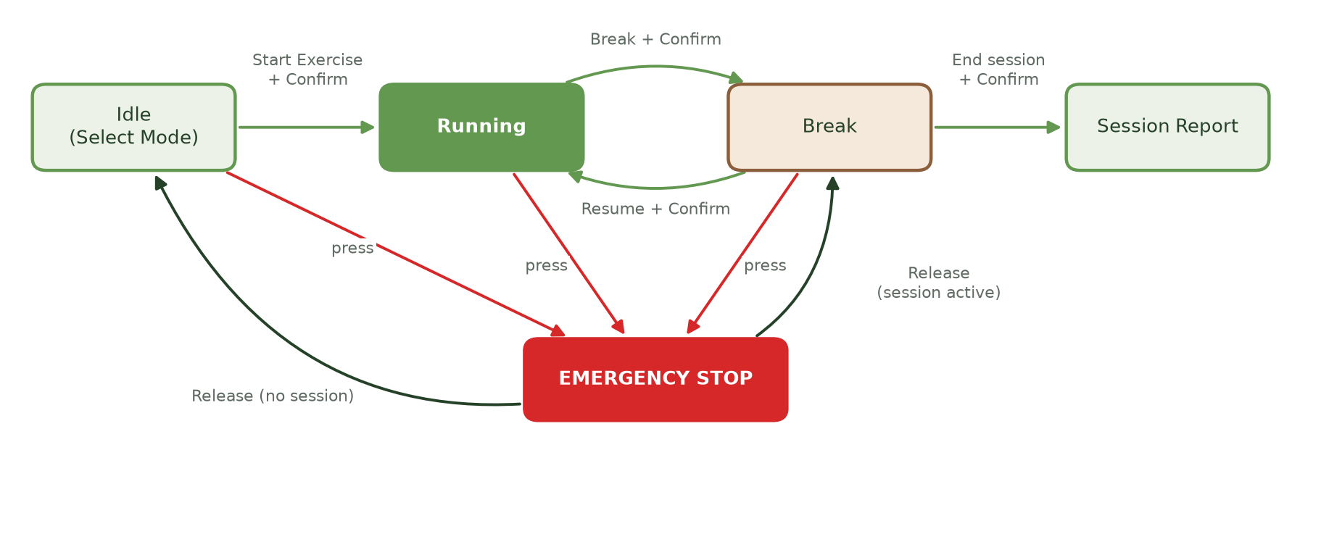
Figure 2: Session States and Transitions
The session state (idle, running, break, E-stop) comes from the device, so a hardware E-stop moves the UI the same way as the on-screen button. This matches the BWS state machine in D008: a break returns the device to manual control, and a session is only ended from there.

5.2. J2 - Therapist Reviews Patient History
- Assigned Patients → tap the patient → Patient Home → View History.
- Patient Details shows the profile (name, ID, age, gender, condition) and a sessions table, newest first: date, session ID, therapist ID, duration, mode.
- Get Report opens a pop-up with duration, breaks / steps / squats, offloading, vitals after and comments. Print sends it to the browser print dialog; Close returns.

5.3. J3 - Registering a New Patient
- Assigned Patients (or All Patients) → Add New Patient.
- Five tabs with a left-hand stepper; the user can jump to any tab or use Next / Back.
- Required: full name, age (1-120) and gender, all on tab 1. Errors on Save return the user to tab 1.
- Save Patient on tab 5 → "Save New Patient?" pop-up (name, age / gender, diagnosis) → Confirm. The device generates the patient ID; a therapist's new patient is assigned to that therapist.
- Returns to the patient list.

5.4. J4 - Admin Assigns a Patient to a Therapist
- Welcome Admin → Therapist → search or scroll → tap the therapist.
- Therapist Details shows the name, username, number of assigned patients and a table of them.
- Assign New patient → a pop-up lists the patients not yet with this therapist → select one → Confirm (disabled until a patient is picked).
- The table refreshes with the new patient.

5.5. J5 - Admin Checks the Device
- Welcome Admin → Device.
- Device Status shows connection, transport, controller state, E-stop, lift position, offloading, battery and the poll / jog rates.
- Engage or Release E-stop with one button; jog the winch and movement for maintenance (disabled while the E-stop is engaged).

6. Error Detection and Handling
The Emergency stop is always visible on the Session screen, drawn above every pop-up, and fires the moment it is pressed, before any dialog opens. Every other state change in a session needs a confirmation pop-up.

6.1. Emergency Stop During a Session
- The therapist presses Emergency stop (or a hardware E-stop is pressed).
- The stop command is sent immediately; the button changes to "E-stop engaged".
- The EMERGENCY STOP pop-up shows "All device motion has been halted" and a checklist:
- To check before confirming:
  - Patient is secure in the harness and not bearing unexpected load
  - Area around the device is clear
  - Cause of the stop has been identified
- During an active session the only option is Release E-stop. Releasing goes to the break screen; the session never restarts on its own.
- From the break screen the therapist chooses Resume Session or End session, so the session data is kept either way.
- Before a session starts, the pop-up also offers Back, which releases the stop and returns to Device Control.
- If the stop command is not acknowledged, a red message reads "E-STOP COMMAND NOT ACKNOWLEDGED - use the hardware E-stop".

6.2. Error and Safety Behaviours
Table 5: Error and Safety Behaviours
Situation | What the user sees | Why
Device link lost (3 failed status reads) on Device Control | Full-screen loader: "Controller not responding - reconnecting…" | Blocks input on stale data
Device link lost during a session | Red banner: "Controller not responding - values may be stale. Use the hardware E-stop if needed."; the Wi-Fi icon shows off | Never covers the E-stop
Any request cannot reach the device | "Cannot reach the device" or "The device did not answer in time" beside the action | The user can retry; the API server or cRIO may be down
Action not allowed right now (server rule) | The server's message, for example "Emergency stop is engaged. Release it first" | The server refuses start, break, resume, movement and unloading during an E-stop, lift and movement while running, and End session outside a break
Jog button held | The command repeats every 150 ms; release sends stop | The device stops motion if it hears nothing for about 450 ms
Offloading set above the limit | Value clamped; the panel shows "Limit reached · Max N kg = N % of body weight" | Offloaded weight is capped at 60 kg (72 kg patient = 83.33 %); the server refuses more with HTTP 422
Body weight above 136 kg | "Max 136 kg" beside the weight field as it is typed | Keeps the offloading limit valid (lowest limit 60 / 136 = 44.12 %)
No body weight entered | A note asks to enter the weight in Patient vitals to calculate kg | Offloaded kg needs a body weight
E-stop engaged | Lift, movement, mode and offloading controls disabled | No motion commands during a stop
Session running | Mode, speed, lift and movement locked; Home and Log out disabled | Settings cannot change and the user cannot leave mid-exercise
Command fails (start, break, resume, end) | Red error text beside the buttons; the pop-up stays open | The user can retry or use the hardware E-stop
Login fails or fields empty | Red message under the password field | Clear recovery without losing the typed username
Saving the report or a new patient fails | Red error text; the pop-up closes and the form data is kept | The user can retry Save
Simulator mode | Yellow SIMULATOR tag in the header; demo logins shown on Login | Avoids mistaking a demo for a live device

6.3. Kiosk Mode
Kiosk mode (kiosk: true in config.js, the default) keeps the therapist inside the app on the tablet:
- Until the app is full screen, a "Tap anywhere to continue" screen covers it; that tap enters full screen.
- The cover is not shown while a text field is being typed in, because Android browsers leave full screen when the keyboard opens. The next tap restores full screen.
- The cover never appears on the Session screen, so the Emergency stop is never covered.
- Right-click and long-press menus, developer-tool keys, view source, reload, zoom and leaving through the Back button are blocked.
Note: A web page cannot hide the address bar or stop a user leaving full screen with Esc or a swipe. For a locked tablet, install the app to the home screen and use the tablet's screen-pinning / kiosk mode.

7. UX Observations and Recommendations
The session flow is safe and consistent. The main gaps are data kept only in the browser before Save, clinical values that are not range-checked, and differences from the roles and flows defined in D008.
Table 6: UX Observations and Recommendations
Area | Observation | Recommendation
Session Report | The session and its counters are stored on the device, but the after-session vitals and comments exist only in the browser until Save. A reload or browser crash loses them, and Back / Home are locked | Keep the unsaved report on the device or in local storage until it is saved
Patient Vitals | SpO2 and heart rate accept any number (for example SpO2 150); only weight and BP format are checked | Add clinical ranges and a warning for out-of-range values before starting
Session Report | Post-session vitals are optional and not validated | Decide whether after-vitals are required; reuse the Vitals validation
Add Patient | Required fields are all on tab 1, but errors only show after tab 5 | Validate tab 1 on Next, or mark tab 1 incomplete in the stepper
Add Patient | Height, weight, diagnosis and the fields on tabs 2-5 are sent but not stored: the CARE 2.0 database has no columns for them | Remove the fields, or add storage for them, so therapists do not enter data that is lost
End of session | Ending takes Break + Confirm + End session + Confirm (4 taps) | Keep as designed for safety; confirm with clinicians that this is acceptable
Device Admin | Release E-stop has no safety checklist, unlike the Session pop-up | Reuse the same checklist pop-up before releasing
Device Admin | Device status is now read only on the Device Control and Session screens, so the Device page shows the last known values (connection, state, lift, battery) and does not refresh | Read the device status while the Device page is open
Patient Details | Print uses the browser print dialog, which a kiosk tablet may block; D008 expects therapists to export reports | Add report export (for example PDF from the device)
Roles (D008) | D008 says the admin may not modify patient data, but All Patients offers Add New Patient to the admin | Hide Add New Patient in the admin view, or update D008
Roles (D008) | D008 has admin add-therapist and reset-password flows and a Maintenance role (testing, calibration, log export); the UI has none of these screens | Confirm the scope and add the screens, or record them as out of scope for this release
Modes (D008) | D008 lists Walking, Balance and Stand; the UI offers Balance, Squat and Walk | Agree one set of mode names across the UI, API and D008
Errors (D008) | D008 lists therapist alerts for battery low / critical, sensors, motors and fall arrest; the UI shows only the battery icon and a fall-arrest count | Add alert pop-ups for these device errors once the API reports them
Therapist List | Search by name only; patient search covers name and ID | Add username search for consistency

8. Open Questions for the Design Team
Questions 1-4 carry over from the previous issue; their status reflects the checklist in the shared review document. Questions 5-7 come from the comparison with D008.
Table 7: Open Questions
S/N | Question | Status
1 | Fields for New Patient tabs 2-5 (Medical, Cardiopulmonary, Orthopedic, Neurological) are placeholders; confirm the real fields. | Open
2 | E-stop pop-up: designs show Cancel / Confirm returning to Select Mode; the build releases to the break screen. Confirm the wording and flow. | Open
3 | Offloading cap of 60 kg: confirm the clinical limit. | Checked
4 | "Create New Account" on login is omitted; confirm accounts stay controller-managed. | Checked
5 | Which D008 features belong in this UI release: Maintenance screens, admin add-therapist / reset-password, report and log export? | Open
6 | Exercise modes: Balance / Squat / Walk (UI) or Walking / Balance / Stand (D008)? | Open
7 | Should the admin be able to add patients (UI today) or only view them (D008)? | Open

