**STUDENT DATABASE MANAGEMENT SYSTEM**

**PREFACE**

1) The project dbms is basically is a model to show how various real life entities in a college are interlinked.  
  
2) This project is an extract from the model which is used in various institutions.  
  
3) This project tries to map a relationship between various departments in an institution, their teachers, various courses by the teacher, and the students.  
  
4) This project keeps a database about various departments in the institution, teachers involved, various courses taught by teacher, students enrolled in the institution and keeps a report on the grades scored by students in various courses.

# 

**PROJECT ANALYSIS**

**A. TECHNOLOGY USED**

The project dbms uses technologies like MySQL, WAMP and PHP for storing and accessing the database also HTML, CSS/BOOTSTRAP to maintain the GUI of the project.

**MYSQL/WAM**P: They were used to store the data of the project.

**PHP:** It was used as a backend language for storing and accessing the database.

**HTML:** Front end language used for developing the architecture of the page.

**CSS&BOOTSTRAP:** Used for designing the page.

**B. ENTITY MAPPED**

**1) STUDENTS**: This stores the various information about student.

**2) DEPARTMENT**: This stores the various information about Department.

**3) COURSES**: This stores the various information about courses.

**4) INSTRUCTOR**: This stores the various information about instructor.

**5) GRADES**: This stores the various information about Grades scored by students.

**C. ER DIAGRAM**

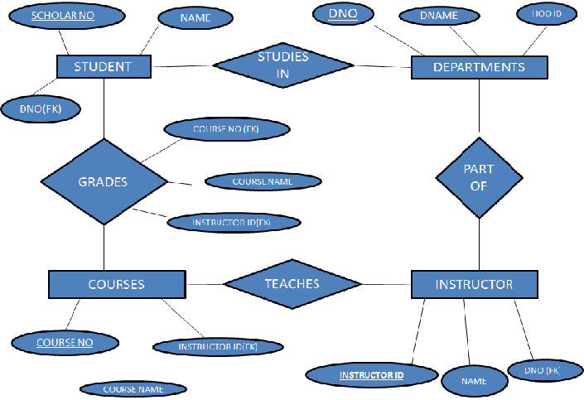

**D. ER TO RELATION MODELLING**

**STUDENT (**SCHOLAR NO. , NAME, DNO)

**DEPARTMENT** (DNAME, DNO, HOD ID)

**INSTRUCTOR** (INSTRUCTOR ID, NAME, DNO)

**GRADES** (SCHOLAR NO., COURSE NO., GRADE)

**COURSE** (COURSE NO., COURSE NAME, INSTRUCTOR ID)

**CONCLUSION**

The project DBMS mapped the various real life entities of the institution like departments, teachers and students and gave us a model through which we can efficiently store ,manipulate and retrieve our data.  
Through this project we got a rough idea about how the data flows between the departments and how it is stored.