Course Name: Computer System Architecture
Course Code: 24CS016

Submitted by: Submitted to:
Name: Rajendra Chaudhary Dr. Navneet Kaur
University Roll No: 2311981617
Section: E2



Chitkara University School of Engineering &amp; Technology,
Chitkara University, Himachal Pradesh- 174103, India.

Title: Emerging Technologies in Computer System Architecture: An In-Depth Analysis

Abstract
As the needs of computing change, old system architectures cannot keep up with the demands of today. To address these issues, a number of revolutionary technologies have been developed. This paper discusses four of these innovations—Quantum Computing, Edge Computing, RISC-V Open-Source Architectures, and Neuromorphic Computing. It describes each technology's underlying principles, architectural aspects, and ongoing research directions, providing insight into how these technologies are set to change the future of computing.

1. Introduction
Traditional computing systems are reaching their maximum performance and efficiency. In response, researchers are looking into alternative solutions that break from conventional models. This paper examines four promising technologies that are more than mere performance enhancements—they mark a change in the way we think about computing architectures. Each of these paradigms has distinct benefits and presents new opportunities for industry and research.

2. Quantum Computing
2.1 Basics and Architectural Significance
Quantum computing relies on qubits, which—contrary to classical bits—can take many values at the same time because of quantum superposition. That enables quantum computers to process enormous sets of inputs in parallel, with important speedup potential for computationally demanding tasks. There are still difficulties, though, like qubit stability, quantum error correction, and interfacing quantum components with classical control [1].

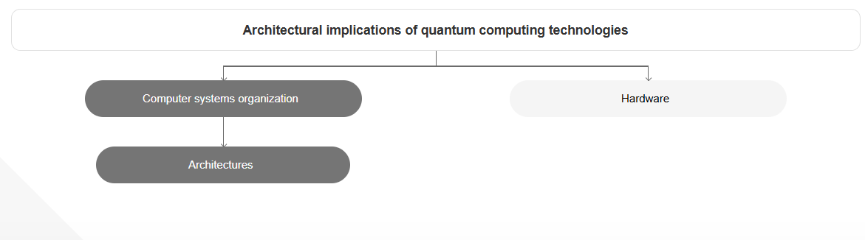
Fig1: Architectural implications of quantum computing technology

2.2 Recent Progress
Van Meter and Oskin have identified critical architectural challenges for scaling quantum computers, including efficient error correction, connectivity between qubits, and fault tolerance at the system level. Their work emphasizes the need to create strong, dependable architectures that must function with the limitations of existing quantum hardware [1].

3. Edge Computing
3.1 Architectural Principles
Edge computing moves computation workloads from central data centers to nearby edge nodes, nearer the sources of data. This data travel reduction reduces latency and simplifies network burden—crucial for applications such as autonomous vehicles, intelligent factories, and telemedicine. Architecturally, this style necessitates secure, efficient, and scalable edge devices that support local computation, storage, and communication [2].

3.2 Research Directions
Caprolu et al. stressed the significance of lightweight virtualization and the necessity of secure communication for distributed edge environments [2]. Gao et al. additionally proposed adaptive methods for service placement optimization and network performance, allowing edge systems to be increasingly dynamic and resource-aware [5].

4. RISC-V Open-Source Architectures
4.1 The Emergence of RISC-V
RISC-V is an open Instruction Set Architecture (ISA) that facilitates modular and extensible processor design. Being open-source, it supports collaborative development and lowers the cost of licensing. With its clean and scalable architecture, RISC-V is used in a broad range of applications, from embedded systems to cloud-scale computing [3].

4.2 Key Innovations
The Ariane processor, constructed with 22nm technology, illustrates RISC-V's capability in creating power-efficient Linux-capable CPUs [3]. On the other hand, the Celerity project presented a 511-core massively parallel RISC-V processor that shows how RISC-V can be scaled for high-end computing environments [6].

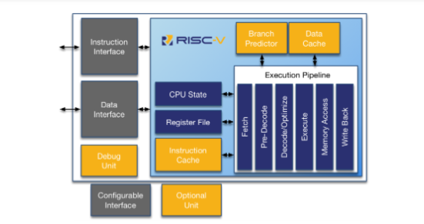
Fig 2: RISE

5. Neuromorphic Computing
5.1 Architecture and Biological Inspiration
Neuromorphic computing takes its inspiration from the human brain, employing spiking neural networks and event-based processing to replicate the way neurons and synapses work. In contrast to traditional systems, these architectures are designed to be energy-efficient and parallel, and they are suited for pattern recognition, real-time learning, and sensory data analysis [4].

5.2 Applications in Real-World Applications
Schuman et al. studied neuromorphic systems based on analog circuits and new devices such as memristors for mimicking biological phenomena [4]. Song et al. also introduced adaptive neuromorphic architectures that can adapt to a workload and perform well with increased robustness in real-world usage [7].

6. Conclusion
Computer architecture is experiencing a fundamental shift. Quantum Computing enlarges computational capabilities using quantum mechanics, Edge Computing distributes brains to enhance responsiveness, RISC-V makes processor design more open to customization, and Neuromorphic Computing closes the artificial/natural intelligence gap. These trends, all in all, overcome the shortcomings of current systems and set the stage for a more intelligent, more responsive computing future.

7. References
[1] Van Meter, R., & Oskin, M. (2006). Architectural implications of quantum computing technologies. ACM Journal on Emerging Technologies in Computing Systems (JETC.
[2] Caprolu, M., Di Pietro, R., Lombardi, F., & Raponi, S. (2019). Edge computing perspectives: architectures, technologies, and open security issues. 2019 IEEE International Conference on Edge Computing (EDGE).
[3] Zaruba, F., & Benini, L. (2019). The cost of application-class processing: Energy and performance analysis of a Linux-ready 1.7GHz 64-bit RISC-V core in 22nm FDSOI technology. arXiv preprint
[4] Schuman, C. D., Potok, T. E., Patton, R. M., Birdwell, J. D., Dean, M. E., Rose, G. S., & Plank, J. S. (2017). A survey of neuromorphic computing and neural networks in hardware.
[5] Gao, B., Zhou, Z., Liu, F., Xu, F., & Li, B. (2021). An online framework for joint network selection and service placement in mobile edge computing. IEEE Transactions on Mobile Computing.
[6] Davidson, S., Xie, S., Torng, C., Al-Hawaj, K., Rovinski, A., & Asanović, K. (2018). The Celerity open-source 511-core RISC-V tiered accelerator fabric: Architecture and implementation. 2018 ACM/IEEE 45th Annual International Symposium on Computer Architecture.
[7] Song, L., Qiao, N., & Li, H. (2019). A framework to explore workload-specific performance and lifetime trade-offs in neuromorphic computing.

