**KALYANI GOVERNMENT ENGINEERING COLLEGE**

**Department of Computer Application**



**CA – 2 ASSIGNMENT**

|  |  |
| --- | --- |
| **Name:** | Rajendra Kumar Shaw |
| **Roll No. :** | MCA/KGEC/22/23 |
| **Stream:** | **MCA** 1st Year 1st Sem **Semester:** 1st semester |
| **Subject:** | Relational Database Management System[MCAN-102] |

**Database Design Of Police Station**

**Table of Contents**

Table of Contents__________________________________________________________1

1. Introduction ________________________________________________________2
2. Problem Definition __________________________________________________ 2
   1. Problem Description _________________________________________________2 3.1. Drawing the E-R diagram ______________________________________ 2 3.2. Mapping the E-R diagram into Relational model ____________________ 3 3.3 Implementing the Relational models in Oracle_______________________5
      1. Conclusion ________________________________________________________7

1

1. Introduction

E-R diagram or Entity Relationship diagram is a graphical representation that depicts relationships among

people, objects, places, concepts or events within a system. Relational Model represents how data is stored in

Relational Databases. A relational database stores data in the form of relations or tables.

As stated in the title a police station database is a system that is used by the police to track and store information about crimes, criminals. The database can be used to perform various tasks, such as keeping track of crimes that have been committed, investigating crimes, and identifying potential suspects. The database can also be used to store information about police officers, staff, and resources. The database design of a police station is a crucial element in the overall security of the station. It enables the police to track the progress of cases, store evidence, and conduct investigations. The database also allows the police to share information with other law enforcement agencies. The database design of a police station must be reliable and efficient. It should be able to handle a large amount of data and be user-friendly. The design should also be flexible so that it can be easily updated as new technologies are developed.

1. Problem Definition

Draw the ER diagram of a police station, with all proper notations. Map the ER diagram into Relational Model and write down all the schemas after mapping.

1. Problem Description

3.1. Drawing the E-R Diagram:

First step of creating a Relational model is implementing an E-R diagram according to the given problem statement.

From the above problem description we can derive below entities -

|  |  |
| --- | --- |
| **table** | **contains** |
|  |  |
| **officer** | stores information about officers assigned to police stations. |
|  |  |
| **officer_rank** | stores information about officers assigned to police stations. |
|  |  |
| **accused** | stores information about the accused person's personal details and cases they are |
|  | suspected of. |
|  |  |
| **victim** | stores information about the victim 's personal details. |
|  |  |

2

|  |  |
| --- | --- |
| **complainant** | stores personal details of the person who filed the complaint. |
|  |  |
| **general_diary** | record that contains details about the complaint, date of crime, date of report and |
|  | other information. |
|  |  |
| **crime** | stores the details and categories of different types of crimes and their respective fine |
|  | amounts. |
|  |  |
| **location** | stores street, house number, city, state and postal code entries. |
|  |  |
| **fine** | stores information about different fine types, amount of different crimes. |
|  |  |

After deciding the relationships between different entities or entity sets we can draw the below Entity Relationship diagram for our police station.

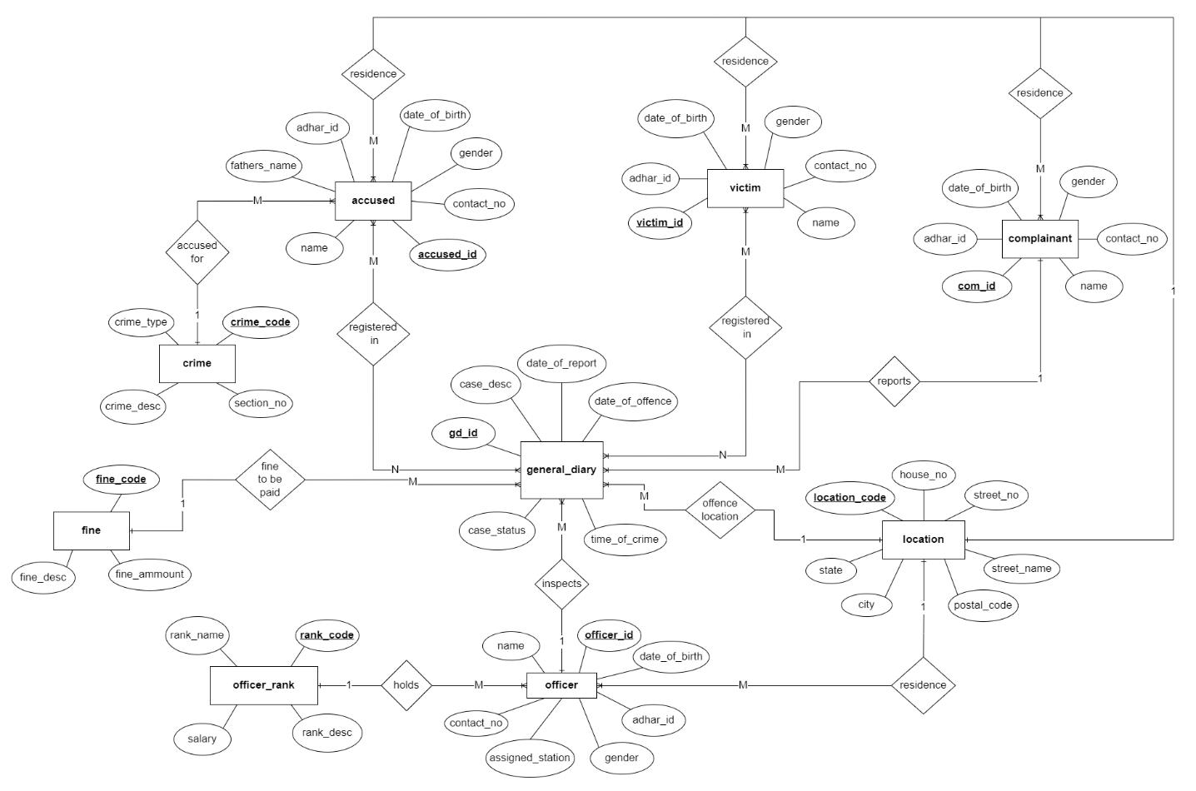

Fig 1: E-R diagram of Police Station

3.2. Mapping the E-R Diagram into Relational Model:

About relational model:

relational model A data model that views information in a database as a collection of distinctly named tables. Each table has a specified set of named columns, each column name or an attribute being distinct within a particular table, but not necessarily between tables. The entries within a particular column of a table must be

3

atomic or single data item and all of the same type. The logical records held in a relational database are viewed as rows in these tables. Each logical record is thus constrained to contain only a set of elementary data items each of a prespecified type.

After designing the ER diagram of the system, we need to convert it to Relational models which can directly be implemented by any RDBMS like Oracle, MySQL etc.

First we convert each entity and relationship to tables. Then we add the key attributes of all participating entities as primary keys of the tables with their respective data types. The entity’s attributes become the other fields of the tables with their respective data types. The value set becomes the domain for the attributes. For implementing the relationships between entity or entity sets we follow the below rules -

* 1 : 1 or 1 : N relationship type is converted to foreign key.
* M : N relationship type is converted to a third relation with two foreign keys.

After mapping all the cardinalities we can create the following relational models from the above E-R diagram.

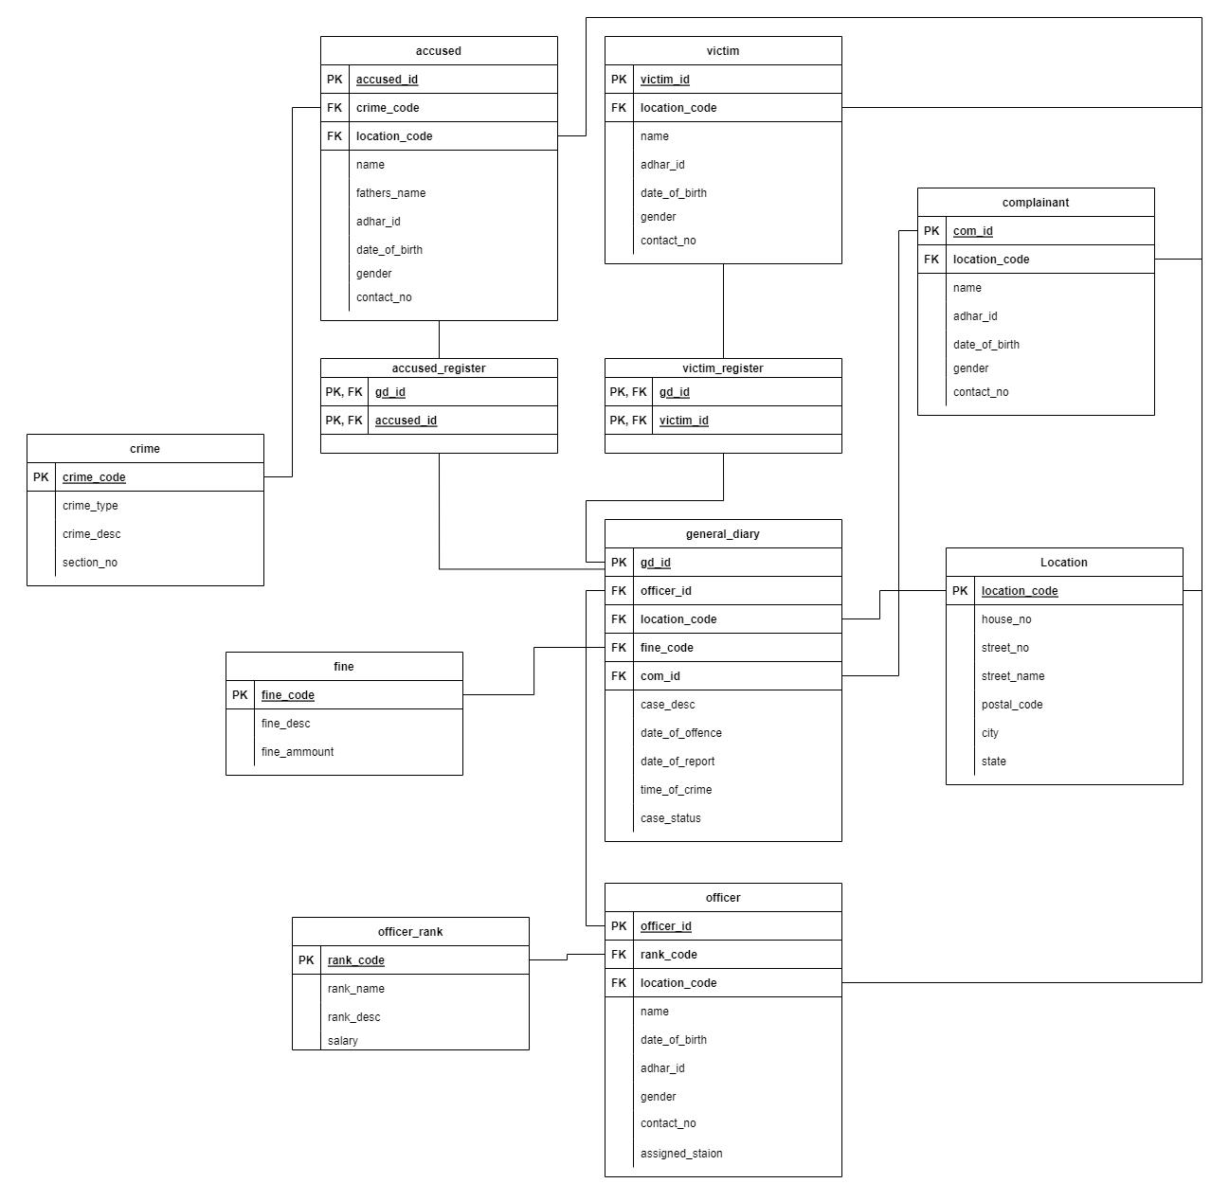

Fig 2 : Relational models implemented from E-R diagram

4

3.3 Implementing the Relational models in ORACLE

After mapping all the relational models we can use a Relational Database Management System and implement all the schemas. Below we have used Oracle, a powerful database server management software from Oracle Corporation to design the database of our police station.

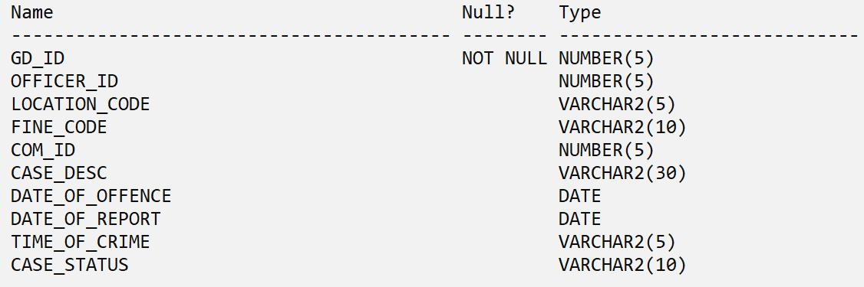

Fig 3 : Schema of table genearl_diary.

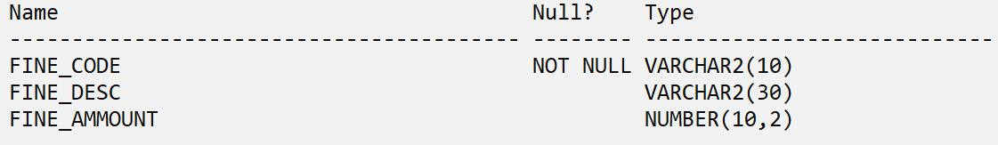

Fig 4 : Schema of table fine.

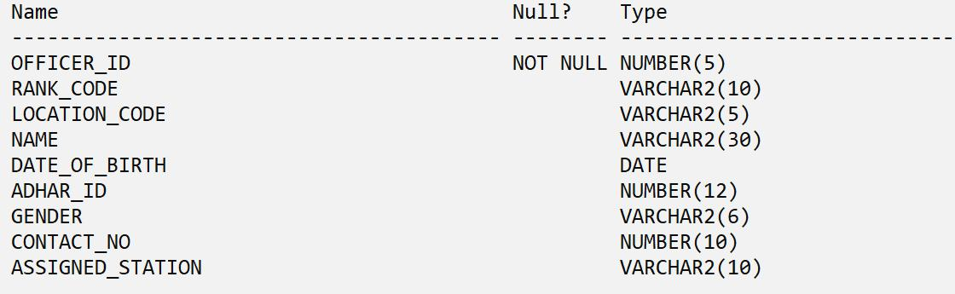

Fig 5 : Schema of table officer.

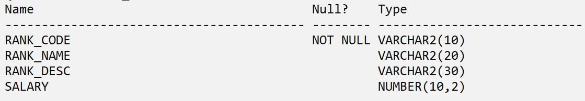

Fig 6 : Schema of table officer_rank.

5

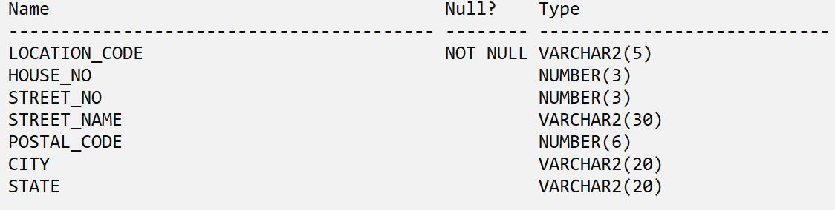

Fig 7 : Schema of table location.

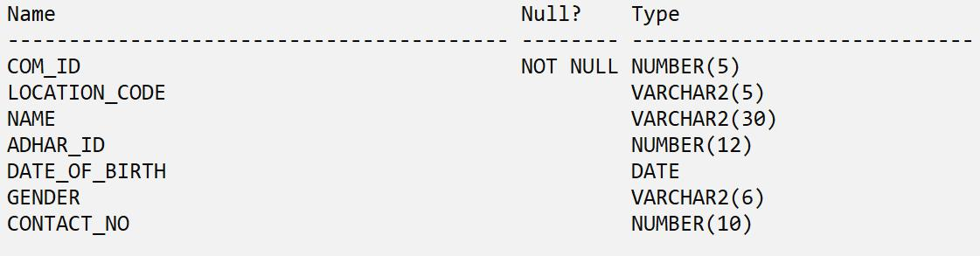

Fig 8 : Schema of table complainant.

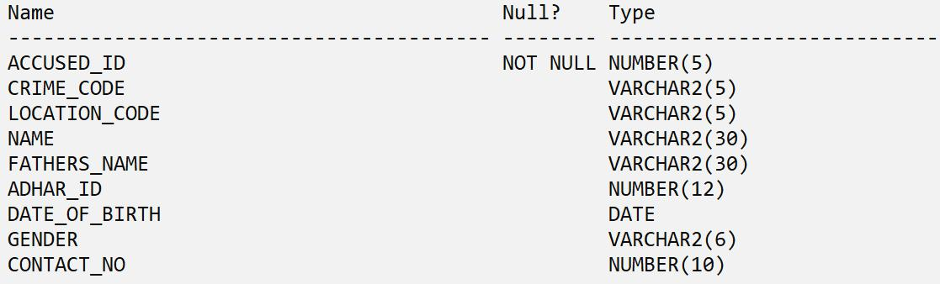

Fig 9 : Schema of table accused.

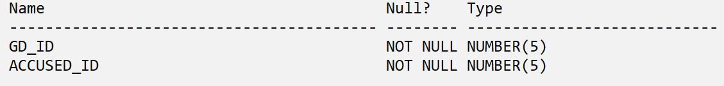

Fig 10 : Schema of table accused_register.

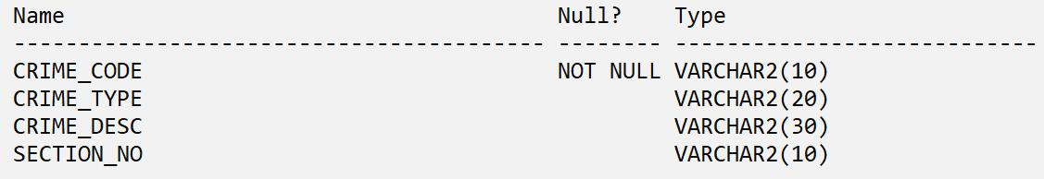

Fig 11 : Schema of table crime.

6

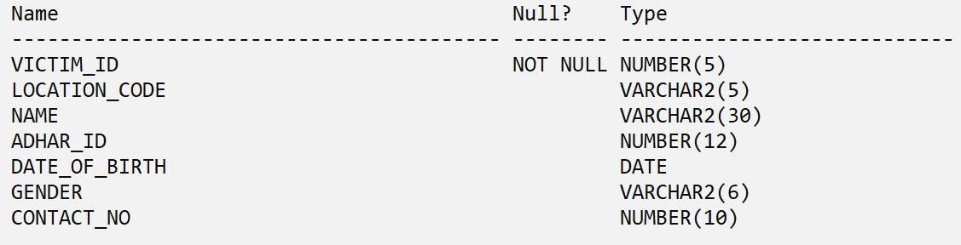

Fig 12 : Schema of table victim.

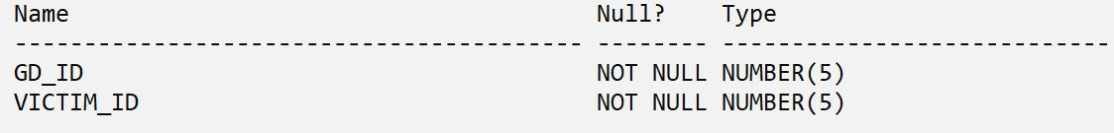

Fig 13 : Schema of table victtim_register.

1. Conclusion

In conclusion, a database is a far more efficient mechanism to store and organise data than spreadsheets. It allows for a centralised facility that can easily be modified and quickly shared among multiple users. Similarly the database design of a police station is a crucial element in the overall security of the station. It enables the police to track the progress of cases, store evidence, and conduct investigations. The database also allows the police to share information with other law enforcement agencies.

7