Kalyani Government Engineering College

Department of Computer Application



# **ASSIGNMENT- 1**

|  |  |
| --- | --- |
| Name | Rajendra Kumar Shaw |
| Roll | 10271022021 |
| Stream | MCA 2nd Sem |
| Subject Name | Operating System Lab(Unix) |
| Subject Code | MCAN-292 |

**INDEX**

|  |  |  |  |  |
| --- | --- | --- | --- | --- |
| **No.** | **Topic** | **Page** | **Date** | **Signature** |
| 1 | Assignment 1 | 3-11 | 03-03-2023 |  |
|  |  |  |  |  |
|  |  |  |  |  |
|  |  |  |  |  |
|  |  |  |  |  |
|  |  |  |  |  |
|  |  |  |  |  |
|  |  |  |  |  |
|  |  |  |  |  |
|  |  |  |  |  |
|  |  |  |  |  |
|  |  |  |  |  |
|  |  |  |  |  |
|  |  |  |  |  |

Q1.List the contents of files 't1' 't2' and 't3' using a single command.

Sol:

Command :

$ cat t1 t2 t3

Output:

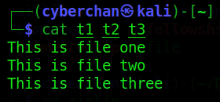

Q2.quickly create three new files t1, t2 and t3

Sol:

Command :

$ touch t1 t2 t3

Q3.Output the contents of the fields 1 and 3 from a text file student where the delimiter between  
the fields is ":"

Sol:

Command :

$ cut –d”:” –f1,3 student.txt

Output:

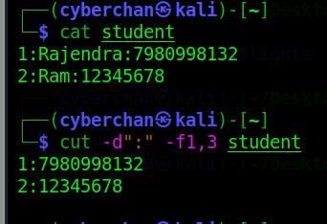

Q4.List all the lines in a file ending with a ";"

Sol:

Command :

$ grep ‘\;$’ sample

Output:

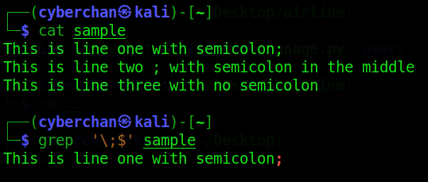

Q5.List all the lines in a file which do not end with a semicolon

Sol:

Command :

$ grep –v ‘\;$’ sample.txt

Output:

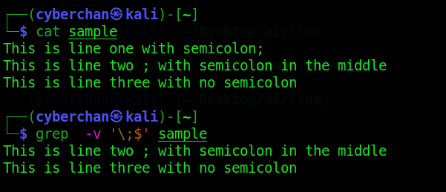

Q6.list the files of the parent directory

Sol:

Command :

$ ls

Output:

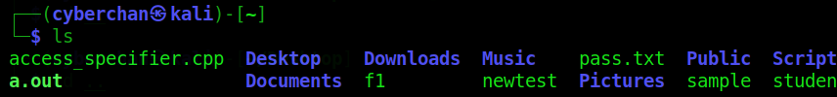

Q7.Find out from /bin and /usr/sbin directories all the file names begin with "s"

Sol:

Command :

$ ls –d /bin/[s]*

$ ls –d /usr/sbin/[s]*

Output:

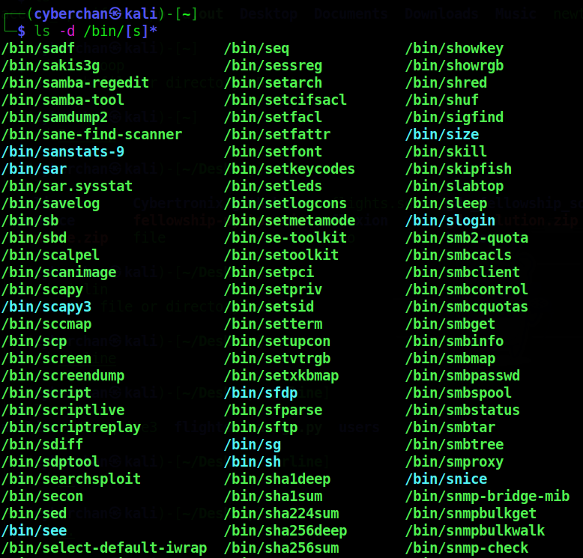

Q8.Redirect the number of users currently logged on to a file aaa

Sol:

Command :

$ who > aaa

Output:

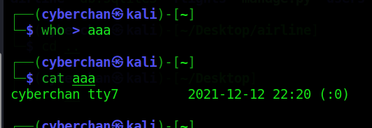

Q9.redirect the sorted output of names currently logged on users to a file

Sol:

Command :

$ who | cut –d” ” –f1|sort|uniq| > sortedUsers

Output:

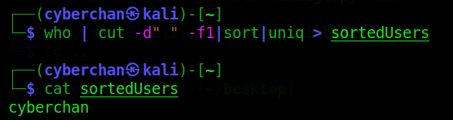

Q10.display first 10 lines and last 10 lines from a file aaa

Sol:

Command :

$ head -10 aaa

$ tail -10 aaa

Output:

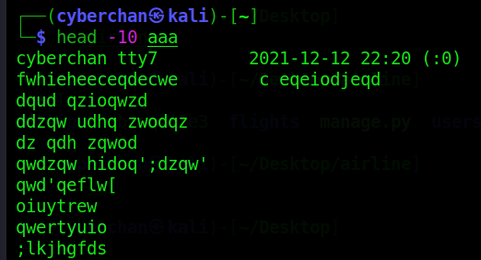

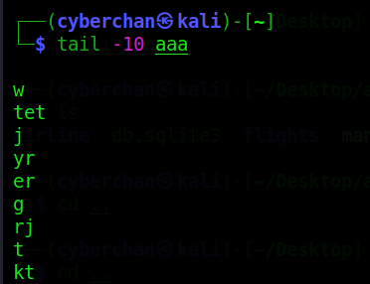

Q11.display 15 lines from the middle of the file. File contains 100 lines, you have to display 45-60 lines

Sol:

Command :

$ head -60 | tail -45 aaa

Output:

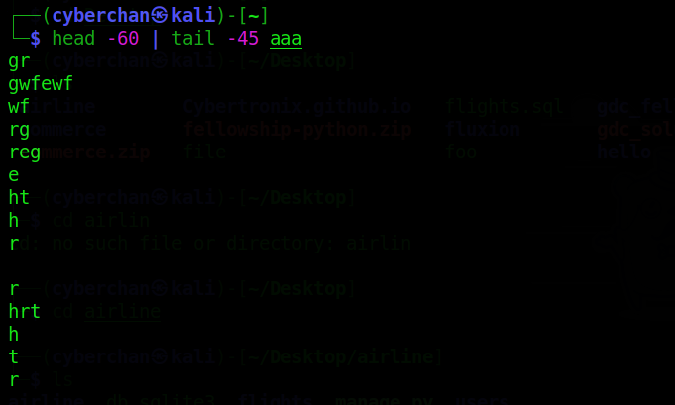

Q12. Write down the default permission of a file. Write a command to set all permission for the user and remove all permission for group and others

Sol:

Command :

$ ls –l t1

-rw-r--r-- //default permission of t1

$ chmod 700 t1

Output:

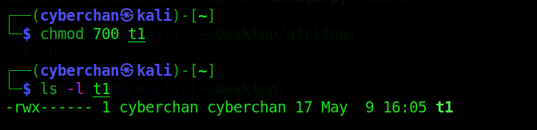

Q13.move the files p1 and p2 to the directory dest

Sol:

Command :

$ mv p1 p2 dest

Output:

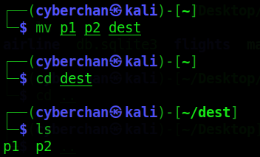

Q14.There re two texts files c1 and c2. Write a command to display total number of words in both the files

Sol:

Command :

$ wc –w c1 c2

Output:

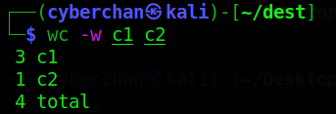

Q15.List all the file names starting with a, b or s

Sol:

Command :

$ ls [abs]*

Output:

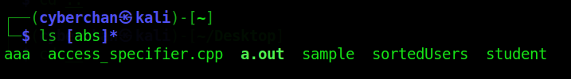

Q16. Create a new file named f1. Convert all the words of the file to uppercase.

Sol:

Command :

$ cat >> f1

abcdef cntrl+d

$ cat f1|tr[a-z][A-Z]

Output:

ABCDEF

Q17. Display the total number of words in both files ‘temp’ and ‘exam’

Sol:

Command :

$ wc –w temp exam

Output:

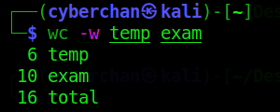

Q18. Write a command to display the current date on the terminal preceded by the string “Today is”

Sol:

Command :

$ echo “Today is $(date+%D)”

Output:

Today is 10-03-2023