**Database Lab Take Home Assignment - 3**

**Database Creation**

**First Part**

| **create database 214161008_03;** |
| --- |



| **use 214161008_03;** |
| --- |



**Employee Table Creation**

| **create table employee (  first_name varchar(30) not null,  middle_name varchar(30),  last_name varchar(30),  ssn integer,  birth_date date,  address varchar(30),  sex char(1),  salary integer,  super_ssn integer,  dept_no integer,  primary key (ssn),  check (sex in ('M' ,'F')) );** |
| --- |

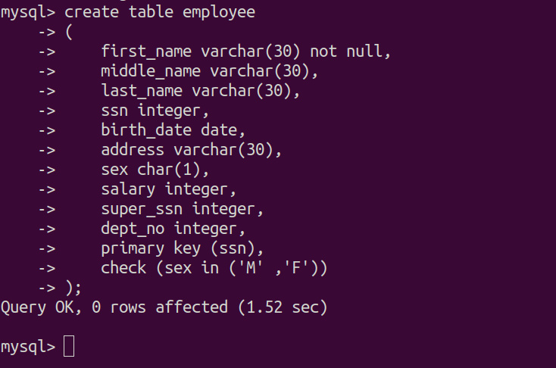

**Department Table Creation**

| **create table department (  dept_name varchar(30),  dept_no integer,  mgr_ssn integer,  mgr_start_date date,  primary key (dept_no),  foreign key (mgr_ssn) references employee(ssn) );** |
| --- |

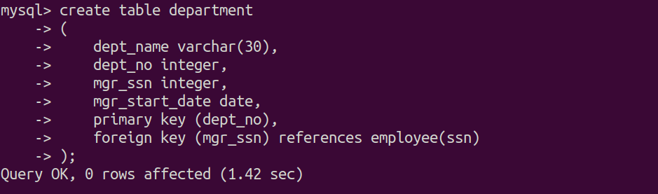

**Department Location Table Creation**

| **create table department_location (  dept_no integer,  location varchar(30),  primary key (dept_no, location),  foreign key (dept_no) references department(dept_no) )*;*** |
| --- |

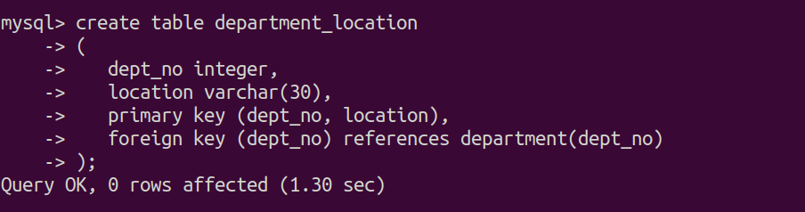

**Project Table Creation**

| **create table project (  project_name varchar(30),  project_no integer,  project_location varchar(30),  dept_no integer,  primary key (project_no),  foreign key (dept_no) references department(dept_no) );** |
| --- |

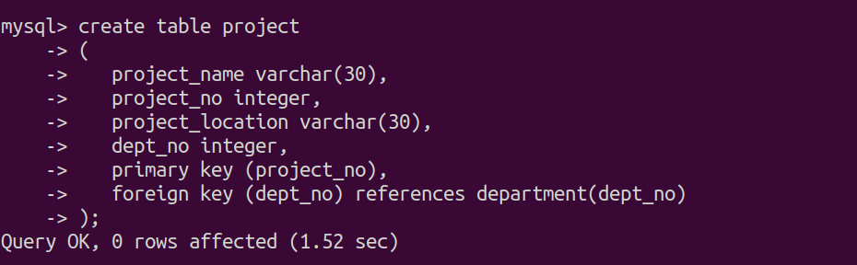

**Works_on Table Creation**

| **create table works_on (  employee_ssn integer,  project_no integer,  hours float,  primary key (employee_ssn, project_no) );** |
| --- |

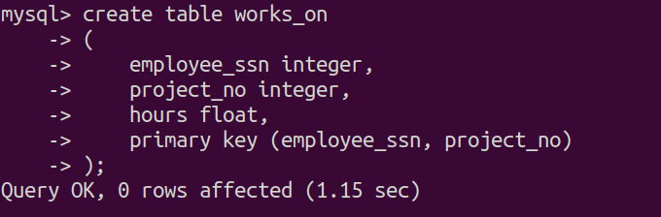

**Dependent Table Creation**

| **create table dependent (  employee_ssn integer,  dependent_name varchar(30),  sex char(1),  birth_date date,  relationship varchar(10),  primary key (employee_ssn),  check (relationship='Spouse' or relationship='Child' or relationship = 'Parent'),  foreign key (employee_ssn) references employee(ssn) );** |
| --- |

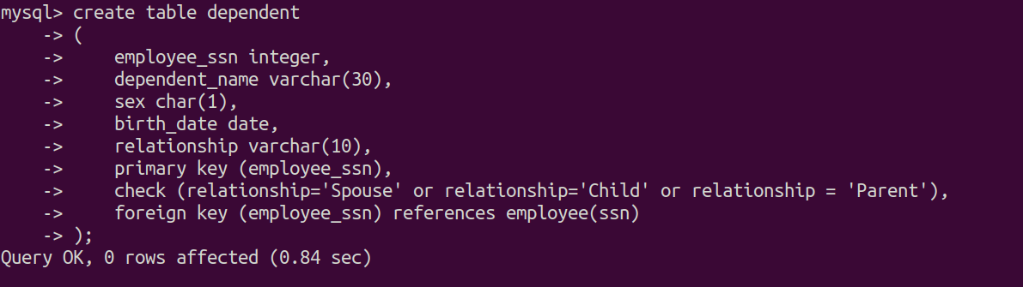

**Insert into Employee Table**

| **insert into employee (first_name, middle_name, last_name, ssn, birth_date, address, sex, salary, super_ssn, dept_no) values ('John', 'B', 'Smith', 123456789, '1965-01-09', '731 Fondren, Houston, TX', 'M', 6500, 999887777,5); insert into employee (first_name, middle_name, last_name, ssn, birth_date, address, sex, salary, super_ssn, dept_no) values ('Franklin', 'T', 'Wong', 333445555, '1955-12-08', '638 Voss, Hoston, TX', 'M', 8000, 987654321, 5); insert into employee (first_name, middle_name, last_name, ssn, birth_date, address, sex, salary, super_ssn, dept_no) values ('Alicia', 'J', 'Zelaya', 999887777, '1968-07-19', '3321 Castle, Spring, TX', 'F', 7200, 888665555, 4); insert into employee (first_name, middle_name, last_name, ssn, birth_date, address, sex, salary, super_ssn, dept_no) values ('Jennifer', 'S', 'Wellas', 987654321, '1941-06-20', '291 Berry, Bellaire, TX', 'F', 6780, 987987987, 4); insert into employee (first_name, middle_name, last_name, ssn, birth_date, address, sex, salary, super_ssn, dept_no) values ('Ramesh', 'K', 'Narayan', 666884444, '1962-09-15', '975 Fire Oak, Humble, TX', 'M', 5700, 123456789, 5); insert into employee (first_name, middle_name, last_name, ssn, birth_date, address, sex, salary, super_ssn, dept_no) values ('Joyce', 'A', 'English', 453453453, '1972-07-31', '5631 Rice, Houston, TX', 'M', 8600, 666884444, 5); insert into employee (first_name, middle_name, last_name, ssn, birth_date, address, sex, salary, super_ssn, dept_no) values ('Ahmad', 'V', 'Jabbar', 987987987, '1969-03-29', '980 Dallas, Hoston, TX', 'M', 6950, 453453453, 4); insert into employee (first_name, middle_name, last_name, ssn, birth_date, address, sex, salary, super_ssn, dept_no) values ('James', 'E', 'Borg', 888665555, '1937-11-10', '450 Stone, Houston, TX', 'M', 7800, 987654321, 1);** |
| --- |

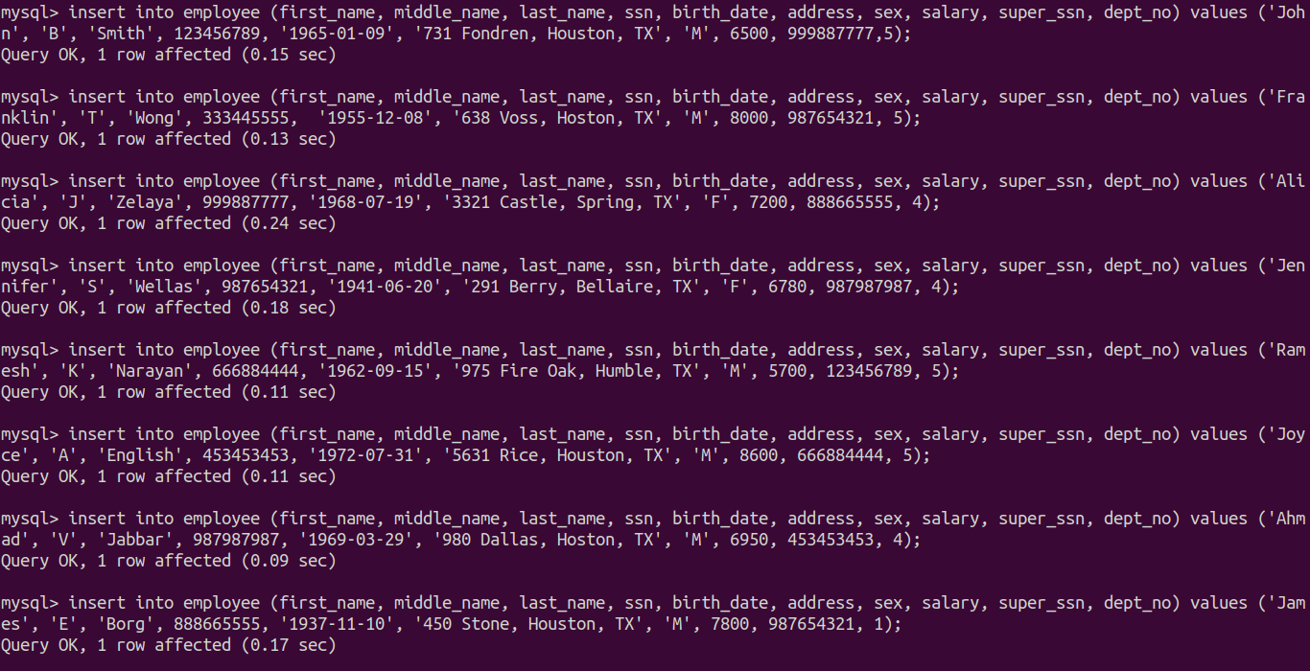

**Insert into Department Table**

| **insert into department(dept_name, dept_no, mgr_ssn, mgr_start_date) values ('Research', 5, 333445555, '1980-02-15'); insert into department(dept_name, dept_no, mgr_ssn, mgr_start_date) values ('Administration', 4, 987654321, '1982-05-30'); insert into department(dept_name, dept_no, mgr_ssn, mgr_start_date) values ('Headquarters', 1, 888665555, '1984-11-01'); insert into department(dept_name, dept_no, mgr_ssn, mgr_start_date) values ('Headquarters', 3, 123456789, '1987-12-23'); insert into department(dept_name, dept_no, mgr_ssn, mgr_start_date) values ('Headquarters', 2, 453453453, '1991-06-19');** |
| --- |

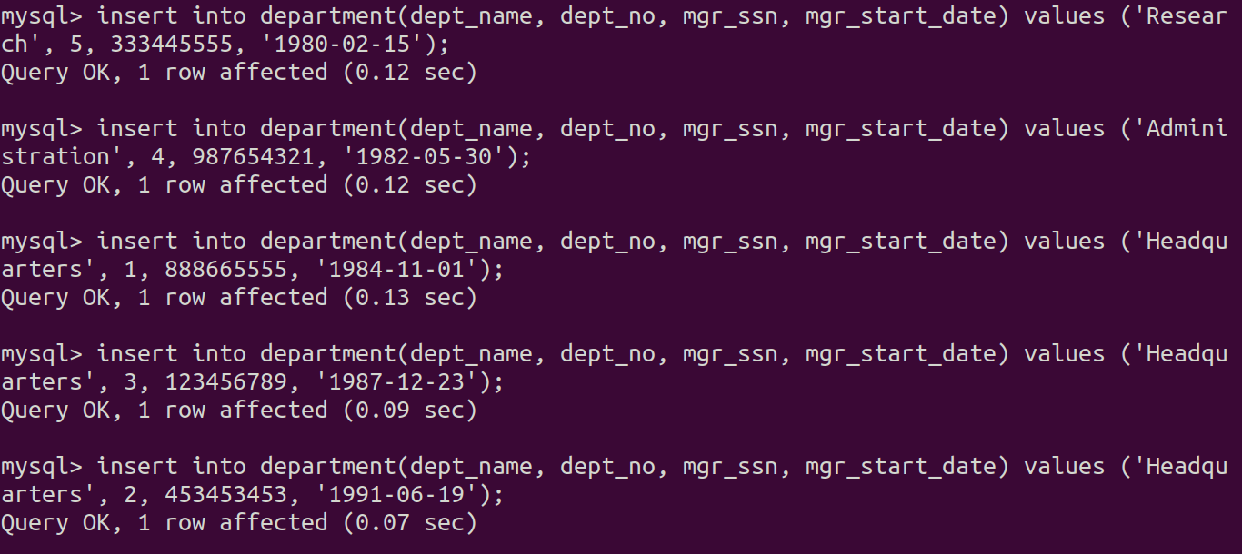

**Insert into Department Location Table**

| **insert into department_location(dept_no, location) values (1, 'Houston'); insert into department_location(dept_no, location) values (4, 'Stanford'); insert into department_location(dept_no, location) values (5, 'Bellaire'); insert into department_location(dept_no, location) values (2, 'Sugarland'); insert into department_location(dept_no, location) values (3, 'Priceton');** |
| --- |

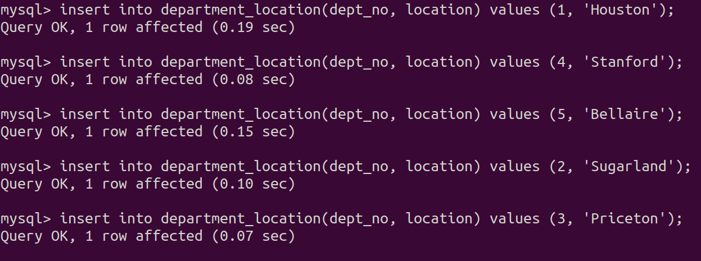

**Insert into Works on Table**

| **insert into works_on(employee_ssn, project_no, hours) values (123456789, 1, 32.5); insert into works_on(employee_ssn, project_no, hours) values (123456789, 2, 7.5); insert into works_on(employee_ssn, project_no, hours) values (666884444, 3, 40.0); insert into works_on(employee_ssn, project_no, hours) values (453453453, 1, 20.0); insert into works_on(employee_ssn, project_no, hours) values (453453453, 2, 20.0); insert into works_on(employee_ssn, project_no, hours) values (333445555, 2, 10.0); insert into works_on(employee_ssn, project_no, hours) values (333445555, 3, 10.0); insert into works_on(employee_ssn, project_no, hours) values (333445555, 10, 10.0); insert into works_on(employee_ssn, project_no, hours) values (333445555, 20, 10.0); insert into works_on(employee_ssn, project_no, hours) values (999887777, 30, 30.0); insert into works_on(employee_ssn, project_no, hours) values (999887777, 10, 10.0); insert into works_on(employee_ssn, project_no, hours) values (987987987, 10, 35.0); insert into works_on(employee_ssn, project_no, hours) values (987987987, 30, 5.0); insert into works_on(employee_ssn, project_no, hours) values (987654321, 30, 20.0); insert into works_on(employee_ssn, project_no, hours) values (987654321, 20, 15.0); insert into works_on(employee_ssn, project_no, hours) values (888665555, 20, 10.5);** |
| --- |

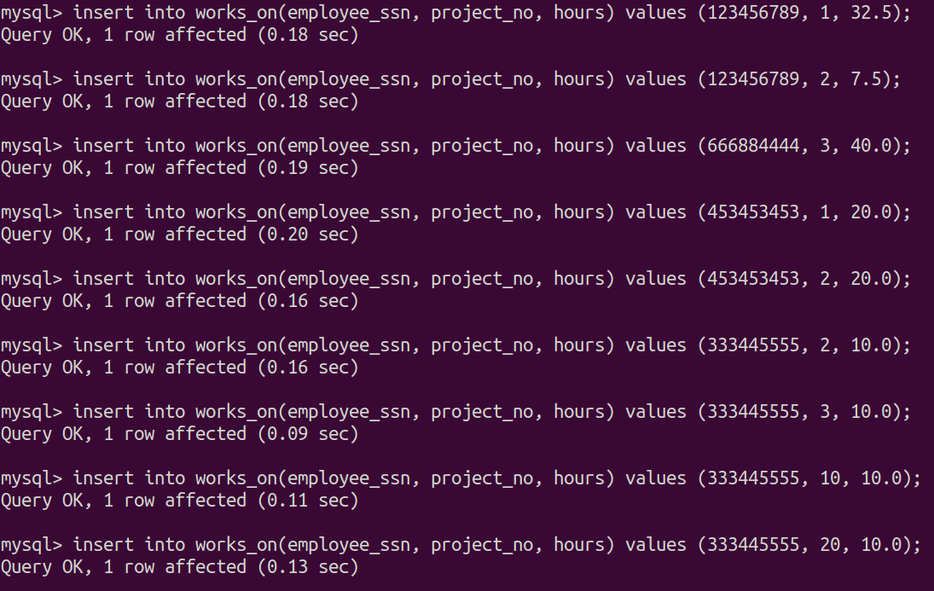

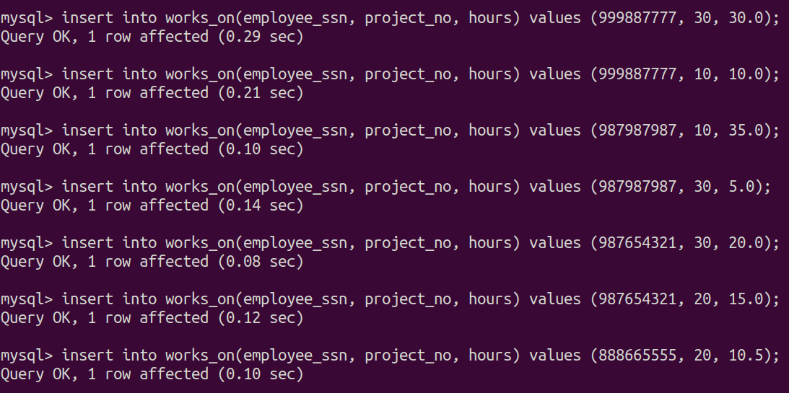

**Insert into Project Table**

| **insert into project(project_name, project_no, project_location, dept_no) values ('ProductX', 1, 'Bellaire', 5); insert into project(project_name, project_no, project_location, dept_no) values ('ProductY', 2, 'Sugarland', 5); insert into project(project_name, project_no, project_location, dept_no) values ('ProductZ', 3, 'Houston', 5); insert into project(project_name, project_no, project_location, dept_no) values ('Computerization', 10, 'Stafford', 4); insert into project(project_name, project_no, project_location, dept_no) values ('Reorganization', 20, 'Hoston', 1); insert into project(project_name, project_no, project_location, dept_no) values ('Newbenifits', 30, 'Stafford', 4);** |
| --- |

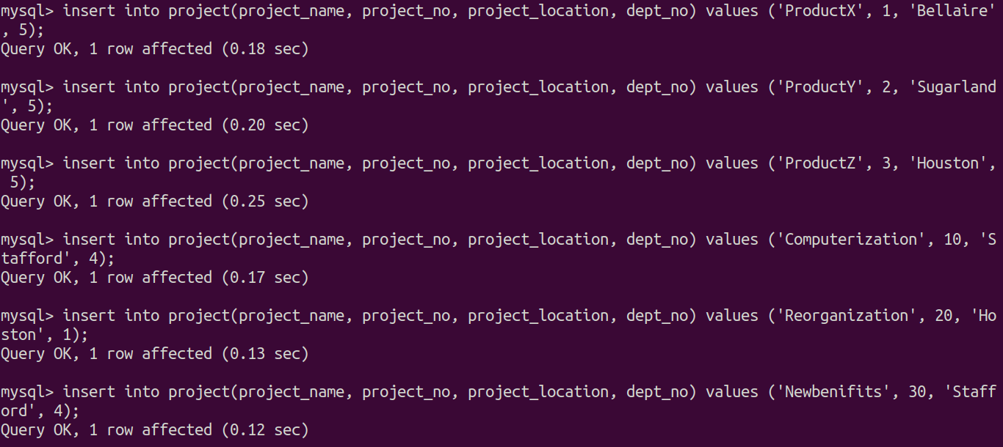

**Insert into Dependent Table**

| **insert into dependent(employee_ssn, dependent_name, sex, birth_date, relationship) values (666884444, 'Andrew', 'M', '1994-12-27', 'Child'); insert into dependent(employee_ssn, dependent_name, sex, birth_date, relationship) values (999887777, 'Ellie', 'F', '1922-04-15', 'Parent'); insert into dependent(employee_ssn, dependent_name, sex, birth_date, relationship) values (123456789, 'Perry', 'F', '1965-02-10', 'Spouse'); insert into dependent(employee_ssn, dependent_name, sex, birth_date, relationship) values (453453453, 'Gillespe', 'M', '1974-07-30', 'Parent'); insert into dependent(employee_ssn, dependent_name, sex, birth_date, relationship) values (987987987, 'Rashid', 'M', '1994-11-07', 'Child'); insert into dependent(employee_ssn, dependent_name, sex, birth_date, relationship) values (888665555, 'Kane', 'M', '1992-08-08', 'Child'); insert into dependent(employee_ssn, dependent_name, sex, birth_date, relationship) values (333445555, 'Adam', 'M', '1975-05-20', 'Spouse'); insert into dependent(employee_ssn, dependent_name, sex, birth_date, relationship) values (987654321, 'Wilson', 'M', '1987-07-15', 'Spouse');** |
| --- |

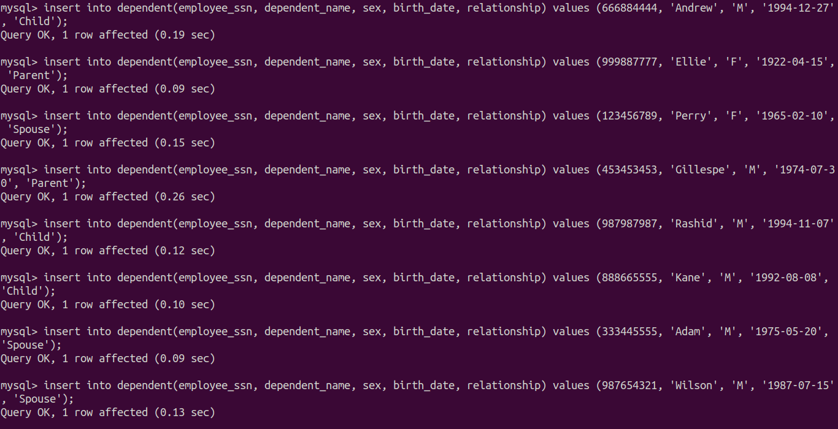

**Alter Employee table and add foreign keys**

| **alter table employee add foreign key (dept_no) references department(dept_no);   alter table employee add foreign key (super_ssn) references employee(ssn);** |
| --- |

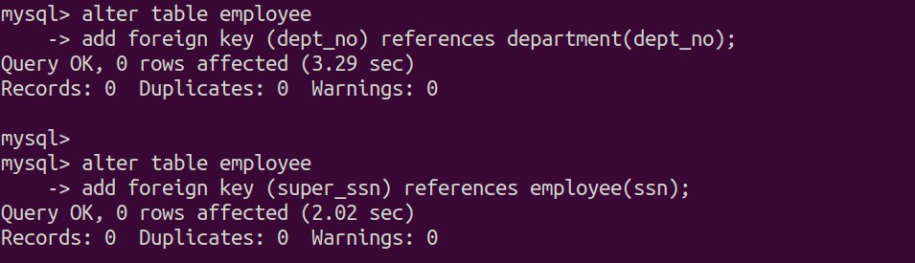

| **select * from employee;** |
| --- |

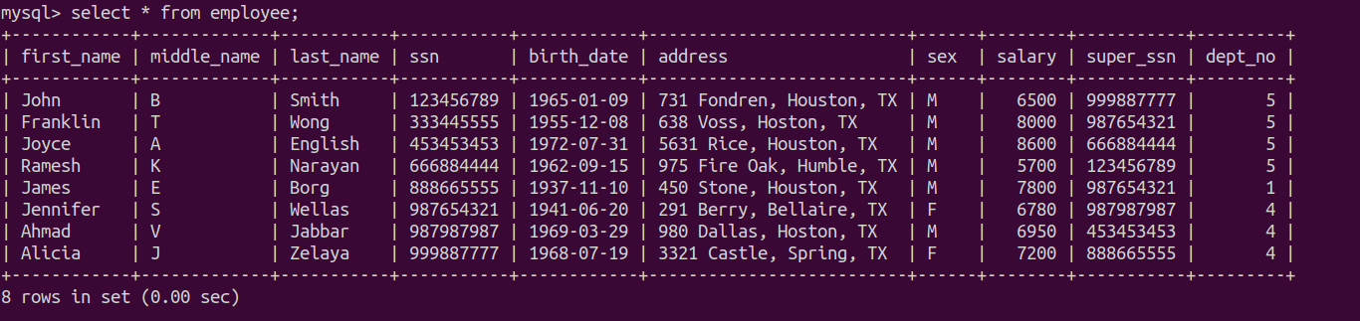

| **select * from department;** |
| --- |

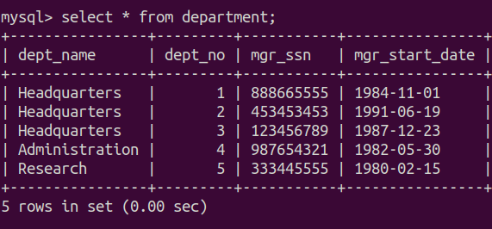

| **select * from department_location;** |
| --- |

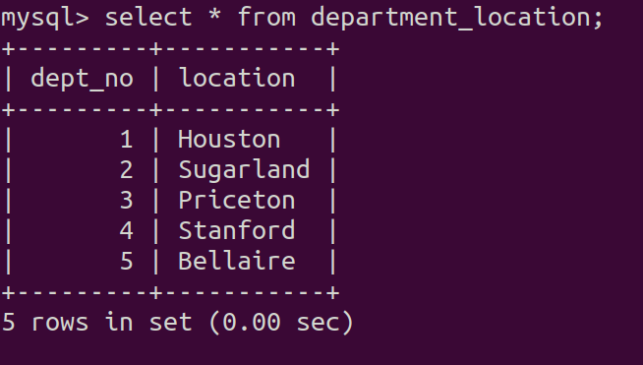

| **select * from works_on;** |
| --- |

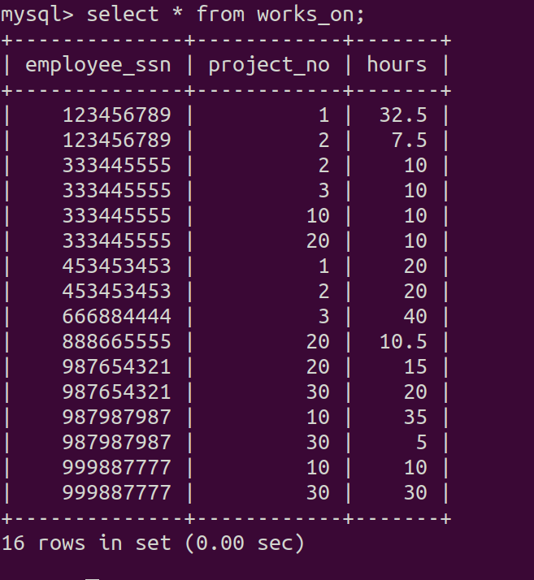

| **select * from project;** |
| --- |

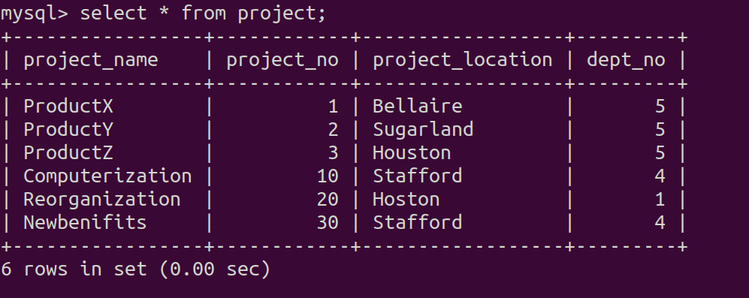

| **select * from dependent;** |
| --- |

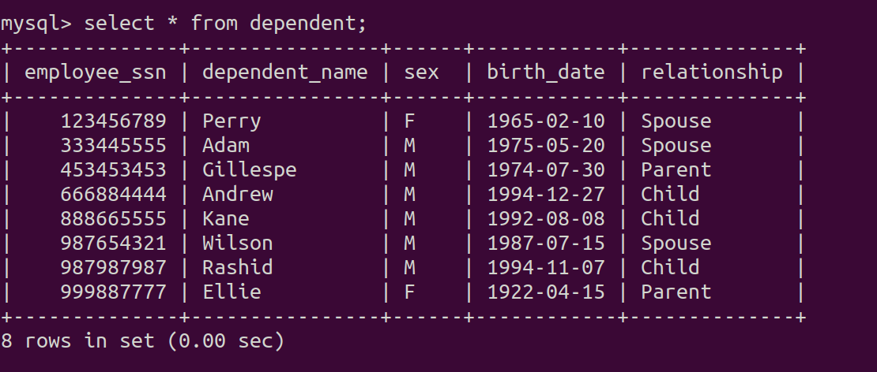

1. **Create a view that has the department name, manager name, and manager salary for every department**

| **create view department_details(dept_name, employeeFName, employeeMidName, employeeLName, employeeSalary) as  select D.dept_name, E.last_name, E.middle_name, E.first_name, E.salary  from department D, employee E  where D.mgr_ssn = E.ssn;** |
| --- |

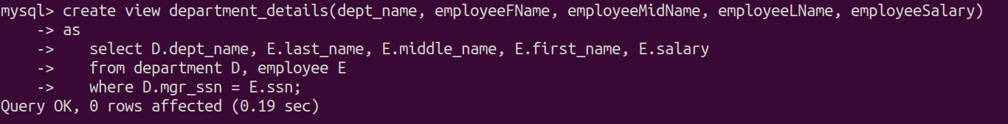

| **select * from department_details;** |
| --- |

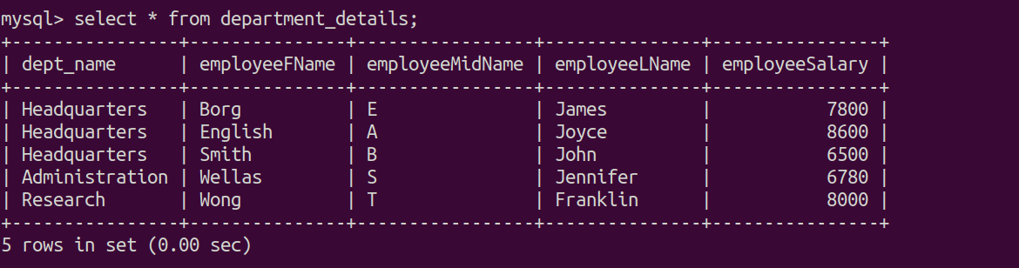

1. **Create a view that has the Employee Name, Supervisor name and employee salary for each employee who works in the "Research" Department.**

| **create view employee_details(employeeFName, employeeMidName, employeeLName, SupervisorFName, SupervisorMidName, SupervisorLName, employeeSalary) as  select employee.first_name as employeeFName, employee.middle_name as employeeMidept_name,  employee.last_name as employeelast_name , Supervisor.first_name as SupervisorFName,  Supervisor.middle_name as SupervisorMidept_name, Supervisor.last_name as Supervisorlast_name,  employee.salary as employee_salary  from employee, employee Supervisor  where employee.dept_no =  (  select dept_no  from department  where dept_name = 'Research'  )  and employee.super_ssn = Supervisor.ssn;** |
| --- |

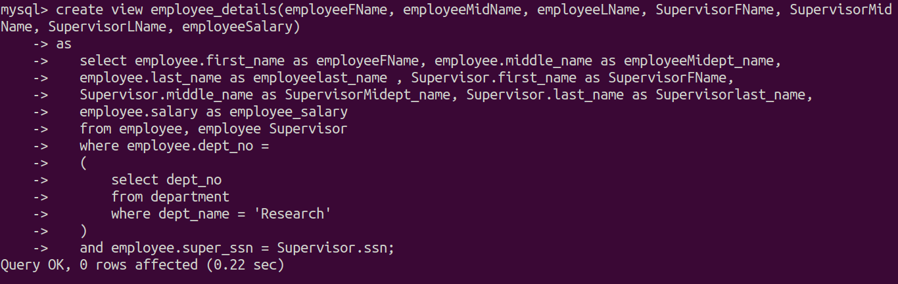

| **select * from employee_details;** |
| --- |

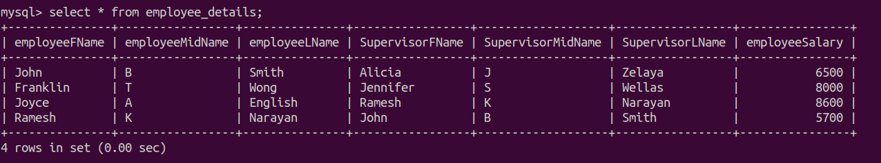

1. **A view that has the Project name, controlling department name, Number of employees, and total hours worked per week on the project, for each project.**

| **create view project_details(project, department, number_of_employees, hours_per_week) as  select P.project_name as project, D.dept_name, count(W.project_no) as number_of_employees, sum(W.hours) as hours_per_week  from project P, department D, works_on W  where P.dept_no = D.dept_no and P.project_no = W.project_no  group by (P.project_no);** |
| --- |

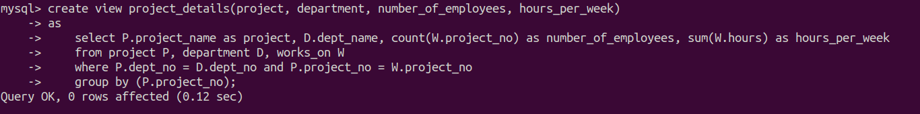

| **select * from project_details;** |
| --- |

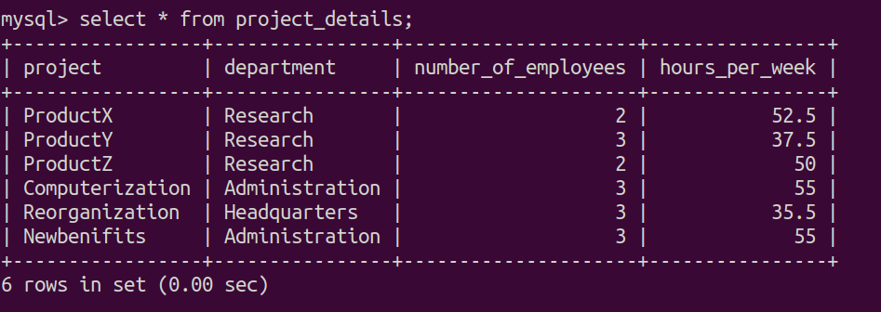

1. **A view that has the project name, controlling department name, number of employees, and total hours worked per week on the project for each project with more than one employee working on it.**

| **create view project_with_more_than_one_employee(project, department, number_of_employees, hours_per_week) as  select P.project_name as project, D.dept_name, count(W.project_no) as number_of_employees, sum(W.hours) as hours_per_week  from project P, department D, works_on W  where P.dept_no = D.dept_no and P.project_no = W.project_no  group by (P.project_no)  having count(W.project_no) > 1;** |
| --- |

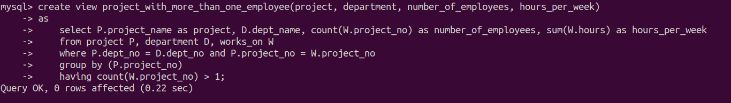

| **select * from project_with_more_than_one_employee;** |
| --- |

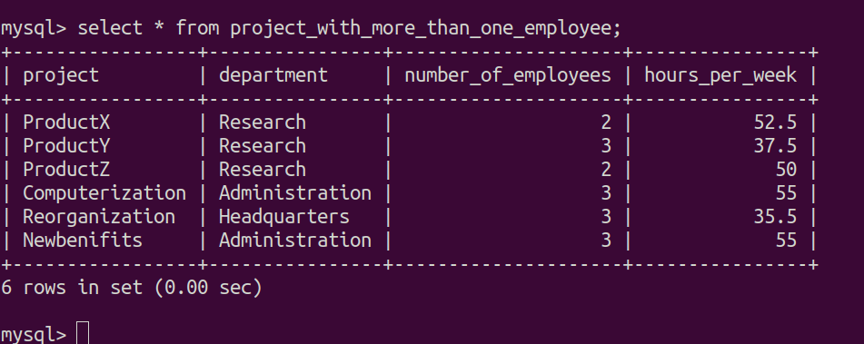

**Second Part**

| **create view dept_summary(D, C, total_s, average_s) as select dept_no, count(*), sum(salary), avg(salary) from employee group by dept_no;** |
| --- |

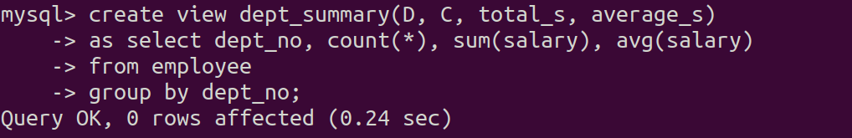

| 1. **select * from dept_summary;** |
| --- |

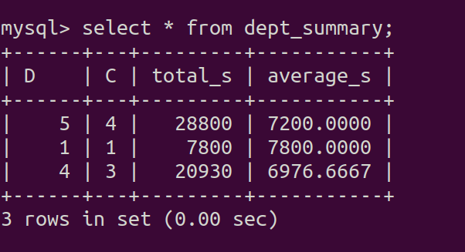

| 1. **select D, C from dept_summary where total_s > 100000** |
| --- |

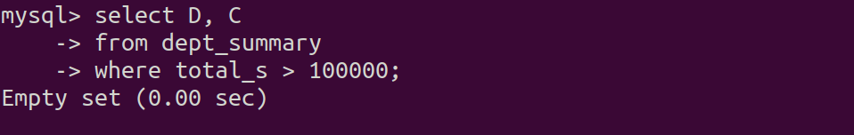

Since no department is having total salary greater than 100000 hence it will return empty set

| 1. **select D, average_s from dept_summary where C > (  select C  from dept_summary  where D = 4 );** |
| --- |

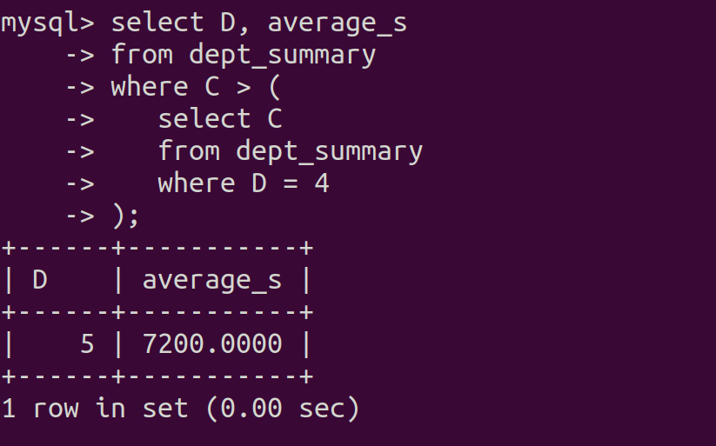

| 1. **update dept_summary set D *= 3* where *D = 4*;** |
| --- |

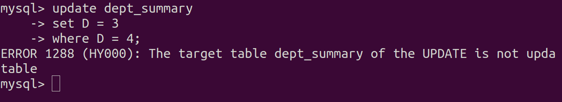

The view is not updatable since the view is using aggregate function (group by).

| 1. **delete from dept_summary where C > 4;** |
| --- |

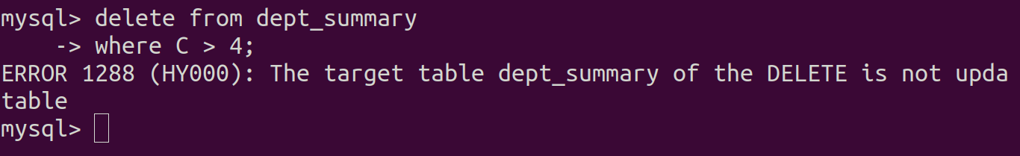

The view is not updatable since the view is using aggregate function (group by).